**LAB # 07**

**Working with UML Diagrams in MS-VISIO**

## **Introduction**

**Definition**

* UML stands for Unified Modeling Language which is used in object oriented software engineering.
* It can be used to model an application structures, behavior and even business processes.
* There are 14 UML diagram types to help you model these behavior.

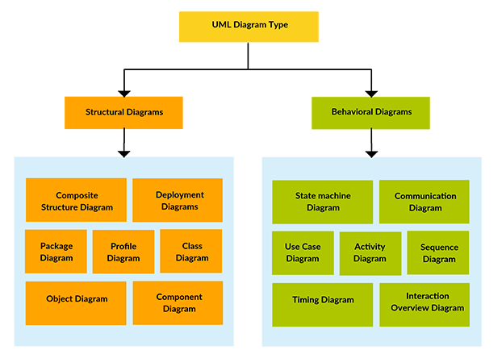

**TYPES OF UML DIAGRAMS**

* **Structure diagrams** show the things in a system being modeled. In a more technical term, they show different objects in a system.
* **Behavioral diagrams** shows what should happen in a system. They describe how the objects interact with each other to create a functioning system.

**USECASE DIAGRAMS**

Use case diagrams give a graphic overview of the actors involved in a system, different functions needed by those actors and how these different functions are interacted. You can easily identify the main actors involved and the main processes of the system.

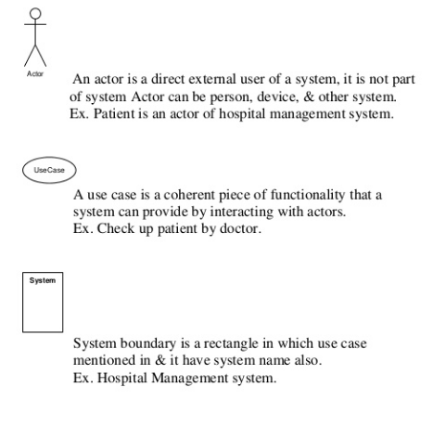

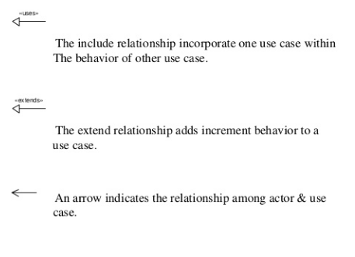

**EXAMPLE**

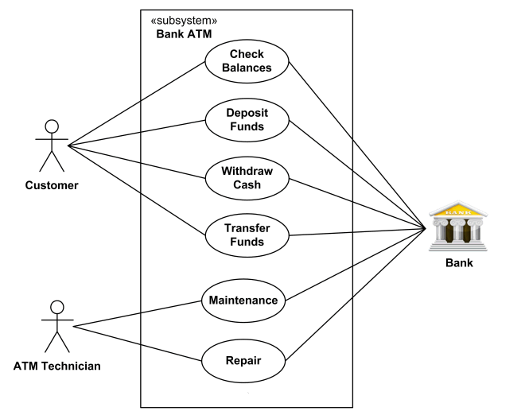

**ACTIVITY DIAGRAM**

Activity diagrams represent workflows in a graphical way. They can be used to describe business workflow or the operational workflow of any component in a system

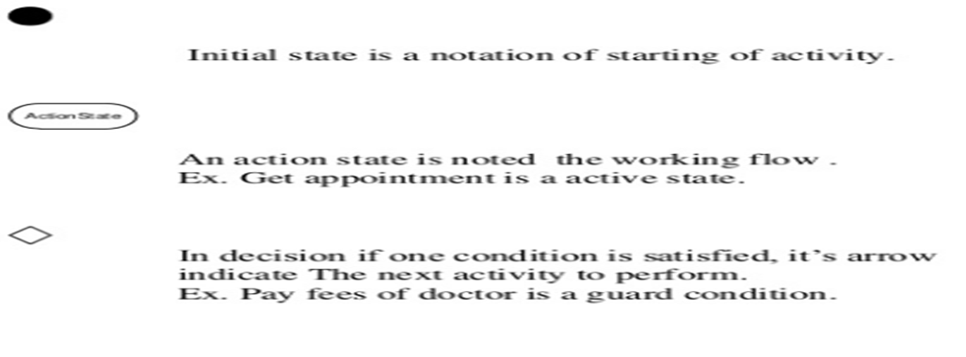

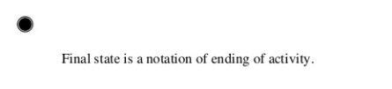

**EXAMPLE**

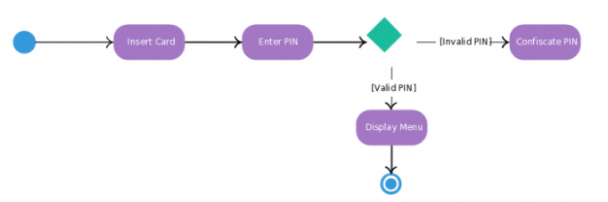

**SEQUENCE DIAGRAM**

Sequence diagrams, commonly used by developers, model the interactions between objects in a single use case. They illustrate how the different parts of a system interact with each other to carry out a function, and the order in which the interactions occur when a particular use case is executed. In simpler words, a sequence diagram shows different parts of a system work in a ‘sequence’ to get something done.

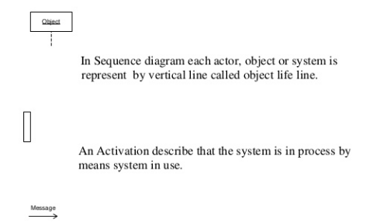

**EXAMPLE**

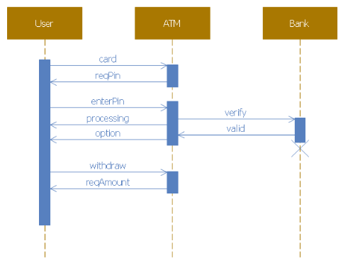

## **Lab Tasks**

Draw these UML DIAGRAMS for Online Shopping System:

Task 1: Use case Diagram

Task 2: Activity Diagram

Task 3: Sequence Diagram