Statistics is: ‘the science of learning from data, and of measuring, controlling, and communicating uncertainty; and it thereby provides the navigation essential for controlling the course of scientific and societal advances.
Statisticsis a collection of methods for collecting, displaying, analyzing, and drawing conclusions from data.

Structure of Statistics

Descriptive statistics is the branch of statistics that involves organizing, displaying, and describing data.

Descriptive Statistics is primarily about summarizing a given data set through numerical summaries and graphs, and can be used for exploratory analysis to visualize the information contained in the data and suggest hypotheses etc. It is useful and important. It has become more exciting nowadays with people regularly using fancy interactive computer graphics to display numerical information
Inferential statistics is the branch of statisticsthat involves drawing conclusions about a population based on information contained in a sample taken from that population.

Inferential Statistics is concerned with methods for making conclusions about a population using information from a sample, and assessing the reliability of, and uncertainty in, these conclusions. This allows us to make judgements in the presence of uncertainty and variability, which is extremely important in underpinning evidence-based decision making in science, government, business etc.

Data
Any bit of information that is expressed in a value or numerical number is data. For example, the marks you scored in your Math exam is data, and the number of cars that pass through a bridge in a day is also data. Data is basically a collection of information, measurements or observations.
What is Data?
Data refers to the fresh information or a set of given facts, in numerical figures collected by individuals or obtained from various sources for a specified purpose.
Raw data is an initial collection of information. This information has not yet been organized. After the very first step of data collection, you will get raw data. For example, we go around and ask a group of five friends their favouritecolour. The answers are Blue, Green, Blue, Red, and Red. This collection of information is the raw data.
Then there is discrete data and continuous data.
Discrete data is that which is recorded in whole numbers, like the number of children in a school or number of tigers in a zoo. It cannot be in decimals or fractions.
Continuous data need not be in whole numbers, it can be in decimals. Examples are the temperature in a city for a week, your percentage of marks for the last exam etc.

What is Grouped Data?
- Grouped Data is a statistical concept that is used to systematically display data that has been collected. Grouped Data is extremely useful as it can show large and complex datasets in an understandable way.
- Grouping the data helps researchers gain insights into how different variables relate to each other and produce visual representations of the information so it is easier to grasp.
- Grouping the data can also help identify trends, outliers, and interesting correlations between different categories within the dataset, allowing a further understanding of large datasets than what would be available if analyzing individual points of data. Grouped Data has become an increasingly popular tool for researchers trying to make sense of vast amounts of information.

What is Ungrouped Data?
Ungrouped data, also known as raw data, is unorganized numerical information that has not been sorted into different categories or groups. Ungrouped data allows you to see the individual values and compare them side-by-side, which can be useful for any number of statistical analyses. This type of data gives a much better picture than grouped data, which organizes numbers into categories for easier interpretation. Ungrouped data may take longer to analyze, but it ultimately yields much greater insight into the nature of a phenomenon.
COMPARISON | UNGROUPED DATA | GROUPED DATA
Meaning | Data that is gathered for the first time during a study or experiment, is called Ungrouped data. | When raw data are grouped into classes, it is termed Grouped data.
Preferred when | Collecting data | Analyzing data
Classification | Not organized and Classified | Organized and Classified
Presentation | Use of lists | Use of frequency tables
Summary | No form of summarization | Summarized in the frequency distribution
For Example: Let us say there are 30 women in a colony, whose age group are as follows:
55, 35, 29, 35, 24, 77, 65, 45, 26, 29, 35, 66, 57, 59, 33, 31, 64, 28, 63, 55, 25, 69, 46, 38, 48, 61, 37, 55, 24, 64
Data available in such a form is called raw data. And each entry i.e. 55, 35, 296, and so forth, is the value or observation.
Suppose we want to analyze the women who are above 35 years, the data presented in the above form does not provide sufficient information, such as the highest or lowest age. So, let us arrange this data in increasing order.
24, 24, 25, 26, 28, 29, 29, 31, 33, 35, 35, 35, 37, 38, 45, 46, 48, 55, 55, 55, 57, 59, 61, 63, 64, 64, 65, 66, 69, 77
Now, you must be wondering – what do we call this type of data?
Well, data given in this form is called arrayed data. An array is nothing but an arrangement of numerical observations in the order of magnitude. Plus, the difference between the largest and smallest number is the range.

Data science process
Data analysis processes

The measurement made on each element of a sample need not be numerical. In the case of automobiles, what is noted about each
car could be its color, its make, its body type, and so on. Such data are categorical or qualitative, as opposed to numerical or
quantitative data such as value or age. This is a general distinction.

Qualitative data are measurements for which there is no natural numerical scale, but which consist of attributes, labels, or
other non-numerical characteristics.
Quantitative data are numerical measurements that arise from a natural numerical scale.
Presentation of Data
Example:The data obtained by measuring the age of randomly selected students enrolled in freshman courses at a university could bepresented as the data list:
or in set notation as:
Exam
A data set can also be presented by means of a data frequency table, a table in which each distinct value is listed in the first
row and its frequency , which is the number of times the value appears in the data set, is listed below it in the second row.
The data set of the previous example is represented by the data frequency table
The data frequency table is especially convenient when data sets are large and the number of distinct values is not too largely

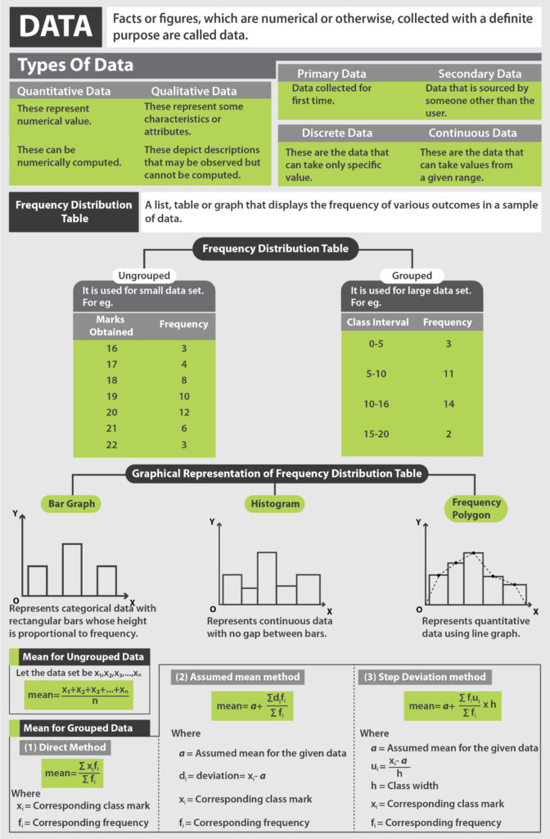

Use of Tally Marks
When the observations are large, it may not be easy to find the frequencies by simply counting, so we make the use of bass (|, \) called the tally marks.
Tallies are usually marked in bunches of five.
The first four tallies are marked vertically. The fifth tally in a bunch is marked diagonally across the earlier 4.
Frequency distribution of ungrouped data:
Given below are marks obtained by 20 students in Math out of 25.
21, 23, 19, 17, 12, 15, 15, 17, 17, 19, 23, 23, 21, 23, 25, 25, 21, 19, 19, 19
The presentation of the above data can be expressed into groups. These groups are called classes or the class interval.
Each class interval is bounded by two figures called the class limits.
Marks  0 - 10  10 - 20  20 - 30 | Number of Students  (Frequency)  0  11  9
Note: The lower value of a class interval is called lower limit and upper value of that class interval is called the upper limit. Thus, each class interval has lower and upper limits.
Class limits in exclusive and inclusive form:
● In exclusive form, the lower and upper limits are known as true lower limit and true upper limit of the class interval.
Thus, class limits of 10 - 20 class intervals in the exclusive form are 10 and 20.
● In inclusive form, class limits are obtained by subtracting 0.5 from lower limitand adding 0.5 to the upper limit.
For Example:
In the class interval 10 - 20, 10 is the lower limit and 20 is the upper limit.

Exclusive form of data:
This above table is expressed in the exclusive form.
In this, the class intervals are 0 - 10, 10 - 20, 20 - 30. In this, we include lower limit but exclude upper limit.
Data in the inclusive form:
Marks obtained by 20 students of class VIII in Math text are given below.
23, 0, 14, 10, 15, 3, 8, 16, 18, 20, 1, 3, 20, 23, 24, 15, 24, 22, 14, 13
Let us represent this data in the inclusive form.
Marks  0 - 10  11 - 20  21 - 30 | Number of Students  (Frequency)  6  9  5
Here, also we arrange the data into different groups called class intervals, i.e., 0 - 10, 11 - 20, 21 - 30.
0 to 10 means between 0 and 10 including 0 and 10.
Here, 0 is the lower limit and 10 is the upper limit. 11 to 20 means between 11 and 20 including 11 and 20.
When the data is expressed in the inclusive form, it is converted to exclusive form by subtracting 0.5 from lower limit and adding it to upper limit of each class interval.
11 - 20 is expressed in the inclusive form which can be changed and taken as 10.5 - 20.5 which is the exclusive form of the data.
Similarly, 21 - 30 can be taken as 20.5 - 30.5.
Class size: Difference between the true upper limit and true lower limit of a class interval is called the class size.
Class size remains the same for all class intervals.
For the class interval 10 - 20
Class size is 10, i.e., (20 - 10 = 10)

Class mark: Mid-value of each class interval is called its class mark.
Class mark = ½ (Upper limit + Lower limit)
For the class interval 10 - 20
Class mark = (10 + 20)/2
= 30/2 = 15
Range: The difference between the maximum value and the minimum value of the observation is called the range.
In the above data, the maximum value is 24 and the minimum value is 0.
Therefore, range = 24 - 0 = 24

Class Interval
Class interval is a term that is used to denote the numerical width of a class in a frequency distribution. In a grouped frequency distribution, data is arranged in the form of a class. The difference between the upper-class limit and the lower limit gives the class interval.
A grouped frequency distribution can be sorted either on the basis of exclusive or inclusive class intervals.

Class Interval Example
Suppose there is a class given by 11 - 21. 11 will be known as the lower class limit while 21 is the upper limit. The class interval is given by 21 - 11 = 10.

Class Interval Formula
To determine the class interval, the lower limit of the class is subtracted from the upper limit. The class interval formula is given as follows:
Class interval = Upper Limit - Lower Limit.
Important Notes on Class Interval
- A class interval can be defined as the width of the class.
- The class interval formula is given as upper limit - lower limit.
- In an exclusive class interval, the upper limit of one class is the same as the lower limit of the next class.
- In an inclusive class interval, the upper class limit of one class does not get repeated in the lower limit of the succeeding class.
Example 1: What is the class interval of the following frequency distribution table?
Class | Frequency
15 - 22 | 4
22 - 29 | 8
29 - 36 | 5
36 - 43 | 1
- Solution: The is an exclusive class interval. The class interval formula is upper limit - lower limit.
Class | Class Interval
15 - 22 | 22 - 15 = 7
22 - 29 | 29 - 22 = 7
29 - 36 | 36 - 29 = 7
36 - 43 | 43 - 36 = 7
- Example 2: What is the class interval for the given classes?
Class | 12 - 15 | 16 - 19 | 20 - 23 | 24 - 27 | 28 - 31 | 32 - 35
- Solution: This is an inclusive class interval. Thus, the class needs to be converted to an exclusive class interval.
Class | Adjusted Class | Class interval
12 - 15 | 11.5 - 15.5 | 4
16 - 19 | 15.5 - 19.5 | 4
20 - 23 | 19.5 - 23.5 | 4
24 - 27 | 23.5 - 27.5 | 4
28 - 31 | 27.5 - 31.5 | 4
32 - 35 | 31.5 - 35.5 | 4

- Example 2: Given below are the weekly pocket expenses (in $) of a group of 25 students selected at random.
37, 41, 39, 34, 41, 26, 46, 31, 48, 32, 44, 39, 35, 39, 37, 49, 27, 37, 33, 38, 49, 45, 44, 37, 36
Construct a grouped frequency distribution table with class intervals of equal widths, starting from 25 - 30, 30 - 35, and so on. Also, find the range of weekly pocket expenses.
Solution: The following table represents the given data:
Weekly expenses (in $) | Number of students
25-30 | 2
30-35 | 4
35-40 | 10
40-45 | 4
45-50 | 5
Total | 25
In the given data, the smallest value is 26 and the largest value is 49. So, the range of the weekly pocket expenses = 49 - 26 = $23.

What is Frequency Distribution Table in Statistics?
Frequency distribution in statistics is a representation of data displaying the number of observations within a given interval. The representation of a frequency distribution can be graphical or tabular. Now let us look at another way to represent data i.e., graphical representation of data. This is done using a frequency distribution table graph. Such graphs make it easier to understand the collected data.
- Bar graphs represent data using bars of uniform width with equal spacing between them.
- A pie chart shows a whole circle, divided into sectors where each sector is proportional to the information it represents.
- A frequency polygon is drawn by joining the mid-points of the bars in a histogram.

. Let us take the example of the heights of ten students in cms.

Frequency Distribution Table
139, 145, 150, 145, 136, 150, 152, 144, 138, 138
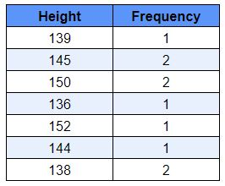
This frequency table will help us make better sense of the data given. Also when the data set is too big (say if we were dealing with 100 students) we use tally marks for counting. It makes the task more organised and easy. Below is an example of how we use tally marks.
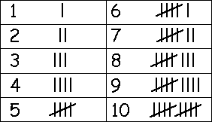

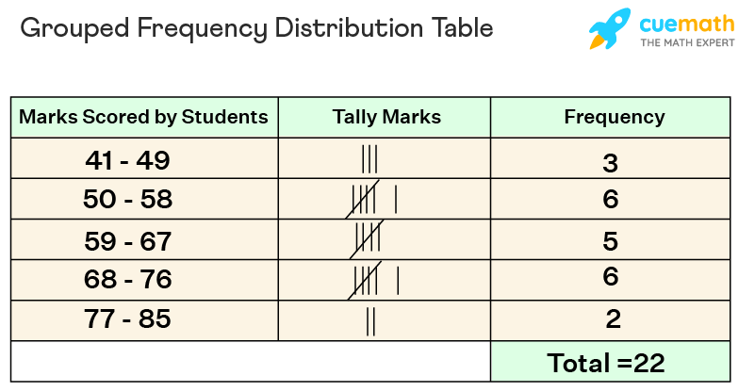

Cumulative Frequency Distribution Table
Cumulative frequency means the sum of frequencies of the class and all the classes below it. It is calculated by adding the frequency of each class lower than the corresponding class interval or category. An example of a cumulative frequency distribution table is given below:

