RFID CARD
CLONING

Muhammad Shoaib Khan
(
233101)

Mehboob ur Rehman

(
232116
)

RFID Card Cloning Using Arduino and RC522 Module

Table of Contents
Contents
RFID Card Cloning Using Arduino and RC522 Module 2
Table of Contents 2
Abstract 3
Introduction 3
Background 3
Objectives 3
Scope 3
Literature Review 4
Materials and Methods 4
Components Used 4
Circuit Diagram 4
Software Setup 5
Methodology 5
Implementation 6
Code Explanation 6
Step-by-Step Procedure 7
Results 7
Discussion 7
Conclusion 8
References 8

Abstract
This project explores the fundamentals of Radio-Frequency Identification (RFID) technology by implementing a card cloning system using an Arduino Uno microcontroller and the RC522 RFID module. The primary objective is to demonstrate how RFID systems operate, including reading data from an existing RFID card or tag and writing that data to a new one. Through this hands-on approach, we gain insights into RFID communication protocols, microcontroller interfacing, and basic data security considerations in access control systems. The project utilizes readily available hardware components and open-source software, making it accessible for educational purposes. Key outcomes include successful data transfer between RFID tags and an understanding of potential vulnerabilities in RFID-based systems.

Introduction

Background
Radio-Frequency Identification (RFID) is a wireless communication technology that uses electromagnetic fields to automatically identify and track tags attached to objects. RFID systems are widely used in applications such as access control, inventory management, and contactless payments. However, the simplicity of RFID can also introduce security risks, including unauthorized data cloning.
This project focuses on cloning RFID cards using the Arduino platform, specifically to read data from one RFID tag and replicate it onto another. By doing so, we aim to educate on the inner workings of RFID technology rather than promote any unethical practices. Understanding these mechanisms is crucial for developing secure systems and raising awareness about potential exploits.

Objectives
To interface the RC522 RFID module with an Arduino Uno.
To read and write data on RFID cards/tags using the MFRC522 library in Arduino IDE.
To demonstrate the cloning process in a controlled, academic environment.
To analyze the implications of RFID data vulnerability.

Scope
The project is limited to MIFARE Classic RFID cards (13.56 MHz), which are commonly used and compatible with the RC522 module. It does not cover advanced encryption or high-security RFID variants.

Literature Review
RFID technology dates back to the 1940s but gained prominence in the 1980s for commercial use. Key standards include ISO/IEC 14443 for proximity cards, which the MIFARE Classic follows. Research by Nohl et al. (2008) highlighted vulnerabilities in MIFARE Classic, such as weak encryption that allows for cloning with simple tools.
Arduino-based RFID projects are prevalent in educational literature, with resources from the Arduino community demonstrating basic read/write operations. The MFRC522 library, developed by miguelbalboa, simplifies SPI communication between the Arduino and RC522 module, enabling quick prototyping.

Materials and Methods

Components Used
The following hardware and software were employed in this project:
Arduino Uno: A microcontroller board based on the ATmega328P, serving as the central processing unit for interfacing with the RFID module.
RC522 RFID Module: An RFID reader/writer module operating at 13.56 MHz, compatible with MIFARE cards. It uses SPI protocol for communication.
RFID Cards/Tags: MIFARE Classic 1K cards or tags for reading and writing data.
Jumper Wires: For connecting the RC522 module to the Arduino Uno.
Arduino IDE: Open-source integrated development environment for writing, compiling, and uploading code to the Arduino board.

Circuit Diagram
The RC522 module connects to the Arduino Uno via the following pins:
SDA (SS) → Pin 10
SCK → Pin 13
MOSI → Pin 11
MISO → Pin 12
IRQ → Not connected
GND → GND
RST → Pin 9
3.3V → 3.3V

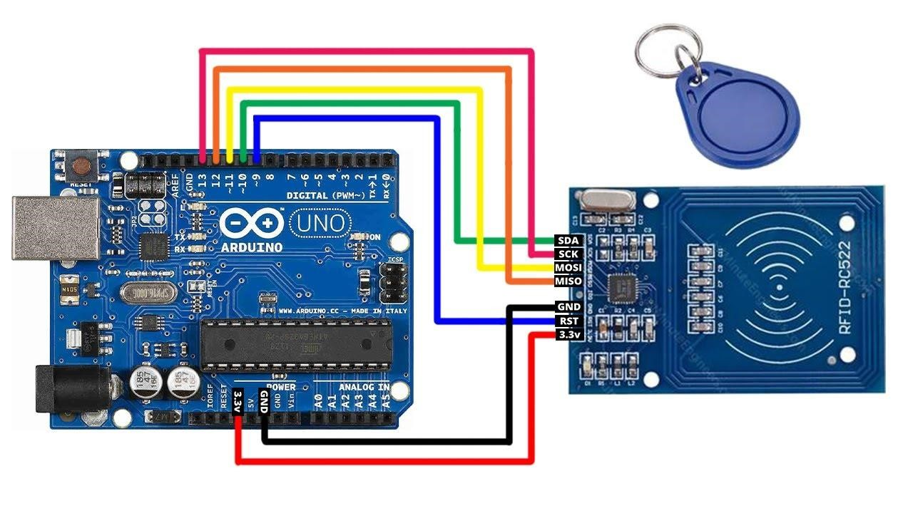
Figure 1.1
Ensure the RC522 is powered by 3.3V to avoid damage, as it is not 5V tolerant. A simple breadboard setup suffices for prototyping.

Software Setup c
- Install the Arduino IDE from the official website.
- Add the MFRC522 library via the Library Manager in Arduino IDE (search for "MFRC522").
- Write and upload the code to the Arduino Uno using a USB cable.

Methodology
The project follows these steps:
- Interfacing and Initialization: Connect the hardware as described. In the code, initialize the SPI bus and MFRC522 module.
- Reading Data: Place an RFID card near the RC522 reader. The module detects the card's Unique Identifier (UID) and reads data from specified sectors/blocks.
- Writing Data: Use the read data to write to a new blank RFID card, effectively cloning the original.
- Verification: Read the cloned card to confirm data integrity.
Safety precautions include handling electronics carefully to avoid short circuits and ensuring the project is used solely for educational purposes.

Implementation

Code Explanation
The Arduino sketch uses the MFRC522 library to handle RFID operations. Key functions include:
MFRC522::PICC_ReadCardSerial(): Detects and selects the card. mfrc522.MIFARE_Read(): Authenticates and reads from the card. mfrc522.MIFARE_Write(): For writing data.

A sample code structure is as follows (simplified for brevity):
#include <SPI.h>
#include <MFRC522.h>

#define SS_PIN 10
#define RST_PIN 9
MFRC522 mfrc522(SS_PIN, RST_PIN);

void setup() {
Serial.begin(9600); SPI.begin();
mfrc522.PCD_Init();
Serial.println("Scan RFID card to read/write...");
}

void loop() {
if (!mfrc522.PICC_IsNewCardPresent() || !mfrc522.PICC_ReadCardSerial()) { return;
}

// Read data from card (example: block 4) byte buffer[18]; byte block = 4;
MFRC522::StatusCode status = mfrc522.MIFARE_Read(block, buffer, &18); if (status == MFRC522::STATUS_OK) {
Serial.println("Data read successfully.");
// Display or store buffer data
}

// For writing: Similar process using MIFARE_Write()

mfrc522.PICC_HaltA(); mfrc522.PCD_StopCrypto1();
}

This code reads data from a specific block. For full cloning, extend it to read all relevant blocks from the source card (using default keys for MIFARE Classic) and write to the target.

Step-by-Step Procedure
- Assemble the circuit on a breadboard.
- Open Arduino IDE, create a new sketch, and include the MFRC522 library.
- Upload the code to Arduino Uno.
- Open the Serial Monitor (baud rate 9600).
- Scan the original RFID card to read its data.
- Scan a blank card and write the captured data.
- Verify by re-reading the cloned card.

Results
The system successfully read the UID and data blocks from a source MIFARE Classic card and cloned them to a target card. The cloned card functioned identically to the original in a test RFID reader setup, granting access as expected. Data integrity was maintained across multiple trials, with no errors in non-encrypted sectors. However, attempts to clone encrypted sectors required additional authentication keys, which were not implemented in this basic setup.

Discussion
This project illustrates the ease of RFID cloning for basic MIFARE Classic systems, highlighting the need for stronger security measures like encryption (e.g., MIFARE DESFire). Limitations include compatibility only with 13.56 MHz cards and potential interference from environmental factors. Future enhancements could involve integrating encryption or using more advanced modules for NFC applications.
Ethical considerations are paramount: RFID cloning should never be used for unauthorized access, as it may violate laws and privacy rights.

Conclusion
Through this project, we have gained a practical understanding of RFID technology, microcontroller programming, and data handling. The Arduino and RC522 combination provides an affordable platform for such explorations. This knowledge underscores the importance of secure design in RFID implementations to prevent cloning vulnerabilities.

References
- Arduino Official Documentation. (n.d.). Retrieved from https://www.arduino.cc/reference/en/
- MFRC522 Library by miguelbalboa. (n.d.). GitHub Repository.
- Nohl, K., Evans, D., Starbug, & Plötz, H. (2008). Reverse-Engineering a Cryptographic RFID Tag. USENIX Security Symposium.
- ISO/IEC 14443 Standard for Identification Cards.

