Name: Shoaib Akhtar

Roll NO: 20P-0147

Submitted To: Sir Muhammad Ali

TASK #1

Here we are creating a topology with of two PC’s with a single switch.

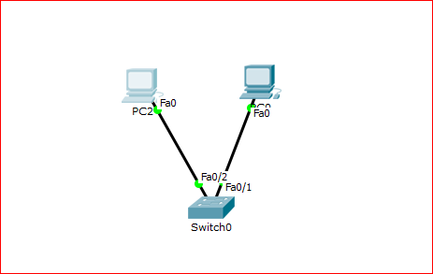

Here we have assigned the ip addresses and below you can see the screenshots

PC 0 : 192.168.100.2

PC 1 : 192.168.100.1

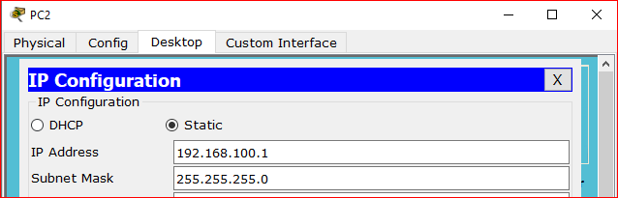

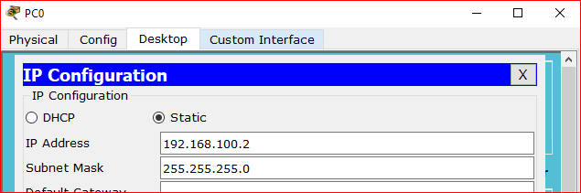

And below you can see that the ping has been successful ☺

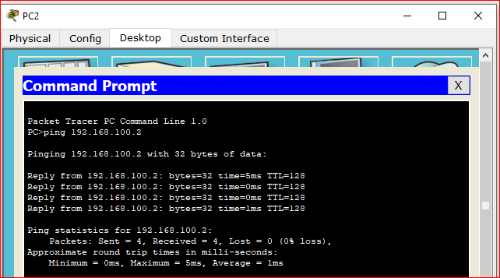

TASK #2

Here we are creating a topology with of two PC’s with a single Hub.

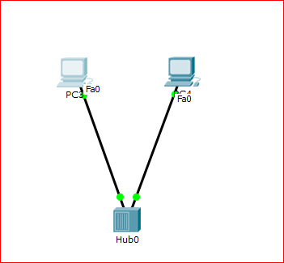

Here we have assigned the ip addresses and below you can see the screenshots

PC 3 : 192.168.100.3

PC 4: 192.168.100.4

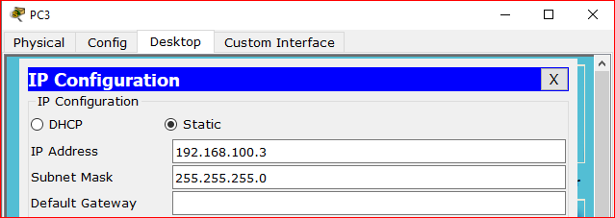

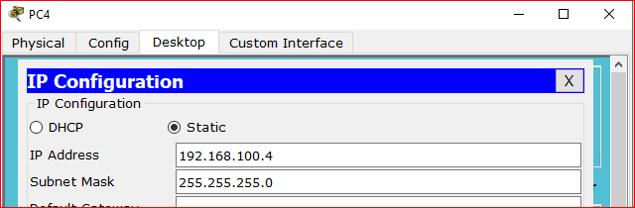

And below you can see that the ping has been successful ☺



# Task 3

Now we will create a topology with switch and Hub

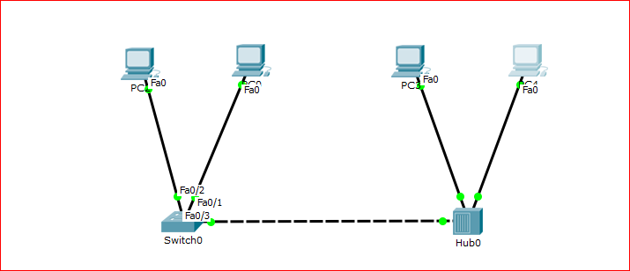

Below you can see that we sent ping to PC0 from PC4 and that went successful.

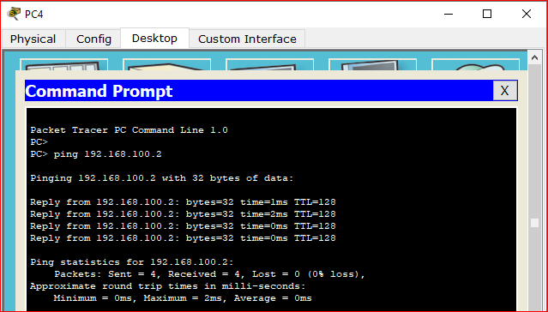

# Task 4 : - Difference between switch and Hub

**Switch**

Switch is a intelligent device as compared to Hub and Switch is layer-2 Device

**HUB**

Hub is a not that intelligent as compared switch and Hub is Layer-1 architecture.