Question -1

1. Implement the topology given in figure A on cisco packet tracer.

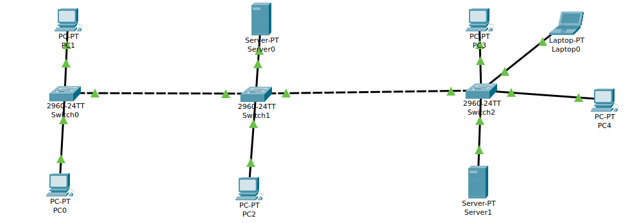

2: Assign ip address to computers

PC 0 = 192.168.1.4
PC 1 = 192.168.1.5
PC 2 = 192.168.1.6
SERVER 0 = 192.168.1.7
SERVER 1 = 192.168.1.8
PC 3 = 192.168.1.9
LAPTOP 0 = 192.168.1.10
PC 04 = 192.168.1.11

3: Ping the server from any computer
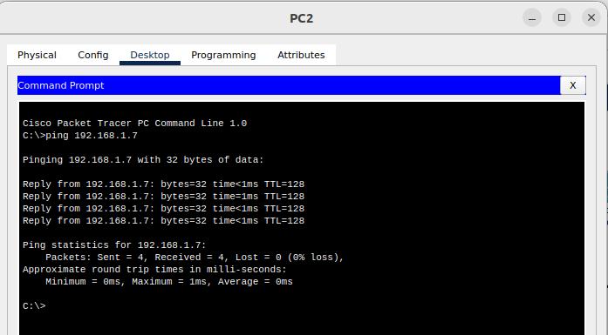
5. Do change the IP of Switch0 from PC0 using its command prompt.

First of all click on switch and go to Cli mode of switch 0 and give the following commands
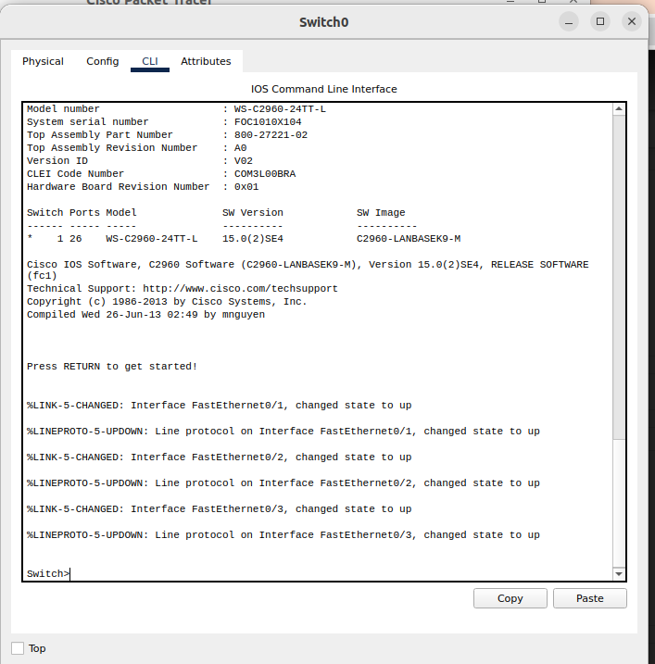

1: enable (It wakes up the switch)
2: conf t (goint itnto the configuration mode)
3: interface vlan 1 (Setting the interface)
4: ip address 192.168.1.1 255.255.255.0
5: no shutdown
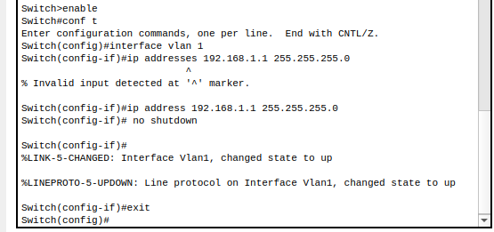

Now, try to telnet the switch from our PC, it refuses because we have not applied authentication on the switch yet.
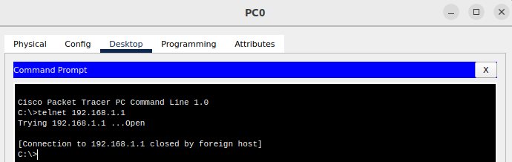

Secure Shell Server (SSH) and FTP services. Each Telnet, SSH, or FTP session requires one vty-line. You can add security to your system by configuring the software to validate login requests.

1: exit
2: line vty 0 15
3: password cisco
4: login
5: end

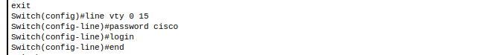

Now, we can easily telnet. But it does not let us go in the switch enabled mode because we have not set the password on the switch yet.

1: conf t
2: enable password cs
3: exit

Now changing the ip adress of switch 1 from PC 0

1: telnet 192.168.1.1 (Establishing the connection with switch0)
2: password : cisco
3: en
4: password: cs
5: conf t
6: interface vlan 1
7: ip address 192.168.01.47 255.255.255.0

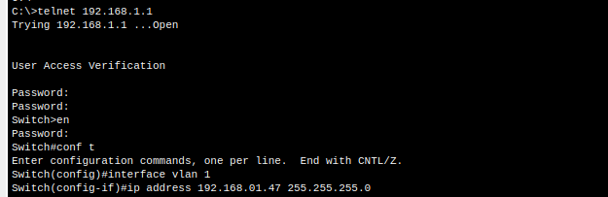

Now ip address of the switch has been changed. As you can see we have pinged from PC-3 to switch 0 with 192.168.01.47 ip address and it went successful.

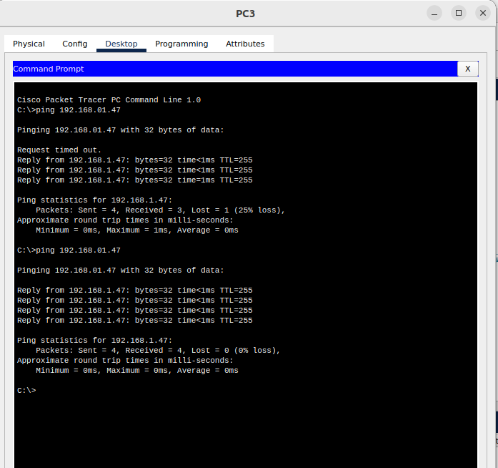

Question -2

1. Implement the figure B topology on cisco packet tracer.

2. The IP should assign to the computer using static method. The Network on one side of FastEthernet
should like this XX.XX.0.0 i.e. your roll number like 3879(38.79.0.0) and on another side it should
be 3880(38.80.0.0).

Network-1

PC 0 = 1.47.1.1
PC 1 = 1.47.1.2
PC 2 = 1.47.1.3
PC 3 = 1.47.1.4

Network-2

PC 4 = 38.79.1.1
LAPTOP-0 = 38.79.1.2
LAPTOP-1 = 38.79.1.3
PC 5 = 38.79.1.4
PC 6 = 38.79.1.5

