First of all click on Wireshark then apply the DNS filter.
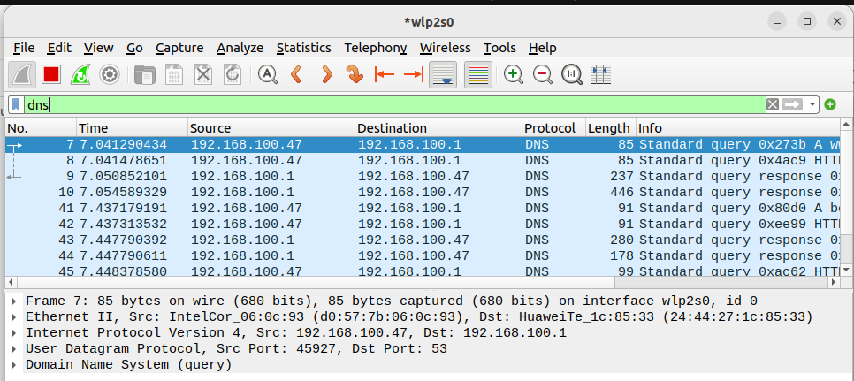

Now double click on any DNS packet.

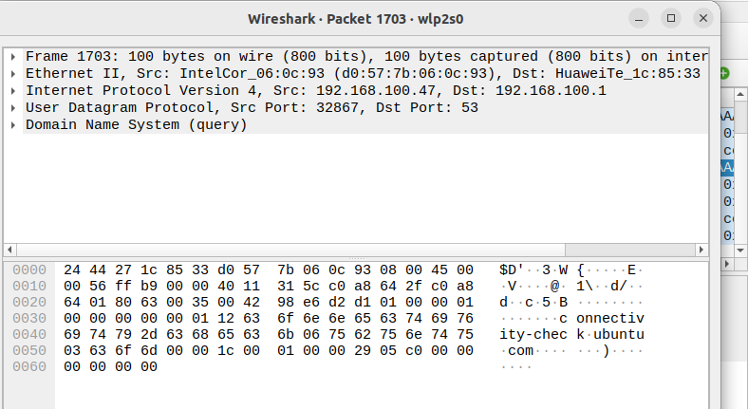
Now we will discover every single layer of TCP/IP with the help of wireshark.

Application layer

Click on Domain Name System and see the information of Application layer.

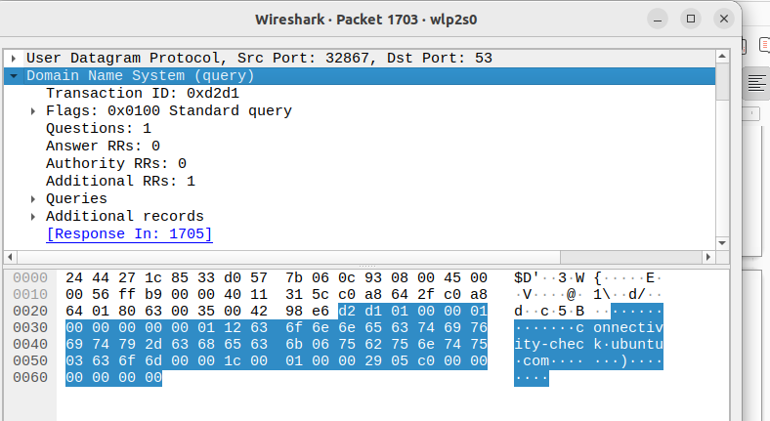
Flags: 0x0100 standard query
Questions: 1
Answer RRs: 0
Authority Rrs: 0
Additional Rrs: 1
Queries: connectivity_check ubuntu.com

Transport Layer

Now click on User datagram protocol.

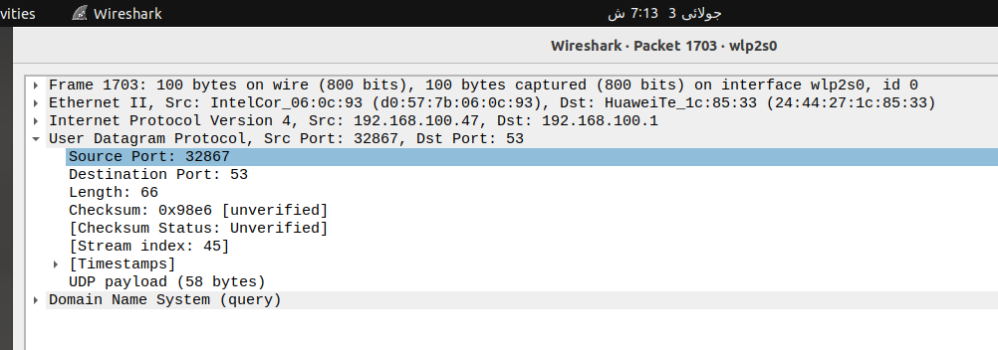

source port: 32867
Destination port: 53

Network Layer

Now click on Internet Protocol Version.

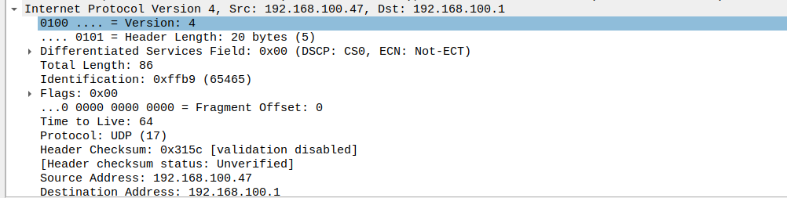
Sources address: 192.168.100.47
Destination address 192.168.100.1

Data link layer

For data link layer click on Ethernet II.
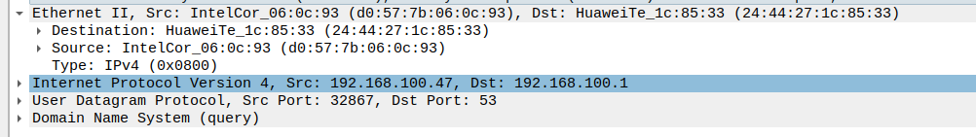
destination: Huawei_ic: 85:33
Source: Intelcor_06:0c:93

Physical Layer

For physical layer click on frame.
