FINAL YEAR PROJECT REPORT

Fixing the Gaps
A Stakeholder-Driven Power BI Dashboard for Resource Allocation and School Performance in Pakistan

Business Intelligence & Advanced Data Analytics
Capstone Project Documentation
Prepared for: Government Education Decision-Making Context
Technology: Microsoft Power BI, Power Query, DAX
Dataset: Pakistan Education Performance Dataset
Source: https://www.kaggle.com/code/jihyeseo/pakistan-school-data-eda/notebook
Data Period: 2013–2016
Team Members:
- Shoaib Yousaf
- Abdhur Rahman
- Raja Iqbal
- Muzammil Khalid

Table of Contents
Table of Contents 2
1. Introduction 4
1.1 Project Overview 4
1.2 Problem Statement 4
1.3 Project Objectives 4
2. Stakeholders and Intended Users 4
3. Data Source and Dataset 5
4. Data Model and Power BI Architecture 5
5. Key Measures and Indicators 5
6. Dashboard 1 — Executive Governance Panel 6
6.1 Questions Answered 6
6.2 Main Visuals 6
6.3 Executive Risk & Intervention 7
Recommended Government Action 8
7. Dashboard 2 — District Infrastructure Audit 8
7.1 Questions Answered 8
7.2 Advanced Visuals and Interactivity 8
7.3 Key Findings 9
Recommended Government Action 9
8. Dashboard 3 — Policy Impact & Socio-Economic 9
8.1 Questions Answered 10
8.2 National-Level Context 10
8.3 Anomaly & Intervention Analysis 10
Q1 — Regional Education Performance Gap 10
Q2 — Policy Performance Reversal 11
Q3 — Infrastructure–Outcome Anomaly 11
Q4 — Priority Intervention Drivers 11
9. Consolidated Recommended Government Actions 12
10. Report Design Checklist Assessment 12
10.1 Overall Report Effectiveness 12
10.2 Information Architecture Effectiveness 13
11. UX, Navigation and Interactivity 13
12. Limitations 13
13. Future Enhancements 13
14. Conclusion 14

1. Introduction

1.1 Project Overview
This project develops an interactive Power BI reporting solution for analyzing school performance, infrastructure, enrollment, retention and policy context in Pakistan. It is designed to help government education stakeholders move from high-level monitoring to evidence-based identification and prioritization of intervention areas.

1.2 Problem Statement
Educational data can be difficult to convert into actionable decisions when performance, infrastructure, gender participation, geography and contextual indicators are viewed separately. This project addresses that pain point by combining these indicators into a structured, interactive decision-support environment.

1.3 Project Objectives
- Consolidate education, infrastructure, geographic and contextual indicators into a structured Power BI model.
- Provide an executive-level view of education performance.
- Identify regional and district-level disparities.
- Detect gender enrollment and infrastructure-related risks.
- Analyze education, learning and retention trends.
- Identify districts requiring priority intervention.
- Provide policy and socio-economic context for interpreting education outcomes.
- Use advanced Power BI visuals and interactivity to support faster decision making.
- Translate analytical findings into recommended government actions.

2. Stakeholders and Intended Users
Persona | Need | Dashboard
Senior Education Executives | Rapid overview and major risks | Executive Governance Panel
Policy/Risk Decision Makers | Risk identification and priority intervention | Executive Risk & Intervention
District/Operational Officers | Infrastructure and district investigation | District Infrastructure Audit
Policy Analysts | Longitudinal and socio-economic context | Policy Impact & Socio-Economic
BI/Monitoring Teams | Detailed anomaly investigation | Analysis / Intervention Views

3. Data Source and Dataset
The project uses the Pakistan Education Performance Dataset sourced from Kaggle. The available data covers 2013–2016 and contains education performance, enrollment, infrastructure, geographic and contextual indicators.
- Boys and girls enrollment
- Complete primary schools
- Single-classroom and single-teacher schools
- All/partial/no facility indicators
- Electricity, drinking water and toilets
- Building condition
- Total schools
- Province and city information
- Year and national contextual indicators

4. Data Model and Power BI Architecture
The model separates the education fact table from time, geography and context dimensions, supporting reusable DAX measures, filtering, drill-down and drill-through.
Table | Purpose
Fact_Education_Metrics | Core education, enrollment, infrastructure and outcome measurements
Dim_Time | Year dimension for temporal analysis
Dim_Geography | Province, city, population, area and location information
Dim_Context | National policy and socio-economic context
Measures | Reusable DAX measures and risk calculations

5. Key Measures and Indicators
Measure | Purpose
Avg_Boys_Enrollment_Pct | Average boys enrollment
Avg_Girls_Enrollment_Pct | Average girls enrollment
Gender_Enrollment_Gap | Difference between boys and girls enrollment
Utility_Deficit_Rate | Share represented by No Facility
Single_Teacher_Strain_Rate | Teacher-capacity pressure
Single_Classroom_Strain_Rate | Classroom-capacity pressure
Avg_Education_Score | Education performance
Avg_Learning_Score | Learning performance
Avg_Retention_Score | Retention performance
Avg_Electricity / Avg_Drinking_Water / Avg_Toilet | Facility coverage indicators
Overall_Risk_Score | Maximum of relevant risk scores

6. Dashboard 1 — Executive Governance Panel
The Executive Governance Panel is the main executive-facing dashboard. It provides a compact view of the overall education situation and highlights areas requiring deeper investigation.
Executive Governance Panel
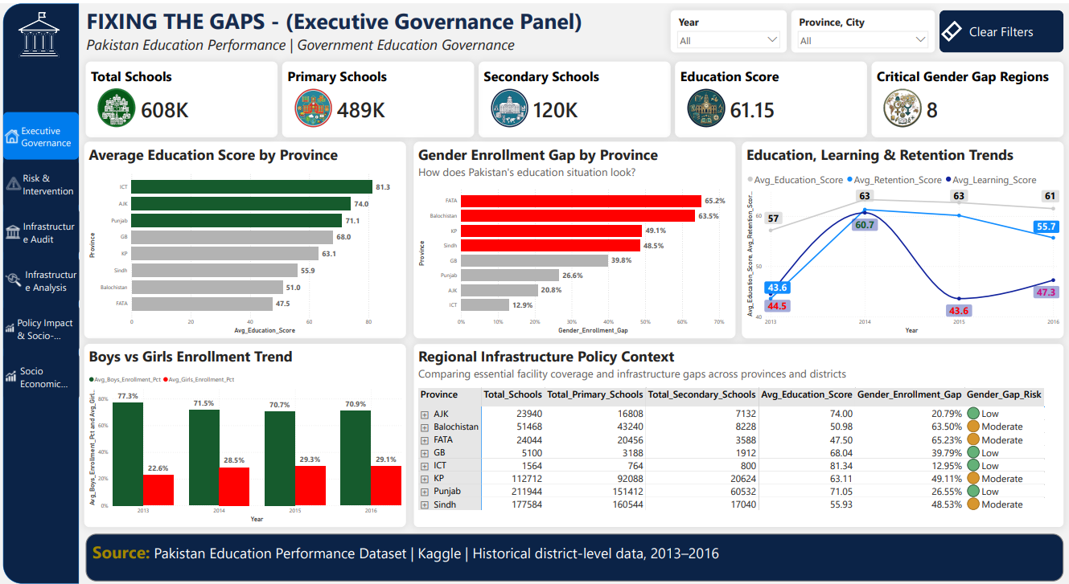

6.1 Questions Answered
- How many schools are represented?
- What is the overall education performance?
- Which regions show critical gender gaps?
- Which regions show critical infrastructure conditions?
- How do education, learning and retention change over time?
- How large is the boys-versus-girls enrollment gap?

6.2 Main Visuals
- KPI cards
- Critical Gender Gap Regions card
- Critical Infrastructure Regions card
- Education Score by Province
- Gender Enrollment Gap by Province
- Education, Learning & Retention Trends
- Boys vs Girls Enrollment Trend

6.3 Executive Risk & Intervention
Executive Risk & Intervention
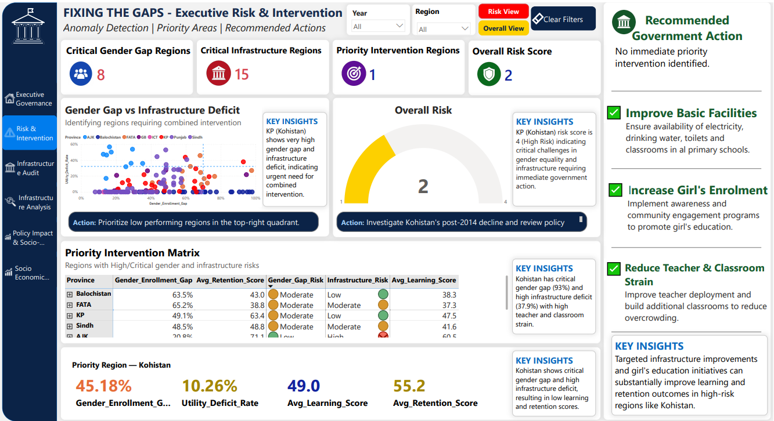

This supporting page adds anomaly detection, risk scoring, a Priority Intervention Matrix, a gauge for Overall Risk Score, priority region indicators and recommended actions.
Kohistan Indicator | Value
Gender Enrollment Gap | 93.0%
Gender Gap Risk | Critical
Utility Deficit | 37.89%
Single Teacher Strain | 28.6%
Single Classroom Strain | 20.5%
Infrastructure Risk | High
Learning Score | 42.1
Retention Score | 30.0

Recommended Government Action
Prioritize an integrated intervention in Kohistan combining gender participation measures, essential facility improvement, teacher and classroom capacity support, learning support and retention measures. Monitor annual indicators to evaluate progress.

7. Dashboard 2 — District Infrastructure Audit
The District Infrastructure Audit focuses on school facility coverage and district-level infrastructure deficiencies for operational and regional users.
District Infrastructure Audit
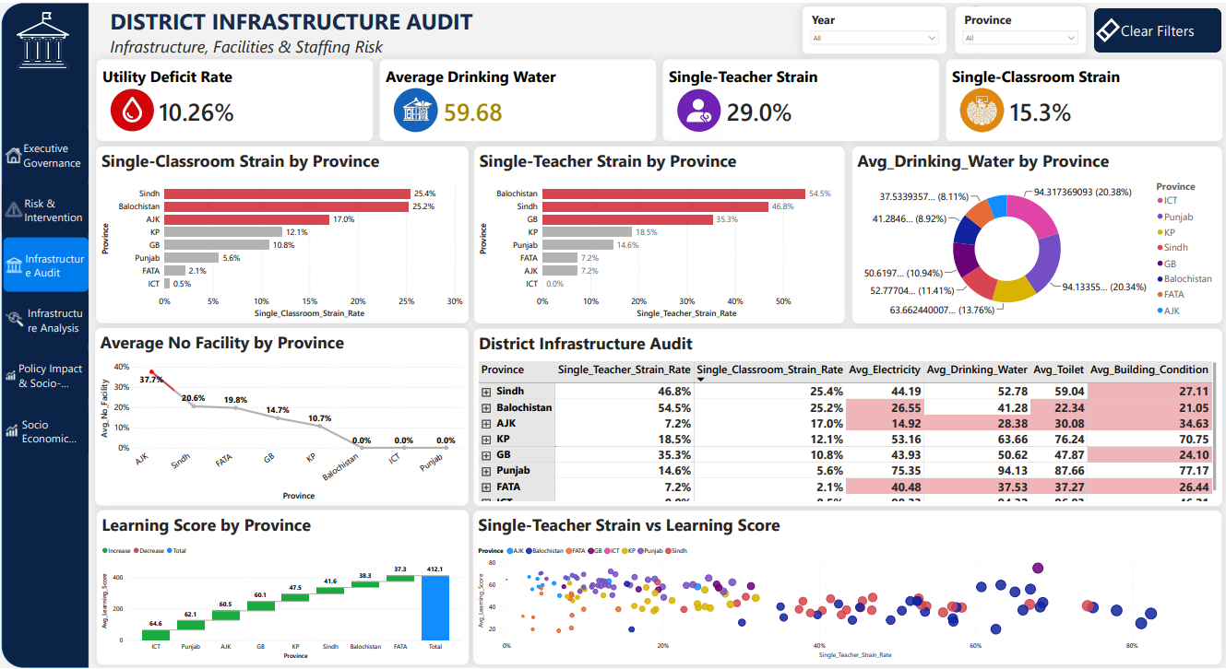

7.1 Questions Answered
- Which provinces and cities have the largest infrastructure deficits?
- Where are electricity, drinking water and toilet facilities weakest?
- Which districts have high teacher strain?
- Which districts have high classroom strain?
- Which regions have High or Critical infrastructure risk?
- Which districts combine infrastructure deficiencies with weak outcomes?

7.2 Advanced Visuals and Interactivity
- Decomposition Tree
- Treemap
- Province → City hierarchy
- Drill-through
- X/Y average reference lines
- Conditional formatting
- Infrastructure risk matrix

7.3 Key Findings
District | No Facility | Education | Learning | Retention
Kohistan | 37.89% | 40.1 | 42.1 | 30.0
Thatta | 44.42% | 45.6 | 36.7 | 24.3
Tharparkar | 52.89% | 51.1 | 34.8 | 33.1
Haveli | 56.69% | 72.7 | 63.2 | 55.6
Hattian | 53.74% | 71.2 | 65.3 | 55.6
Sudhnoti | 50.16% | 73.8 | 50.0 | 85.4
Tor Ghar | 43.64% | 52.0 | 57.0 | 51.0

The results show that infrastructure deficit alone does not explain educational outcomes. Sudhnoti is a useful contrast because its No Facility value is high while retention is comparatively strong.

Recommended Government Action
Prioritize integrated interventions in Kohistan, Thatta and Tharparkar, combining essential facility improvement with teacher availability, classroom capacity, learning support and student-retention measures. Investigate stronger districts such as Sudhnoti for potentially transferable practices.

8. Dashboard 3 — Policy Impact & Socio-Economic
This dashboard places education performance in national policy and socio-economic context.
Policy Impact & Socio-Economic Dashboard
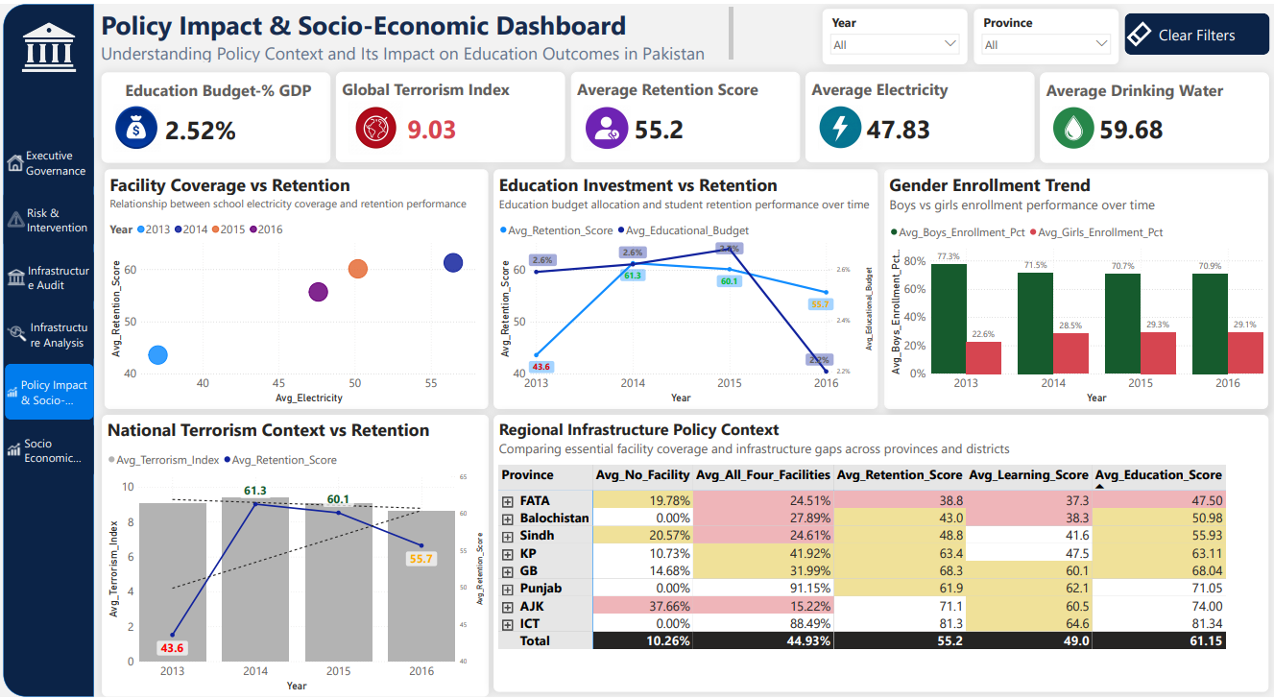

8.1 Questions Answered
- How does education performance change over time?
- How does national education investment change over time?
- How does retention change alongside national context?
- What is the relationship between facility coverage and retention?
- How does gender enrollment change?
- How does terrorism context change alongside retention?
- Which regional infrastructure conditions require investigation?

8.2 National-Level Context
Educational Budget Spend of GDP and Global Terrorism Index are treated as national-level context indicators. They respond to Year but are not interpreted as province-specific values.

8.3 Anomaly & Intervention Analysis
Anomaly & Intervention Analysis
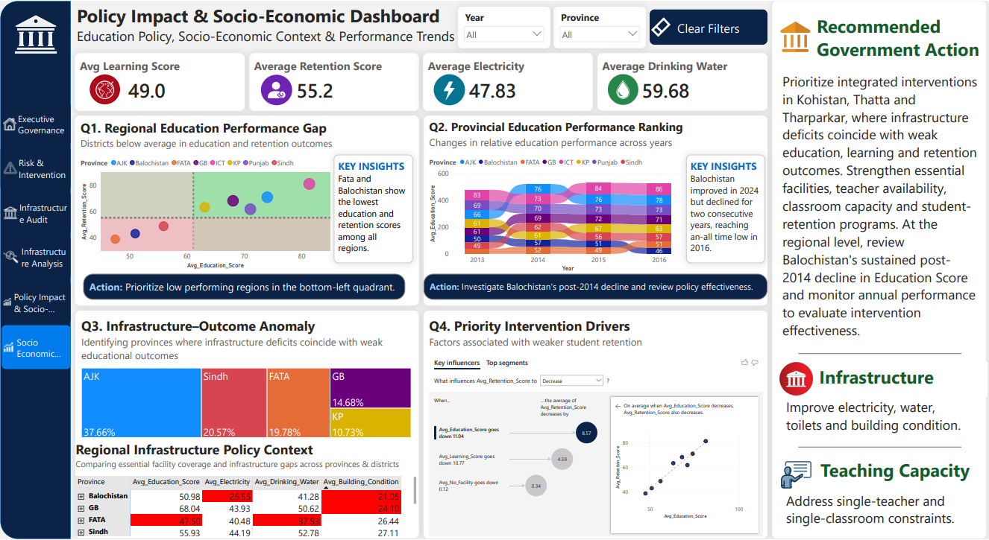

Q1 — Regional Education Performance Gap
Question: Which regions show comparatively weak education, learning and retention outcomes?
Region | Education | Learning | Retention
FATA | 47.5 | 37.3 | 38.8
Balochistan | 51.0 | 38.3 | 43.0
Sindh | 55.9 | 41.6 | 48.8
KP | 63.1 | 47.5 | 63.4
GB | 68.0 | 60.1 | 68.3
Punjab | 71.1 | 62.1 | 61.9
AJK | 74.0 | 60.5 | 71.1
ICT | 81.3 | 64.6 | 81.3

Recommended action: Prioritize further district-level investigation in weaker-performing regions, particularly FATA, Balochistan and Sindh, combining outcome monitoring with infrastructure and staffing analysis.

Q2 — Policy Performance Reversal
Question: Which province demonstrates a notable reversal in education performance over time?
Province | 2013 | 2014 | 2015 | 2016 | Pattern
AJK | 66.2 | 75.7 | 76.0 | 78.1 | Sustained improvement
Sindh | 48.9 | 61.7 | 56.2 | 56.9 | Improvement, decline, stabilization
Balochistan | 49.8 | 57.2 | 50.8 | 46.1 | Improvement followed by two years of decline

Key finding: Balochistan is the strongest policy-performance reversal candidate. Its score improved in 2014, then declined in 2015 and 2016, ending below its 2013 level.
Recommended action: Conduct a targeted policy and implementation review in Balochistan, examining district-level resource allocation, infrastructure, teacher capacity and implementation effectiveness. Monitor annual performance after interventions.

Q3 — Infrastructure–Outcome Anomaly
Question: Which districts combine infrastructure deficits with weak educational outcomes?
District | Province | No Facility | Education | Learning | Retention
Kohistan | KP | 37.89% | 40.1 | 42.1 | 30.0
Thatta | Sindh | 44.42% | 45.6 | 36.7 | 24.3
Tharparkar | Sindh | 52.89% | 51.1 | 34.8 | 33.1

Recommended action: Prioritize integrated intervention in Kohistan, Thatta and Tharparkar, combining essential facility improvements with teacher, classroom, learning and retention measures.

Q4 — Priority Intervention Drivers
Question: Which factors are associated with weaker student retention?
Influencer | Change | Associated Retention Change
Avg_Education_Score | Decreases by 11.04 | Retention decreases by 8.57
Avg_Learning_Score | Decreases by 10.77 | Retention decreases by 4.59
Avg_No_Facility | Decreases by 0.12 | Retention decreases by 0.34

The strongest useful interpretation is that lower education and learning performance are strongly associated with weaker retention. These are statistical associations, not proof of causation.
Recommended action: Focus retention interventions on education and learning improvement, supported by infrastructure, staffing and district-level evidence.

9. Consolidated Recommended Government Actions
Priority Area | Evidence | Recommended Action
Gender Gap | Critical gaps; Kohistan showed 93.0% | Target girls' enrollment and participation measures and investigate access barriers.
Infrastructure | High No Facility in multiple districts | Improve electricity, water, toilets and building condition in priority districts.
Teacher Capacity | High single-teacher strain in risk areas | Review teacher deployment and prioritize high-strain districts.
Classroom Capacity | High single-classroom strain | Increase classroom capacity and reduce single-classroom constraints.
Learning | Lower learning is associated with lower retention | Implement targeted learning and foundational-skills support.
Retention | Weak retention in Kohistan, Thatta and Tharparkar | Develop district-specific retention interventions and monitor annually.
Balochistan Reversal | 49.8 → 57.2 → 50.8 → 46.1 | Conduct a focused policy and implementation review and monitor recovery.

10. Report Design Checklist Assessment

10.1 Overall Report Effectiveness
Checklist | Implementation | Status
Solves a business pain point | Centralizes education, infrastructure and policy information to identify intervention areas. | Achieved
Supports better decision making | Interactive filtering, risk analysis, drill-through, anomaly detection and actions. | Achieved
Impact can be measured | Potential measures include reduced analysis time, faster prioritization and improved monitoring. | Partially measurable / future evaluation
Adapted to intended audiences | Separate executive, risk, operational and policy views. | Achieved
Branding is consistent | Consistent titles, navigation, typography, KPI design and visual language. | Achieved
Professional design | Structured layouts, spacing, conditional formatting and varied advanced visuals. | Achieved
Visuals are readable | Visuals are selected according to analytical purpose with subtitles and context. | Achieved
UX is consistent | Common slicers, navigation, page structure and formatting. | Achieved
Metrics have context | Year/province filters, trends, reference lines and risk classifications. | Achieved

10.2 Information Architecture Effectiveness
Requirement | Implementation
Audience-aware views | Executive, risk, operational and policy-analysis pages match different personas.
Logical structure | Monitor → Identify → Investigate → Prioritize → Act.
Progressive detail | Users move from KPIs to province/city and district-level analysis.
Decision-oriented reporting | Each analysis page answers a defined question and leads toward action.

11. UX, Navigation and Interactivity
- Year and Province slicers
- Navigation buttons
- Province → City hierarchy
- Drill-through
- Conditional formatting
- KPI cards
- Advanced visuals
- Recommended Action panels

12. Limitations
- Data covers 2013–2016.
- National budget and terrorism indicators are contextual, not province-specific.
- Key Influencers identifies associations, not causation.
- Some district-level explanations require additional data.
- More recent government data would improve future versions.

13. Future Enhancements
- More recent data and automated refresh
- District-level education budgets
- Teacher deployment and attendance
- Student attendance and examination performance
- Socio-economic household indicators
- Forecasting and predictive analytics
- Automated anomaly alerts
- Role-based reporting

14. Conclusion
The project demonstrates how Power BI can transform complex education data into an interactive, stakeholder-driven decision-support solution. The report guides users from executive monitoring through anomaly detection, district investigation, prioritization, and recommended action.
The three dashboard areas—Executive Governance, District Infrastructure Audit and Policy Impact & Socio-Economic—provide complementary perspectives. Their analytical pages extend the solution with risk identification, infrastructure–outcome analysis, policy-performance reversal analysis and retention-driver analysis.
The final solution follows the principle: Data → Insight → Priority → Action. This aligns the report with the instructor's checklist by addressing a business pain point, supporting decision making, providing audience-specific views, maintaining consistent design and establishing a logical information architecture.

