**Process of Patching of Container running as Window Agent**

**How We created Window Agent:-** Through **Dockerfile** We created an Image of Agent and push this into container registry. Then We deployed this image into HACT managed AKS Cluster and it will work as Window Agent in our Azure devops Pipeline.

Docker builds images automatically by reading the instructions from a Dockerfile -- a text file that contains all commands, in order, needed to build a given image.

We can install other software’s like Python, SVN, ant, Java etc... On that machine as required by jobs.

* We need to update all vulnerabilities In the **Dockerfile** on the path SelfHostedWindowsAgent/Dockerfile in repo.

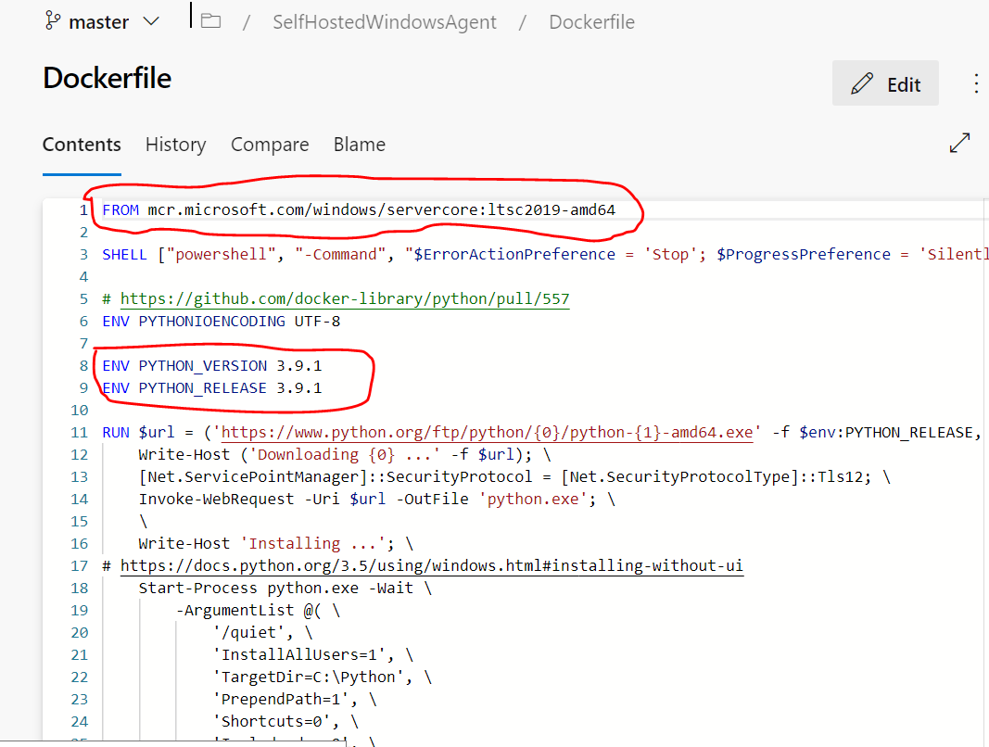

* **FROM:** It tells docker, from which base image you want to base your image from.So here We update the image of our Agent.
* **ENV:** Here we update the environment variable.To update python, please replace the old version with new version by setting the PYTHON_VERSION, PYTHON_RELEASE and PYTHON_PIP_VERSION.
* **RUN**: Run instruction allows you to install your application and packages required for it. We can update svn, please replace the URL of old version with the URL of newest version.
* To update git-lfs, please replace the URL of old version with the URL of newest version.

Here in Dockerfile we have 2 UR So Plz mention which URL need to change or mention the line no from screenshot.

Then we need to run the build pipeline named as “**selfHostedWindowsAgent**”.

Please add screenshot of Pipeline here.

or

Click on the project Settings 🡪 scroll down to the Pipelines Section 🡪 Agent Pools as shown in the below image.

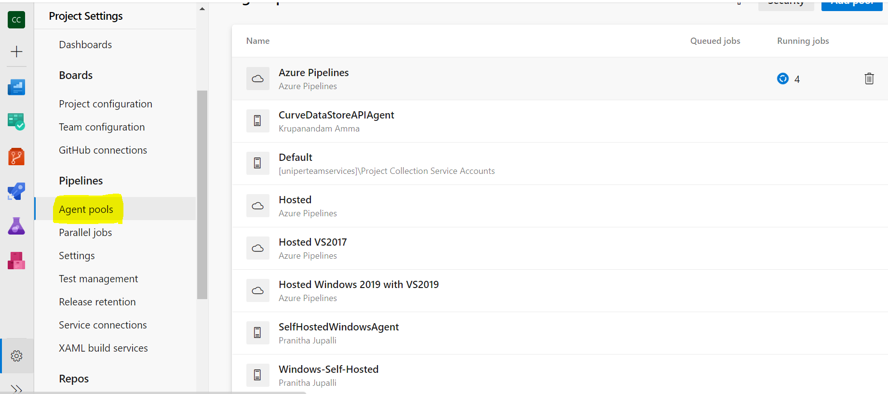

Click On the Agent Pools than it will list the Agent pools which are available in Projects as shown in above image.

From the list of Agent Pools, we need to select the Agent Pool and click on the same agent Pool then on the top bar we can find the “**Update all agents**” button as shown in the below image and click on it.

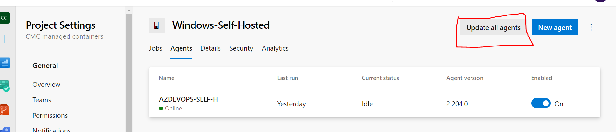

And we need to to update the latest images from the ACR repository Microsoft as below and we need to update the minor releases of the vulnerability software’s in the docker file.

**Schedule:** Every 3 months

We need to upgrade the agent during non- business hours.

**Responsibilities:**

HaCT is responsible for configuring and maintaining a proper configuration of docker windows agent – installing software’s and build tools, updating them, ensuring that all build servers in an agent pool have required configuration.

**Communication:** connect us on - UIT-HACT-AKS@uniper.energy