2.6 Multiple Scheduler

In this demo, we will explain the use of multiple scheduler.

* Login to your aws console
* Restart your ec2 instance and your EKS cluster nodes
* Open your terminal and SSH to the ec2 instance

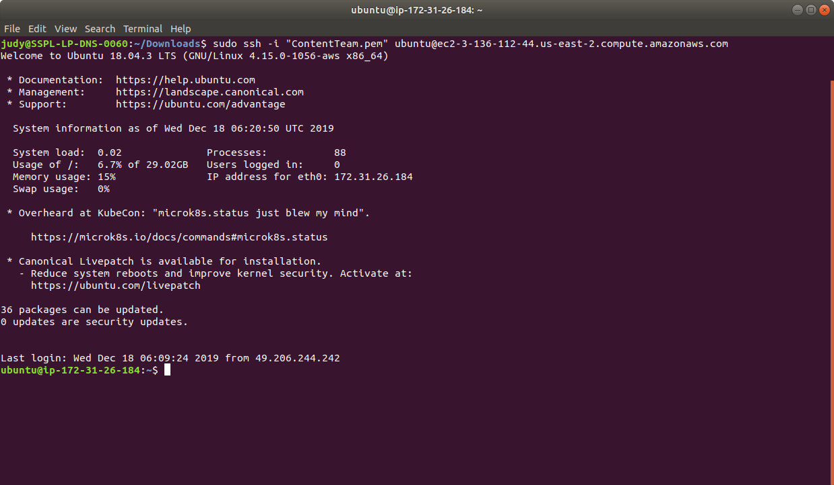

* If you don’t have an existing EKS cluster, create one with the command, **eksctl create cluster --name=myeks-cluster --nodes=2 --region=us-east-2**
* Verify that the scheduler pod is running as shown below:

**kubectl get pods --namespace=kube-system**

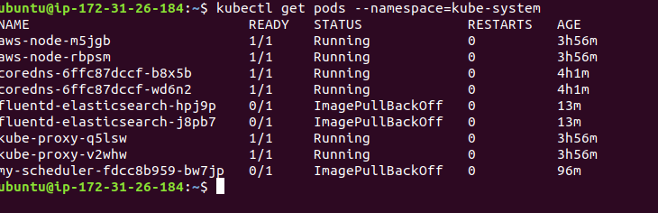

* Since scheduler is running, let’s create some pods and direct them to be scheduled by either the default scheduler or the one we just deployed. In order to schedule a given pod using a specific scheduler, we specify the name of the scheduler in that pod spec as shown below:

**cat > pod1.yaml**

apiVersion: v1

kind: Pod

metadata:

name: no-annotation

labels:

name: multischeduler-example

spec:

containers:

- name: pod-with-no-annotation-container

image: k8s.gcr.io/pause:2.0

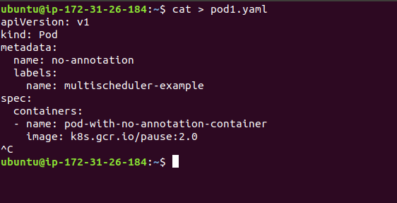

* When no scheduler name is supplied, the pod is automatically scheduled using the default-scheduler.
* Save this file as **pod1.yaml** and submit it to the Kubernetes cluster using kubectl command as shown below:

**kubectl create -f pod1.yaml**

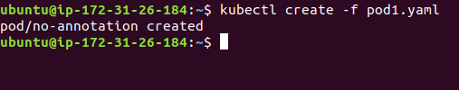

* We will now specify that pod should be scheduled using the scheduler that we deployed (custom scheduler)- my-scheduler.   
  **Note**: The value of **spec.schedulerName** should match the name supplied to the scheduler command as an argument in the deployment config for the scheduler, as shown below:

**cat > pod2.yaml**

apiVersion: v1

kind: Pod

metadata:

name: annotation-default-scheduler

labels:

name: multischeduler-example

spec:

schedulerName: default-scheduler

containers:

- name: pod-with-default-annotation-container

image: k8s.gcr.io/pause:2.0

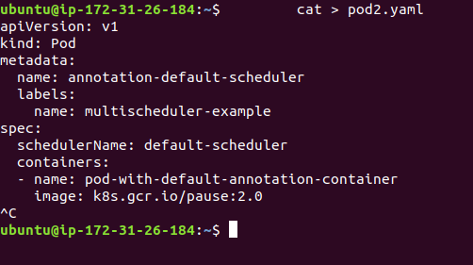

* Save this file as **pod2.yaml** and submit it to the Kubernetes cluster using kubectl commands as shown below:

**kubectl create -f pod2.yaml**

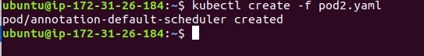

* This is how we create multiple pods that run on multiple schedulers.