4.3 Rollout Status Check

In this demo, we will show you how to check the rollout status.

* Login to your aws console
* Restart your ec2 instance and your EKS cluster nodes
* Open your terminal and SSH to the ec2 instance

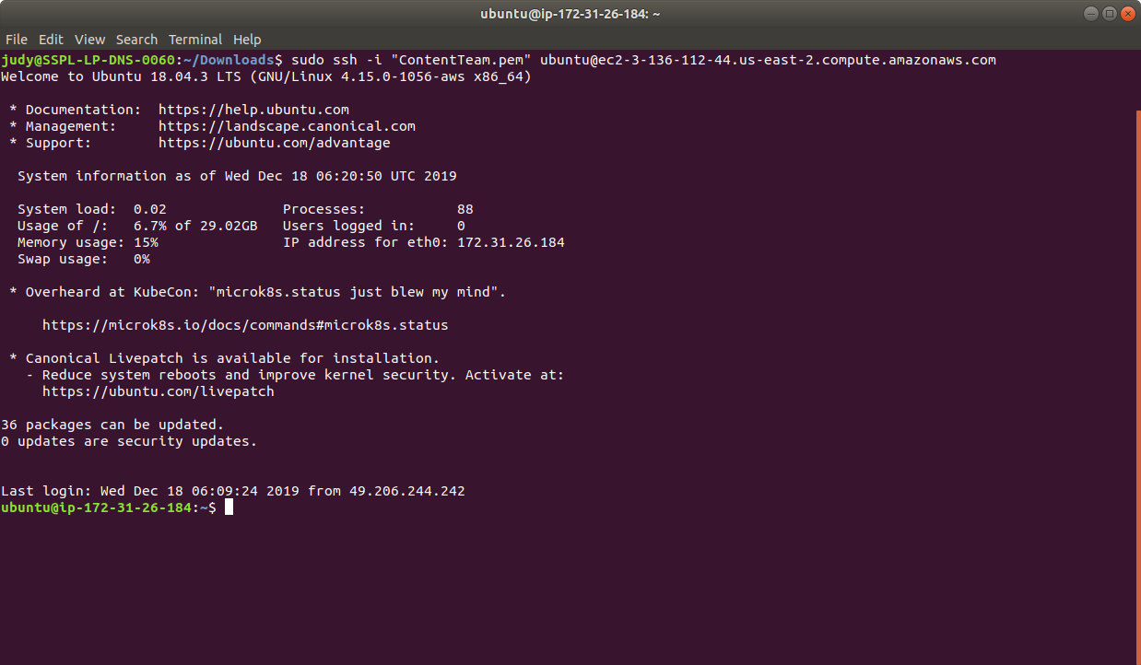

* If you don’t have an existing EKS cluster, create one with the command, **eksctl create cluster --name=myeks-cluster --nodes=2 --region=us-east-2**
* Create the following yaml file:

**cat > nginx-deployment.yaml**

apiVersion: apps/v1

kind: Deployment

metadata:

name: nginx-deployment

labels:

app: nginx

spec:

replicas: 3

selector:

matchLabels:

app: nginx

template:

metadata:

labels:

app: nginx

spec:

containers:

- name: nginx

image: nginx:1.7.9

ports:

- containerPort: 80

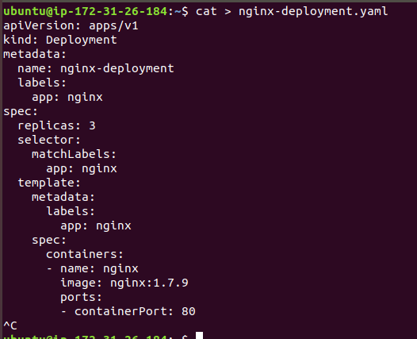

* Next, create the deployment by running the kubectl command **kubectl apply -f nginx-deployment.yaml** as shown below:

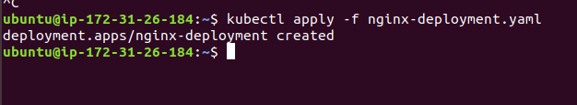

* Run kubectl get deployments to check if the deployment was created. If the deployment is still being created, the output will look like the one shown below:

**kubectl get deployments**

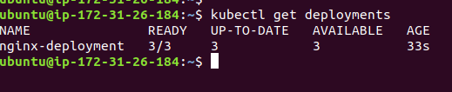

* Now, to see the deployment rollout status, run the **kubectl rollout status deployment.v1.apps/nginx-deployment**. The output should be like the one shown below:

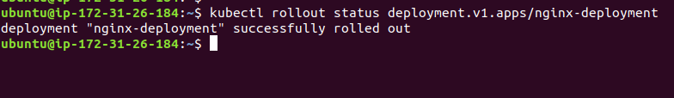

* Sometimes, you may want to rollback a deployment.   
  **For example**: When the deployment is not stable, such as crash looping.
* Suppose you have made a typo while updating the deployment, by putting the image name as nginx:1.91 instead of nginx:1.9.1, the output will be like the one shown below:

**kubectl set image deployment.v1.apps/nginx-deployment nginx=nginx:1.91 --record=true**

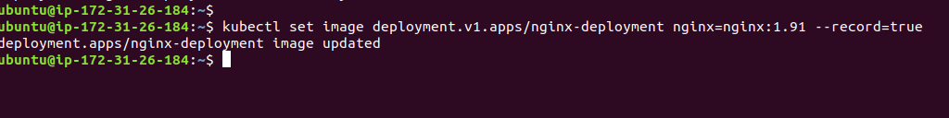

* So, now you can check the rollout history as shown below:

**kubectl rollout history deployment.v1.apps/nginx-deployment**

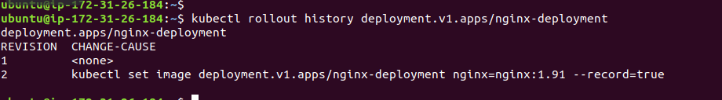

* This is how we can update the deployment rollout using kubectl commands.