1.2 Pod Creation Using yaml File 

1.2.1: In this demo, we will show you how to create pods using a yaml file.

Step 1: Creating multi-container pods

* Login to your aws console
* Restart your ec2 instance and your EKS cluster
* Open your terminal and SSH to the ec2 instance
* Create a new file named sample.yaml file to create a multi-container pod with the following commands:

**cat > sample.yaml**

apiVersion: v1

kind: Pod

metadata:

name: multi-container

spec:

terminationGracePeriodSeconds: 0

containers:

- name: nginx

image: nginx:1.10-alpine

ports:

- containerPort: 80

- name: alpine

image: alpine:3.5

command: ["watch", "wget", "-qO-", "localhost"]

* Apply the yaml with the command ***kubectl create -f sample.yaml.*** You’ll get the following result:

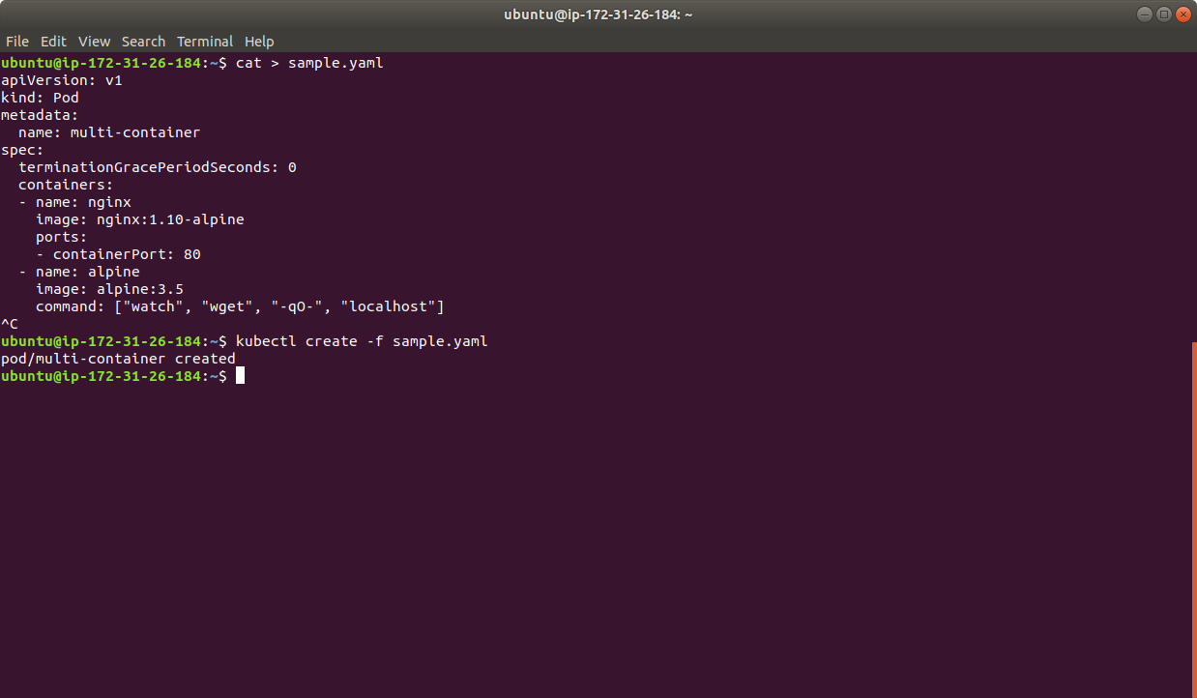

**Step 2 : Creating a single container pod**

* Create a single container pod with a tomcat image which is available on the Docker hub using the command **kubectl run tomcat --image=tomcat:8.0**
* You’ll get the following result:



* Run kubectl get pods to view the pods running. You’ll get the following result:

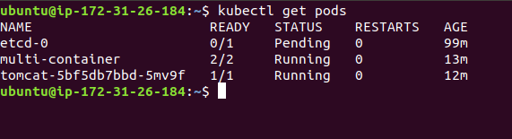

* Stop the cluster nodes and ec2 instance once you’re done
* You can delete the cluster by running this command, **eksctl delete cluster --name my-eks-cluster**
* You can delete the stack with the command, a**ws2 cloudformation delete-stack --stack-name eksctl-my-eks-cluster-cluster** and the instance from the console