2.3 Create a Pod with Resource Requirements and Limits

In this demo, we will show you how to create a pod with certain resource requirements and limits.

* Login to your aws console
* Restart your ec2 instance and your EKS cluster nodes
* Open your terminal and SSH to the ec2 instance

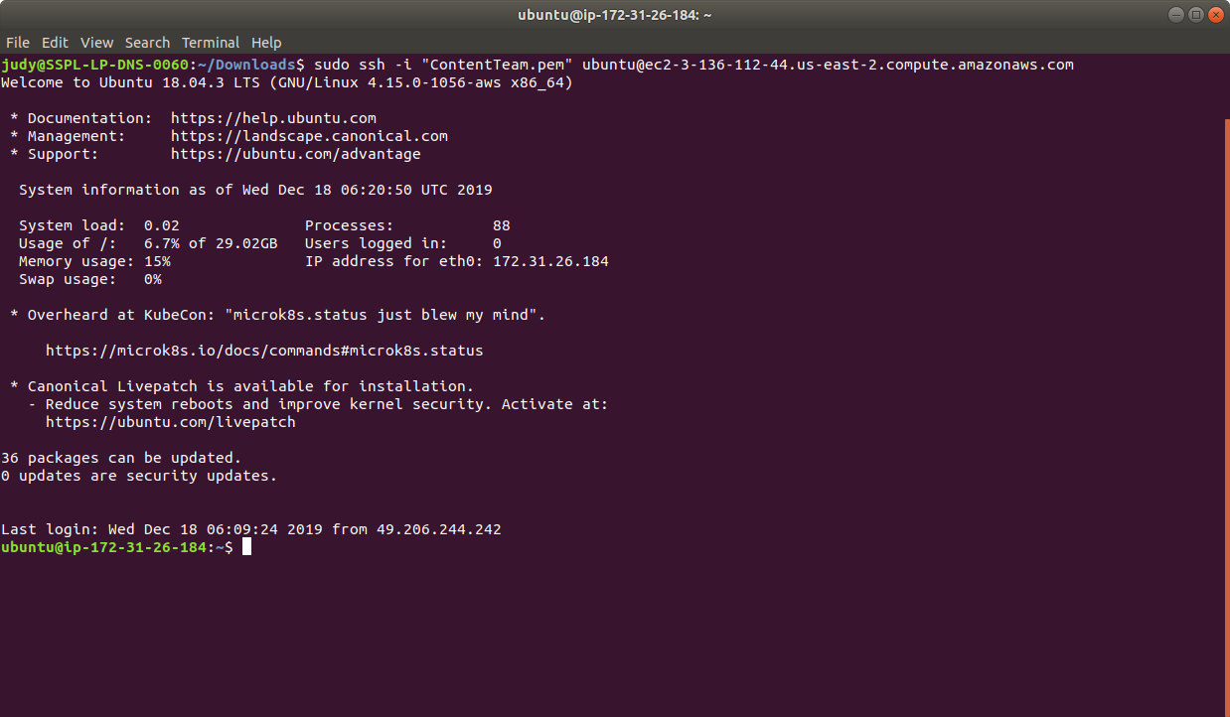

* If you don’t have an existing EKS cluster, create one with the command, **eksctl create cluster --name=myeks-cluster --nodes=2 --region=us-east-2**
* Create a custom namespace with the command **kubectl create namespace cpu-example**

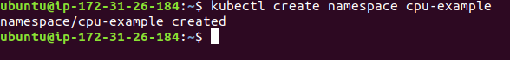

* Create a custom yaml with our resource limits (CPU, memory) as shown below:

**cat > cpu-request-limit.yaml**

apiVersion: v1

kind: Pod

metadata:

name: cpu-demo

namespace: cpu-example

spec:

containers:

- name: cpu-demo-ctr

image: vish/stress

resources:

limits:

cpu: "1"

requests:

cpu: "0.5"

args:

- -cpus

- "2"

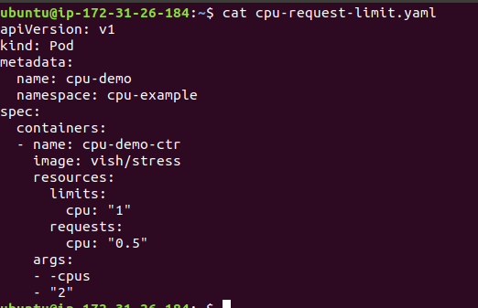

* We have defined the resources (CPU, memory) as max and min value, which we will be using to create a namespace with the defined limit configuration and limit. Use kubectl command to create a pod from the created yaml as shown below:

**kubectl apply -f cpu-request-limit.yaml**



* Next, view the detailed information about the pod, by using the kubectl command. The output shows that one of the containers in the pod has a CPU request of 500 milliCPU and a CPU limit of 1 CPU as shown below:

**kubectl get pod cpu-demo --output=yaml --namespace=cpu-example**

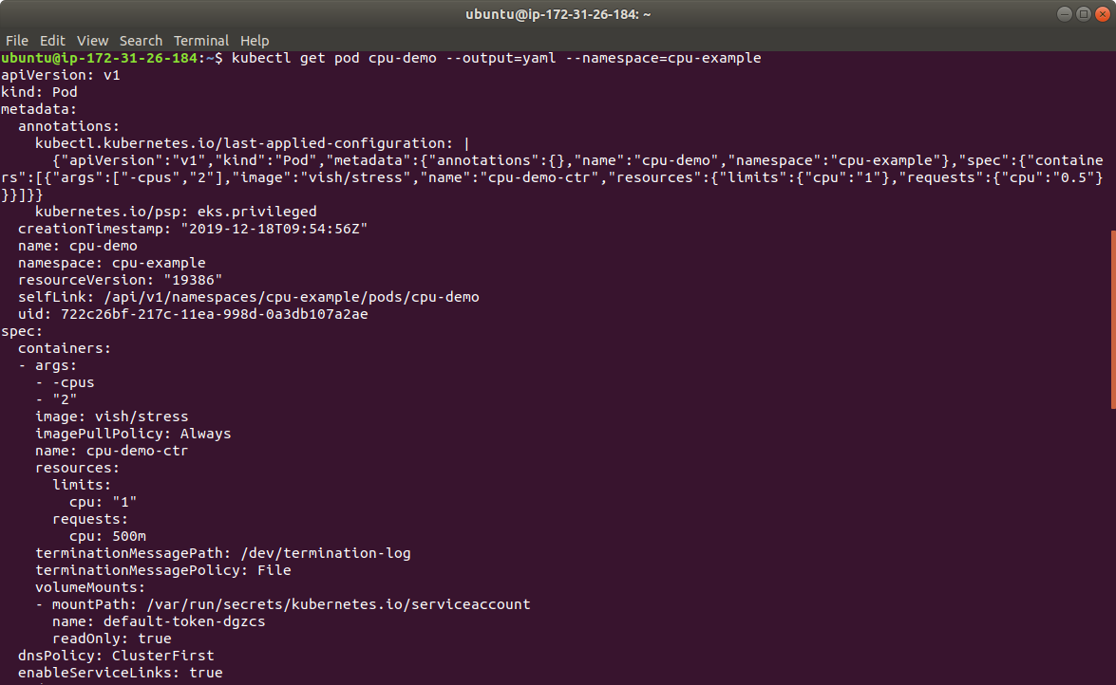

* This is how we set resource limits like CPU or memory for the created namespace.

