1.5 Service Creation

1.5.1 In this demo, we will show you how to create a service using a yaml file.

* Login to your aws console
* Restart your ec2 instance and your EKS cluster nodes
* Open your terminal and SSH to the ec2 instance

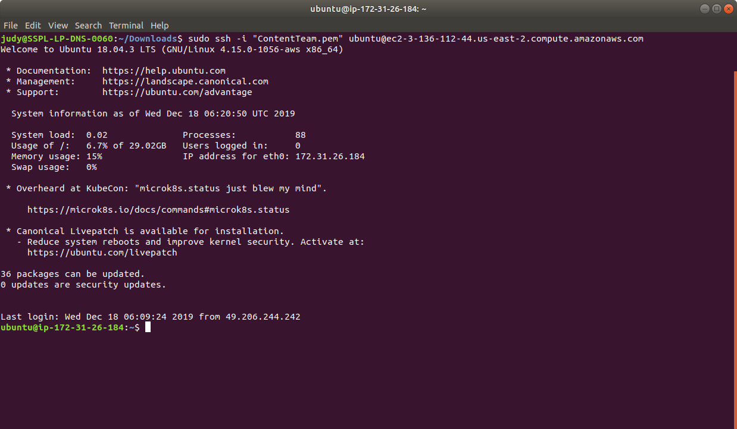

* If you don’t have an existing EKS cluster, create one with the command, **eksctl create cluster --name=myeks-cluster --nodes=2 --region=us-east-2**
* We are going to use this to create a service in Kubernetes Engine. Create a service configuration yaml with the command **cat > service-example.yaml**
* Enter the following content in the file and save it:

apiVersion: v1

kind: Service

metadata:

name: example-service

labels:

app: example-service

spec:

ports:

- port: 80

targetPort: 4000

type: NodePort

selector:

app: example-pod

---

apiVersion: v1

kind: ReplicationController

metadata:

name: example-replica

labels:

app: example-replica

spec:

replicas: 1

template:

metadata:

labels:

app: example-pod

spec:

containers:

- name: example-container

image: zlabjp/docker-example:release-0.1.0

ports:

- containerPort: 4000

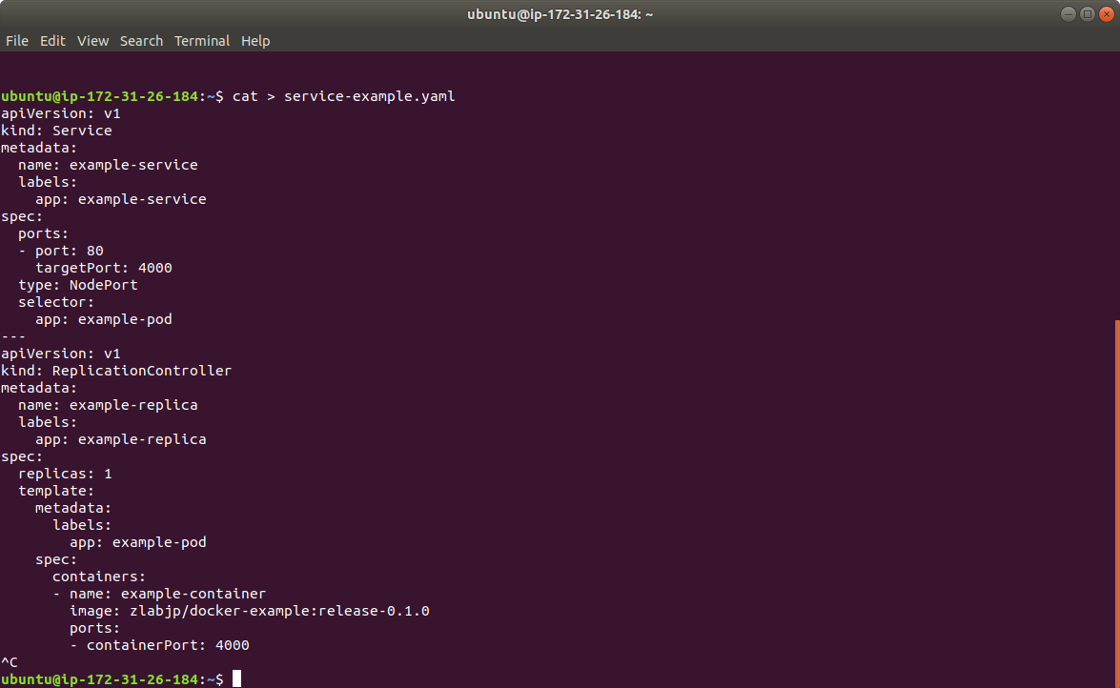

* Create the service by running the command **kubectl apply -f service-example.yaml** as shown below:

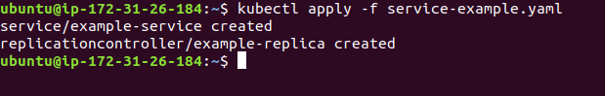

* Run **kubectl get service** to check if the service was created. The output will be like the one shown below:

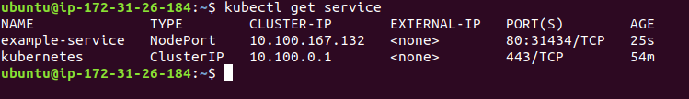

1.5.2 In this demo, we will show you how to create a service using kubectl commands.

* Use the **kubectl expose replicationcontroller/example-replica** command to create a service for your replicas as shown below:



* You can also view the created deployment using **kubectl get services** command as shown below:

