2.5 Create DaemonSets

In this demo, we will show you how to create DaemonSets

* You can use the Kubernetes command line tool, kubectl, to interact with the API Server. Using kubectl is straightforward if you are familiar with the docker command line tool. However, there are a few differences between the docker commands and the kubectl commands. So let us begin and understand what these differences are.
* Login to your aws console
* Restart your ec2 instance and your EKS cluster nodes
* Open your terminal and SSH to the ec2 instance

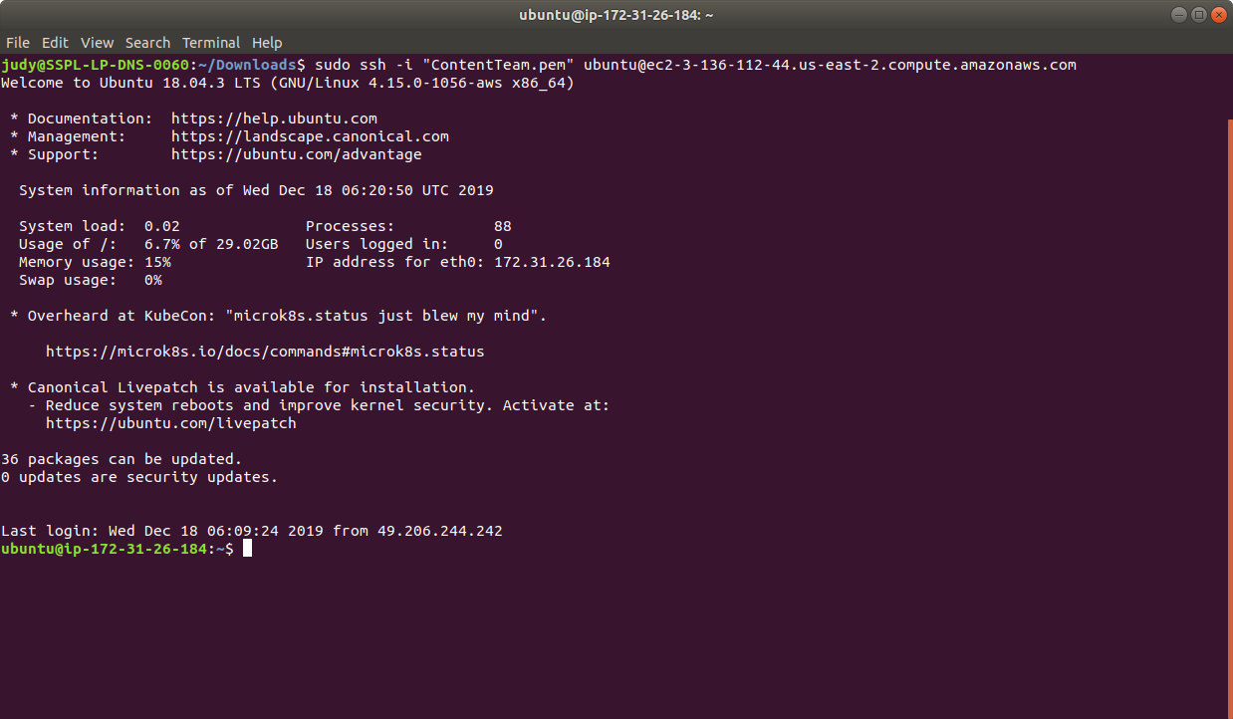

* If you don’t have an existing EKS cluster, create one with the command, **eksctl create cluster --name=myeks-cluster --nodes=2 --region=us-east-2**
* Create a DaemonSet in a YAML file with the command **cat > daemonset.yaml.** The file below describes a DaemonSet that runs the fluentd-elasticsearch Docker image.

apiVersion: apps/v1

kind: DaemonSet

metadata:

name: fluentd-elasticsearch

namespace: kube-system

labels:

k8s-app: fluentd-logging

spec:

selector:

matchLabels:

name: fluentd-elasticsearch

template:

metadata:

labels:

name: fluentd-elasticsearch

spec:

tolerations:

- key: node-role.kubernetes.io/master

effect: NoSchedule

containers:

- name: fluentd-elasticsearch

image: gcr.io/fluentd-elasticsearch/fluentd:v2.5.1

resources:

limits:

memory: 200Mi

requests:

cpu: 100m

memory: 200Mi

volumeMounts:

- name: varlog

mountPath: /var/log

- name: varlibdockercontainers

mountPath: /var/lib/docker/containers

readOnly: true

terminationGracePeriodSeconds: 30

volumes:

- name: varlog

hostPath:

path: /var/log

- name: varlibdockercontainers

hostPath:

path: /var/lib/docker/containers

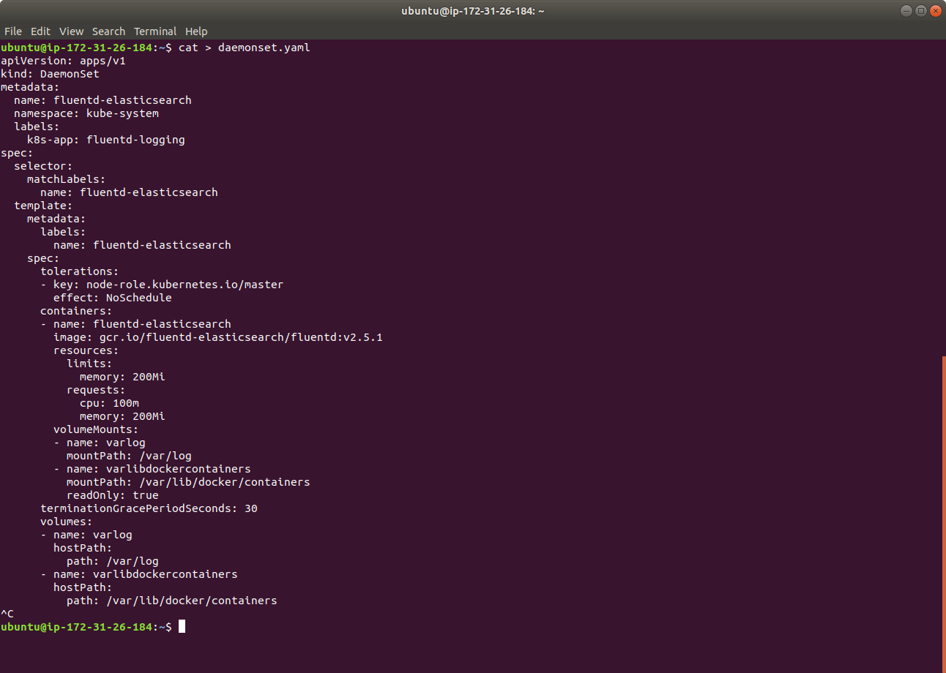

* Create a DaemonSet based on the YAML file using kubectl command as shown below

**kubectl apply -f deamonset.yaml**

