1.4 Deployment Creation

1.4.1: In this demo, we will show you how to create deployments

**Step 1 : Creating a deployment from a yaml file**

* Login to your aws console
* Restart your ec2 instance and your EKS cluster nodes
* Open your terminal and SSH to the ec2 instance

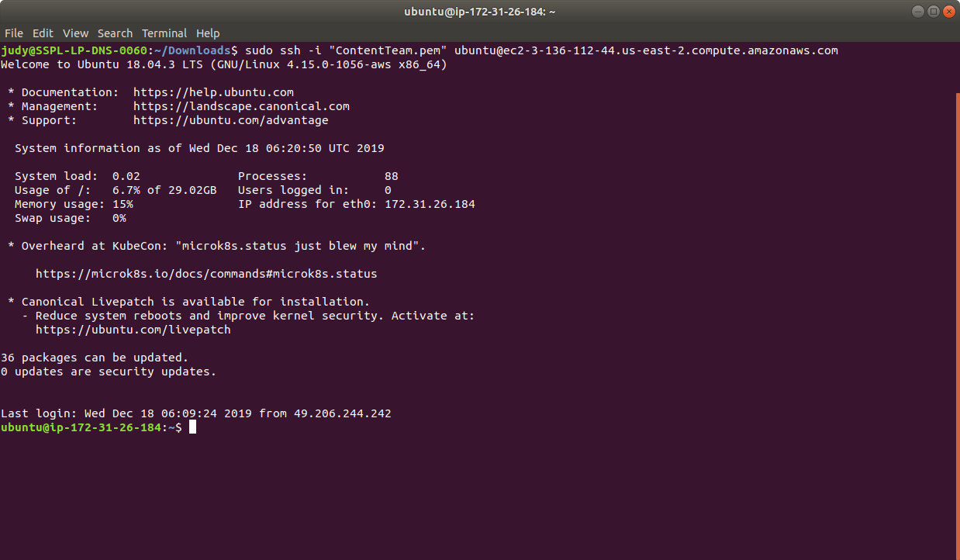

* If you don’t have an existing EKS cluster, create one with the command, **eksctl create cluster --name=myeks-cluster --nodes=2 --region=us-east-2**
* Create a new yaml file named *nginx-deployment.yaml* using the following commands:

**cat > *nginx-deployment.yaml***

* Enter the following into the yaml file and save it:

apiVersion: apps/v1

kind: Deployment

metadata:

name: nginx-deployment

labels:

app: nginx

spec:

replicas: 3

selector:

matchLabels:

app: nginx

template:

metadata:

labels:

app: nginx

spec:

containers:

- name: nginx

image: nginx:1.7.9

ports:

- containerPort: 80

* Create the deployment by running the command:

***kubectl apply -f nginx-deployment.yaml***

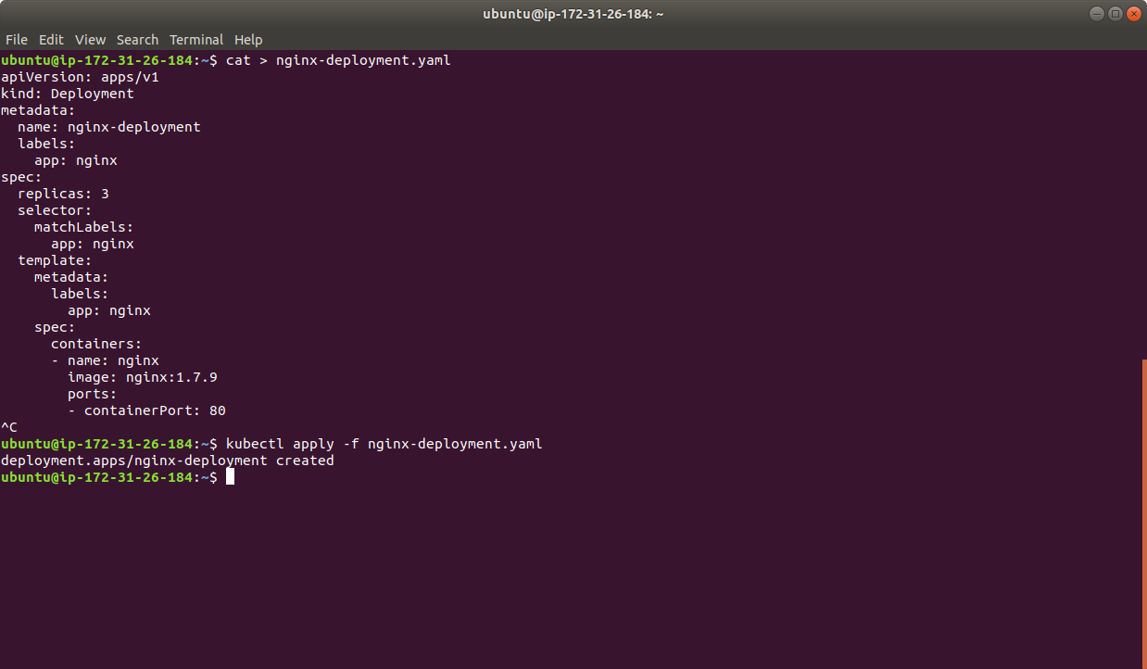

* Run ***kubectl get deployments*** to check if the deployment was created.

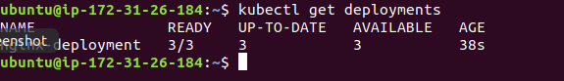

**Step 1 : Creating a deployment with the kubectl command**

* Use the kubectl create command to create a deployment that manages a pod.

**kubectl create deployment hello-node --image=gcr.io/hello-minikube-zero-install/hello-node**

* You can see the created deployment when the command is executed



* You can also view the created deployment using ***kubectl get deployments*** command as shown below:

