WellViewer
The WellViewer has been developed to support the creation of the necessary input files for the wells in the MikeShe model from a JupiterXL database. The wells in MikeShe are divided in extraction wells and observation wells. This division is reflected in the WellViewer.

The WellViewer is a one-page user interface that has the following functionality:

- Read wells from:
  - JupiterXL MS-Access database.
  - ESRI point shape file.
  - MikeShe setup.
- Read extractions and head observations from JupiterXL MS-Access database and attach to the wells previously read in.
- Select wells located inside a MikeShe model area.
- Select plants based on mean yearly extraction within a period of time
- Select intakes based on number of head observations within a period of time
- Write specialized NOVANA point shapes with entries for each intake.
- Write MikeShe input files for detailed time series for selected observations.
- Write MikeShe input files for extraction wells.
- Write input files for LayerStatistics.

The user interface is divided into three columns that show Plants, Wells and Intakes. The “Plants” column and the “Wells” column can be connected so only the wells attached to selected plant are shown. Other than that the columns are independent.

In the left there is a button for each of the data sources that can be read in. At the bottom of the “Plants” and “Intakes” column there is a button for each of the supported output formats. The two buttons below the Plants column writes files with extraction data and the three buttons below the Intake column writes files with head observation data. The buttons will only be active when sufficient data has been read in.
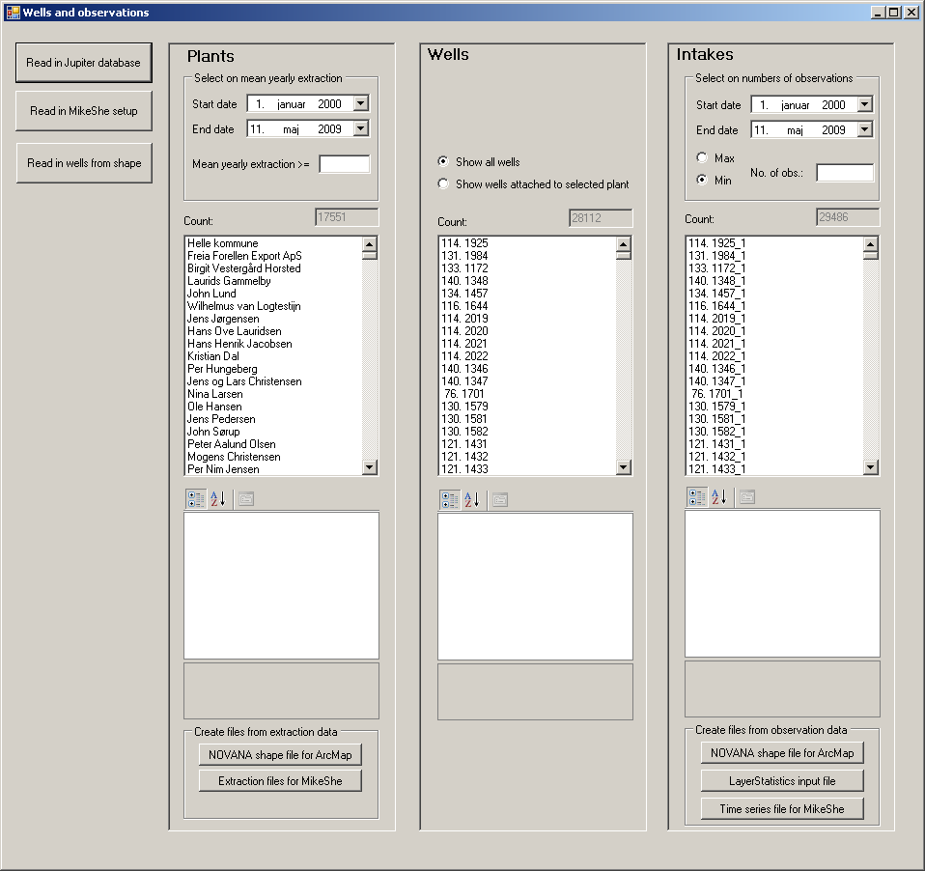

Limitations
There is a limit to the maximum amount of data that can be loaded. This limit depends on the available RAM in the computer. If the memory limit is exceeded try dividing the database and perform your task in multiple steps.

The WellViewer does not handle unit conversion. Thus the data to be read in has to be in the same unit as required by the MikeShe-model. If data are read in from a JupiterXL-database the units will be in SI (Extraction in m³ and head observation in m) as required by MikeShe.

Description of the functionality

Read buttons
There are three read buttons each representing a different data source that can be read.

Read in Jupiter database
This button is used to read in data from a Jupiter XL database. These databases can be downloaded here: jupiter.geus.dk/JupiterWWW/DownloadPCJupiter?xl=1
When a file has been selected a dialog appears asking what kind of data should be read. Here it is possible to select “Head observations”, “Plants and Extraction”, “Lithology” and “Chemistry”. If no wells have been read previously information about the wells will also be read in. This is indicated by the check box “Wells”, which it is not possible to change.

When a wells is read in it is defined whether it is an extraction well or not. The wells are marked as extraction wells if the “purpose” field of the “BOREHOLE” table has one of the following values:
"C","G","V","VA","VD","VH","VI","VM","VP","VV" or if the ”USE” field in the same table has one of these values: "C","G","V","VA","VD","VH","VI","VM","VP","VV".

When plants and extractions are read in the wells are attached to the plant. A plant can have a subplant and if a well is attached to both plants according to Jupiter it is removed from the upper plant when read in. Otherwise the subsequent distribution of extraction on the intakes will be wrong.

If it is chosen to read in head observations it will only read in the wells that have at least one head observation.

Read in MikeShe setup
This button has two types of functionality. If wells have been read in the wells outside the horizontal model area of the MikeShe model will be removed.
If no wells have been read in, it will read the wells containing detailed time series information.

Read in wells from shape.
With this button it is possible to select a point shape file and construct wells based on information in the data table. It is expected that there is an entry for each intake. The required information is:

- Well ID (string)
- Intake number (integer)
- X – coordinate (double)
- Y – coordinate (double)
- Top of intake in meters above sea level (double)
- Bottom of intake in meters above sea level (double)
- Terrain in meters above sea level (double)
- Start year of active period (integer) (optional)
- End year of active period (integer) (optional)

To locate the correct column in the shape file the WellViewer reads the file ShapeReaderConfiguration.xml that is located in the bin directory. This file defines the names of the required columns. The file has the following format:

<?xml version="1.0"?>
<ShapeReaderConfiguration xmlns:xsi="http://www.w3.org/2001/XMLSchema-instance" xmlns:xsd="http://www.w3.org/2001/XMLSchema">
<WellIDHeader>BOREHOLENO</WellIDHeader>
<IntakeNumber>INTAKENO</IntakeNumber>
<XHeader>XUTM</XHeader>
<YHeader>YUTM</YHeader>
<TOPHeader>INTAKTOPK</TOPHeader>
<BOTTOMHeader>INTAKBOTK</BOTTOMHeader>
<TerrainHeader>JUPKOTE</TerrainHeader>
<FraAArHeader>FRAAAR</FraAArHeader>
<TilAArHeader>TILAAR</TilAArHeader>
</ShapeReaderConfiguration>

To read in wells from a shape file where the columns are named differently it is only necessary to change this file.

When a shape file has been selected a dialog appears showing the columns in the shape file. With this dialog it is possible to create a select string so only some of the wells are read. If no select string is created it reads in all wells.

All wells read in from shape files are assumed to be used for extraction in the active period. If the columns defining the active period cannot be found the intakes will be active always. The active period only is only used when distributing the extraction of a plant on the attached active intakes.

Write buttons
There is a write button for every format that is supported. The buttons are logically divided between extraction and observations.

NOVANA shape for ArcMAP (Plants)
This button writes a point shape file with entries for each intake attached to the selected plants that has extraction.

Extraction files for MikeShe
This button writes the necessary input files for pumping wells in MikeShe. It writes a text-file with an entry for each intake attached to the selected plants and this file can be imported in the well editor. It also writes a .dfs0-file with the yearly extraction rate in items for each intake. It distributes the extraction from the plant evenly on all active intakes each year. If an intake has multiple screens top most level and the bottom most levels are used, so the intake will appear to be screened over the entire depth.
The name of the text-file is “WellEditorImport.txt” and the name of the .dfs0-file is “Extraction.dfs0”. If these files exist in the chosen output directory, they will be overwritten without warning. If a well does not contain the necessary information it will be listed in the file “WellsWithMissingInfo.txt”.

NOVANA shape for ArcMAP (Head observations)
This button writes a point shape file with entries for each of the selected intakes. The point shape contains various data from the JupiterXL-database and statistics on the head observation time series.

LayerStatistics input file
This button writes an input file that can be used by the utility layerstatistics.exe. It will include all the selected intakes. It can either produce an entry for each head observation in the time series or it can take the average. This is chosen in the dialog that appears when the button is pressed.

Time series file for MikeShe
This button writes a text-file that can be imported as a detailed time series output in MikeShe. It also writes the necessary .dfs0-files. An entry is written for all the selected intakes. Writing the .dfs0-files may take a long time. This can be followed by the progress bar that will appear in the lower left corner.

