**Project Details:**

**Requirements:**

**Task Description:**- Create an application that loads JSON file that contains all of the US states.   
- Provide type head search and sort functionality.   
- Script must be created using Backbone.js. Search and sort functionality must be added as mixins.   
- Please provide a link to the final version of an app on GitHub

**Tool Used:**

JSON, Backbone JS, JavaScript, CSS, HTML.

**Screen Shot-1:**

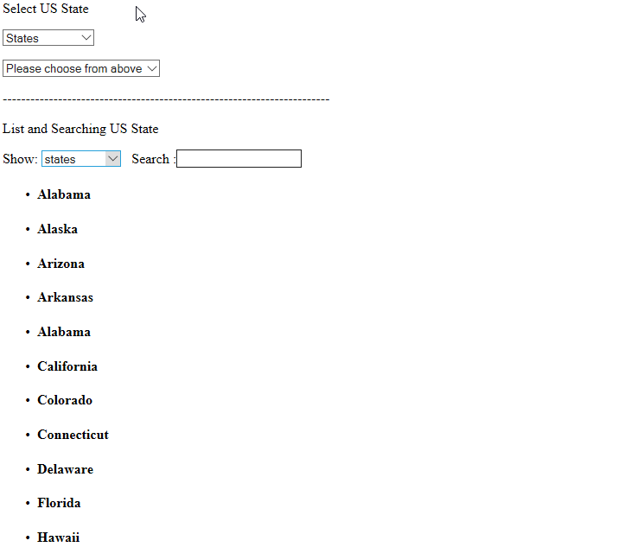

**Screen Shot-2:**

