.

**Idea/Approch:** To build live interactive community based webapp where students can clear doubts with help of experienced mentors in a fun and interactive learning manner

**Minsitry/Oragnistaion name:** National Digital Education

Architecture(NDEAR) DepartmentOf school Education & Literatcy (DOSEL)

**Problem Statement**: Teaching-Learning Marketplace/volunteer matchmaking.

**Team name:** Teamrex

**Team Leader Name:** Sumit Baghel

**College Code:**

**Idea / solution prototype**

* A login page where student and teacher can login through their DIKSHA id.
* Admin panel to verify registered teachers by activating there account.
* Student will take image of doubt/question .He will receive sms when teacher will take doubt.
* Teacher will solve doubt by live video calling feature
* Group of student having same doubt can join video call.

**Technology Stack**

* Front-end – Html/css/javascript/reactsjs
* Back-end - Node.js / Express.js
* Databases – Mysql

**Use Cases**

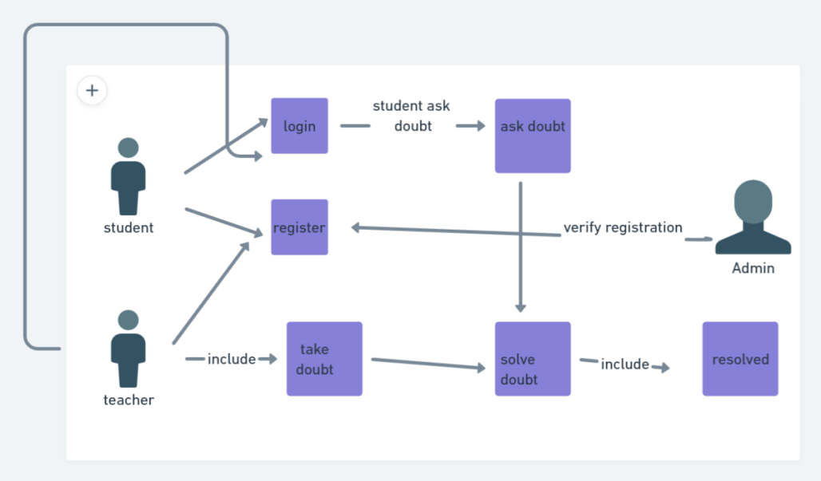

* **Student login/register**
* **Teacher login/register then admin verify**
* **Student will ask doubts**
* **Teacher will take doubts then solve**
* **Student will click resolved if doubt get resolved.**

**Dependencies**

* **Lack of students**
* **Lack of teachers**
* **web users**
* **Unavailability of data to verify teachers.**