Selenium_Session1_Assignment

Assignment – 1.1

Introduction

This assignment will help you understand the concepts learnt in the session.

Objective

In this challenge, we review some concepts of Selenium IDE to get familiar with importance of

automation.

Task

Record a new session for base URL as https://magento.com/ and then click on the icon to navigate to

customer login page and then to Registration Page and automate all the fields.

Note: Leave captcha. No need to automate

**Expected Result:**

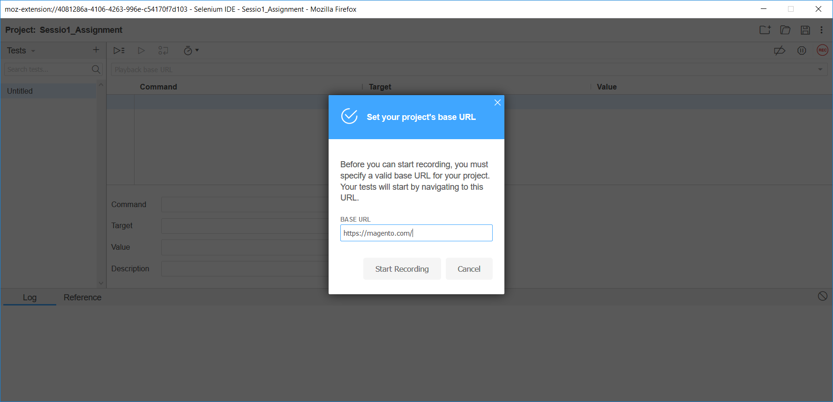

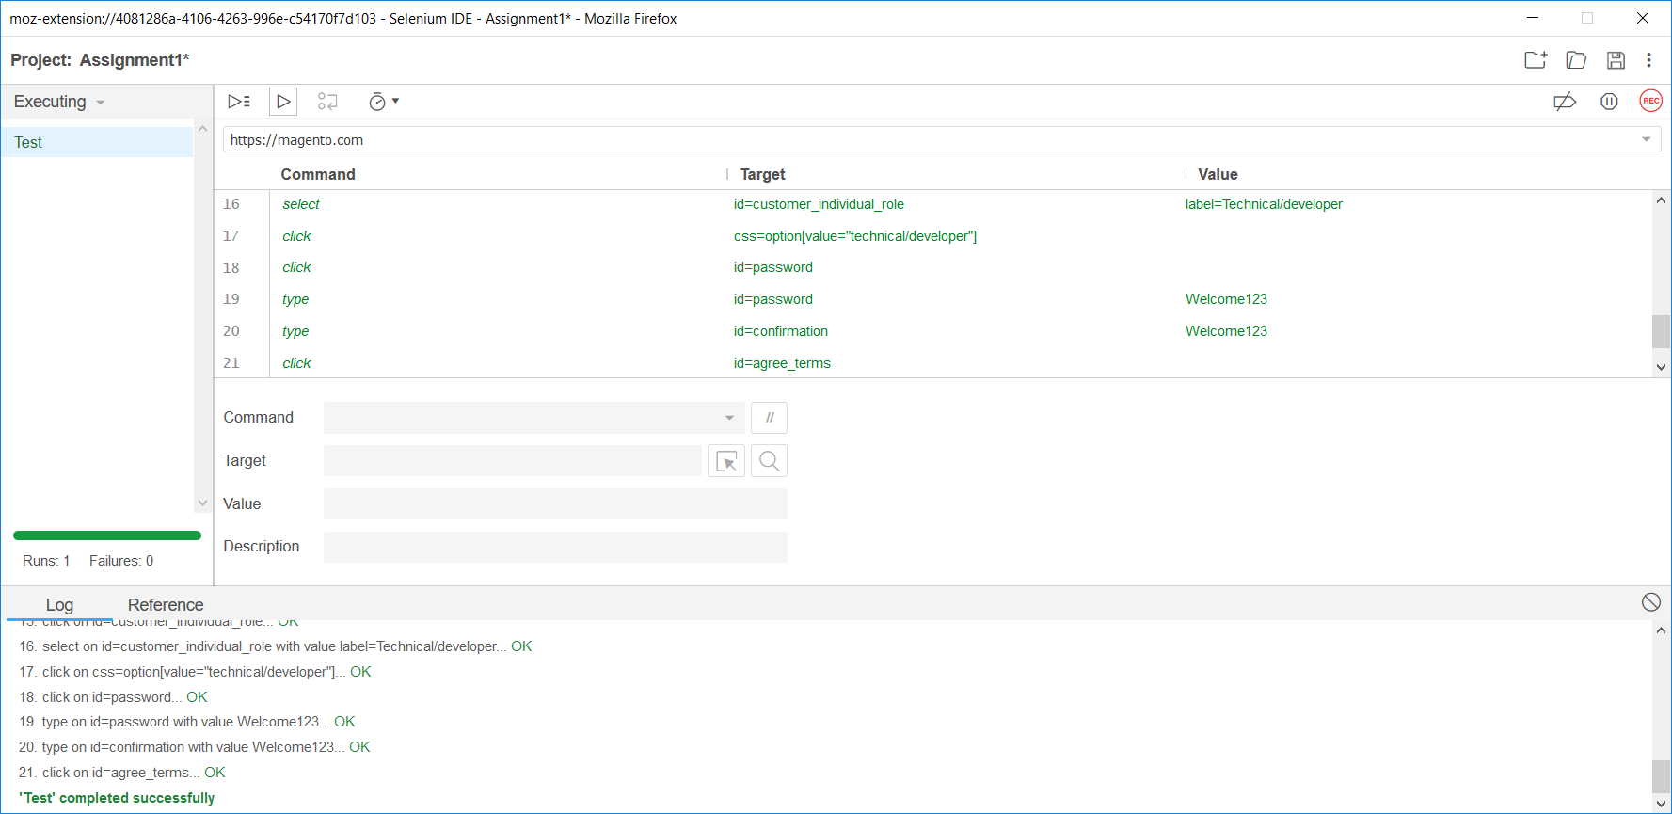



Assignment – 1.2

Introduction

This assignment will help you understand the concepts learnt in the session.

Objective

In this challenge, we review the configuration of selenium WebDriver.

Task

Please try to configure Internet Explorer browser and Chrome Browser. We will do the same in the

session as well. But before that try to check on the exception you’re getting.

**4. Expected Output**

IEBrowser Configuration:

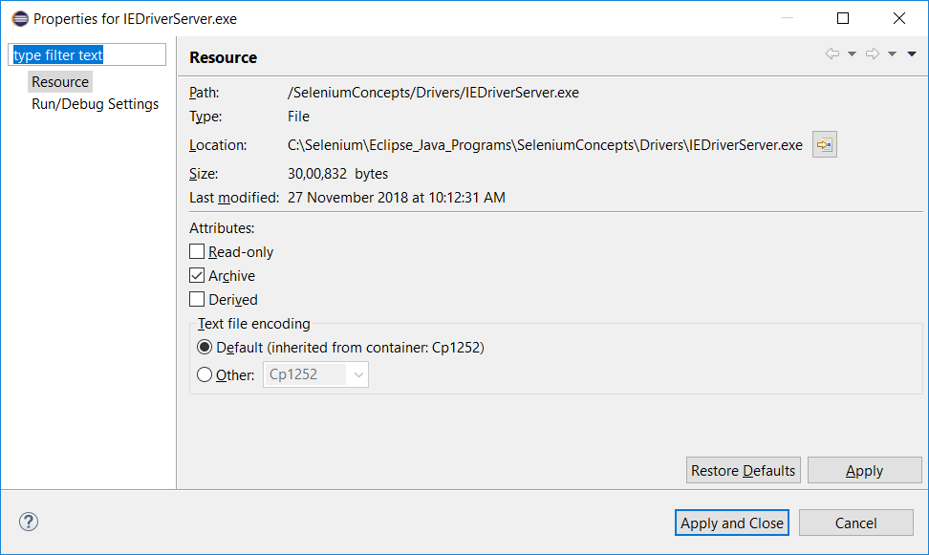

Chrome Browser configuration:

