**Session_2 _Assignments:**

**Program1:**

1. **Write a program to find the highest among the given 3 numbers.**

//Largest number= Using IF ELSE

import java.util.Scanner;

public class Largest{

public static void main(String[] arg)

{

int x=10, y=20,z=5;

if (x>=y && x>=z)

System.out.println(x + " Is the Largest Number");

else if(y>=x && y>=z)

System.out.println(y + " Is the Largest Number");

else

System.out.println(z + " Is the Largest Number");

}

}

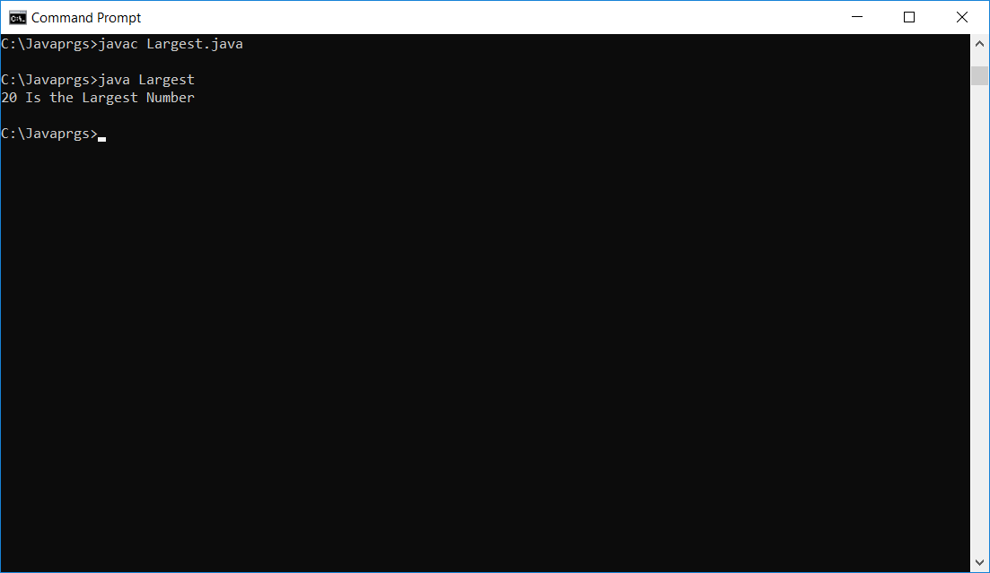

**Attached is the below Java file**



**2. Write a program to print the following pattern:**

**X – pattern**

Comments:

0 1 2 3 4

0 x x

1 x x

2 x

3 x x

4 x x

It is in diagonal (0,0) to (0.4) means **row==col**

**This always sum to 4(size-1)**

//

public class CrossPrint

{

public static void main(String[] args)

{

int size=5;

char display='X';

for (int row = 0; row < size; row++) {

for (int col = 0; col < size; col++) {

if (row == col || row + col == size - 1) {

System.out.print(display);

} else {

System.out.print(" ");

}

}

System.out.println();

}

}

}

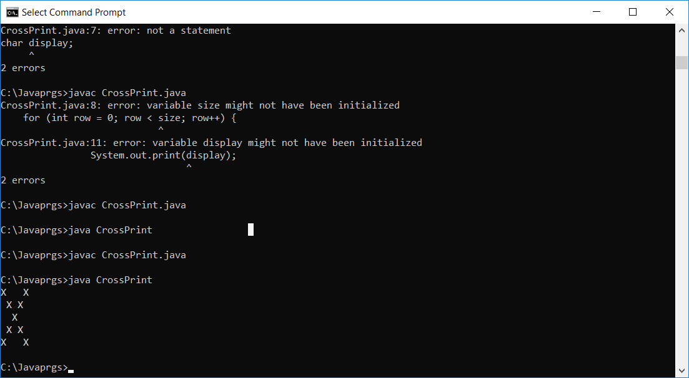

**Attached is the below java file**

