**Session_4 _Assignments:**

**1. Create an abstract class Figure with following properties and functions:**

**Properties: double dim1;**

**Methods: abstract void findArea();**

**abstract void findPerimeter();**

**Create three subclasses Circle, Rectangle and Triangle that extends Figure class**

**and define both the methods.**

**Write a program that will find the area and perimeter of 3 Figures and print the**

**details for all.**

Answer:

Need to define Abstract super class,having 2 methods

1.Perimeter of the shape

2.Area of the shape

And this class having ,subclasses. One for a circle,rectangle and triangle.

A circle has one additional attribute,its Radius.

A rectangle has 2 additional attributes, its width and height

A triangle also 2 attributes.

//Only Perimeter of s3 shapes

import java.util.Scanner;

public class Perimeter

{

int r, l, b, s1, s2, s3;

double pi = 3.14,perimeter;

Scanner s = new Scanner(System.in);

void circle()

{

System.out.print("Enter radius of circle:");

r = s.nextInt();

perimeter = 2 * pi * r;

System.out.println("Perimeter of circle:"+perimeter);

}

void rectangle()

{

System.out.print("Enter length of rectangle:");

l = s.nextInt();

System.out.print("Enter breadth of rectangle:");

b = s.nextInt();

perimeter = 2 * (l + b);

System.out.println("Perimeter of rectangle:"+perimeter);

}

void triangle()

{

System.out.print("Enter length of first side of triangle:");

s1 = s.nextInt();

System.out.print("Enter length of second side of triangle:");

s2 = s.nextInt();

System.out.print("Enter length of third side of triangle:");

s3 = s.nextInt();

perimeter = s1 + s2 + s3;

System.out.println("Perimeter of triangle:"+perimeter);

}

public static void main(String[] args)

{

Perimeter obj = new Perimeter();

obj.circle();

obj.rectangle();

obj.triangle();

}

}

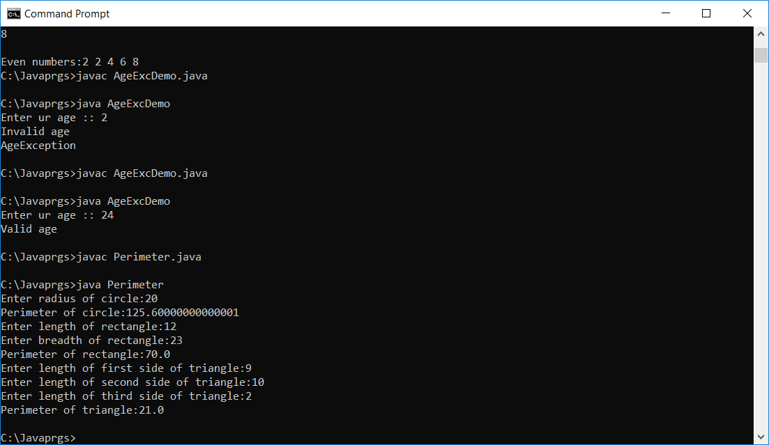



**2. Declare an integer array of size 10. Initialize using for loop with 1 to 10, and print**

**all even numbers from an array.**

**i**mport java.util.Scanner;

public class ArrayofEven{

public static void main(String[] arg)

{

int n;

Scanner s = new Scanner(System.in);

System.out.print("Enter no. of elements you want in array:");

n = s.nextInt();

int a[] = new int[n];

System.out.println("Enter all the elements:");

for (int i = 0; i < n; i++)

{

a[i] = s.nextInt();

}

System.out.println("");

System.out.print("Even numbers:");

for(int i = 0 ; i < n ; i++)

{

if(a[i] % 2 == 0)

{

System.out.print(a[i]+" ");

}

}

}

}

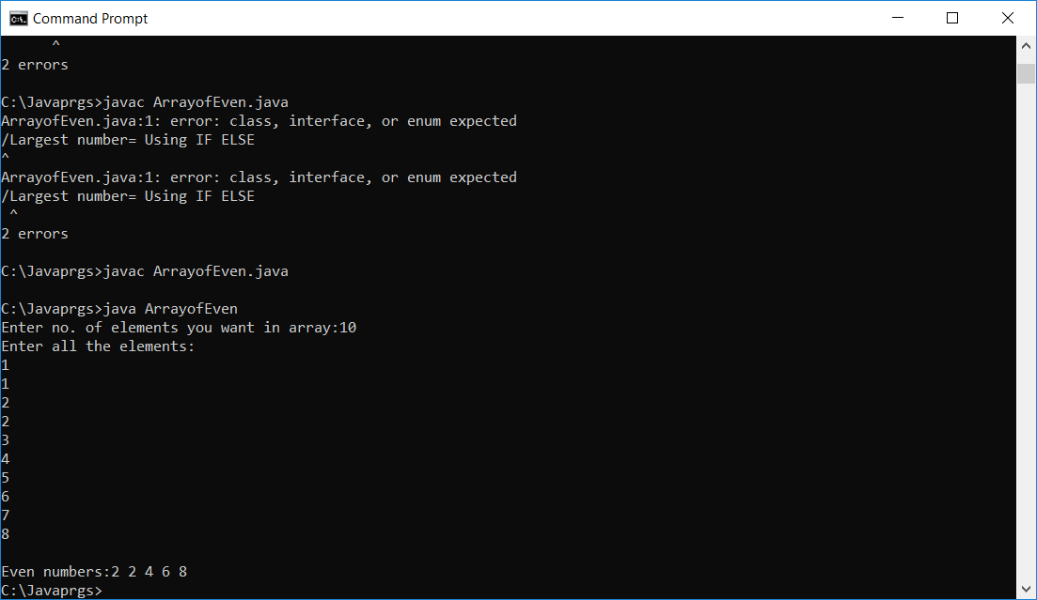



**3. Write a program to generate a user-defined exception called**

**NegativeAgeException if the user inputs negative value for age.**

//created an exception class AgeException which extends the built-in Exception class

import java.util.Scanner;

class AgeException extends Exception {

public AgeException(String str) {

System.out.println(str);

}

}

public class AgeExcDemo {

public static void main(String[] args) {

Scanner s = new Scanner(System.in);

System.out.print("Enter ur age :: ");

int age = s.nextInt();

try {

if(age < 18) //read the input from user using Scanner after that we check the age in try block

throw new AgeException("Invalid age");

else

System.out.println("Valid age");

}

catch (AgeException a) {

System.out.println(a);

}

}

}

