**Session_3 _Assignments:**

**1. Write a program in Java to show the use of super and this keyword with a constructor, methods,**

**variables.**

/* superclass Person */

class Person

{

Person()

{

System.out.println("Person class Constructor");

}

}

/* subclass Student extending the Person class */

class Student extends Person

{

Student()

{

// invoke or call parent class constructor

super();

System.out.println("Student class Constructor");

}

}

/* Driver program to test*/

class Test

{

public static void main(String[] args)

{

Student s = new Student();

}

}

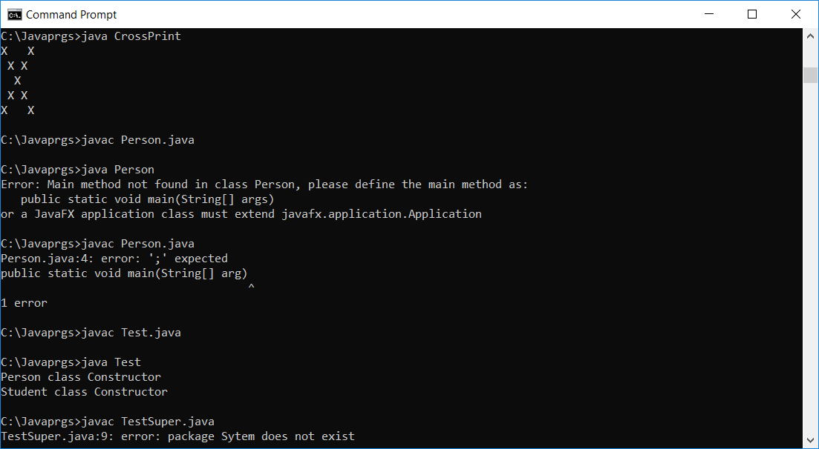



**2. Create a class Student which has some private data like name, phone number, roll number,**

**class, use getter and setters to access this private data.**

//Getter & Setter

public class Student {

public static void main(String[] arg)

{

private int rollNumber;

private String name;

private int marks1;

private int marks2;

private int marks3;

public void setName(String s) {

name = s;

}

public String getName() {

return name;

}

public void setRollMumber(int r) {

if (r > 0) {

rollNumber = r;

} else {

rollNumber = 1;

}

}

public int getRollNumber() {

return rollNumber;

}

public void setMarks1(int m) {

if (m >= 0 && m <= 100) {

marks1 = m;

} else {

marks1 = 0;

}

}

public int getMarks1() {

return marks1;

}

public void setMarks2(int m) {

if ((m >= 0) && (m <= 100)) {

marks2 = m;

} else {

marks2 = 0;

}

}

public int getMarks2() {

return marks2;

}

public void setMarks3(int m) {

if ((m >= 0) && m <= 100) {

marks3 = m;

} else {

marks3 = 0;

}

}

public int getMarks3() {

return marks3;

}

System.out.println("Roll Number: " + rollNumber);

System.out.println("Name: " + name);

System.out.println("Marks in first subject: " + marks1);

System.out.println("Marks in second subject: " + marks2);

System.out.println("Marks in second subject: " + marks3);

}

}

}

