**Session_1 _Assignments:**

**Program1:**

**1. Write a program to print the sum of two numbers without using + operator. Other operators**

**can be used.**

//Using Iterative solution (XOR bitwise Operator)

import java.util.Scanner;

public class ToAddNumber{

public static void main(String[] arg)

{

int x, y ;

Scanner in = new Scanner(System.in);

System.out.print("Input first number: ");

x = in.nextInt();

System.out.print("Input second number: ");

y = in.nextInt();

while(y != 0){

int carry = x & y;

x = x ^ y; //SUM of two bits

y = carry << 1; //Shifts carry to 1 bit to calculate SUM

}

System.out.print("Sum: "+x);

System.out.print("\n");

}

}

**Output:**

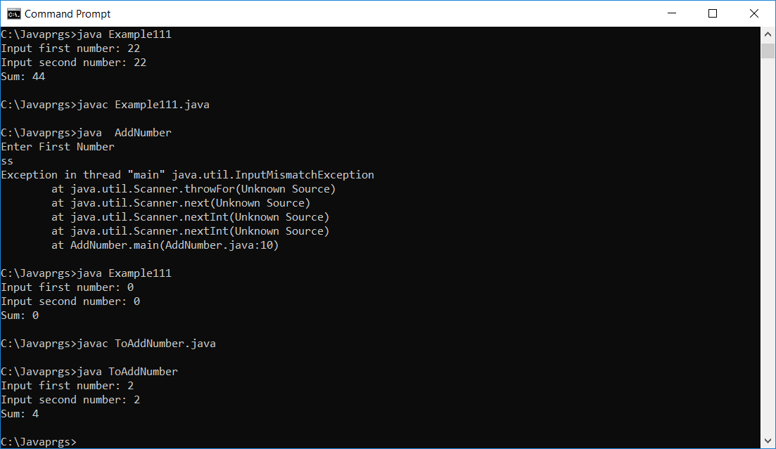

**Program 2:**

**Write a program to print the result of the following expressions provided the integer variable**

**a is 20 and b is 10.**

**int b = a-- - --a;**

**int c = a--;**

**int d = a>>2;**

**int e = a&b;**

//Using Iterative solution (XOR bitwise Operator)

import java.util.Scanner;

public class PrintInteger{

public static void main(String[] arg)

{

int a=20,b=10;

int c,d,e;

System.out.print("value of a-- - --a = " +(a-- - --a));

System.out.print("\n");

System.out.print("value of c= a-- = " +(a--));

System.out.print("\n");

System.out.print("value of d= a>>2 = " +(a>>2));

System.out.print("\n");

System.out.print("value of e= a&b = " +(a&b));

}

}

