

**AMERICAN INTERNATIONAL UNIVERSITY–BANGLADESH (AIUB)**

**FACULTY OF SCIENCE & INFORMATION TECHNOLOGY**

**INTERNSHIP AFFILIATIONREPORT ON**

***Internship at***

***Investment Corporation of Bangladesh***

An Internship Report Presented to the

OFFICE OF PLACEMENT and

DEPARTMENT OF COMPUTER SCIENCE

In Partial Fulfillment of the Requirements for th e Degree

***Bachelor of Science in Computer Science and Engineering***

**Supervised By**

**ABHIJIT BHOWMIK**

**Associate Professor & Special Assistant [OSA]**

**Department of Computer Science**

**American International University – Bangladesh**

**Submitted By**

**Jannatul Nusrat**

**19-40885-2**

**Bachelor of Science in Computer Science & Engineering**

Spring 2022-2023

Date of Submission: April 13, 2022

# II. LETTER OF SUBMITTAL

12 April,20222

Abhijit Bhowmik

Associate Professor & Special Assistant [OSA]

Department of Computer Science

American International University-Bangladesh.

Subject: **Submission of Internship Report on IT intern at Investment Corporation of Bangladesh(ICB).**

Dear Sir,

With due respect, I am a student of your renowned institution submitting my internship report on the IT Department at “Investment Corporation of Bangladesh” under the supervision of S.M. Serajul Islam, Assistant General Manager of Human Resource Department. I was exposed to the IT sector of the institution and was able to learn a great deal about how the Govt. institution’s IT services work due to this internship opportunity at ICB. I gave IT support to the head office as well as one subsidiary company (Asset Management Company Limited). I also set up IP addresses in different departments’ desktops. Even though there were a few flaws, I believe that the experience I've had has greatly served its intended purpose. I express my sincere gratitude for the opportunity to report on this subject. I correctly comprehended and carried out my obligations, and finished my paper within the allotted time frame.

I am happy and honored to be a part of this internship program and I’d like to express my gratitude to you and my honorable office supervisors for providing me with the opportunity to take part in this internship.

Your Sincerely,



Jannatul Nusrat

ID: 19-40885-2

BSc. in CSE

American International University-Bangladesh

Date: 12.04.2022

**III. LETTER OF ENDORSEMENT**

The Internship Affiliation Report entitled “*Internship at Investment Corporation of Bangladesh*”, has been submitted to the Office of Placement and Department of Computer Science in partial fulfillment of the requirements for the degree of **Bachelor of Science in Computer Science & Engineering** by **Jannatul Nusrat, 19-40885-2**. This report is presented to the Internship Defense Committee for evaluation and has been accepted.

|  |  |  |
| --- | --- | --- |
|  |  |  |
| Abhijit Bhowmik  *Internship Supervisor* (academic)  Associate Professor & Special Assistant [OSA]  Department of Computer Science American International University- Bangladesh |  | S.M. Serajul Islam  *Internship Supervisor* (industry)  Assistant General Manager,  Human Resource Department  Investment Corporation of Bangladesh. |
|  |  |  |
| MD. AL-AMIN  Internship Supervisor (External)  Lecture  Department of Computer Science  *Faculty of Science & Technology* |  | Prof. Dr. Dip Nandi  Professor & Director  Department of Computer Science  *Faculty of Science & Information Technology* |

**IV. ACKNOWLEDGEMENT**

First of all, I would like to thank almighty Allah, for his grace in accomplishing my internship report timely.

I would like to express my gratitude to the **Faculty of Science & Technology** to keep internship credit in the curriculum of the graduation program and give me a scope of tasting the flavor of industry oriented tasks and the field of work with my interest. I am also grateful to the **Faculty of Science & Technology & Office of Placement & Alumni**, AIUB to arrange an opportunity for choosing an own interested organization and complete internship there.

I am also thankful to my organization supervisor **S.M. Serajul Islam**, Assistant General Manager of human resource department, *Investment Corporation of Bangladesh* from the core of my heart for his kind support, guidance, constructive, supervision, instructions and advice and for motivating me to do my internship smoothly at *ICB*.

I feel proud and gratified that I was always held the under supervision of the Information Technology team and got advices directly from **Md. Kamrul Hasan**, Senior System Analyst, Programming department, *Investment Corporation of Bangladesh*. Here, with daily reporting along with mental and professional support enhances my experience in the internship life.

I am also indebted to the employees of IT team specially **Nitish Ranjan Bhowmik**, Assistant Programmer, *Investment Corporation of Bangladesh* who gave me immense support while working on project and also in technical issues. Moreover, to prepare this report and other documentation regarding Internship Report and I would show appreciation to all the members of Information Technology (IT) team, who always advised me and helped me through hands and pens.

# V. TABLE OF CONTENTS

|  |  |
| --- | --- |
| **TOPICS** | ***Page no*.** |
| 1. **Title Page** | 1 |
| 1. **Letter of Submittal** | 2 |
| 1. **Letter of Endorsement** | 3 |
| 1. **Acknowledgement** | 4 |
| 1. **Table of Content** | 5 |
| 1. **List of Tables &Figures** | 6 |
| 1. **Introduction** | 7 |
| * 1. Rationale | 7 |
| * 1. Background | 8 |
| * 1. Objectives | 11 |
| 1. **Activities** | 12 |
| * 1. Work Load | 12 |
| * 1. Organization Wide | 13 |
| * 1. Other Relevant Activities | 14 |
| 1. **Constraints/Challenges** | 15 |
| * 1. Identified/Observed in the Organization | 16 |
| * 1. Academic Preparation | 17 |
| * 1. Personal/Professional Skills | 18 |
| 1. **Acquired Knowledge** | 19 |
| * 1. Consequences to Organization | 19 |
| * 1. Implications to University’s Internship Program | 20 |
| * 1. Effects on Personal/Professional Skills | 20 |
| 1. **Concluding Statements** | 21 |
| * 1. Summary | 21 |
| * 1. Recommendations/Suggestions for future strategic actions | 21 |
| * + 1. Organization | 21 |
| * + 1. University | 22 |
| * + 1. Personal/Professional | 22 |
| 1. **Recommendation Letters** | 23 |
| 1. **References** | 24 |
| 1. **Appendices** | 25 |

**VI. LIST OF TABLES & FIGURES**

|  |  |
| --- | --- |
| **TITLES** | ***Page no*.** |
| **2.1 Figure: Assigned task-01** | 3 |
| **2.2 Figure: Assigned task-02(Registration Page)**  **2.3 Figure: Assigned task-03(Login Page)** |  |
|  |  |
|  |  |
|  |  |
|  |  |
|  |  |
|  |  |
|  |  |
|  |  |
|  |  |
|  |  |
|  |  |
|  |  |
|  |  |
|  |  |
|  |  |
|  |  |
|  |  |
|  |  |
|  |  |
|  |  |
|  |  |
|  |  |
|  |  |
|  |  |
|  |  |
|  |  |
|  |  |
|  |  |
|  |  |

1. **INTRODUCTION**

An internship program is a practical work experience that provides students with an opportunity to apply their theoretical knowledge to real-world scenarios. In the context of a Bachelor of Science (BSc) degree in Computer Science and Engineering (CSE), an internship program allows students to gain hands-on experience in the field of computer science and engineering. During an internship, students work with professionals in the industry to gain practical experience, learn new skills, and expand their knowledge in their chosen field of study. Internships can be paid or unpaid, and can vary in length from a few weeks to several months, depending on the program and the employer. In the last semester of graduation, American International University-Bangladesh (AIUB) offers internships to help its students finish their bachelor's degree by providing them with practical experience.

* 1. **Rationale**

The purpose of internship program is to provide students with practical experience, build their professional network, develop new skills, and test out potential career paths. I got a chance to join Investment Corporation of Bangladesh (ICB) as an intern student. The internship program has been really helpful in improving both my profession and my communication skills. I have the opportunity to become familiar with the IT environment because I work in the Investment Corporation of Bangladesh head office. I had the chance to gain skills by working in various departments under IT division. With the help of group discussions and group activity sessions, I was able to identify problematic situations. The training has helped me to better understand the differences between academic education and the demands of an IT office culture. It includes all of the necessary information for the three-credit internship course. I had access to all of my vast expertise and experience.

* 1. **Background**

Investment Corporation of Bangladesh (ICB) is mainly an investment bank which is a statutory corporation of Government of the People’s Republic of Bangladesh, was established on 1st October, 1976[1]. ICB has 8 branch offices in Dhaka, Chittagong, Rajshahi, Khulna, Barisal, Sylhet and Bogra & the headquarter is situated in Dhaka. It was established to accelerate the pace of industrialization and develop a sound securities market in Bangladesh [2]. Now it is one of the largest investors in share market of our country. ICB has 3 subsidiaries companies and they were constituted after the amendment of the ICB Ordinance 1976.

The companies are:

1. ICB Capital Management Ltd. (ICML)
2. ICB Asset Management Company Ltd. (IAMCL)
3. ICB Securities Trading Company Ltd. (ISTCL).

The main activities of ICB are investing in share market, providing loans and advances, acting as manager/trustee/custodian of mutual funds are some of main activities of ICB. It's the most successful state-owned corporation of Bangladesh in terms of profitability [1].

* 1. **Objectives**

Traditional classroom environments are insufficient for teaching professional skills. I was first really nervous about working in the real world. I was able to gain a practical understanding of how to operate in real life, in industry, or in an organization by visiting the headquarters because, until that point, I had only a theoretical understanding of those concepts. This experience gave me more confidence and allowed me to eventually develop my ability to work with people, officers, and management. The ability to communicate with others is another essential talent that I have acquired. My improved verbal accuracy, my level of activity and confidence overall have increased as a result of the internship.

1. **ACTIVITIES**

I joined ICB as an IT intern. Internship is designed to provide students or recent graduates with practical skills and experience in a particular field. My internship period was 12 weeks and my whole internship in ICB was very well organized by the Human Resource Department. They scheduled my 12 weeks of internship to work in 5 divisions under IT department and in a subsidiary company (AMCL).

* 1. **Work-Related**

I have gained different knowledge/skill in different departments. I am giving a short description of my work in different departments below.

* 1. **Asset Management Company Limited**

I was under the supervision of **Tanvir sir**. He showed me every software of the company. Also, he gave us the chance to browse those software. He showed me the data center as well. Then I was assigned some data entry task in the AMCL’s website through admin panel. I am attaching the screenshot below:

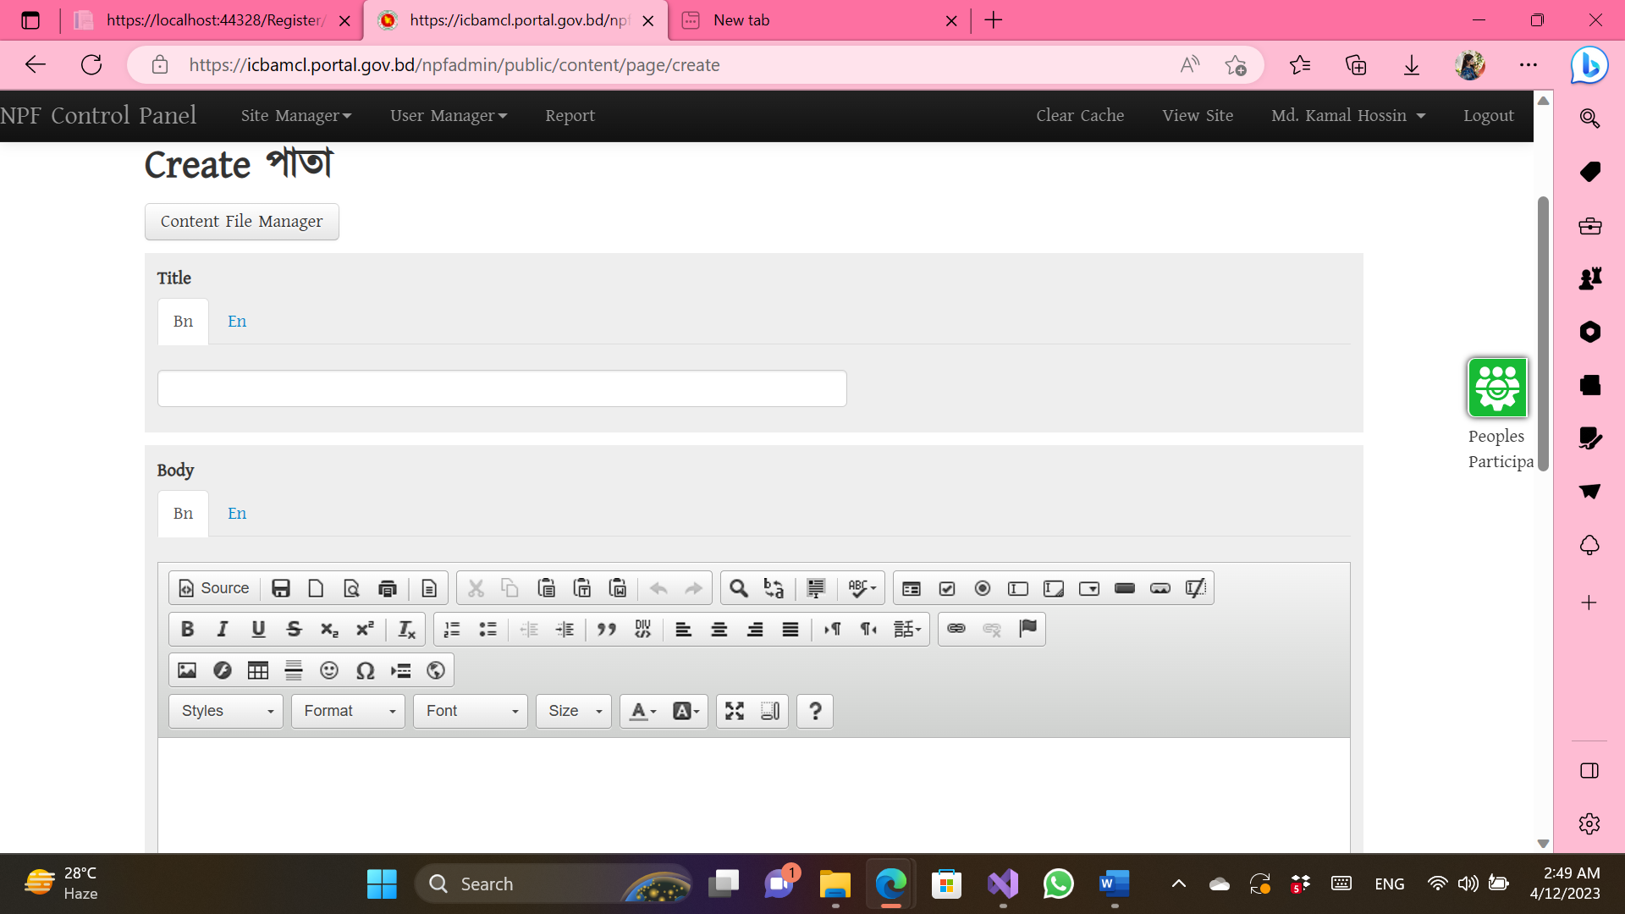

**Figure 2.1 Assigned Task-01**

* 1. **Programming Department**

**Nitish Ranjan Bhowmik** sir supervised me in programming department. Programming department develops every software and website of ICB. ICB believes in in-house production that’s why it has such a strong programming team. Previously made applications are mostly desktop based and department is converting those desktop applications into web based applications so that those can be accessed from any desktop. Nitish sir showed us 5/6 web ap plications and how they work. After showing and briefing about websites, sir gave me a task to create a login and registration page with validation. I am attaching the screenshots below:

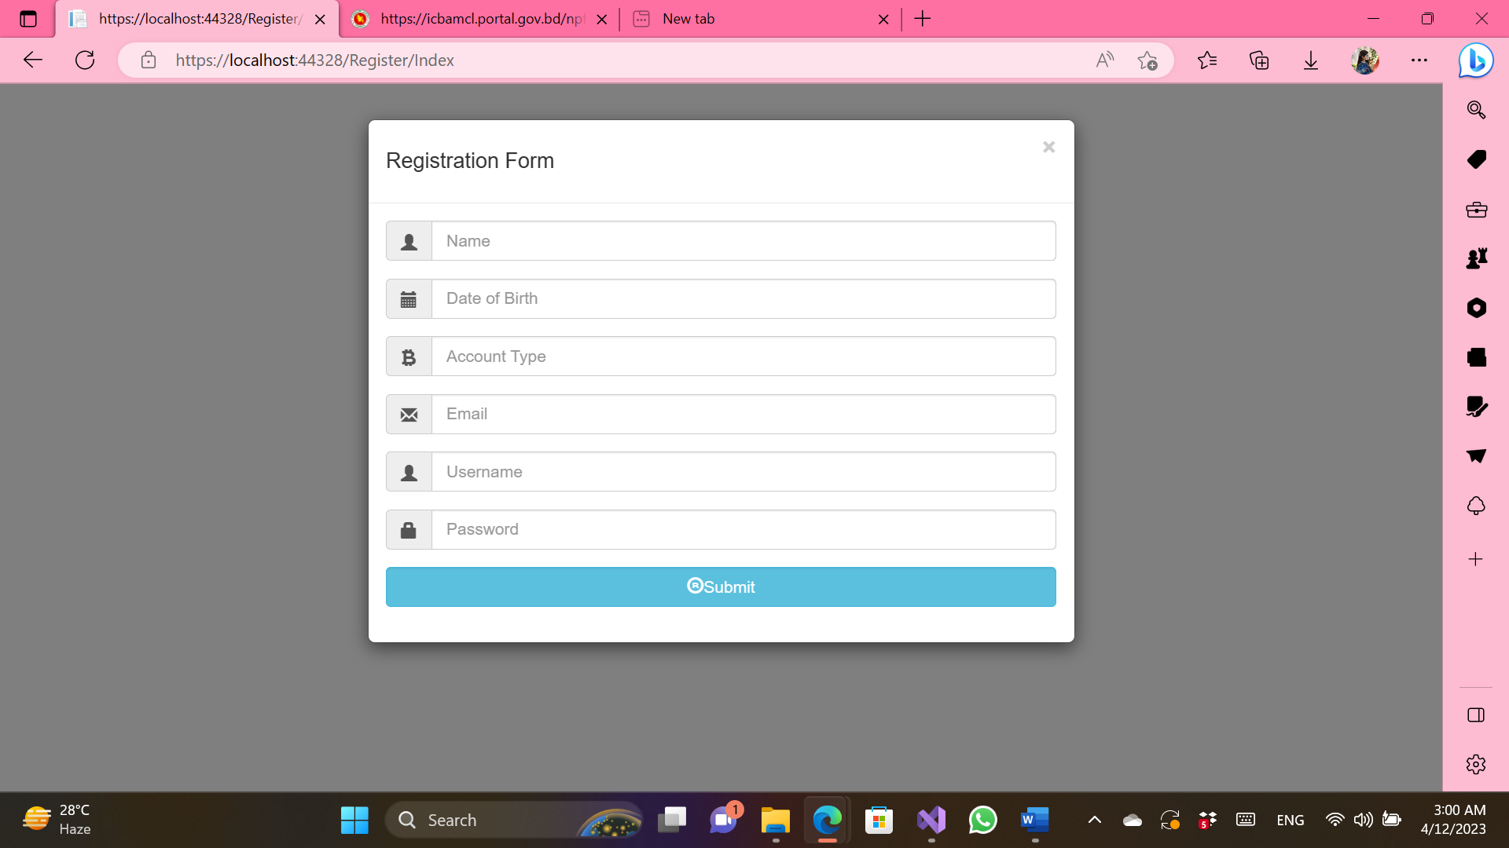

**Figure 2.2 Assigned Task-02 (Registration Page)**

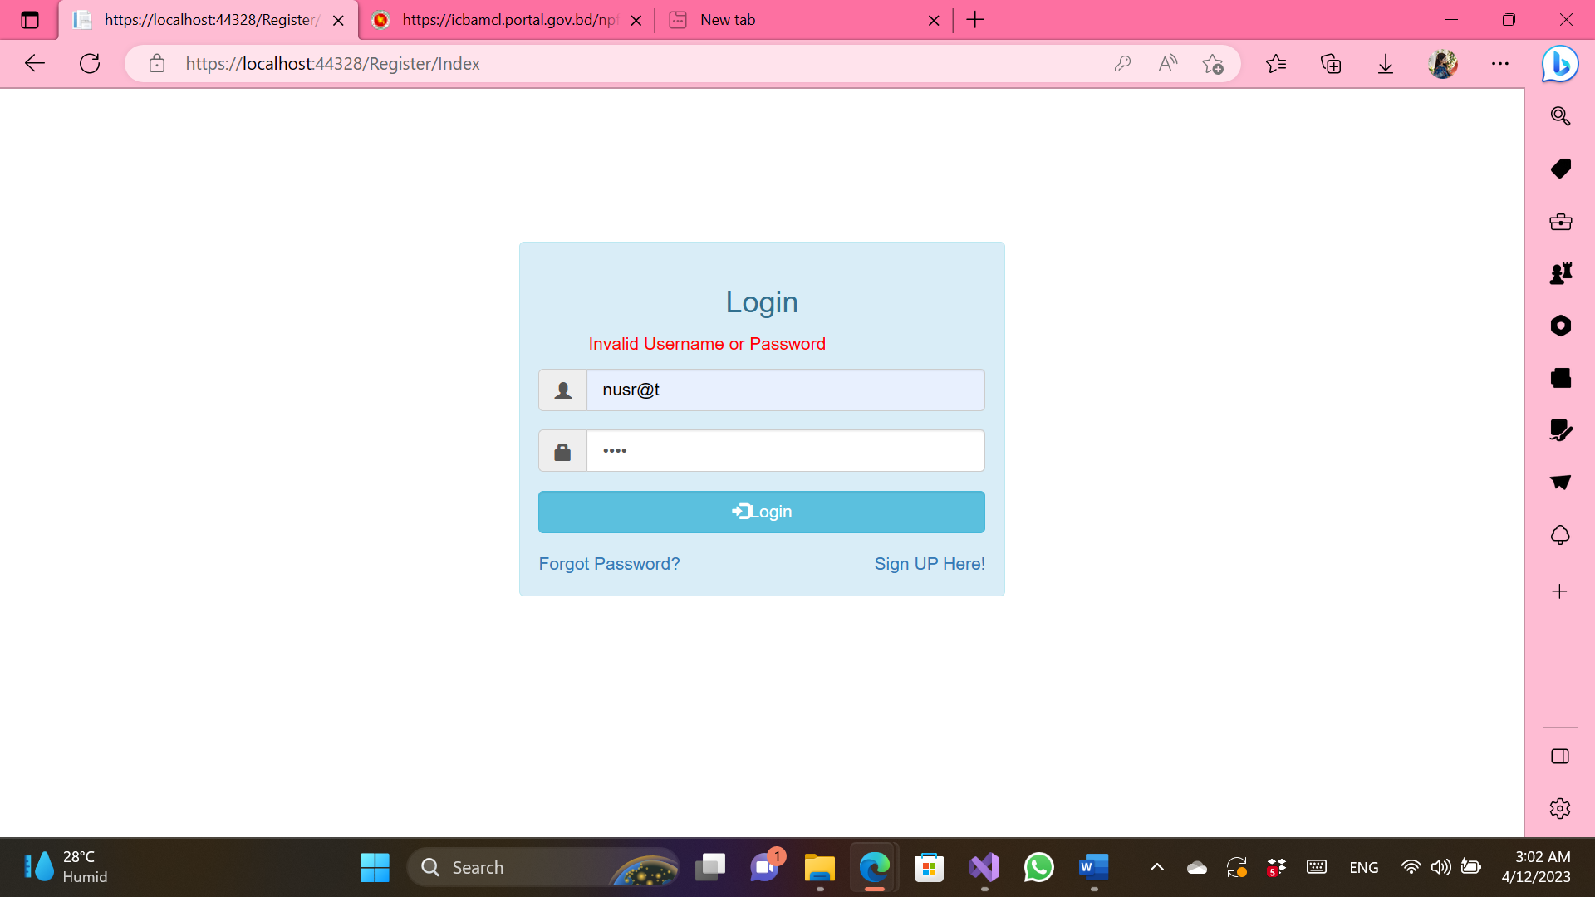

**Figure 2.3 Assigned Task-03 (Login Page)**

* 1. **System Analysis Department**

In this department, I got to know about E-Nothi which is completely a new thing to me. This has made the work process completely paperless which is really very great initiative. E-Nothi eradicates the risk of paper getting lost or misplaced. This department justifies software requirements, designs databases and then sends the designs to the programming department. Programming department then builds applications according to the designs.

* 1. **Hardware & Communication Department**

In this department, I was supervised by **Muhammad Mamunur Rashid** sir, system analyst. Sir mainly showed me the networking side. How computers are connected with data center and how they centrally manages the IP addresses, he explained me very nicely. He also showed me the data center. Another important task of this department is to arrange Zoom meetings. I was also assigned a task here. I was asked to change IP addresses in few computers of different department and I successfully completed the task.

* 1. **MIS, ICT Security & Data Admin Department**

**Muhammad Abul Khayer Azad** sir, senior system analyst, supervised me in this department. Sir gave me a overall idea of what MIS actually is. He showed me how ICB is storing data in multiple places to ensure data safety. If one place gets destroyed, then data can be retrieved from another place. Data can be uploaded in the cloud from any branch and from any branch it can be retrieved as well. That’s how this department ensures data safety.

* 1. **Innovation Cell**

**Md. Hafizur Rahman** sir, assistant programmer, supervised me in this department. He gave me the idea what innovation means. I used to think innovation is something connected with technology, but I was wrong. Innovation can be achieved without technology as well. From him I got to know few innovations that this department made. They are:

* Pension system
* Systematic Investment Plan
* E-directory
* Client’s income tax

This department accepts innovative idea from employees of all departments, then justifies if the idea is innovative or not and then finally starts the process to implement it.

* 1. **Organization-wide**

I'm engaged by Investment Corporation of Bangladesh’s IT division. Any corporation’s most important and busiest departments is this one. The network crew and system team are constantly busy. Either physically or virtually, they are working. Due to the heavy workload, office hours end at 5 pm but employees must continue working until 7 or 8 pm every day. They offer assistance with technology. Introduce new tools and software for the corporation’s operations. Therefore, this division is a crucial division of the bank.

* 1. **Other relevant activities**

I joined the office exactly on time, gave my attendance first and then went to my scheduled department everyday. I sometimes performed additional data entry work. I checked the share market as well. I made a curve of the trend of share market as well. I also did the job of organizing files by numbering them. I also helped in making the presentation slide for the recent seminar arranged by the innovation cell.

1. **CONSTRAINTS/CHALLENGES**

Issues and Problems encountered and identified during the internship affiliation with the organization/company.

* 1. Identified/Observed in the Organization: **The administration of the NCC Bank IT division team is excellent. I'm on a very organized infrastructure team at work. The workplace is wonderful and quite welcoming. However, the infrastructure lacks a lot of organization. They don't have enough IT staff, they have out-of-date machines, and they employ outdated software, all of which are bad for IT work. Their work moves slowly as a result of these issues.**
  2. Academic Preparation: Throughout my study, I engaged in a lot of activities. Current real-life examples are unique to these situations. With our extensive resources, we have discovered that the key lies in our capacity for situational adaptation and improvement work. Some concerns that we mostly examine theoretically but that we encounter in real-life work are brought up during my internship. But because I already had a theoretical understanding of those topics, it was simple for me to pick up the practical job. These university courses in operating systems, data communication, electronic devices, and computer networks are very helpful to me in my office employment. But for me to complete my work successfully, I need to learn new things. Therefore, some of the mismatches between my academic understanding and my internship experience occurred, but I made an effort to work through them.
  3. Personal/Professional Skills: Professional skills cannot be learned in a traditional classroom. At first, I had a lot of concerns about working in the real world. Going to the IT office allowed me to obtain practical knowledge of how to work in real life and how the real IT industry works because up until that point, I only had a theoretical understanding of those concepts. This experience gave me more identity and eventually enabled me to collaborate with my client and colleague. One more important skill I have developed is the capacity to communicate with others. My ability to talk more clearly. My understanding of networks, hardware, and system management expanded. Overall, the internship experience has helped me become a lot more active and self-assured.

1. **ACQUIRED KNOWLEDGE**

These are the valuable lessons/knowledge/skills/behavior/practices you have learned or acquired from your internship.

* 1. Consequences to Organization: I was completely astonished by the environment when I started my internship at NCC Bank Ltd. As a beginner, I found it confusing how all of these records were being kept track of and preserved. I did, however, regularly adjust and gain confidence. For me, adjusting to this new way of life turned out to be difficult. Although learning new things can be challenging, I believe I am capable of overcoming those obstacles. My coworkers, on the other hand, always assist me in any circumstance and teach me what I need to know about applying it to real-world work. They helped me feel confident, which is very helpful to me.
  2. Implications to University’s Internship Program: I would want to show my appreciation to the Faculty of Science & Technology for including internship credit in the undergraduate program's curriculum and giving me the ability to get a taste of industry-focused tasks and the field of work that interests me. In addition, I appreciate AIUB, the Office of Placement & Alumni, and the Faculty of Science & Technology for giving me the opportunity to arrange my internship with the business of my choice.
  3. Effects on Personal/Professional Skills: This internship had a significant impact on me. My capacity to adjust to various circumstances both personally and professionally enhanced as a result. I'm grateful that I have the opportunity to do this before beginning full-time employment with any organization. Here, I picked up skills like accepting responsibility, doing tasks on time, being punctual, working under pressure, communicating with other people, etc. My abilities have actually increased as a result of this. Additionally, I've learned how to deal with challenges, handle circumstances, and respond to various events, my technical knowledge, theoretical knowledge, and so on.

1. **CONCLUDING STATEMENTS**
   1. Summary: The internship program has greatly contributed to the growth of both my career and my skill for teamwork. In organizations, it's crucial to collaborate in teams and value the thoughts and suggestions of coworkers. I learn to recognize dangerous situations through group talks and activity sessions. I've gained experience in It support remotely servicing other branches and the other employees at our head office. Also did a lot of networking, and system troubleshooting. Learned how to fix monitor and CPU, also professional Excel. The internship program has helped me realize the differences between academic education and the workload of a professional, which is beneficial for my future career.
   2. Recommendations/Suggestions for Future Strategic Actions: As we are in the "golden age" of technological development, I would like to suggest some steps that need to be taken to guarantee a safe and secure digital banking service to the country's common people who use NCC Bank LTD's services as well as upgrade the computers and other technical tools of the bank. As one of the nation's fastest-growing banking institutions, they should also add more staff to their IT division to speed up work, improve the quality of the work, and save time.
      1. Organization: The internship program is a vital element for undergraduate students and upcoming jobs. Internships were started with huge benefits and for other reasons in order to connect moral practice with both the actual world and the classroom. Student combines their early internship with pre-internship coursework, and analytical papers after their internship program and submitted to the intern supervisor.
      2. University: I want to thank the Faculty of Science and Technology once more for giving us the chance to understand and respect the competitive situation that exists within the professional field. In many aspects, it has actually advanced my understanding of computer and website creation.
      3. Personal/Professional: Due to the internship experience, my group work skills have improved, which has been a huge assistance. I was hired by NCC Bank Limited without having any prior experience with the position. My manager went through the full process with me. After one week of training, I felt more confident. Because of the favor of the Almighty Allah and the assistance of my supervisor, I was able to comfortably complete the many responsibilities I undertook each day during my internship.
2. **RECOMMENDATION LETTER**



1. **REFERENCES**
2. [Investment_Corporation_of_Bangladesh](https://en.wikipedia.org/wiki/Investment_Corporation_of_Bangladesh)
3. [Investment Corporation of Bangladesh - Banglapedia](https://en.banglapedia.org/index.php/Investment_Corporation_of_Bangladesh)
4. <https://www.wikipedia.org/>
5. 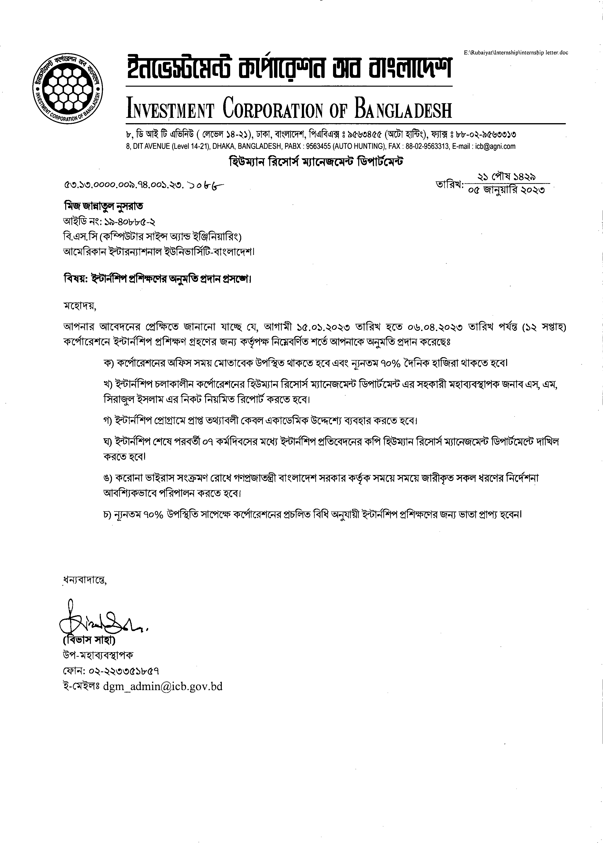**APPENDICES**