

**AMERICAN INTERNATIONAL UNIVERSITY–BANGLADESH (AIUB)**

**FACULTY OF SCIENCE & INFORMATION TECHNOLOGY**

**INTERNSHIP AFFILIATIONREPORT ON**

**Internship at**

**Polygon Technology.**

An Internship Report Presented to the

OFFICE OF PLACEMENT and

DEPARTMENT OF COMPUTER SCIENCE

In Partial Fulfillment of the Requirements for the Degree

***Bachelor of Science in Computer Science & Engineering***

**Supervised By**

**Moahimen-Bin-Noor**

**Assistant Professor**

**Submitted By**

**Ahsan, MD Fasiul**

**19-40959-2**

Semester

Date of Submission: **31 December, 2022**

# LETTER OF SUBMITTAL

I am honored to present my Internship Report, which is the partial fulfillment of the Bachelor of Science in Computer Science & Engineering requirements. I am obliged to give such an opportunity to complete my internship at American International University-Bangladesh (AIUB). In this report, I attempted to explain everything I did and experienced during my internship under the Department of IT at Polygon Technology. I was assigned to work as an Intern web developer in the department of IT. My core responsibilities included assisting core team member of development team, providing technical support, and attend on every meeting to say everyday work progress to supervisor. It was a great pleasure to work with IT team of Polygon Technology and serve them throughout my internship. My supervisor was open-minded and let me interact freely with the trainees. For the entire work days, it was a wonderful and enriching experience for me. I want to convey my sincere gratitude for allowing me to serve as an intern under their supervision. I am pleased to be a part of this internship opportunity.

I shall be highly obliged if you are kind enough to receive this report and provide your valuable judgment. It will be my enormous pleasure to find this report valuable and informative to have a clear perspective on the report.

Sincerely yours,



Md Fasiul Ahsan

Id: 19-40959-2

Program: BSc CSE

**LETTER OF ENDORSEMENT**

The Internship Affiliation Report entitled “**Internship at Polygon Technology**”, has been submitted to the Office of Placement and Department of Computer Science in partial fulfillment of the requirements for the degree of Bachelor **of Science in Computer Science & Engineering** by **Ahsan, Md Fasiul & 19-40959-2**. This report is presented to the Internship Defense Committee for evaluation and has been accepted.

(*Any opinions, suggestions made in this report are entirely that of the author of the report. The University does not condone nor reject any of these opinions or suggestion.)*

|  |  |  |
| --- | --- | --- |
|  |  |  |
| Mohaimen-Bin-Noor  *Internship Supervisor* (academic)  Assistant Professor & Special Assistant  Department of Computer Science |  | Victor Stany Rozario  External  Assistant Professor & Special Assistant  Department of Computer Science |
|  |  |  |
| Saddam Hossain Tonmoy  *Internship Supervisor* (industry)  Lead Software Engineer |  | Sofian Al Mahmood Khan  *Internship Supervisor* (industry)  In Charge, Culture & People Operation |
| Prof. Dr. Dip Nandi  Director  *Faculty of Science & Technology* |  |  |

**ACKNOWLEDGEMENT**

First of all, I would like to thank almighty Allah, for his grace in accomplishing my internship report timely.

I would like to express my gratitude to the Faculty of Science & Information Technology to keep internship credit in the curriculum of the graduation program and give me a scope of tasting the flavor of industry-oriented tasks and the field of work with my interest. I am also grateful to the Faculty of Science & Technology& Office of Placement & Alumni, AIUB to arrange an opportunity for choosing an own interested organization and complete internship there.

I am also thankful to my organization supervisor **Mr. Sofian Khan**, In Charge of Culture & People Operation, Polygon Technology Limited from the core of my heart for his kind support, guidance, constructive, supervision, instructions and advice and for motivating me to do my internship smoothly at Polygon Technology.

I feel proud and gratified that I was always held the under supervision of the Software Design & Development team and got advices directly from **Mr. Sofian Khan**, In Charge of Culture & People Operation, Polygon Technology. Here, with daily reporting along with mental and professional support enhances my experience in the internship life.

I am also indebted to the employees of SE team specially **Mr. Saddman Hossain**, Lead Software Engineer, Polygon Technology who gave me immense support while working on client-end and also in technical issues. Moreover, to prepare this report and other documentation regarding Internship Report and else I would show appreciation to all the members of IT team, who always advised me and helped me through hands and pens.

# TABLE OF CONTENTS

|  |  |
| --- | --- |
| **TOPICS** | ***Page no*.** |
| 1. **Title Page** | 1 |
| 1. **Letter of Submittal** | 2 |
| 1. **Letter of Endorsement** | 3 |
| 1. **Acknowledgement** | 4 |
| 1. **Table of Content** | 5 |
| 1. **List of Tables &Figures** | 6 |
| 1. **Introduction** | 7 |
| * 1. Rationale | 7 |
| * 1. Background | 7 |
| * 1. Objectives | 9 |
| 1. **Activities** | 10 |
| * 1. Work Load | 10 |
| * 1. Organization Wide | 11 |
| * 1. Other Relevant Activities | 11 |
| 1. **Constraints/Challenges** | 12 |
| * 1. Identified/Observed in the Organization | 12 |
| * 1. Academic Preparation | 13 |
| * 1. Personal/Professional Skills | 13 |
| 1. **Acquired Knowledge** | 14 |
| * 1. Consequences to Organization | 14 |
| * 1. Implications to University’s Internship Program | 14 |
| * 1. Effects on Personal/Professional Skills | 14 |
| 1. **Concluding Statements** | 15 |
| * 1. Summary | 15 |
| * 1. Recommendations/Suggestions for future strategic actions | 16 |
| * + 1. Organization | 16 |
| * + 1. University | 16 |
| * + 1. Personal/Professional | 16 |
| 1. **Recommendation Letters** | 17 |
| 1. **References** | 19 |
| 1. **Appendices** | 20 |

**LIST OF TABLES & FIGURES**

|  |  |
| --- | --- |
| **TITLES** | ***Page no*.** |
| * 1. **figure: Logo and overview of Polygon Technology**   2. **figure: Building of Polygon Technology Ltd.**   3. **figure: Cultural program in office** | 7  8  12 |
|  |  |
|  |  |
|  |  |
|  |  |
|  |  |
|  |  |
|  |  |
|  |  |
|  |  |
|  |  |
|  |  |
|  |  |
|  |  |
|  |  |
|  |  |
|  |  |
|  |  |
|  |  |
|  |  |
|  |  |
|  |  |
|  |  |
|  |  |
|  |  |
|  |  |
|  |  |
|  |  |
|  |  |
|  |  |

1. **INTRODUCTION**

**1.1 Rationale**

This report is important for me and anyone else who wants to work in a professional organization and collaborate with other people. During my internship, I got a chance to see things from a different point of view. This will be taken into account in the report. The internship report shows what a student learned in their internship program over the course of three months. A student puts what they learned as an undergraduate to use during an internship. A student's supervisor can know a lot about the student's job while the teacher is reading the internship reports. I'm excited to work on this report because it will help people understand what I can do. This internship report will help me learn more about what I have learned at my company and during my internship program. This report will show me where I need to be more creative and unique. I will be aware of my strengths and weaknesses, as well as those of others, and work to make them better. So, future students could use this report as a starting point to learn about and try out things related to teaching support.

**1.2 Background**

Polygon Technology is a Technology development and Business solution provider that covers all areas of the industries. The company is focused in both Private and Public sector of the countries’ ever-growing high-tech application requirements and Enovation needs. PolygonTech (Polygon Technology) has an experience in the industry for the last twelve (12) years.



Figure 1.1: Logo and overview of Polygon Technology

The company’s mission is lots of years of experience with different Bangladesh Start-ups has helped us understand one’s frustration of not getting the right help.

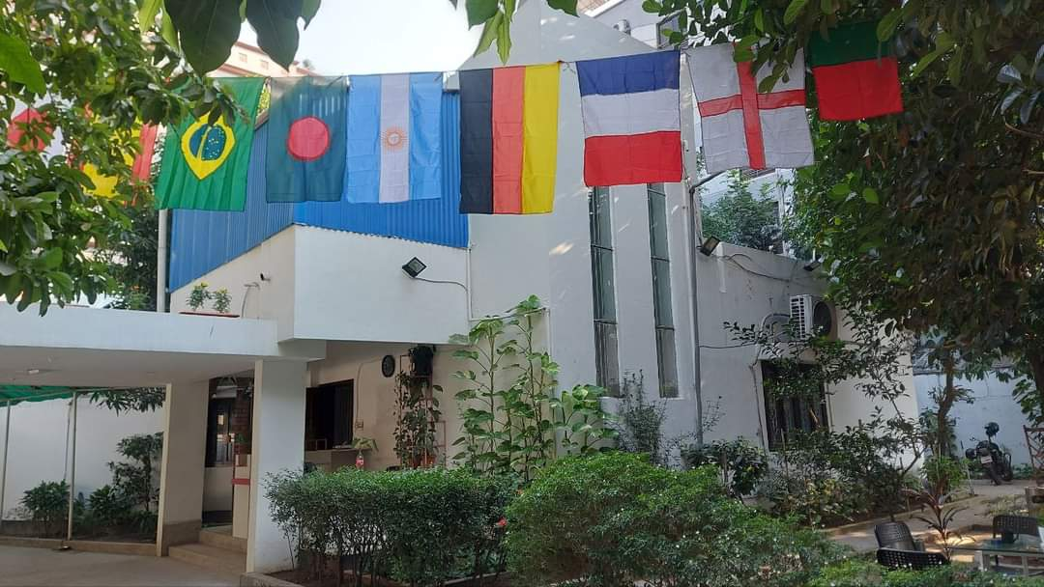

Figure 1.2: “Office Building” of Polygon Technology Ltd.

We are aimed to help anyone and everyone in a timely & efficient manner. PolygonTech is working and collaborating with several organizations in the country, we have a very strong relationship with the Government of Bangladesh and both International and local Non-Governmental Organization (NGO’s) that are operating in Bangladesh. As a Technology development and Business solution provider we assist and help prominent institutions and company businesses to grow and achieved their goals. We provide a highly innovative market based best practices technology platform to our valued clients in order to deliver optimum productivity and automation to their business processes. Since the dawn of technological advancement and innovation PolygonTech has proven it’s worth and capability in delivering world’s best practice business automation that acts as a building block towards a successful execution of business functions and the implementation of the re-engineering of the client’s organization. We specialized in delivering Technological solution in several branches of the government institutions with the application of Artificial Intelligence, Software Quality Testing, Product Consultancy, Business Vaccine, Software Development, Mobile Applications and Mobile Banking. Our strengths are based on the principles of research and development, adopting new technologies, applying industry best practices and listening to the needs of our values client as well as taking their invaluable feedback.

**1.3 Objectives**

An internship is mostly for undergraduate students who want to taste the industrial sector's working environment and those who wish to study and acquire additional expertise in specific fields. An internship's purpose is to prepare a student for future career goals. An internship is required to earn a Bachelor of Science in Computer Science degree from American International University-Bangladesh (AIUB). I completed an internship with the Polygon Technology as an internship student in Fall 2022-2023.This company is good at innovation and research. As a result, I can confidently state that finishing an internship at such a facility is an excellent opportunity for me. I applied for the internship as an internship student in order to-

* get knowledge about the efficient development technique
* gain knowledge about the intern course included
* get professional experience in the industry as an entry-level employee
* get an understanding of professionalism

1. **ACTIVITIES**

A task plan defining the intern's responsibilities is required for completion of an internship program. The regularity and maturity with which a teacher organizes instructional assignments show the instructor's comprehension of their role. Through the internship program, interns learn how systems function and what is required to manage them effectively.

**2.1 Work-Related**

I was complete my internship as a trainee developer in the IT department of Polygon Technology. Where my duty was weekly three days, Sunday, Tuesday and sometimes Thursday. My work time was sharp 10 am to 4 pm on working days. I attend and started work under my supervisor was **Mr. Sofian Khan**.

The objectives of the internship are to:

* Discuss the growing relevance of Web technology and how it is transforming the IT department's job.
* Learn what strategic web development is and how to use a framework to find strategic Internet usage. Compare the many sorts of web technologies and how they can be leveraged to help its bottom line.
* Investigate new technology and topics that affect web development. Analyze the role of web technologies in companies using a web development strategy.
* Examine the skills that web development professionals require.
* Create web applications that are relevant to real life and society.
* Attended Meetings and getting ideas on how to communicate with clients.
* Testing some application as an end user.

The theoretical components I learn from documentation of the language server and various resources, also my supervisor help me to understood everything regarding the internship curriculum. They give me a curriculum which I have to complete at very first to strong my knowledge about language and basic data structure, algorithm, html, CSS, JavaScript, Software quality testing. I have to make new designs regarding software, meeting with clients, testing some software and practice project which are evaluated by my internship supervisor.

My primary responsibility in work, I have to come work exact time, learn punctuality and attend morning session meetings. After that I have to describe to my supervisor about everything what I do.

After that give progress note to my supervisor. Sometimes I have to go our honorable MD sir room, where he gives us description about work and motivate us.

**2.2 Organization-wide**

I worked as a trainee web developer at the department of IT on the company, the department of IT at PolygonTech is dedicated to providing international standard industry level and research-oriented website and service. I was the helping hand of this core lab team. I effort to make a good design and make good communication among lab team. I also make some illustration design for their project and testing. I was testing their new implemented features. If I found bug, I was informed them to fix it.

**2.3 Other Relevant Activities**

As a trainee developer, I worked with a new coworker, performed lab work, and developed time management skills. I also interacted often with various teams on several levels. My internship teammates were kind and informed me that I could communicate with the core lab team anytime I want. They provided me with constructive criticism to assist me enhance my public speaking and showing abilities. This has been a fantastic and beneficial method of education for me. As a developer trainee, I discovered how to adjust to the company's laws and regulations, interact with my superiors, comprehend my task, and assist them based on my issues. My supervisor was always open-minded, kind, and helpful; thus, I never had any issues throughout my time in the sector. I am better at managing my time, communicating with others, being a leader, settling issues, and ensuring that everything runs well. As the trainee's primary point of contact, I have focused on refining my abilities, communicating through email, and conversing with my supervisor and the administration. On the other side, the workplace climate is quite amicable, with coworkers often organizing cultural events so that staff never feel forced to work.

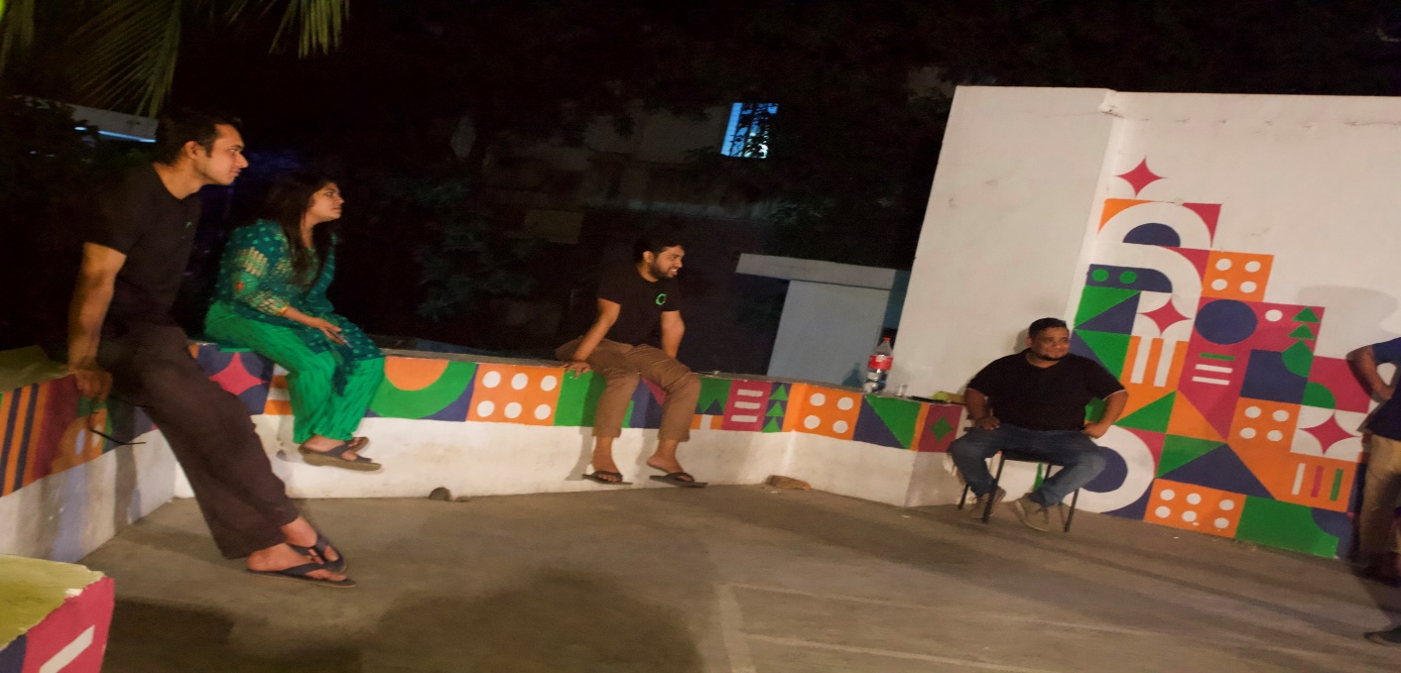

Figure 1.3: Cultural program in office

1. **CONSTRAINTS/CHALLENGES**

All of the jobs are challenging. Accepting hurdles and applying themselves to their line of work might help someone achieve their goals. As a trainee developer at PolygonTech, I faced numerous significant challenges, which I attempted to overcome as precisely as possible.

**3.1 Identified/Observed in The Organization**

The Polygon Technology is located in the heart of excellence. This group promotes the development of new ideas, abilities, and life-changing experiences. PolygonTech’s mission has always been to gratify the curiosity of trainee who want a wider range of learning and new challenges in their trainee life. Interns are prepared to be leaders in their fields through training and development. The development stage is characterized by the transformation of trainees into active participants in both industry and extracurricular activities. It is known for being a forerunner in the pursuit of excellence and high-quality goods and services, which it has achieved and maintained. Interns benefit the most from the company's resources and services since they have the most to gain. The company’s founders' commitment to innovation and creativity and a diverse administration, professional instructors, and well-trained support staff have assured that the school remains a catalyst for change and the development of leaders in a variety of sectors.

**3.2 Academic Preparation**

The internship experience allowed me to enhance my skills. Now I can claim that I was able to increase my abilities, if only somewhat. This internship was beneficial to me since I am committed to obtaining a degree in technology and will be industry-ready with this knowledge. I must remark that this internship was advantageous to me. Because I am a student of computer science, the duty post topic I was assigned during my internship was likewise in the applied scientific sector. I used to be assigned as a web developer or a Software quality tester, skills that I acquired in college. It was one of the most crucial classes I took for my degree. I understood all there was to know about this topic, even how difficult it was for students to understand. As a consequence, I was faced with various challenges, but I was able to overcome them thanks to my industrial training. In contrast, industrial life has proved to be a rigorous and unique experience. For me, it had been an unusual scenario. Therefore, whenever I began a new focused endeavor, I had to mentally prepare myself to adjust and discover how to unwind. If I do not comprehend the assignment, it is hard for me to unravel anything, but my supervisor is always prepared to assist me. Otherwise, it is challenging to comprehend. Following that, my academic understanding substantially increased my adaptability.

**3.3 Personal/Professional Skills**

I finished my "Web Technologies" course about six months ago, and my "Advance Web Technology" and "Software Quality and Testing" course just finished. I had no experience prior to my internship following the conclusion of the course. During the first few months of my internship, I had to deal with a challenging scenario in order to gain the experience. I've been having some problems because I don't know some crucial things that I need to know in order to progress. prior to that, internship My education was minimal, and I had no idea how to handle any situation. Prior to my internship, I had no prior industry experience. However, as a result of my internship, I now have a comprehensive understanding of what it takes to be a competent employee. Patience and consistency are important in the profession. Additionally, solid communication skills with all team members are required. I consider myself successful because, with the help of my intern supervisor, I was able to provide practical assistance to a senior who needed it. As a result of this internship, I was able to develop a pleasant personality in my thinking.

1. **ACQUIRED KNOWLEDGE**

**4.1 Consequences of Organization**

I can honestly state that my internship at Polygon Technology as a trainee developer in the IT department was a fantastic learning and personal experience for me. My enthusiasm for this three-month internship program has grown since the first day. I am convinced that it will assist me in landing a job as a frontend developer in the future. Everything, especially in this case, is tough to quantify and express precisely in the little time I have throughout my internship term. It is, however, an incredible opportunity for me to learn more about the fascinating field of development. I have done everything possible to include all of the necessary information in my report. During my internship, I studied professional techniques and acquired expertise. During my internship, I learned about a number of important elements that my training supervisor discussed with me.

**4.2 Implications to university's Internship**

I'd like to thank the Faculty of Science and Technology (FST) for including internship credit in my graduate degree and giving me the opportunity to try out teaching-related activities and fields of employment. I am also grateful to the Office of Placement & Alumni (OPA) for allowing me to attend my preferred company. An internship at Polygon Technology is an excellent way to gain experience and knowledge. This internship will aid those students in their job search. They will be able to choose their career path with foresight. The internship program of Polygon Technology should be improved. As a result, they are able to capture the interest of students.

**4.3 Effects on Personal/Professional Skills**

Each student must complete an internship as part of the academic curriculum to be considered a graduate of the Faculty of Science and Technology's Computer Science & Engineering (CSE) program. In addition, as a Computer Science student, I did the Internship that was needed as part of my program. I was engaged as a trainee developer under the supervision of a supervisor. As a trainee, I was assigned to the web developer. I can't say the Internship didn't teach me something. I've picked up a number of new talents that I believe will help me progress in my job. I've honed a diverse set of soft skills. I've learnt how to communicate, be punctual, and solve problems from the standpoint of a miner. The following are the talents I have gained as a result of this internship program:

• Moral ethics

• Punctuality

• Time Management

• End-to-end communication

• Positivity

• Active listening

• Openness to feedback

• Working under time constraints

1. **CONCLUDING STATEMENTS**
   1. **Summary**

The Department of Computer Science at American International University-Bangladesh is dedicated to offering an education that matches international standards for undergraduate and graduate students. Each faculty member holds the highest level of qualification, ensuring that students receive the best possible education and expertise. The American International University-Bangladesh (AIUB) is dedicated to carrying out activities that help humanity, such as research and application projects. This university's internship credit was really beneficial to my career; I was able to learn how to operate in the industry for this program. And because Polygon Technology is a firm who works a lot of international clients, I wouldn't be able to learn as much if I couldn't complete the internship program here. Working with the members of this amazing organization has taught me a lot of valuable skills that I will use in my future work.

**5.2 Recommendations/Suggestions**

I can now appreciate how beneficial this internship has been for me personally and professionally. There is room for development, such as providing trainees with more opportunities to work on actual projects, and there is a need for greater professionalism, such as providing trainees with a detailed worksheet outlining the tasks expected of them. There is a demand for premium courses or trainings that provide trainees with a deeper understanding of their respective fields.

**5.2.1 Organization**

Polygon Technology offers its interns an extraordinary chance for their future careers. Undoubtedly, this is a world-class internship program. Even in the midst of a pandemic, they continue to accept interns. After completing my internship at a single office, I am now equipped to manage the pandemic issue. At a pandemic, if a person becomes sick, they are able to assist them much, and they always pay on time during this period. If I overlook anything, my supervisor and senior programmer may assist me in resolving this issue. This experience, though, would be more realistic. This is the finest chance for my career.

**5.2.2 University**

American International University-Bangladesh must provide a virtual session on internship opportunities (AIUB). Students who have finished or are currently undertaking internships at corporations or colleges should be surveyed by our institution's administration about internship training. This information might be utilized by the university to determine whether or not students are learning important things as a consequence of the internship program, and if so, what further they should be taught.

**5.2.3 Personal/Professional**

I hope that the internship will aid in my personal development and have a big influence on my career. My communication, writing, analytical, time management, and self-management abilities have all increased. Nonetheless, I feel that our university administration might be far more successful in a number of areas. Throughout the internship program, all interns should be supervised and monitored concurrently. Permitting interns to attend additional courses to enhance their communication and time management skills.

1. **RECOMMENDATION LETTER**

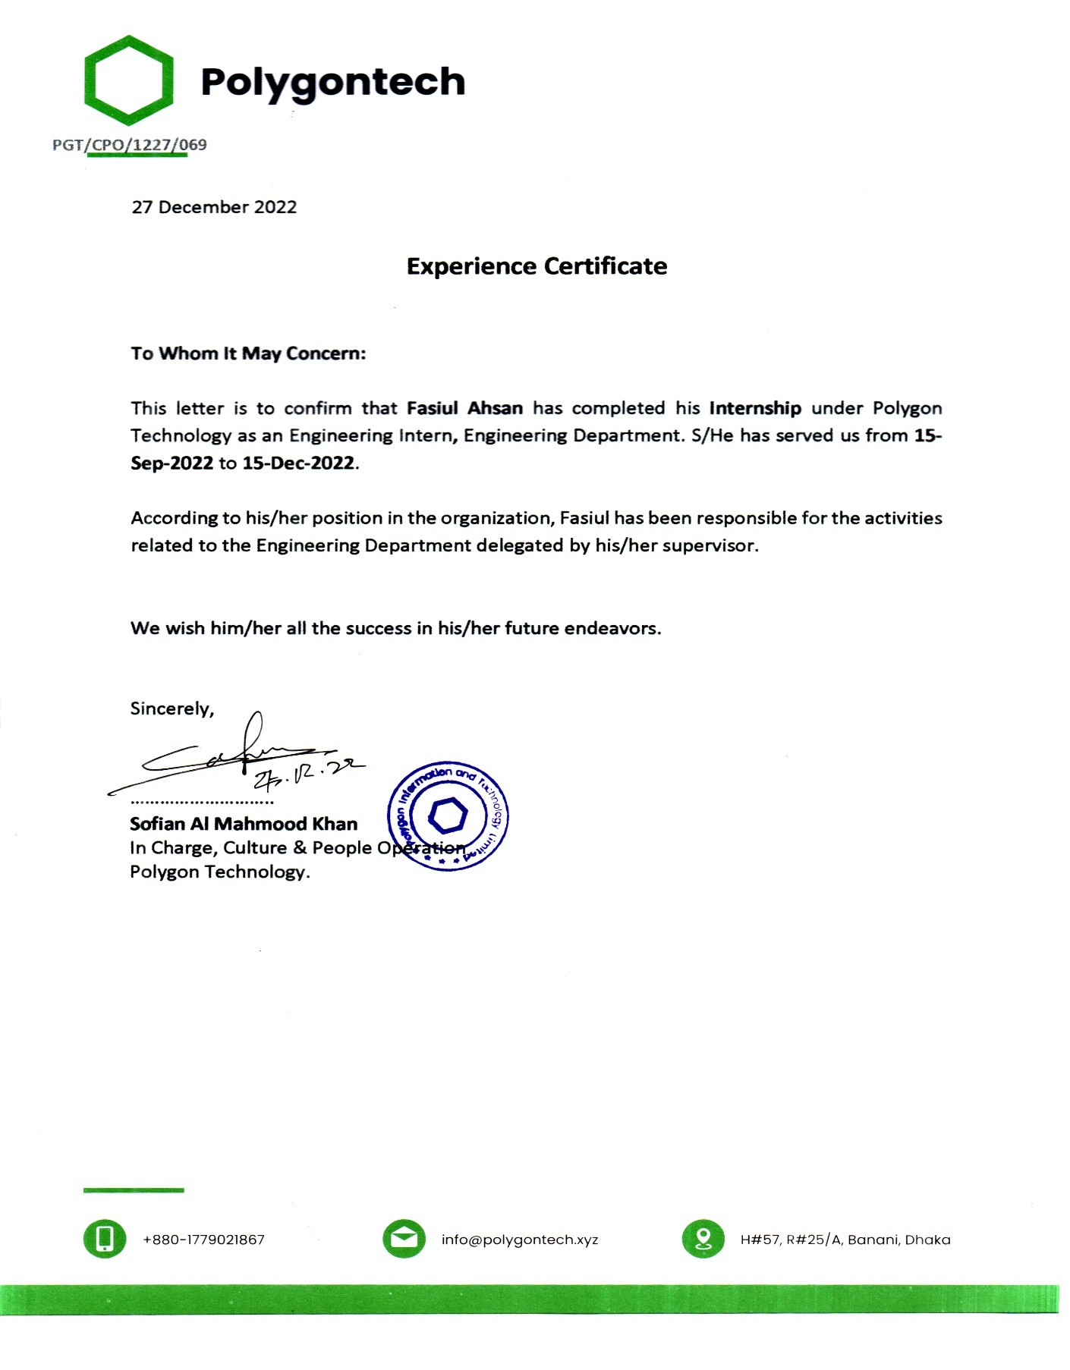

**APPOINTMENT LETTER**

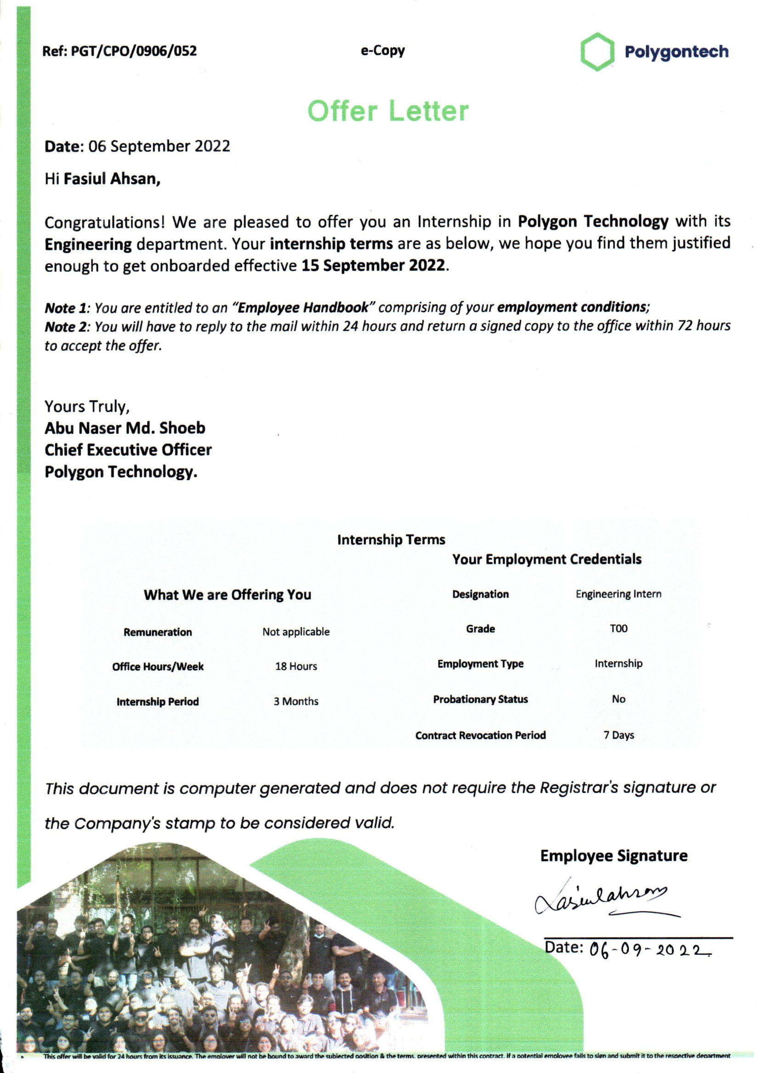

1. **REFERENCES**
2. “Polygon Technology”, Polygon Information and Technology Limited. Available: [ https://polygontech.xyz/]
3. A. I. U. B. S. D. D. (itsd.aiub.edu), *American International University-Bangladesh (AIUB)*. [Online]. Available: https://www.aiub.edu/faculties/fst/ug-course-catalog.
4. A. I. U. B. S. D. D. (itsd.aiub.edu), *American International University-Bangladesh (AIUB)*. [Online]. Available: https://www.aiub.edu/about/information.
5. **APPENDICES**

**Md Fasiul Ahsan**

Junior Software Developer

Dhaka, Bangladesh

Email: [fasiulahsan1997@gmail.com](mailto:fasiulahsan1997@gmail.com)

Phone: 01672297104

GitHub: <https://github.com/FasiulAhsan>

**Skills:**

Expertise: HTML, CSS, Bootstrap, React, Laravel

Comfortable: SQL, Nodejs.

Tools: Vscode, Postman, Chrome dev-tool, GitHub

Familiar with: OOP concepts, C++, Java, PHP

**Project:**

1. **Doctors Portal (PHP, JavaScript, MySQL)**

Doctor can login, patient can login, doctor can see patient list who are waiting for prescription

Patient can book doctors

Doctor can give prescription, see prescribed patient, see total list of patient report who are prescribed.

Can see doctors and their activeness.

**2. Tourism Management (React, Laravel, MySQL**)

Tourist agency, Traveler can Login, Registration

Tourist agency, Traveler can update their profile.

Dashboard for Tourist agency.

Add Tour Packages Details

**Educational Information**

**AMERICAN INTERNATION UNIVERSITY- BANGLADESH** *2018-2022*

BSc in computer science and engineering

* GPA: 3.37 on a scale of 4.00

**Dhanmondi Ideal College,**

*2016-2017*

HSC

* GPA: 4.17 on a scale of 5.00

**KACHUA GOVT. PILOT HIGH SCHOOL**  *2014-2015*

SSC

* GPA: 4.67 on a scale of 5.00

# Reference

**Name: Dr. Dip Nandi.**

Designation: Assistant Professor& Director, Faculty of science and Technology.

Institution: American International University- Bangladesh (AIUB).

Email: dip.nandi@aiub.edu

**Name: DR. MUHAMMAD FIROZ MRIDHA**

Designation: Faculty of science and Technology.

Institution: American International University Bangladesh (AIUB).

Email: firoz.mridha@aiub.edu

**Name: SAZZAD HOSSAIN**

Designation: Faculty of science and Technology.

Institution: American International University Bangladesh (AIUB).

Email: sazzad@aiub.edu