- Name: Shobhana Bathina
- Candidate ID: BS/REG/120846
- Domain: Python Developer Intern
TASK-1:
Understand Python file handling, automation logic, and exception handling.
CODE:
# File Automation System using Python
# Import required modules
import os
import shutil
import csv
# Function to create and write into a text file

def write_text_file():
try:
# Open file in write mode
file = open("sample.txt", "w")

# Write content into file
file.write("Hello Student!\n")
file.write("This is Python File Handling Project.")

# Close file
file.close()

print("Text file created successfully.")

except Exception as e:
print("Error while writing text file:", e)

# Function to read text file
def read_text_file():
try:
# Open file in read mode
file = open("sample.txt", "r")

# Read content
content = file.read()

# Print content
print("\nFile Content:")
print(content)

# Close file
file.close()

except FileNotFoundError:
print("File not found.")

except Exception as e:
print("Error while reading file:", e)
# Function to write CSV file

def write_csv_file():
try:
# Open CSV file
with open("students.csv", "w", newline="") as csvfile:

# Create CSV writer object
writer = csv.writer(csvfile)

# Write headings
writer.writerow(["ID", "Name", "Course"])

# Write student data
writer.writerow([1, "Rahul", "CSE"])
writer.writerow([2, "Anjali", "ECE"])

print("CSV file created successfully.")

except Exception as e:
print("Error while writing CSV:", e)
# Function to read CSV file

def read_csv_file():
try:
with open("students.csv", "r") as csvfile:

# Read CSV file
reader = csv.reader(csvfile)

print("\nCSV File Content:")

# Print rows one by one
for row in reader:
print(row)

except FileNotFoundError:
print("CSV file not found.")

except Exception as e:
print("Error while reading CSV:", e)

# Function to rename a file

def rename_file():
try:
# Rename sample.txt to new_sample.txt
os.rename("sample.txt", "new_sample.txt")

print("File renamed successfully.")

except FileNotFoundError:
print("File not found for renaming.")

except Exception as e:
print("Error while renaming file:", e)

# Function to move file into another folder

def move_file():
try:
# Create folder if not exists
if not os.path.exists("Backup"):
os.mkdir("Backup")

# Move file to Backup folder
shutil.move("new_sample.txt", "Backup/new_sample.txt")

print("File moved successfully.")

except FileNotFoundError:
print("File not found for moving.")

except Exception as e:
print("Error while moving file:", e)

# Function to delete file

def delete_file():
try:
# Delete CSV file
os.remove("students.csv")

print("CSV file deleted successfully.")

except FileNotFoundError:
print("File not found for deletion.")

except Exception as e:
print("Error while deleting file:", e)

# Main Program

print("===== File Automation System =====")

write_text_file()
read_text_file()

write_csv_file()
read_csv_file()

rename_file()
move_file()

delete_file()

print("\nAll operations completed.")

OUTPUT:
===== File Automation System =====
Text file created successfully.

File Content:
Hello Student!
This is Python File Handling Project.
CSV file created successfully.

CSV File Content:
['ID', 'Name', 'Course']
['1', 'Rahul', 'CSE']
['2', 'Anjali', 'ECE']
File renamed successfully.
File moved successfully.
CSV file deleted successfully.
All operations completed.

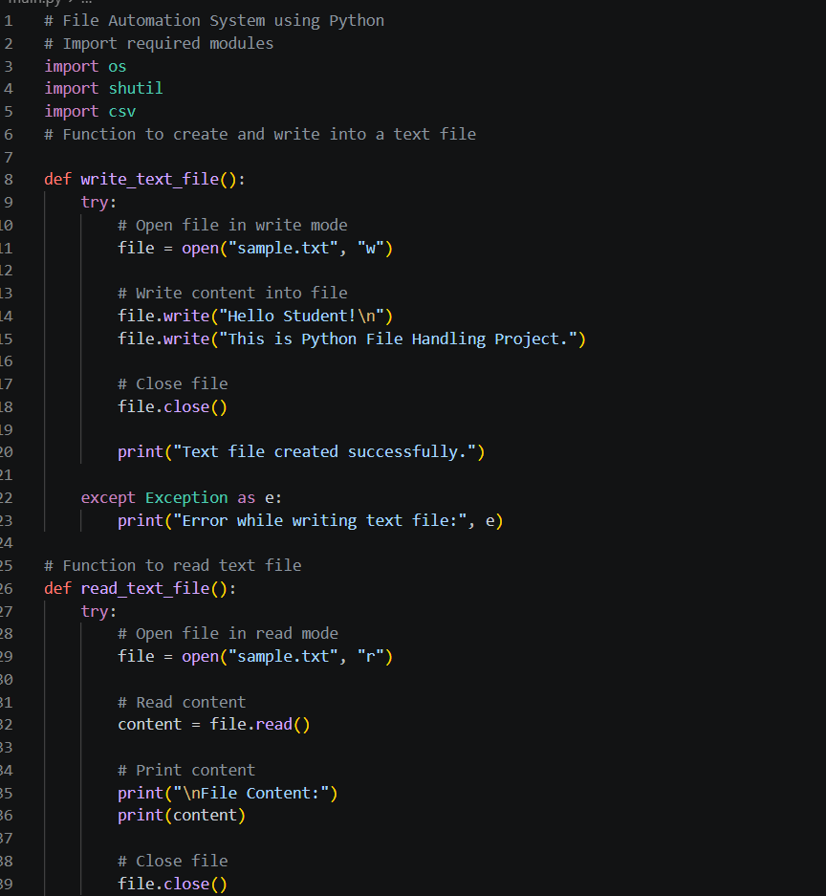
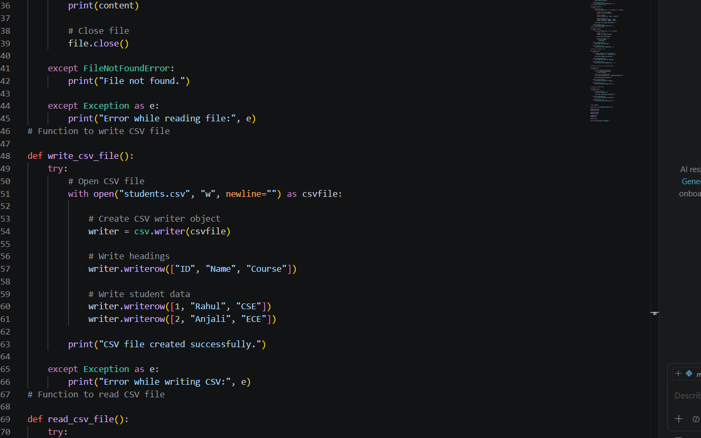

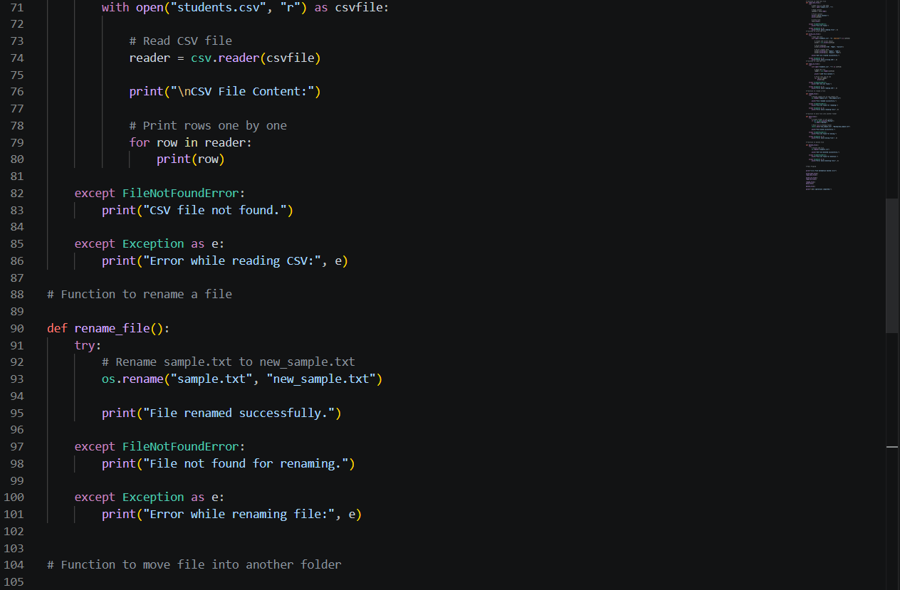
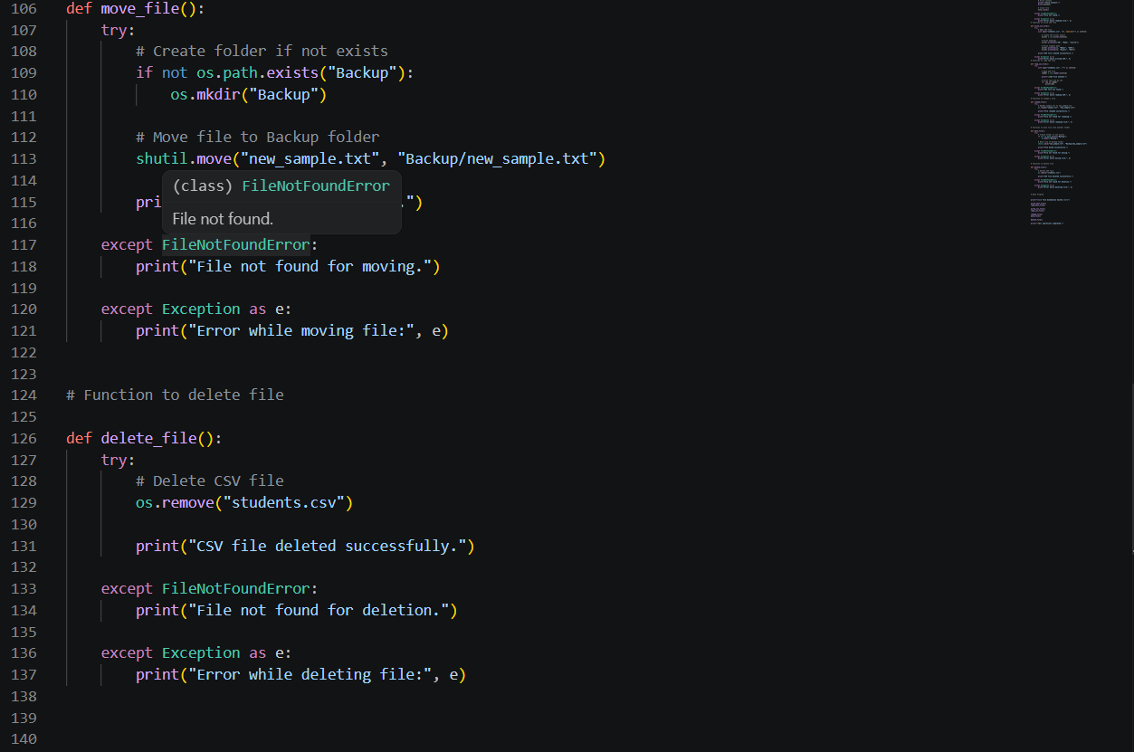
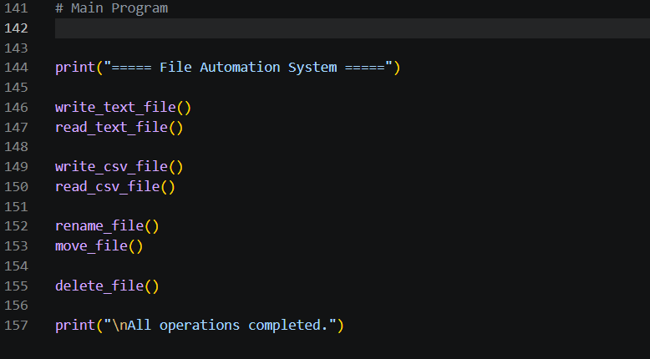
OUTPUT:
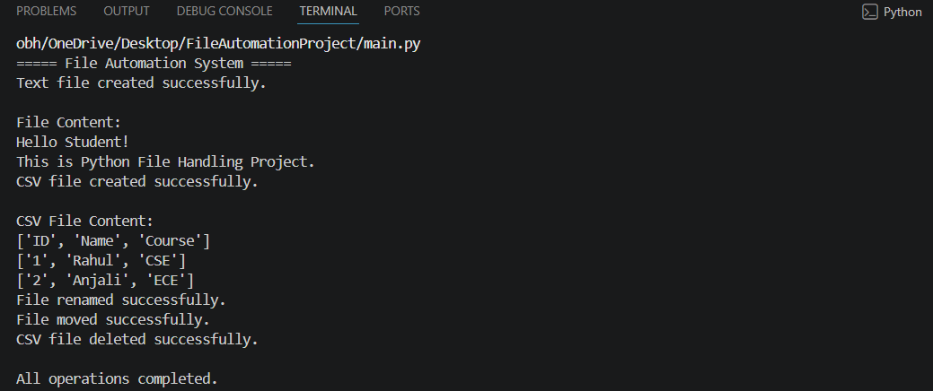
FILES CREATED:
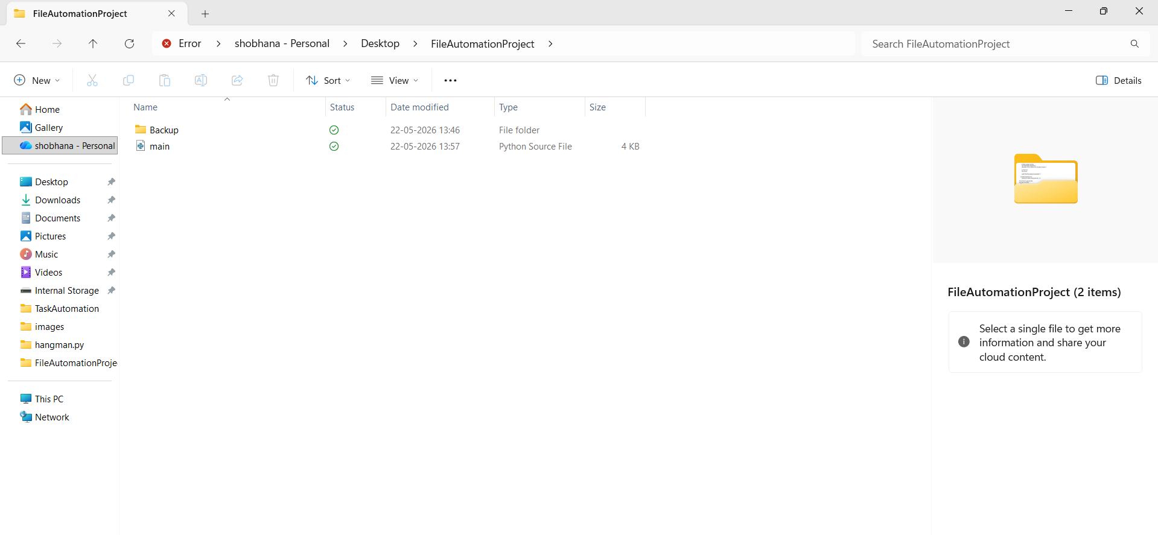

Code Snippet 1 – Writing Data into a Text File
# Open text file in write mode
file = open("sample.txt", "w")
# Writing data into file
file.write("Hello Student!\n")
file.write("This is Python File Handling Project.")
# Closing file
file.close()
This part of the code creates a text file named sample.txt and writes some data into it.
Code Snippet 2 – Reading Data from Text File
# Open file in read mode
file = open("sample.txt", "r")
# Read complete content
content = file.read()
# Display file content
print(content)
# Close file
file.close()
This code is used to read the content from the text file and display it on the screen.
Code Snippet 3 – Writing Data into CSV File
with open("students.csv", "w", newline="") as csvfile:
writer = csv.writer(csvfile)
# Writing column headings
writer.writerow(["ID", "Name", "Course"])
# Writing student records
writer.writerow([1, "Rahul", "CSE"])
writer.writerow([2, "Anjali", "ECE"])
This snippet creates a CSV file and stores student information in tabular format.
Code Snippet 4 – Reading CSV File
with open("students.csv", "r") as csvfile:
reader = csv.reader(csvfile)
for row in reader:
print(row)
This part reads the CSV file row by row and prints the stored data.
Code Snippet 5 – Renaming a File
# Rename existing file
os.rename("sample.txt", "new_sample.txt")
This code changes the file name from sample.txt to new_sample.txt.

Code Snippet 6 – Moving File to Backup Folder
# Create Backup folder if it doesn't exist
if not os.path.exists("Backup"):
os.mkdir("Backup")
# Move file into Backup folder
shutil.move("new_sample.txt", "Backup/new_sample.txt")
This snippet creates a folder named Backup and moves the file into that folder.
Code Snippet 7 – Deleting a File
# Delete CSV file
os.remove("students.csv")
This code removes the CSV file from the system after execution.
Code Snippet 8 – Exception Handling
try:
file = open("sample.txt", "r")
except FileNotFoundError:
print("File not found.")

Hosted link: https://gist.github.com/shobhanabathina/1cdb9e5aefd49345668d630a8ca5008e

Github repo link: https://github.com/shobhanabathina/Alfido_tech-python.git

