**Topics: Descriptive Statistics and Probability**

1. Look at the data given below. Plot the data, find the outliers and find out $μ, σ, σ^{2}$

|  |  |
| --- | --- |
| **Name of company** | **Measure X** |
| Allied Signal | 24.23% |
| Bankers Trust | 25.53% |
| General Mills | 25.41% |
| ITT Industries | 24.14% |
| J.P.Morgan & Co. | 29.62% |
| Lehman Brothers | 28.25% |
| Marriott | 25.81% |
| MCI | 24.39% |
| Merrill Lynch | 40.26% |
| Microsoft | 32.95% |
| Morgan Stanley | 91.36% |
| Sun Microsystems | 25.99% |
| Travelers | 39.42% |
| US Airways | 26.71% |
| Warner-Lambert | 35.00% |

Ans: A)Mean = 33.27%

Variance=0.0287%

Std – 16.95%

Outliers= Morgan Stanley(91.36%)

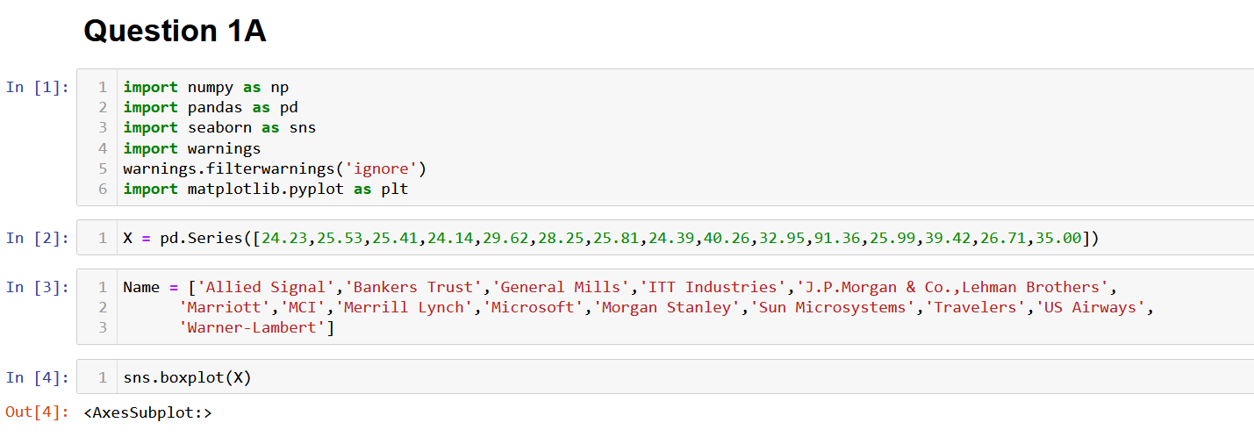

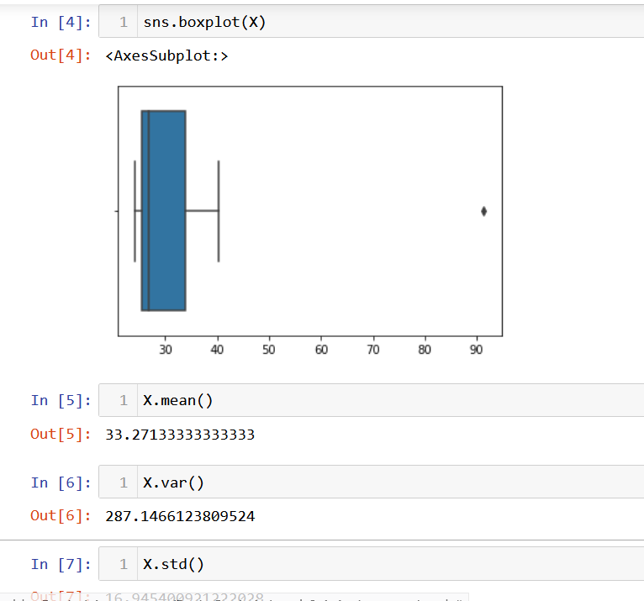



Answer the following three questions based on the box-plot above.

1. What is inter-quartile range of this dataset? (please approximate the numbers) In one line, explain what this value implies.

**Ans**: The inter-quartile range is the difference between the 75th percentile of the data & 25th

of the data & the middle of the data lies in this range.

1. What can we say about the skewness of this dataset?

**Ans**: Positively Skewed.

1. If it was found that the data point with the value 25 is actually 2.5, how would the new box-plot be affected?

**Ans**: There wont to be the any outliers in the data anymore,& 25th,50th &75th percentiles move slightly to the left



Answer the following three questions based on the histogram above.

1. Where would the mode of this dataset lie?

**Ans**: 4 & 8.

1. Comment on the skewness of the dataset.

**Ans**: Positively Skewed

1. Suppose that the above histogram and the box-plot in question 2 are plotted for the same dataset. Explain how these graphs complement each other in providing information about any dataset.

**Ans**: They both are right-skewed & both have outliers the median can be easily visualized in the boxplot where as in histogram mode is more visible.

1. AT&T was running commercials in 1990 aimed at luring back customers who had switched to one of the other long-distance phone service providers. One such commercial shows a businessman trying to reach Phoenix and mistakenly getting Fiji, where a half-naked native on a beach responds incomprehensibly in Polynesian. When asked about this advertisement, AT&T admitted that the portrayed incident did not actually take place but added that this was an enactment of something that “could happen.” Suppose that one in 200 long-distance telephone calls is misdirected. What is the probability that at least one in five attempted telephone calls reaches the wrong number? (Assume independence of attempts.)

**Ans**: p_x=probability of exactly x calls getting misdirected =5Cx*(p^x)*(q^(5-x))

P=probability of a call getting misdirected=1/200

q=probability of a call not getting misdirected=199/200

probability of at least one call misdirected =p_1+p_2+p_3+p_4+p_5

=1-p_0

=1-5CO*(p^0)*(q^5)

=0.0248=2.48%

1. Returns on a certain business venture, to the nearest $1,000, are known to follow the following probability distribution

|  |  |
| --- | --- |
| x | P(x) |
| -2,000 | 0.1 |
| -1,000 | 0.1 |
| 0 | 0.2 |
| 1000 | 0.2 |
| 2000 | 0.3 |
| 3000 | 0.1 |

1. What is the most likely monetary outcome of the business venture?

**Ans**: The most likely monetary outcome of the business venture is 2000$ as for 2000$ the probability is 0.3 which is maximum as compared to others.

1. Is the venture likely to be successful? Explain

**Ans**: Yes. The probability that the venture will make more than 0 or a profit p(x>0)+p(x>1000)+p(x>2000)+p(x>3000) = 0.2+0.2+0.3+0.1 = 0.8,this states that there is a good 80% chances for this venture to be making a profit.

1. What is the long-term average earning of business ventures of this kind? Explain

**Ans**: The long -term avg is Expected value = sum(x*p(x)=800$ which means on an avg the returns will be +800$ The long -term avg is Expected value = sum(x*p(x)=800$ which means on an avg the returns will be +800$.

1. What is the good measure of the risk involved in a venture of this kind? Compute this measure

**Ans**: The good measure of the risk involved in a venture of this kind depends on the variability in the distribution. The higher variance more chance of risk vae(x) = E(x^2)-(E(x))^2=2800000-800^2=2160000