ESG Decoded · Analyst Series
ESG Decoded
One company, one deep read : environment, social & governance performance analyzed the way a research analyst reads it, not the way a press release writes it.
Infosys Limited
NSE: INFY · BSE: 500209 · IT Services & Consulting
ISSUE NO. 01 | FY 2024–25 FULL ANALYST REPORT

📋 Executive Summary
Infosys continues to demonstrate strong ESG performance, driven by mature governance practices, transparent reporting, and ambitious climate commitments. Environmental progress is supported by sustained renewable-energy adoption and six years of carbon-neutral operations, while governance remains the strongest pillar on the back of independent board oversight and robust ethics policies. The company's primary ESG challenge now lies in reducing Scope 3 emissions and strengthening board-level diversity. Overall, Infosys represents a relatively mature ESG performer within the Indian IT services sector, its next stage of leadership will be defined by execution, not new commitments.

📋 Company Overview SECTION 01
Headquarters Bengaluru, IN Market Cap (approx.) ₹6.7–7.0 L Cr  Employees ~3,17,000 Reporting Standard BRSR + GRI  Carbon Status Neutral (6th yr) Fiscal Year End 31 Mar 2025 | ESG MATURITY STAGE  Emerging → Developing → Integrated → Leading  ✔ Leading

🌱 Environmental Analysis SECTION 02
Scope 1 Emissions  8,745 tCO₂e | Scope 2 Emissions (market-based)  34,351 tCO₂e | Renewable Electricity (India ops)  81.8%
Wastewater Recycled  100% | Green-Certified Office Area  84% | Net Zero Target  2040

FY24 Scope 2 | FY25 Scope 2 | Why It Changed | Implication
~42,000 tCO₂e | 34,351 tCO₂e | Renewable expansion | Lower operational carbon risk

Analyst read, not just the number
• Renewable electricity surpassed 80% for the first time, ahead of most domestic IT peers still climbing toward that mark.
• Six straight years of carbon neutrality, plus a tightened Vision 2030 target (90% Scope 1+2 cut, 40% Scope 3 cut), shows the company treating its baseline as a floor, not a ceiling.

Why this matters
Lower operational emissions cut exposure to future carbon-pricing costs and signal the easy wins are largely done, supply-chain emissions are the harder work ahead.

🔮 If this trend continues
At its recent pace of 4–5 points a year, renewable electricity could near-fully displace grid power well before 2030, shifting the spotlight to Scope 3 as the real test of the climate target.

Evidence: Infosys ESG Report FY24-25 (Environment chapter); BRSR Principle 6 disclosures.

💡 ONE THING THAT SURPRISED ME
Infosys has held carbon-neutral status for six straight years, yet Scope 3, the layer it controls least, is the one metric standing between "neutral" and its 2030 climate-positive ambition.

👥 Social Analysis SECTION 03
Women in Workforce  ~39% | Women on Board  22.2% | Employee Base  ~3.17 lakh
"Best Cos. for Women in India"  7th yr running | Ethisphere "World's Most Ethical"  5th yr running | CSR Focus Areas  Skilling, Rural Dev.

Analyst read, not just the number
• A ~17-point gap between workforce-level (~39%) and board-level (22.2%) female representation shows diversity gains are concentrated below the governance layer.
• Repeat "Most Ethical Company" recognition points to a genuine culture strength, harder for peers to replicate than a one-off target.

Why this matters
Workforce diversity supports talent-pipeline resilience in a tight labor market; the board-level gap matters because that layer sets policy, not just implements it.

Evidence: Infosys ESG Report FY24-25 (Social chapter); BRSR Principle 3 disclosures; Infosys corporate recognitions page.

🏛 Governance Analysis SECTION 04
Board Independence  Majority independent | Female Directors  22.2% | Chairman–CEO Separation  Yes
ESG / Sustainability Oversight  Board-level | Anti-Bribery / Anti-Corruption Policy  Yes | Whistleblower Policy  Yes

Analyst read, not just the number
• A non-executive independent chairman, separate from the CEO & MD role, with independent directors chairing audit, risk and sustainability committees, a structurally conservative setup that reduces key-man risk.
• Board gender diversity (22.2%) is modest relative to the rest of the framework, the one place governance form outpaces governance composition.

Why this matters
Strong governance lowers long-term operational and reputational risk, making future earnings more predictable and reducing the cost of capital.

Evidence: Infosys Integrated Annual Report FY2025 (Board & Governance section); BRSR Principle 1 disclosures.

PAGE 2 OF 3
🎯 Materiality Assessment SECTION 05
Issue | Materiality
Cybersecurity | ★★★★★
AI Governance | ★★★★★
Data Privacy | ★★★★★
Employee Retention | ★★★★☆
Scope 3 Emissions | ★★★★☆
Water Use | ★★☆☆☆

Why this matters
ESG isn't generic, for a people-and-data business, cybersecurity, AI governance and data privacy are the issues that could actually move enterprise value. Water use, a headline issue for manufacturing, is low-materiality here.

✅ KPI Achievement Tracker SECTION 06
Goal | Progress | Note
Net Zero 2040 | 🟢 On Track | Consistent with roadmap
Scope 1 Reduction | 🟢 Ahead | Outpacing baseline
Scope 3 Reduction | 🟡 Moderate Risk | Least controllable lever
Wastewater Recycling | 🟢 Achieved | 100% target met
Renewable Energy | 🟢 Ahead | 81.8% vs. multi-year plan

📈 Trends & Milestones SECTION 07
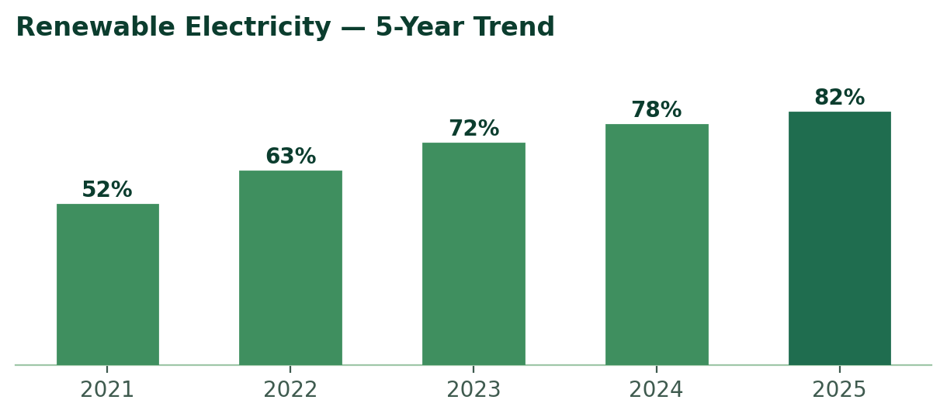
Year | Milestone
2019–20 | Carbon-neutral status achieved
2021 | Climate-positive-by-2030 vision announced
2023 | Responsible AI / AI governance framework introduced
2025 | Vision 2030 emissions targets revised upward

Five-year renewable-electricity series is directional, reconstructed from disclosed year-on-year progress; treat as trend illustration rather than an audited restatement.

🗺️ ESG Heatmap SECTION 08
Issue | Risk | Opportunity
Carbon | 🟡 | 🟢
Cybersecurity | 🔴 | 🟢
AI Governance | 🟡 | 🟢
Diversity | 🟡 | 🟡
Water | 🟢 | 🟢

⚠️ ESG Risks & Red Flags SECTION 09
Risk | Description
Data Privacy & AI Governance | Heavy exposure to client data and rapid gen-AI adoption raises data-handling and model-governance risk.
Talent Retention | IT services margins depend on utilization; attrition swings affect delivery cost and client continuity.
Scope 3 Concentration | Travel, commute and supply-chain emissions sit outside direct operational control, the hardest 2030 target.
Cybersecurity | A breach at Infosys carries downstream risk for client operations, not just its own.
Global Regulatory Exposure | Shifting AI, data-localization and labour regulation across geographies can raise compliance cost.
Automation of Own Workforce | AI-led productivity gains reducing entry-level hiring could tension with the skilling narrative.

🟡 Scope 3 dependency 🟡 Board diversity below workforce diversity 🟢 Strong disclosure 🟢 Stable governance

🧭 ESG SWOT SECTION 10
Category | Assessment
Strength | Mature, independent governance framework with board-level ESG oversight.
Weakness | Scope 3 emissions and board gender diversity trail the rest of the ESG profile.
Opportunity | Rising client demand for "green AI" and sustainable-by-design digital services.
Threat | Tightening AI and data-localization regulation across key export markets.

🤝 Stakeholder Impact SECTION 11
Stakeholder | Primary Impact
Investors | Lower governance risk
Employees | Strong learning ecosystem
Communities | CSR & rural-development spend
Customers | Better cybersecurity posture
Suppliers | Pressure to cut emissions

PAGE 3 OF 3
⭐ Investment Perspective SECTION 12
ESG Strengths  • Mature governance framework  • Long-term, tightening climate targets  • Strong, assured disclosure quality | ESG Concerns  • Scope 3 emissions trajectory  • Board-level gender diversity  • Supplier sustainability oversight

Overall View
Infosys demonstrates strong ESG maturity with above-average governance and transparent reporting. The next stage of ESG leadership will depend on execution of supplier decarbonization rather than additional climate commitments.

If I were Chief Sustainability Officer…
"I would prioritize supplier engagement and annual Scope 3 disclosure before introducing any new climate commitments, the credibility gap right now is in execution, not ambition."

Questions I'd ask management
1. How will supplier emissions be reduced, and on what timeline?
2. How are AI-related risks monitored at the board level?
3. Is board gender diversity expected to increase, and by when?
4. Will Scope 3 progress be reported annually against the 2030 target?

🚀 ESG Momentum Score SECTION 13
Area | Status | Momentum
Environment | Strong | ↑ High
Social | Moderate | → Stable
Governance | Strong | ↑ Improving

8.8 / 10 Strong target progression and disclosure improvements suggest ESG performance is still improving rather than plateauing.

📐 Global Framework Alignment SECTION 14
Framework | Status
GRI | ✅ Aligned
BRSR | ✅ Aligned
TCFD | 🟡 Partial
ISSB | 🟡 Emerging
CDP | ✅ Reported

4.5 / 5 Disclosure Maturity : comprehensive alignment to established frameworks; TCFD and ISSB adoption still maturing, in line with the broader sector.

🔬 Data Quality Score SECTION 15
Section | Confidence | Reason
Environmental | ★★★★★ | Third-party assured
Social | ★★★★☆ | Some metrics estimated
Governance | ★★★★★ | Fully disclosed

📊 ESG Scorecard — In-House Rating SECTION 16
Pillar | Performance | Targets | YoY Improvement | Disclosure
Environmental | 40% | 30% | 20% | 10%
Social | 40% | 30% | 20% | 10%
Governance | 40% | 30% | 20% | 10%
Transparency | Standards 35% | Granularity 35% | Assurance 30% | —

Environmental |  | 8.5 / 10
Social |  | 7.6 / 10
Governance |  | 8.8 / 10
Transparency |  | 8.4 / 10
Overall |  | 8.3 / 10

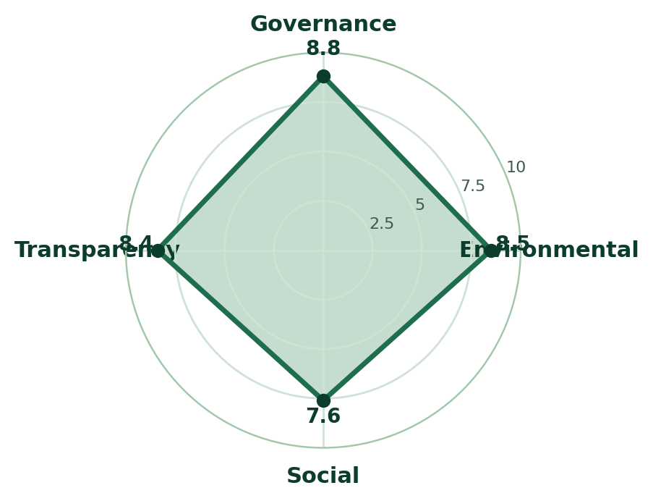
Pillar profile at a glance: the shape leans toward Governance and Environmental, board structure and climate commitments are ahead of social-disclosure depth.

Confidence: High (92%) Complete BRSR · Detailed GRI mapping · Third-party assurance · Multi-year historical data available

Methodology: each pillar is scored on performance, ambition of targets, year-over-year momentum, and disclosure quality, not benchmarked against MSCI, Sustainalytics, or any third-party rating agency.

⚖️ Peer Benchmark & Industry Ranking SECTION 17
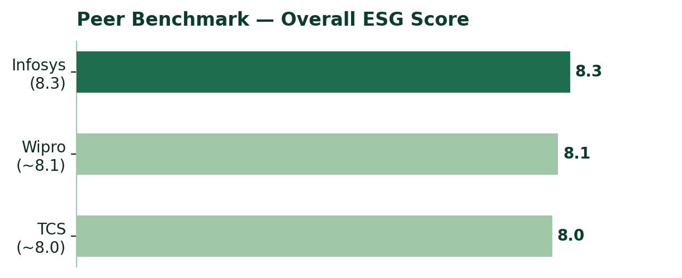
Rank | Company | Overall ESG
🏆 | Infosys | 8.3
🥈 | Wipro | ~8.1
🥉 | TCS | ~8.0

⚠ Methodology caveat
Illustrative comparison based on publicly disclosed FY2025 information, Infosys is the only company scored against this issue's full weighted methodology (Section 16). Wipro and TCS figures are directional estimates, not same-methodology assessments. Detailed peer scorecards will be published in future ESG Decoded issues.

🏅 Analyst's Verdict SECTION 18
★★★★☆
Verdict  Strong Performer | Risk Level  Low–Moderate | Disclosure Quality  Excellent | Industry Position  Top Quartile

🔭 ESG Outlook — Next 12 Months SECTION 19
Bullish Factors  • Renewable energy expansion  • AI governance investment  • Consistent carbon-neutral record | Watch Closely  • Scope 3 emissions trajectory  • Board diversity progression  • Talent-retention trends | Potential Catalyst  • Better supplier engagement  • Annual Scope 3 disclosure  • Expanded green-AI services

Primary sources: Infosys ESG Report FY2024–25, Infosys Integrated Annual Report FY2025, Business Responsibility & Sustainability Report (BRSR), and Infosys corporate ESG disclosures. Peer references: Wipro Form 20-F FY2025, Wipro BRSR FY25-26, TCS FY2025 investor communications.
Figures marked "~" are best-available public estimates compiled from company disclosures and reputable secondary sources; not sourced from any paid ESG database. Evidence citations reference report chapters and BRSR principles, not specific page numbers. Independent verification is recommended before use in investment or academic work. This report is analyst-style commentary, not investment advice.
ESG Decoded · Issue 01 · Version A : Full Analyst Report

