AGENTIC AI PYTHON DEBUGGING SYSTEM
Requirements Document, Use Cases, HLD and LLD
Technical Design Report
Confidential – Organization details intentionally omitted

1. Requirements Document
The Agentic AI Python Debugging System is a Streamlit-based application that helps a developer inspect an uploaded Python project, identify syntax and test-related problems, obtain an AI-assisted diagnosis, review a proposed correction, and validate an approved change by running automated tests.

1.1 Purpose
The purpose is to reduce manual effort in locating Python project errors by combining project analysis, Gemini-based diagnosis, controlled repair approval, and pytest-based validation.

1.2 Scope
- Accept a Python project as a ZIP archive.
- Validate and safely extract the uploaded archive.
- Identify Python files, test files, imported modules, dependencies, syntax errors and unreadable files.
- Run project tests only after the user gives consent.
- Send relevant source code and test output to Gemini for diagnosis when the service is available.
- Use a clearly identified local fallback when Gemini cannot be reached; the fallback does not generate replacement code.
- Display diagnosis and suggested corrected code for user review.
- Apply a proposed repair only after user approval, then run tests again to validate the result.

1.3 Functional Requirements
ID | Functional requirement
FR-01 | The system shall allow the user to upload a Python project in ZIP format.
FR-02 | The system shall validate the archive and reject unsafe archive entries.
FR-03 | The system shall extract valid project files into a working directory.
FR-04 | The system shall scan the project and identify Python source files and test files.
FR-05 | The system shall detect Python syntax errors using Python AST parsing.
FR-06 | The system shall identify imported modules and project dependencies where available.
FR-07 | The system shall display analysis metrics and relevant file information.
FR-08 | The system shall request user consent before executing uploaded project tests.
FR-09 | The system shall execute tests using pytest and capture the output.
FR-10 | The system shall allow the user to select a Python source file for diagnosis.
FR-11 | The system shall send source code and test output to Gemini for AI diagnosis when available.
FR-12 | The system shall validate the structure and fields of the AI response.
FR-13 | The system shall validate the syntax of proposed corrected code before presenting it.
FR-14 | The system shall use a local fallback diagnosis when Gemini is unavailable.
FR-15 | The local fallback shall not generate or apply replacement code.
FR-16 | The system shall display the diagnosis, confidence and recommended action.
FR-17 | The system shall require user approval before applying a proposed repair.
FR-18 | The system shall rerun tests after an approved repair and display the results.

1.4 Non-Functional Requirements
Quality attribute | Requirement
Usability | The interface should provide a clear, step-by-step workflow for project upload, analysis, diagnosis and validation.
Security | Uploaded ZIP files must be checked before extraction; sensitive files such as .env should not be exposed or committed.
Reliability | Failures in the Gemini service should be handled without crashing the complete application.
Safety | Suggested code must be reviewed and approved by the user before it is applied.
Maintainability | The application should keep UI, extraction, analysis, repair and test execution responsibilities in separate modules.
Performance | The system should provide progress or clear status feedback during analysis and test execution.

1.5 Constraints and Assumptions
- The uploaded project is expected to be a Python project with tests that can be executed through pytest.
- Gemini diagnosis depends on API availability, valid credentials and applicable usage limits.
- A passing test suite does not prove that the project is completely free of defects.
- The local fallback reports only what can be inferred from test output and does not produce a code repair.

2. Use Case Document
Primary actor: Developer / User. Supporting external service: Google Gemini API. Testing tool: pytest.

2.1 Use Case Diagram
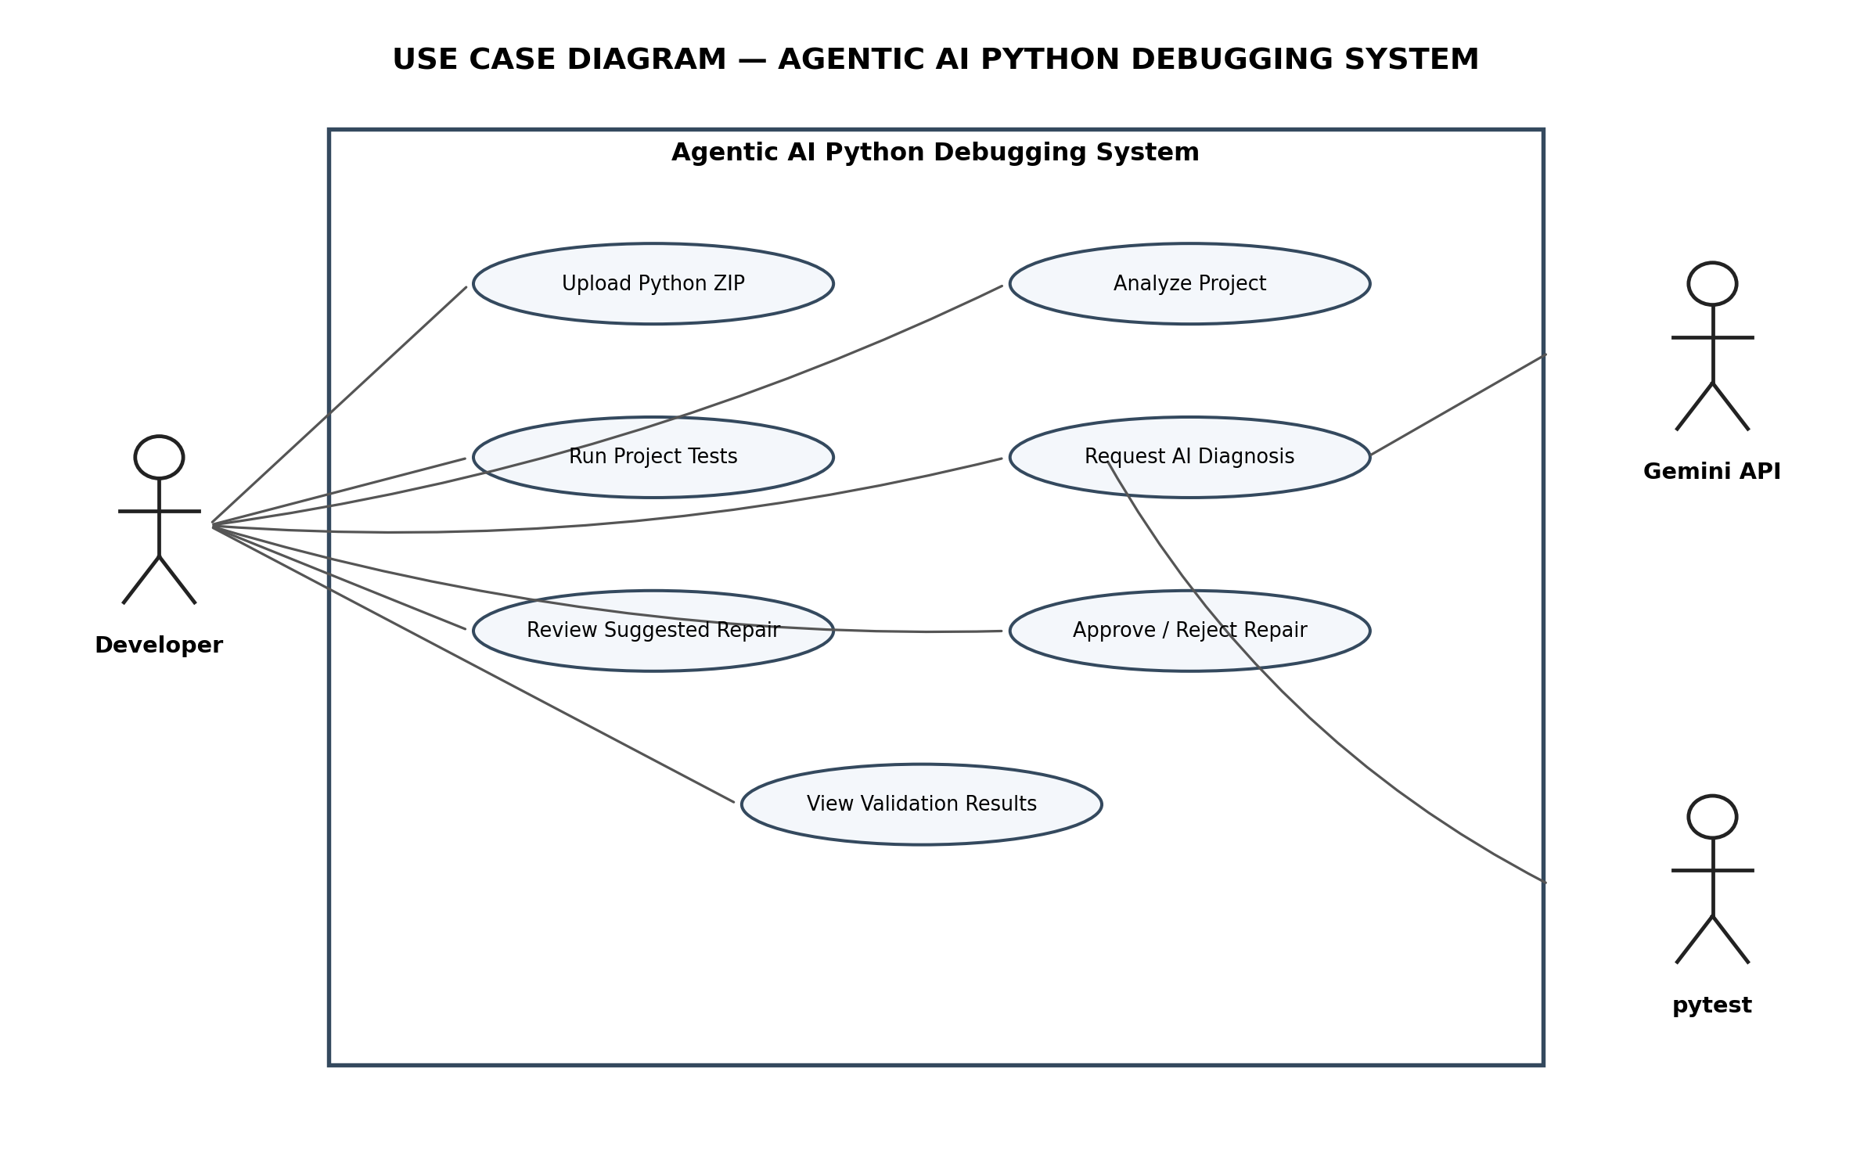
Figure 2.1: UML use case diagram showing the developer and supporting services.

UC-01: Upload Python project
Primary actor: Developer
Precondition / trigger: The user selects and uploads a ZIP file containing a Python project.
Main outcome: A valid archive is accepted and made available for analysis; invalid or unsafe archives are rejected.

UC-02: Analyze project
Primary actor: Developer
Precondition / trigger: The user starts project analysis after upload.
Main outcome: The system extracts and scans files, identifies Python/test files, imports, syntax errors and unreadable files, and displays the findings.

UC-03: Run project tests
Primary actor: Developer
Precondition / trigger: The user reviews the project and gives consent to execute tests.
Main outcome: The system runs pytest, captures the output and displays pass, fail, error and skipped counts.

UC-04: Request AI diagnosis
Primary actor: Developer
Precondition / trigger: The user selects a Python file and requests diagnosis.
Main outcome: The system sends the selected source code and test output to Gemini when available.

UC-05: Receive diagnosis
Primary actor: Gemini API
Precondition / trigger: The system sends a diagnosis request to Gemini.
Main outcome: Gemini returns a structured diagnosis with status, bug type, explanation, confidence and, when a bug is found, candidate corrected code. The system validates the response.

UC-06: Review and approve repair
Primary actor: Developer
Precondition / trigger: A candidate repair is available for review.
Main outcome: The user reviews the suggested code and chooses whether to approve it. No repair is applied without approval.

UC-07: Validate repair
Primary actor: Developer
Precondition / trigger: The user approves a candidate repair.
Main outcome: The system applies the approved change to the working copy, reruns tests and displays the validation outcome.

2.2 Alternative and Exception Flows
Condition | System response
Invalid or unsafe ZIP | The system rejects the archive and displays an error; extraction does not proceed.
Syntax error found | The system reports the affected file and syntax location; diagnosis or testing may be limited until the syntax problem is corrected.
Test execution fails | The system captures and displays pytest output for diagnosis.
Gemini unavailable | The system retries the request and then uses the local fallback. The fallback does not generate replacement code.
AI response invalid | The response is rejected rather than being treated as a valid repair.
Repair rejected by user | The original working file remains unchanged.
Post-repair tests fail | The system displays the failed validation results; it must not claim the repair is successful.

3. High-Level Design (HLD) Architecture
The HLD describes the major components of the system and how information moves between them. The developer interacts with the Streamlit application. The application coordinates the Python core modules, Gemini API and pytest, and presents diagnosis and validation results to the developer.
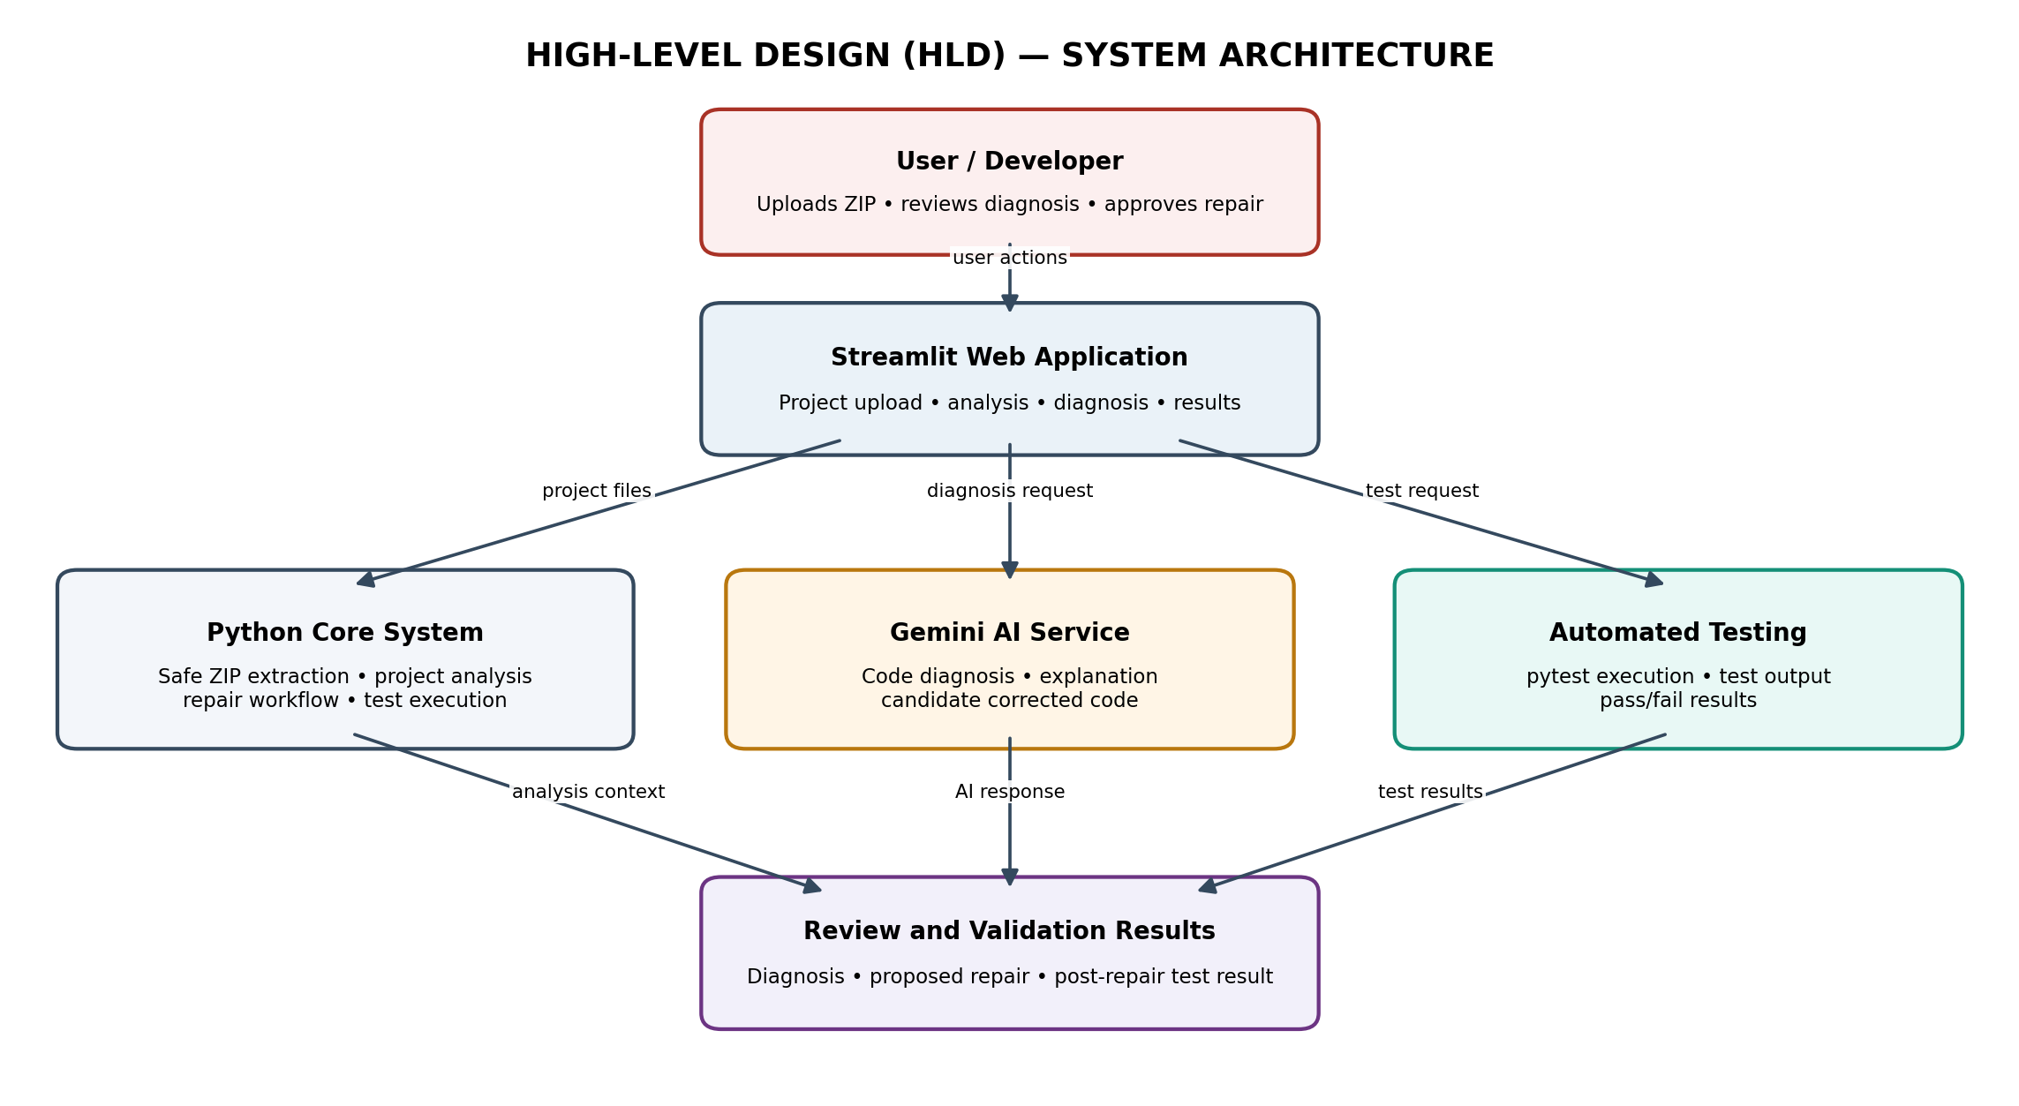
Figure 3.1: High-level system architecture

3.1 HLD Component Description
Component | Responsibility
User / Developer | Uploads a project, starts analysis and tests, requests diagnosis, and reviews or approves a repair.
Streamlit Web Application | Provides the user interface and coordinates the project workflow.
Python Core System | Performs safe ZIP extraction, project scanning, repair orchestration and test execution.
Gemini AI Service | Analyses source code and test output and may return a diagnosis and candidate corrected code.
pytest | Executes automated project tests and provides test results.
Review and Validation Results | Shows the diagnosis, proposed repair and test outcomes to the user.

4. Low-Level Design (LLD) Architecture
The LLD describes the internal modules and their responsibilities. The Streamlit frontend calls the core modules in sequence. The repair engine communicates with Gemini, validates the returned structure and candidate code, and presents a repair for user approval. The test runner executes pytest before and after an approved repair.
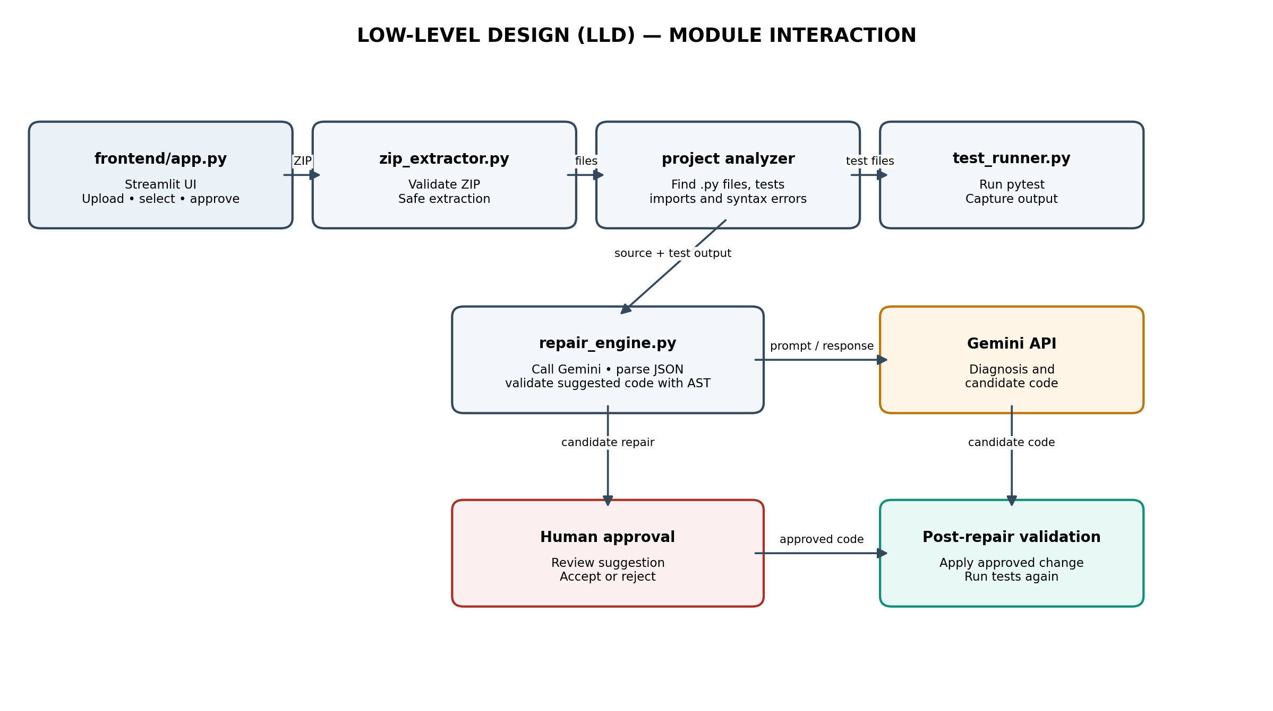
Figure 4.1: Low-level module interaction

4.1 Module Responsibilities
Module / service | Responsibility
frontend/app.py | Streamlit interface; handles ZIP upload, analysis display, test consent, source-file selection, diagnosis request, repair review and approval.
core/zip_extractor.py | Validates ZIP entries and safely extracts project files while applying extraction restrictions.
core/project_upload.py / project analyzer | Scans project files and identifies Python files, tests, imports, dependencies, syntax errors and unreadable files.
core/repair_engine.py | Calls Gemini, retries transient failures, validates structured responses, checks candidate code syntax using ast.parse, and invokes local fallback when required.
core/test_runner.py | Runs pytest, captures standard output and errors, applies timeout handling and reports test results.
Google Gemini API | Provides AI-based code diagnosis and candidate corrected code when the service responds successfully.
pytest | Runs automated tests against the uploaded project and after an approved repair.

4.2 Diagnosis and Repair Logic
- The repair engine receives the selected source code, file name and test output.
- It constructs a prompt asking Gemini to identify only evidence-supported defects and return a structured JSON response.
- The response is checked for required fields, valid status, confidence in the range 0 to 1, and valid data types.
- If a bug is reported, the proposed code is checked with Python AST parsing before it is offered for review.
- If Gemini fails after the configured retries, the local fallback classifies the available test output. It does not generate replacement code.
- A proposed repair is applied only after explicit user approval, and pytest is run again to validate the working copy.

4.3 Data Flow
- ZIP upload → archive validation and extraction.
- Extracted project → project analysis and syntax checking.
- User consent → pytest execution and captured test output.
- Selected source code + test output → Gemini diagnosis request.
- Validated diagnosis and candidate code → user review and approval.
- Approved repair → working-copy update → post-repair pytest validation.

5. Design Limitations
- AI-generated corrections may be incomplete or incorrect and must be reviewed.
- Passing tests confirms only that the collected tests passed; it does not guarantee the absence of all defects.
- The local fallback is evidence-based and intentionally avoids generating code when Gemini is unavailable.
- The quality of diagnosis depends on the selected source file, available test output, test coverage and Gemini availability.

