WEEK 2 • CONSOLIDATED TECHNICAL REPORT

Agentic AI Debugging & Test Automation System
Core agent • Gemini integration • pytest • CLI • Streamlit UI
GitHub: https://github.com/shobhis330/agentic-ai-debugging-test-automation

1. Abstract
This Week 2 prototype explores an agentic workflow for AI-assisted Python debugging. The agent runs automated tests, reads failure feedback, requests a structured repair from Gemini, validates candidate syntax, updates the solution and reruns tests within a retry limit. Three controlled bug cases were prepared. A Streamlit interface was added and connected to the existing agent to support browser-based case selection and result review.

2. Problem and objective
Manual debugging often involves repeated cycles of inspecting errors, editing code and rerunning tests. The goal is to automate part of this cycle while using tests as a verification signal. The agent assists with repairs; it does not guarantee that arbitrary code will be correct.

3. Week 2 scope implemented
- Core Python debugging loop with CLI entry point.
- Gemini integration using google-genai for AI repair suggestions.
- Structured JSON fields: bug_type, explanation, fixed_code and confidence.
- Basic response validation and candidate Python syntax compilation.
- pytest execution, failure feedback, retry limit MAX_RETRIES = 3, and PASS / FAIL / ERROR reporting.
- Three controlled evaluation cases: TC01, TC02 and TC03.
- Streamlit app launched in Colab and connected to the existing agent.

4. Workflow
- Load the selected case's solution.py and test_solution.py.
- Run pytest and capture exit code and feedback.
- If tests fail and retries remain, send code and feedback to Gemini.
- Parse and validate structured repair output; compile the candidate code.
- Save the candidate and rerun pytest.
- Stop when tests pass or the retry limit is reached; return a final status.

5. Architecture and tools
Component | Purpose
Streamlit app.py | Browser UI for selecting cases and reviewing logs/code/status.
debugging_agent.py | Controls test execution, repair requests, syntax checks, saving and retries.
Gemini API / google-genai | Returns AI-assisted repair suggestions.
pytest | Runs tests and supplies failure feedback.
agent_cli.py | Command-line wrapper for selecting a case.
JSON | Carries structured repair fields and final machine-readable status.

6. Evaluation cases
Case | Original bug | Expected fix | Bug type
TC01 | Average divides by len(numbers)-1. | Use len(numbers); keep empty-list validation. | Logic / off-by-one
TC02 | is_adult returns age > 18. | Use age >= 18 for this test's expected boundary. | Boundary condition
TC03 | Returns undefined variable tota. | Return the defined variable total. | Undefined name

7. Results and evidence
The shared TC01 output shows an initial test failure, repair attempt 1/3, then a second test run reporting four passed and final status PASS with repair_attempts = 1. This is direct evidence for the captured TC01 run.
TC02 and TC03 were restored to intentionally buggy versions for demonstration and are ready for separate verification. Their final post-repair results should be captured before claiming all three cases pass. Three cases form a controlled demonstration, not a broad benchmark.

8. Streamlit interface
The app.py interface was launched in Google Colab on port 8501. It allows the user to choose TC01–TC03, inspect the selected solution, run the agent, and review logs, repair attempts, repaired code, status and code differences. A path mismatch was identified: the UI displayed cases in the project folder while the agent initially read a separate /content/evaluation_cases folder. CASES_DIR was updated to /content/agentic-ai-debugging-test-automation/evaluation_cases.
The current interface uses predefined cases. A general paste-your-own-code mode is not yet implemented and would require test input/design and isolated execution of untrusted code.

9. Project files and repository
Project folder contains debugging_agent.py, agent_cli.py, app.py, README.md, week2_evaluation_results.csv and evaluation_cases/TC01–TC03. Working solutions were backed up before buggy versions were restored for demonstration.
GitHub repository: https://github.com/shobhis330/agentic-ai-debugging-test-automation

10. Limitations and safety
- Only three controlled cases are prepared; the guideline's final target is at least 15 cases with recorded results.
- Passing tests validates only the behaviors covered by those tests.
- Review AI-generated code before accepting it.
- Arbitrary user code should not be executed publicly without isolation and resource limits.
- TC02 and TC03 need final run evidence.
- Keep API keys in Colab Secrets/environment variables; never commit them.

11. Week 2 status and next steps
The core agent loop, structured repair handling, pytest execution, retry limit, three prepared cases and connected Streamlit UI are implemented or demonstrated. The UI was added early following mentor direction.
- Run TC02 and TC03 and record final logs and test counts.
- Update week2_evaluation_results.csv from actual runs.
- Expand evaluation toward at least 15 cases with recorded results.
- Proceed to Week 3 knowledge/RAG or data-tool and memory requirements.
- Improve execution isolation, guardrails, logging, and later cost/latency measurement.

12. Conclusion
Week 2 progressed from a command-line debugging workflow to a browser-based demonstration. The captured TC01 run shows one repair attempt followed by four passing tests. TC02 and TC03 are prepared for verification; broader evaluation, safety hardening and later knowledge/memory features remain future work.

Appendix A — Actual Application Screenshots
The following screenshots were captured from the running Streamlit application during the TC01 demonstration. They document the initial failing test run and the subsequent automated repair and successful validation.
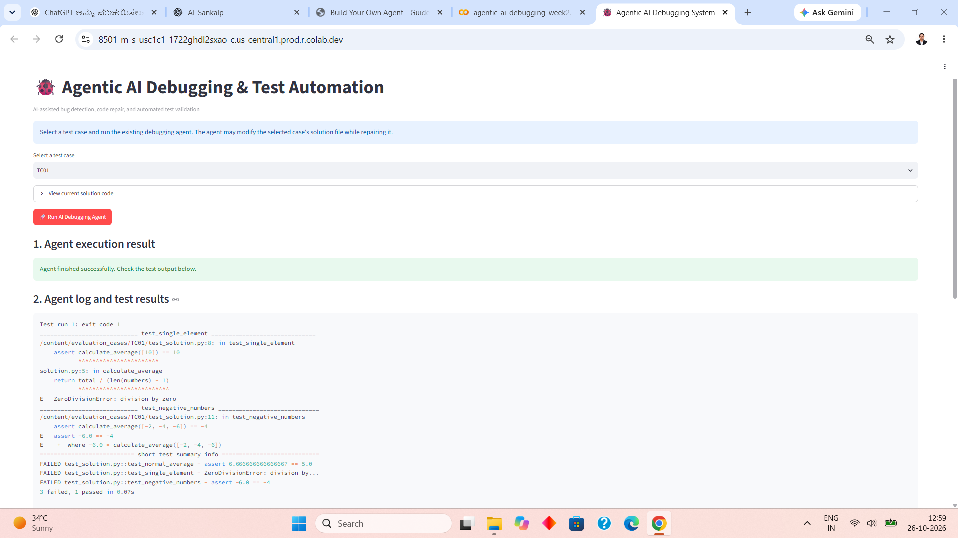
Figure A.1: Actual Streamlit interface showing the initial TC01 test failures.

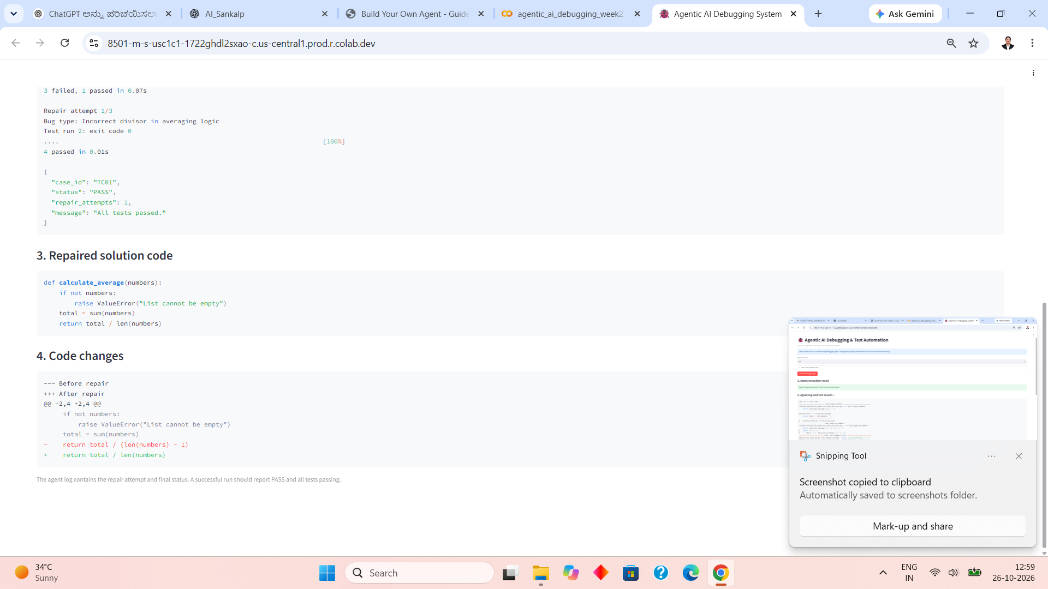
Figure A.2: Actual agent output showing repair attempt 1/3, the corrected calculate_average function, and 4 passing tests.

