### basics

### REPL

Read Eval Print Loop

### comments

# single line comments

docstrings used as multiline comments

### common terms

slice

sequence iterable

elements members

### interpreter

cpython

Clang

VC++ (microsoft)

gcc

jython

## IDEs/environments

idle

pycharm

vscode

jupyter

spyder

### file extensions

.py

.ipynb (python notebook)

jupyter

spyder

.pyc cache

## data types

int

float

str strings

bool

True

False

complex

### false

0

0.0

"" '' empty strings

[ ]

None

False

## keywords

True False

None del

if elif else

break continue pass

while for

def return lambda yield

and or not in is

import as from

global

with

## Operators

### arithmetic

+

-

*

/

=

multiple assignment

% modulo

** power of

// floor division

no increment/decrement

### logical

and

or

not

### relational

<

>

<=

>=

==

=!

### membership

(checking if it exists in a sequence)

in

not in

### identity

(for data types)

is

is not

### bitwise

& and

| or

~ not

^ ex-or

<< left shift

>> right shift

## Functions

### general

print()

type()

frozenset()

input()

eval()

### sequences

len()

sorted()

reversed()

sum()

min()

max()

any()

all()

zip()

map()

filter()

### anonymous

(like inline)

lambda

### cast

int()

str()

float()

list()

set()

tuple()

### numbers

round()

### user defined

def

return

#### parameters/arguments

any number

any data type

default values (right most)

named arguments

args

kwargs

no function polymorphism

global

#### return

default : None

can return multiple values

## strings

text

double or single quotes

"hello"

'hello'

UTF-8

index

negative indexing

out of bounds error

slice

step

| v | i | r | a | t |
| --- | --- | --- | --- | --- |
| 0 | 1 | 2 | 3 | 4 |
| -5 | -4 | -3 | -2 | -1 |

immutable

+ concat

### strings functions/methods

lower() upper()

capitalize() title()

isalpha() isalnum() isdigit()

split() splitlines()

replace()

### string escape sequences

\n newline

\t tab

\b backspace

\v vertical tab

\\ \

\" "

### docstrings

triple quote

## list

any kind of data

duplicates allowed

[ ]

index

negative indexing

out of bounds error

slice

step

mutable

### list functions

append insert extend

remove pop clear

reverse sort sort(reverse=True)

copy

index count

## tuple

any kind of data

duplicates allowed

( )

index

negative indexing

out of bounds error

slice

step

immutable

### tuple functions

index count

## set

{ }

no duplicates

only unique

unordered

no index

no slice/step

members: immutable

mutable

### operations

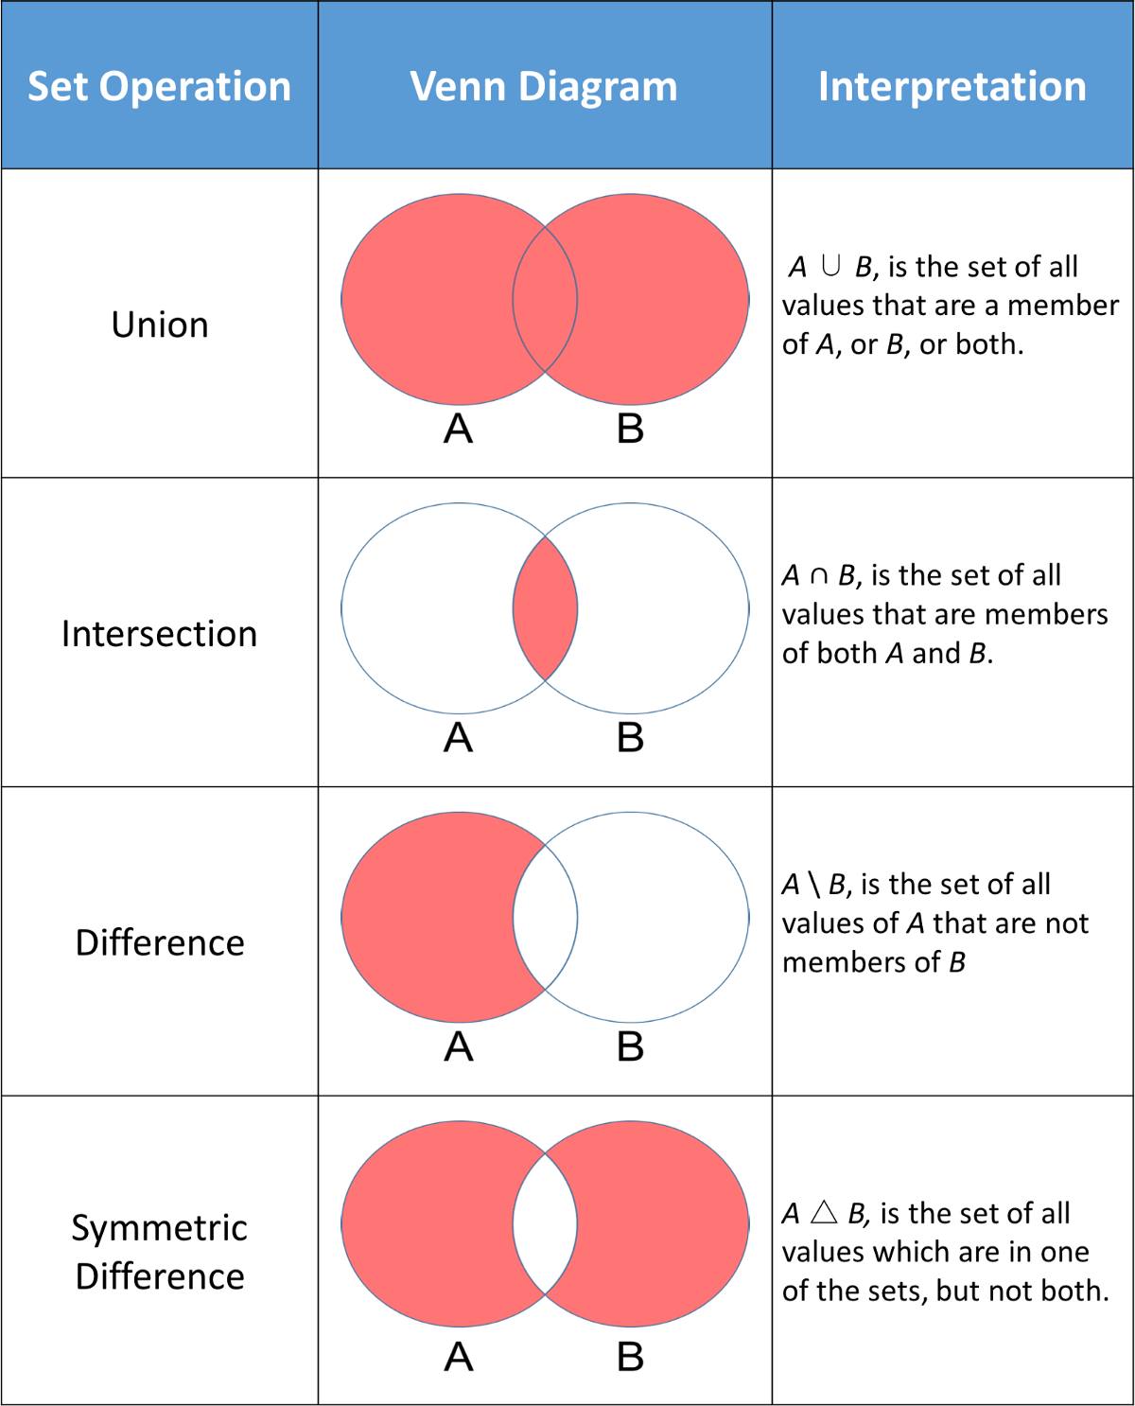

### dict

key: value pair

keys:

unique

immutable

value:

anything

mutable

### dict functions

.keys() .values()

.items()

## flow control

pass

break

continue

### if else

if elif else

### while

else

### for

range

else

## Modules

import

### os

os.mkdir()

os.rmdir()

os.getcwd()

os.listdir()

os.chdir()

os.rename()

os.system()

os.error

### sys

sys.path

sys.version

### __builtins__

### ways to import

1. import colour

colour.blue()

colour.yellow()

colour.green()

1. import colours as c

c.blue()

c.yellow()

c.green()

1. from colour import blue, yellow

blue()

yellow()

~~green()~~

~~red~~

1. from colour import *
2. from colour import blue as b

b()

### __main__

every python file has an object named as __name__

with value "__main__"

## package

music

file_formats

aupwrite.py

mp4write.py

mp3read.py

filters

voice_record.py

karaoke.py

effects

theatre.py

surround.py

heavy_metal.py

echo.py

## Files

with open as

fa = open()

### modes

r read

w write

deletes previous contents, treats it like a new file

a append

r+ read & write

rb, wb, rb+ binary

### methods

fa.read()

fa.readline()

fa.readlines()

fa.write()

fa.seek()

fa.tell()

fa.readable()

fa.writable()

fa.close()

### attributes

fa.closed

## regex

### metacharacters

. any character

except \n

^ starts with

$ ends with

[ ] set of characters

[a-z] any lower case

[0-9] any number

[0-39] [01239]

[aeiou]

[^ ] invert of

+ one or more occurrences

? zero or one occurrence

* zero or more occurrences

{x, y} minimum x , maximum y times

{1,3}

{2,}

( ) group

| alteration

\ escape

### special sequences

\d numbers

[0-9]

\D non digit

invert of \d

\s whitespace

space tab return new_line vertical_tab

\S non whitespace

\w alphanumeric character

[a-zA-Z0-9_]

hello_24

\W non alphanumeric

(invert of \w)

## NumPy

NUmerical PYthon

written in C

ndarray

.ndim

.shape

.dtype

.size

.itemsize

.bytesize

## pandas

PANel DAta

types of data files:

sql

excel

csv

C

### data structure

series

dataframe

### series

1 dim

### functions/methods

head()

min() max() sum()

mean() median() mode()

info()

dtypes()

describe()

shape()

count()

std() mad()

abs()

agg()

### missing values

NaN

NaT

None

isna() isnull()

dropna()

## Other files

### json

javascript object

json.load()

json.loads()

json.dump()

#### table

dict object

list, tuple array

str string

int, float number

True true

False false

None null

### xml

xml.etree

## concurrency

### threads

threading

Thread(target, args)

Lock()

TIMEOUT_MAX

Thread object

getName()

setName()

is_alive()

isDaemon()

join()

start()

Lock object

acquire()

release()

locked()

## sockets



### socket families

socket.AF_INET IPv4

socket.AF_INET6 IPv6

socket.SOCK_STREAM TCP

SOCK_DGRAM UDP

## Exception Handling

Syntax errors

exceptions

* except should be immediately followed by try

### scenarios

1. exception occurs

handled

finally

1. exception occurs

not handled

finally

1. exception never occurred

else

finally

code continues