## basics

### REPL

Read Eval Print Loop

### comments

# single line comments

docstrings used as multiline comments

### common terms

slice

sequence iterable

elements members

### interpreter

cpython

Clang

VC++ (microsoft)

gcc

jython

## IDEs/environments

idle

pycharm

vscode

jupyter

spyder

### file extensions

.py

.ipynb (python notebook)

jupyter

spyder

.pyc cache

## data types

int

float

str strings

bool

True

False

complex

### false

0

0.0

"" '' empty strings

[ ]

None

False

## keywords

True False

None del

if elif else

break continue pass

while for

def return lambda yield

and or not in is

import as from

global

with

## Operators

### arithmetic

+

-

*

/

=

multiple assignment

% modulo

** power of

// floor division

no increment/decrement

### logical

and

or

not

### relational

<

>

<=

>=

==

=!

### membership

(checking if it exists in a sequence)

in

not in

### identity

(for data types)

is

is not

## Functions

### general

print()

type()

frozenset()

input()

eval()

### sequences

len()

sorted()

reversed()

sum()

min()

max()

any()

all()

zip()

map()

filter()

### anonymous

(like inline)

lambda

### cast

int()

str()

float()

list()

set()

tuple()

### numbers

round()

### user defined

def

return

#### parameters/arguments

any number

any data type

default values (right most)

named arguments

args

kwargs

no function polymorphism

global

#### return

default : None

can return multiple values

## strings

text

double or single quotes

"hello"

'hello'

UTF-8

index

negative indexing

out of bounds error

slice

step

| v | i | r | a | t |
| --- | --- | --- | --- | --- |
| 0 | 1 | 2 | 3 | 4 |
| -5 | -4 | -3 | -2 | -1 |

immutable

+ concat

### strings functions/methods

lower() upper()

capitalize() title()

isalpha() isalnum() isdigit()

split() splitlines()

replace()

### string escape sequences

\n newline

\t tab

\b backspace

\v vertical tab

\\ \

\" "

### docstrings

triple quote

## list

any kind of data

duplicates allowed

[ ]

index

negative indexing

out of bounds error

slice

step

mutable

### list functions

append insert extend

remove pop clear

reverse sort sort(reverse=True)

copy

index count

## tuple

any kind of data

duplicates allowed

( )

index

negative indexing

out of bounds error

slice

step

immutable

### tuple functions

index count

## set

{ }

no duplicates

only unique

unordered

no index

no slice/step

members: immutable

mutable

### operations

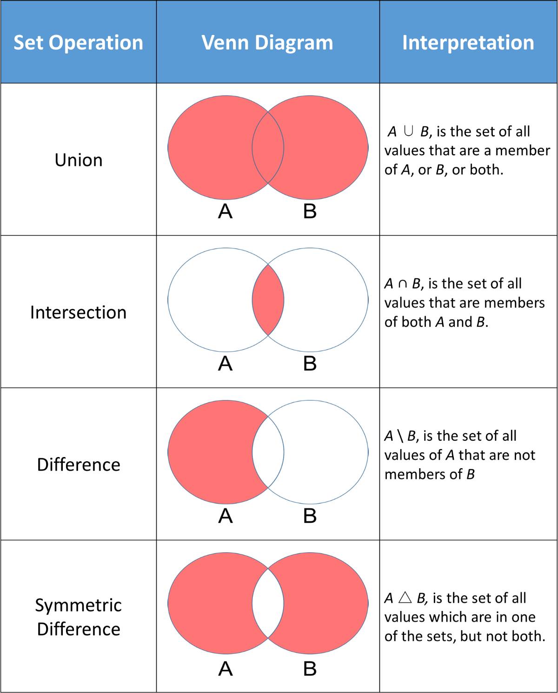

### dict

key: value pair

keys:

unique

immutable

value:

anything

mutable

### dict functions

.keys() .values()

.items()

## flow control

pass

break

continue

### if else

if elif else

### while

else

### for

range

else

## Modules

import

### os

os.mkdir()

os.rmdir()

os.getcwd()

os.listdir()

os.chdir()

os.rename()

os.system()

os.error

### sys

sys.path

sys.version

### __builtins__

### ways to import

1. import colour

colour.blue()

colour.yellow()

colour.green()

1. import colours as c

c.blue()

c.yellow()

c.green()

1. from colour import blue, yellow

blue()

yellow()

~~green()~~

~~red~~

1. from colour import *
2. from colour import blue as b

b()

### __main__

every python file has an object named as __name__

with value "__main__"

## Files

with open as

fa = open()

### modes

r read

w write

deletes previous contents, treats it like a new file

a append

r+ read & write

rb, wb, rb+ binary

### methods

fa.read()

fa.readline()

fa.readlines()

fa.write()

fa.seek()

fa.tell()

fa.readable()

fa.writable()

fa.close()

### attributes

fa.closed