# basics

## generic terms

IDE

### REPL

Read

Eval

Print

Loop

## python generic terms

### IDE

1. Jupyter
2. pycharm
3. spyder
4. VScode
5. visual studio
6. idle

### data

### code files

.py

.ipynb (notebook)

## data types

int whole numbers

float decimal

str string

bool True

False

complex

## operators

### arth

+

-

*

/

%

// floor division

** power

#### compound

+=

/=

*=

-=

### relational (conditional)

< lesser than

> greater than

<= lesser than or equal to

>= greater than or equal to

== equals to

!= not equal to

### logical

and

or

not

### membership

in

not in

### identity

is

is not

## keywords

del

True False

if elif else

for while break continue

None

return def

## false

False

0

0.0

‘’

“”

[ ]

{ }

None

## functions

### generic

print()

type()

### conversion

int()

float()

str()

set()

list()

tuple()

### sequence

sum()

len()

min()

max()

sorted()

any()

all()

## comments

# single line

## strings

text

“”

‘’

immutable

index

out of bound error

negative

slicing

step

| r | c | b |  | w | i | n | s |
| --- | --- | --- | --- | --- | --- | --- | --- |
| 0 | 1 | 2 | 3 | 4 | 5 | 6 | 7 |
| -8 | -7 | -6 | -5 | -4 | -3 | -2 | -1 |

### functions

upper lower capitalize title

startswith endswith

isalpha isdigit isalnum

replace

strip rstrip lstrip

index count

### escape characters

\n new line

\t tab

\b backspace

\\ \

\’ ‘

\" "

\v vertical tab

\r carriage return

### more features

doc strings

r strings

f strings

# Data Structures

## list

declared within square brackets [ ]

can have any data/object

allows duplicates

separated by comma ,

mutable

nesting

index

negative index

slice

step

### list functions

append, insert, extend

remove, pop,pop(number), clear

count, index

copy

reverse, sort, sort(reverse=True)

## tuple

declared within ( )

separated by comma ,

immutable

index

negative index

slice

step

### tuple functions

count, index

## set

declared within { }

should have immutable data/object

does not allow duplicates

unique members

unordered

separated by comma ,

by itself mutable

no nesting

not indexable

### set functions

### operations

intersection

union

sym diff

diff

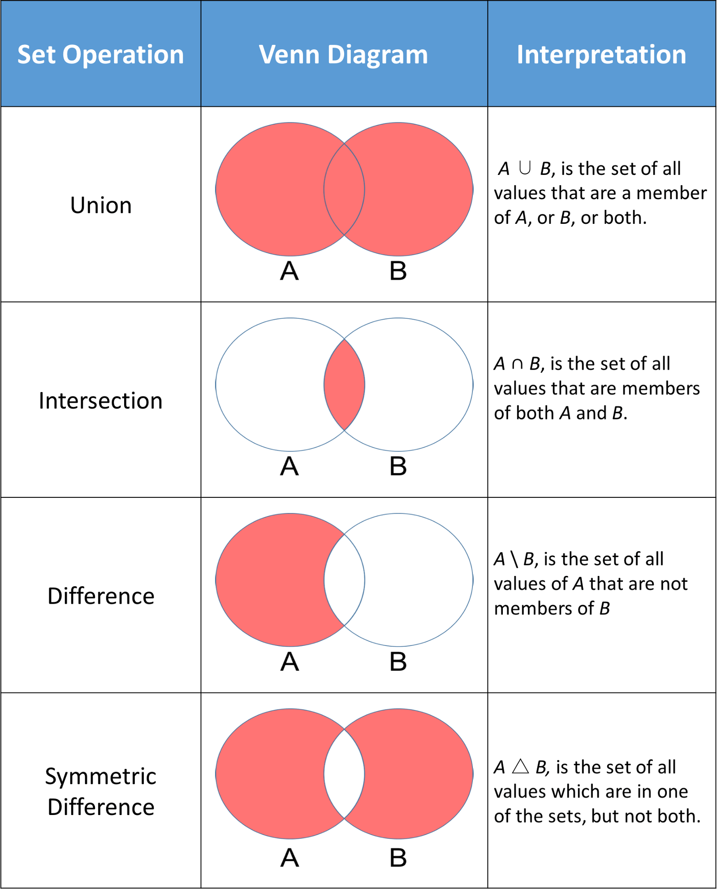

### dict

key:value pairs

values:

anything

modifiable

keys:

no duplicates

immutable

by itself is mutable

nesting

dict as values

## user defined functions

def

return

()

### arguments (parameters):

any number (0 to n)

### return

any number (0 to n)

default is None

### default arguments

right to left

not constant, can be overwritten

### named arguments

### variable number of arguments

*args

**kwargs

### documentation

__doc__