## Basics

### environments & IDEs

IDLE

jupyter

spyder

co-labs

pycharm

VScode

Visual studio

notepad (run it through command line)

### REPL

Read Eval Print loop

### general

object based language

oops

### Joining links

| Day 1 (1st Half) | <https://infineon.webex.com/infineon/j.php?MTID=m485493b713c74dc645673e5622f5e65f> | **758093** |
| --- | --- | --- |
| Day 1 (2nd Half) | <https://infineon.webex.com/infineon/j.php?MTID=mb17d29503d013cd71c5b0226f14cb01c> | **170161** |
| Day 2 | <https://infineon.webex.com/infineon/j.php?MTID=m2f516d03b4de1cc00dea97eba3c5a8ed> | **144354** |
| Day 3 | <https://infineon.webex.com/infineon/j.php?MTID=me062e7052c723d6cba0c9304f5af95cd> | **440173** |
| Day 4 | <https://infineon.webex.com/infineon/j.php?MTID=ma1e06e17a606e4186f59e2583192d37f> | **338384** |

# Python

## Language

### comments

# single line comments

""" multi line comments (doc strings)

### data types (infinite)

int

float

str

bool

True

False

### keywords

True False

and or not

in is

del

if elif else

pass

for while

break continue

def global return

import from as

### naming_conventions

start with alphabets, underscores

can have alphabets, numbers or underscores

## functions

### generic

print()

type()

help()

input()

### conversion

int()

float()

str()

complex()

list()

tuple()

set()

### sequence

len()

min()

max()

sum()

any()

all()

sorted()

### used defined

def

default values

named arguments

arbitrary

args, kwargs

return:

default None

global local

### advance

filter()

map()

lambda

### False

False #bool

0 #value is zero

0.0 #value is zero

None #NoneType

[ ] empty list

{ } empty dict

'' empty string

## operators

chaining

### arithmetic

+

-

/

*

%

// floor division

** power of

=

### logical

and

or

not

### comparative (relational)

<

>

<=

>=

==

!=

### membership

in

not in

### identity

is

is not

### bitwise

&

|

^

~ not

<<

>>

## strings

text data

double quotes & single quotes

"hello"

'world'

**immutable**

index

negative indexing

out of index error

slicing

step

player = “nadal”

| n | a | d | a | l |
| --- | --- | --- | --- | --- |
| 0 | 1 | 2 | 3 | 4 |
| -5 | -4 | -3 | -2 | -1 |

### string functions

lower upper

title capitalize

find rfind count

isalpha isdidgit isalnum

split

### escape characters

\n new line

\t tab

\\ \

\" "

\v vertical

\r return key

### doc-strings

""" """

''' '''

## list

any kind of data

duplicates are allowed

index

negative index

sliced

step

nesting

**mutable**

### list functions

index count

reverse sort() sort(reverse=True)

insert append extend

remove pop clear

## tuple

any kind of data

duplicates are allowed

index

negative index

sliced

step

nesting

**immutable**

### tuple functions

index count

## set

only immutable

duplicates are not allowed

only unique members

unordered

no indexing

no slicing

no nesting

**mutable**

### set functions

union

…

…

### set operation

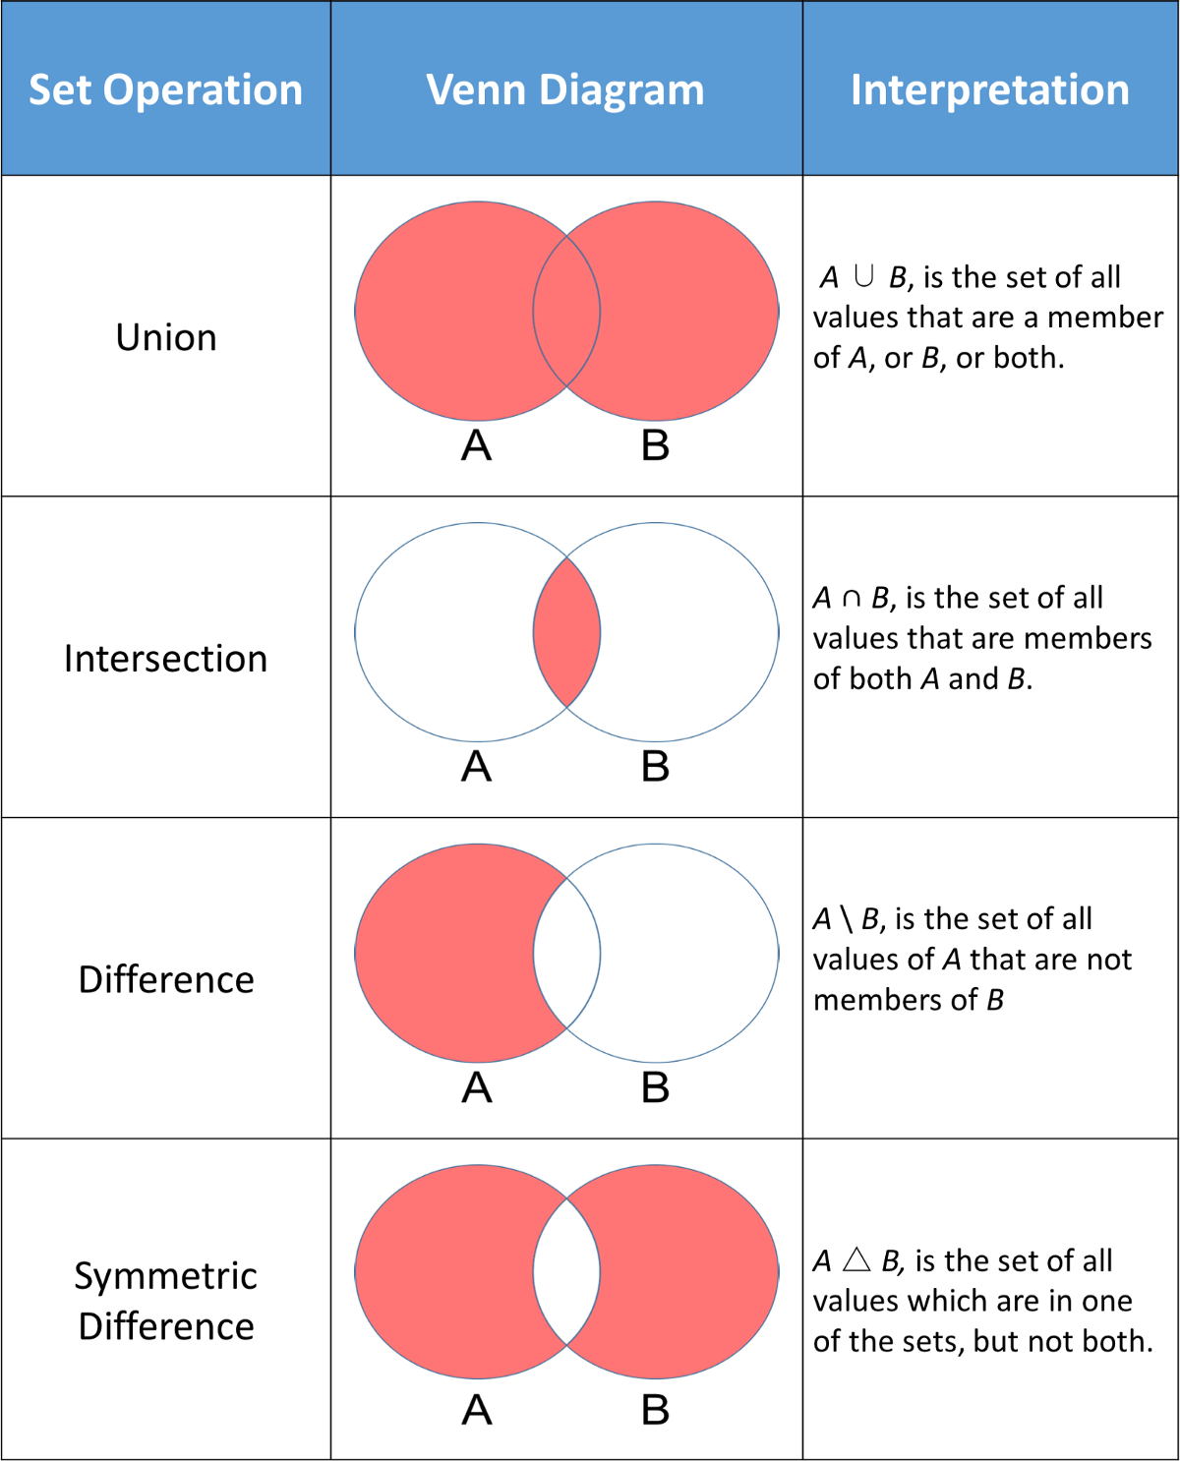

## dict

key:value pair

keys:

immutable

unique

values:

anything

**mutable**

### dictionary functions

values() keys()

## flow control

### if else

if

elif

else

### while

while

else with while

### for

else with for

## modules

### builtins:

__builtin__

__builtins__

### import

#### ways to import

1. import colour

colour.blue()

colour.red()

colour.black()

1. from colour import blue, red

blue()

red()

~~black()~~

1. from colour import *

blue()

red()

black()

1. import colour as c

c.blue()

c.red()

c.black()

1. from colour import blue as b

b()

## file handling

### attributes

fa = open()

fa.close()

fa.read()

fa.readline()

fa.readlines()

fa.write()

fa.readable()

fa.writable()

fa.tell()

fa.seek()

fa.closed

### modes

r reading

w writing

always treats it like a new file

a append

r+ read & write

b binary