## Basics

### environments & IDEs

IDLE

jupyter

spyder

co-labs

pycharm

VScode

Visual studio

notepad (run it through command line)

### file types

.py python files

.ipynb python notebooks

### REPL

Read Eval Print loop

### general

object based language

oops

### Joining links

| Day 1 (1st Half) | <https://infineon.webex.com/infineon/j.php?MTID=m485493b713c74dc645673e5622f5e65f> | **758093** |
| --- | --- | --- |
| Day 1 (2nd Half) | <https://infineon.webex.com/infineon/j.php?MTID=mb17d29503d013cd71c5b0226f14cb01c> | **170161** |
| Day 2 | <https://infineon.webex.com/infineon/j.php?MTID=m2f516d03b4de1cc00dea97eba3c5a8ed> | **144354** |
| Day 3 | <https://infineon.webex.com/infineon/j.php?MTID=me062e7052c723d6cba0c9304f5af95cd> | **440173** |
| Day 4 | <https://infineon.webex.com/infineon/j.php?MTID=ma1e06e17a606e4186f59e2583192d37f> | **338384** |

# Python

## Language

### comments

# single line comments

""" multi line comments (doc strings)

### data types (infinite)

int

float

str

bool

True

False

### keywords

True False

and or not

in is

del

if elif else

pass

for while

break continue

def global return

import from as

### naming_conventions

start with alphabets, underscores

can have alphabets, numbers or underscores

## functions

### generic

print()

type()

help()

input()

### conversion

int()

float()

str()

complex()

list()

tuple()

set()

### sequence

len()

min()

max()

sum()

any()

all()

sorted()

### used defined

def

default values

named arguments

arbitrary

args, kwargs

return:

default None

global local

### advance

filter()

map()

lambda

### False

False #bool

0 #value is zero

0.0 #value is zero

None #NoneType

[ ] empty list

{ } empty dict

'' empty string

## operators

chaining

### arithmetic

+

-

/

*

%

// floor division

** power of

=

### logical

and

or

not

### comparative (relational)

<

>

<=

>=

==

!=

### membership

in

not in

### identity

is

is not

### bitwise

&

|

^

~ not

<<

>>

## strings

text data

double quotes & single quotes

"hello"

'world'

**immutable**

index

negative indexing

out of index error

slicing

step

player = “nadal”

| n | a | d | a | l |
| --- | --- | --- | --- | --- |
| 0 | 1 | 2 | 3 | 4 |
| -5 | -4 | -3 | -2 | -1 |

### string functions

lower upper

title capitalize

find rfind count

isalpha isdidgit isalnum

split

### escape characters

\n new line

\t tab

\\ \

\" "

\v vertical

\r return key

### doc-strings

""" """

''' '''

## list

any kind of data

duplicates are allowed

index

negative index

sliced

step

nesting

**mutable**

### list functions

index count

reverse sort() sort(reverse=True)

insert append extend

remove pop clear

## tuple

any kind of data

duplicates are allowed

index

negative index

sliced

step

nesting

**immutable**

### tuple functions

index count

## set

only immutable

duplicates are not allowed

only unique members

unordered

no indexing

no slicing

no nesting

**mutable**

### set functions

union

…

…

### set operation

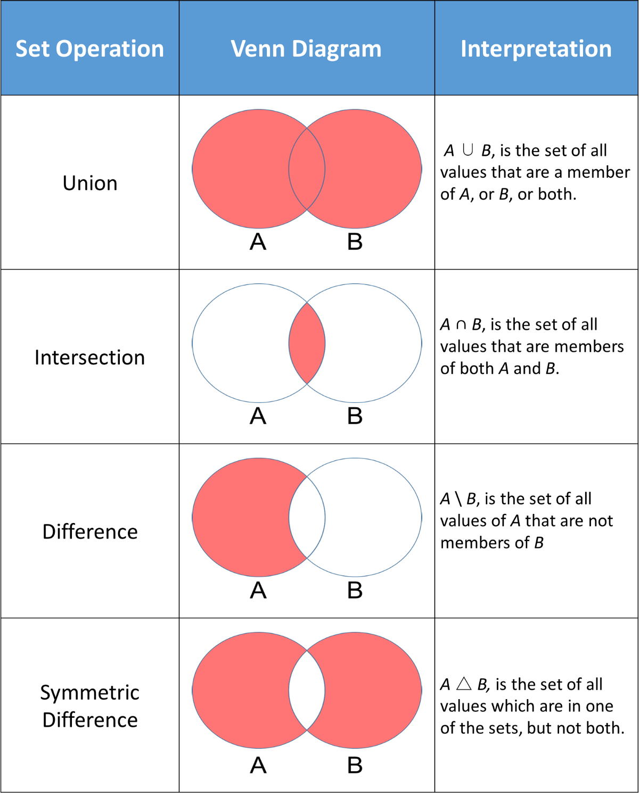

## dict

key:value pair

keys:

immutable

unique

values:

anything

**mutable**

### dictionary functions

values() keys()

## flow control

### if else

if

elif

else

### while

while

else with while

### for

else with for

## modules

### builtins:

__builtin__

__builtins__

### import

#### ways to import

1. import colour

colour.blue()

colour.red()

colour.black()

1. from colour import blue, red

blue()

red()

~~black()~~

1. from colour import *

blue()

red()

black()

1. import colour as c

c.blue()

c.red()

c.black()

1. from colour import blue as b

b()

## Some useful modules:

### Web Development - Frameworks

Django - High-level web framework.

Pyramid - Turbogears, Pylons, Repoz.bfg merged as Pyramid.

TurboGears - Rapid web development megaframework.

Pylons - A lightweight web framework emphasizing flexibility and rapid development.

web2py - High-level framework for agile development.

Flask - microframework for Python based on Werkzeug, Jinja 2. (It's BSD licensed)

### Web Development

Beautiful Soup - A Python library designed for quick turnaround projects like screen-scraping.

scrape - A Python module for web browsing and scraping.

mechanize - Stateful programmatic web browsing in Python.

smtp - mail services

libgmail - A pure Python binding to provide access to Google’s Gmail web-mail service.

Google Maps - This library brings the Google Maps Platform Web Services to your Python application.

Requests - allows you to send HTTP/1.1 requests extremely easily.

Selenium - With this module, developers can programmatically open webpages, enter fields, click buttons, and submit forms.

### GUI (Graphical User Interface)

PyGtk - cross-platform Gtk toolkit.

PyQt - cross-platform Qt framework.

TkInter - The traditional Python user interface toolkit. Comes with the core installation

WxPython - wxWidgets.

PyjamasDesktop - a framework for the cross-platform webkit.

PySimpleGUI - Wrapper for TkInter that makes customer GUI development easy and compact

### Data Sciences, Machine Learning, Artificial Intelligence

SciPy - ecosystem of open-source software for mathematics, science, and machine learning.

Matplotlib - A Python 2D plotting library which produces publication quality figures in a variety of hardcopy formats and interactive environments across platforms. Matplotlib can be used in Python scripts, the Python interpreter, the Jupyter notebook, web application servers etc

Pandas: A fast, powerful, flexible and easy-to-use open source data analysis and manipulation tool.

Numpy - It has advanced math functions and a rudimentary scientific computing package.

### Networking

asyncoro - Asynchronous, concurrent programming framework with coroutines with thread-like interface

Gevent - Coroutine-based network library

TwistedMatrix - Event-driven networking framework

RPyC - Transparent RPC/distributed-computing framework

PyRO - powerful OO RPC

Celery - Distributed task queue for out of band processing/RPC and more.

### Game Development

Pygame - A set of modules designed for writing video games. Pygame - adds functionality on top of the excellent SDL library. This allows you to create fully featured games and multimedia programs in the Python language.

Pyglet

pyOpenGL: The most common cross platform Python binding to OpenGL and related APIs.

### Databases

cx_oracle : engine for all oracle based databases

sqlite3: for SQLite

MySQLdb: Python DB API-2.0-compliant interface for accessing MySQL databases.

PyGreSQL: An open-source module that interfaces to a PostgreSQL database. It embeds the PostgreSQL query library to allow easy use of the powerful PostgreSQL features from a Python script.

Gadfly: A simple relational database system implemented in Python based on the SQL Structured Query Language.

SQLAlchemy: A Python SQL toolkit and Object Relational Mapper that gives application developers the full power and flexibility of SQL.

### Image & Video Manipulation

Python Imaging Library (PIL): PIL adds image processing capabilities to your Python interpreter. This library supports many file formats, and provides powerful image processing and graphics capabilities.

GDmodule: An interface to the GD library written by Thomas Boutell.

VideoCapture: A Win32 Python extension for accessing video devices such as USB WebCams and TV cards.

MoviePy: A Python library for video editing: cutting, concatenations, title insertions, video compositing (a.k.a. non-linear editing), video processing, and creation of custom effects.

pyscreenshot: A cross-platform module that allows to take screenshots without installing 3rd party libraries.

### Excel

pandas

openpyxl

xlsxwriter

writing data

xlrd

reading

xlwt

writing

xlutils

xlrd+xlwt

pylightxl

## file handling

### attributes

fa = open()

fa.close()

fa.read()

fa.readline()

fa.readlines()

fa.write()

fa.readable()

fa.writable()

fa.tell()

fa.seek()

fa.closed

### modes

r reading

w writing

always treats it like a new file

a append

r+ read & write

b binary