# Python

## Basics

### environment/IDEs

IDE - Integrated Development Environment

jupyter notebooks

### editors/tools

text file

VScode

Visual Studio

pyCharm

jupyter

spyder

### anaconda framework

important python libraries

jupyter

spyder

pycharm

R

### general terms (vocabulary)

data (variable, object)

code

functions

sequence iterable

### programming concept

REPL

Read Eval Print Loop

(scripting primarily)

(now also for prog languages)

## Data Types

int integer (natural numbers)

float floating point (decimals, fractions)

11.23

str string (text data)

"ronaldo"

complex

(6 + 3i)

bool

True

False

### false

False

0

0.0

""

[ ]

{ }

None

## comments

# single line comments

## keywords

True False

in not is

and or

if elif else

while

break continue

for

pass

None del

def return

with

## Functions

### general

print()

type()

### sequences

len()

range()

any()

all()

min()

max()

sum()

sorted()

reversed()

### cast

str()

int()

float()

list()

set()

tuple()

## operators

### arithmetic

+ add

- subtract

* multiply

/ divide

% modulo (remainder)

// floor division

** power

= assignment

(no increment/decrement operator)

### relational (comparison)

< less than

> greater than

<= less than or equal to

>= greater than or equal to

== equal to

!= not equal to

### logical

and

(all of them have to be true)

or

(anyone can be true)

not

(negates)

### membership

in

not in

### identity

is

is not

## strings

text

ascii (1 byte)

unicode (2 bytes)

UTF-8 (1 byte)

double quotes or single quotes

"reese"

'reese'

indexed

out of bounds error

negative indexing

slice

no out of bounds error

step

| m | e | s | s | i |
| --- | --- | --- | --- | --- |
| 0 | 1 | 2 | 3 | 4 |
| -5 | -4 | -3 | -2 | -1 |

immutability   
+ concatenates (appends)

### string functions/methods

.upper() .lower()

.capitalize() .title()

.isalpha() .isalnum() .isdigit()

.split() .splitlines()

### escape sequences

\n new line

\b backspace

\t tab space

\\ \  
\" "

\' '

obsolete

\r return

\v vertical tab

## list

any/all kinds

[ ]

ordered

allows duplicate values

indexed

out of bounds error

negative indexing

slice

no out of bounds error

step

mutable

nesting

### list functions/methods

append() insert() extend()

remove() pop() clear()

reverse()

sort() sort(reverse=True)

index() count()

copy()

## tuple

any/all kinds

( )

ordered

allows duplicate values

indexed

out of bounds error

negative indexing

slice

no out of bounds error

step

immutable

nesting

### tuple functions/methods

index() count()

## set

unordered

{ }

no duplicate

only unique

no index

members/elements :

immutable

set by itself : mutable

no nesting

### set operations

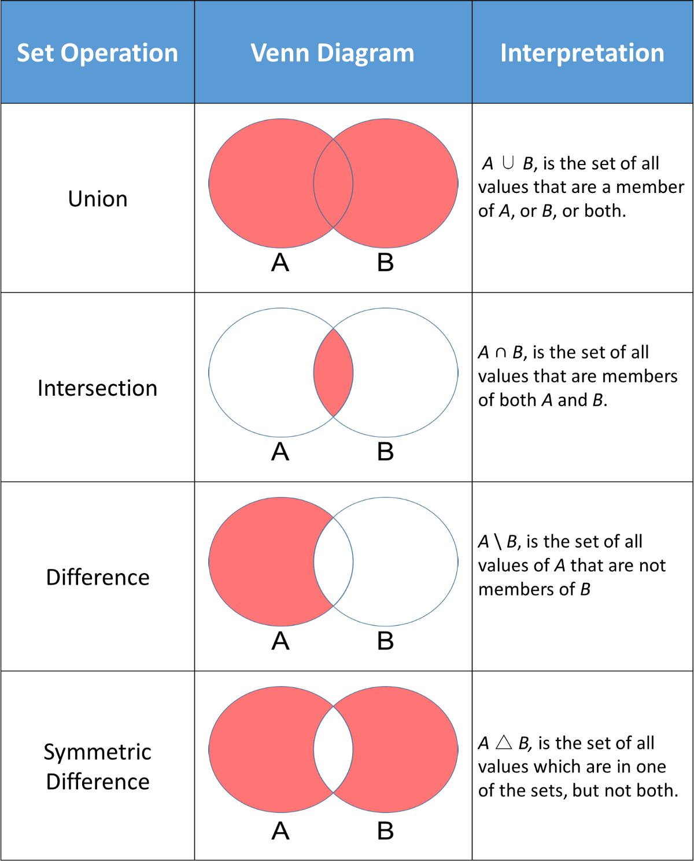

## dict

key:value pairs

ordered

{ : }

value:

anything

mutable/immutable

key:

immutable

strings, numbers

tuples

unique

mutable (by itself)

nesting

as value

### dict functions

.get() .keys()

.values()

.update()

.pop() .popitem()

## Flow Control

break

continue

### if - else

if

elif

else

### while

### for

1. sequences
2. range()

else with for

## Functions (user defined)

### arguments/parameters

any number

default values (right most)

named arguments

### return

multiple

default = None

## Text Files

fa = open()

fa → object, IO_wrapper object, file handler, file pointer

fa.read(n)

fa.readline()

fa.readlines()

fa.write()

fa.readable()

fa.writable()

fa.tell()

fa.seek()

fa.closed

### modes

r read

w write

delete the previous content

treat it like a new file

a append

r+ read & write

with open