## intro

anaconda → framework

IDLE → simple IDE

### environments

jupyter

IDLE

PyCharm

vscode

terminal (command prompt)

### editors

vscode

notepad

vi

sublime

atom

notepad

### code files:

.py

.ipynb

jupyter notebooks:

anaconda → jupyter → browser → select/create folder → python3 →

write code → shift+enter for executing a cell

linux environment

open a terminal → navigate to your folder (cd name) → create a folder (mkdir name)

gedit one.py → write, save, close → python3 one.py

## Basics

### comments

# single line comment

""" """ sometimes used as multiline comment

### keywords

True False

if elif else

break continue

while for

None

### Data Types

int

str string

float

complex

4 + 6i

4 + 6j

bool

True

False

## Operators

### Arithmetic Operators

+ add

- sub

* multiply

/ divide

% modulo

// floor division

** power

= assignment

multiple assignment

no increment/decrement

### Logical Operators

and

or

not

### Relational (conditional) Operators

< less than

> greater than

<=

>=

==

!=

### identity operators

is

is not

### membership operators

in

not in

## strings

text

''

single quotes or double quotes

indexed

negative indexed

IndexError (out of range)

slicing

no IndexError

step

| i | t | a | e | w | o | n |
| --- | --- | --- | --- | --- | --- | --- |
| 0 | 1 | 2 | 3 | 4 | 5 | 6 |
| -7 | -6 | -5 | -4 | -3 | -2 | -1 |

immutable

### string functions

isalnum, isalpha, isdigit

upper, capitalize, title

replace

count, index

### escape sequences:

\n new line

\b backspace

\t tab

\r return

\v vertical tab

## Functions

### general

print

type

### sequence

len

sum

min

max

sorted

### cast (conversion)

int

float

str

list

tuple

set

## list

any data (object)

duplicates allowed

indexed

negative indexed

IndexError (out of range)

slicing

no IndexError

step

mutable

nesting is possible

(to any level deep)

### list functions

append, insert, *extend*

pop, remove, clear

index, count

reverse, sort

copy

## tuple

any data (object)

duplicates allowed

indexed

negative indexed

IndexError (out of range)

slicing

no IndexError

step

immutable

nesting is possible

(to any level deep)

### tuple functions

index, count

## set

unordered

only immutable data allowed

numbers, strings, tuples

duplicates not allowed

only unique values

mutable

nesting is not possible

### set functions

### set operations:

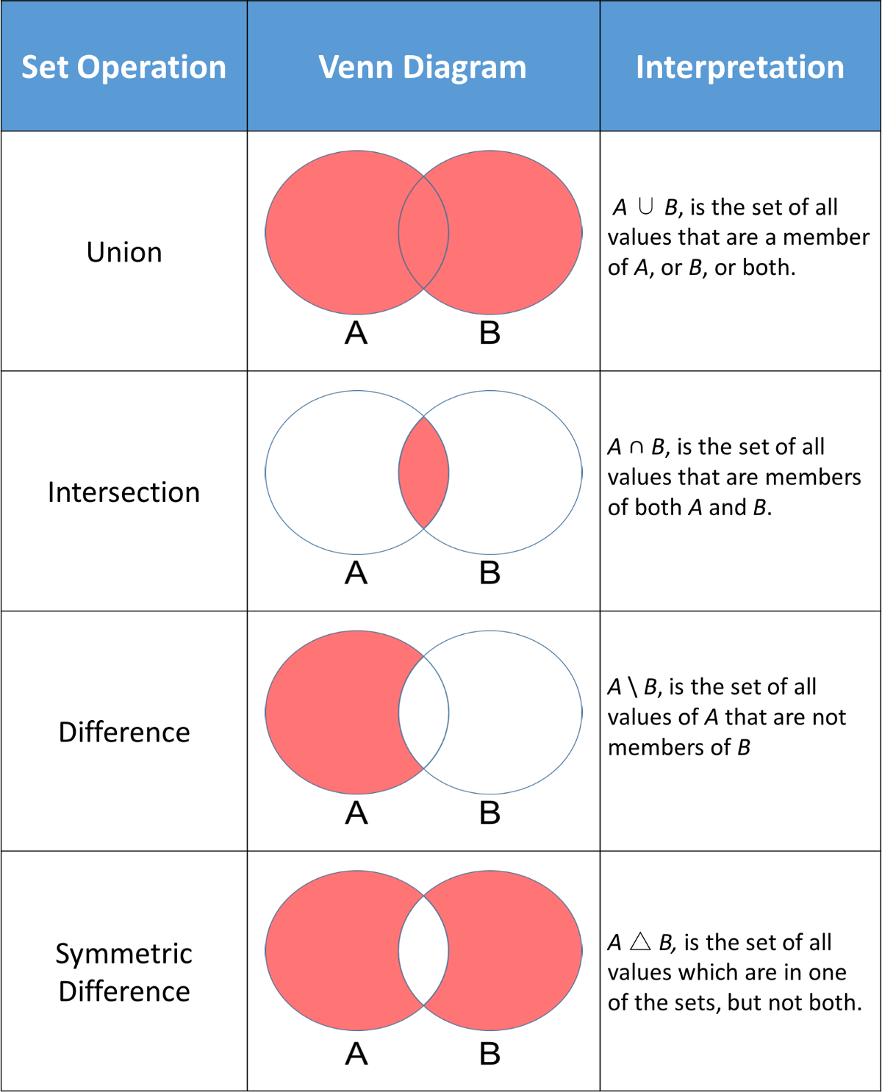

## dict

key : value

ordered (3.6 & above)

unordered (3.5 & below)

index

keys

keys:

immutable

numbers, strings, tuples

unique

values:

anything (mutable also)

by itself dict is mutable

### dict functions

## flow control

### if else

if

elif

else

### while

while

while with else (break)

### for

for

for with else (break)

## Functions

def

defining a function

return

by default None

can return any number

arguments (parameters):

any number (0 to n)

default values

always to the right most

named arguments

variable number of arguments:

args

inner functions

## module

once imported, will not import again

unless reloaded using importlib

### ways of import

1. import colours

colours.white()

colours.black()

colours.blue()

colours.estonia()

colours.greece()

1. from colours import white blue

white()

~~black()~~

blue()

~~estonia()~~

~~greece()~~

1. import colours as c

c.white()

c.black()

c.blue()

c.estonia()

c.greece()

1. from colours import whiteas w

w()

1. from colours import *

white()

black()

blue()

estonia()

greece()