## intro

anaconda → framework

IDLE → simple IDE

### environments

jupyter

IDLE

PyCharm

vscode

terminal (command prompt)

### installations

#### python:

core python: python.org

core + many libraries: anaconda.org

(jupyter notebooks)

#### linux:

sudo apt install python3

sudo apt install python3-pip

pip is the python library installer

pip install flask

### editors

vscode

notepad

vi

sublime

atom

notepad

### code files:

.py

.ipynb

jupyter notebooks:

anaconda → jupyter → browser → select/create folder → python3 →

write code → shift+enter for executing a cell

linux environment

open a terminal → navigate to your folder (cd name) → create a folder (mkdir name)

gedit one.py → write, save, close → python3 one.py

## Basics

### comments

# single line comment

""" """ sometimes used as multiline comment

### keywords

True False

if elif else

break continue

while for

None

### Data Types

int

str string

float

complex

4 + 6i

4 + 6j

bool

True

False

## Operators

### Arithmetic Operators

+ add

- sub

* multiply

/ divide

% modulo

// floor division

** power

= assignment

multiple assignment

no increment/decrement

### Logical Operators

and

or

not

### Relational (conditional) Operators

< less than

> greater than

<=

>=

==

!=

### identity operators

is

is not

### membership operators

in

not in

## strings

text

''

single quotes or double quotes

indexed

negative indexed

IndexError (out of range)

slicing

no IndexError

step

| i | t | a | e | w | o | n |
| --- | --- | --- | --- | --- | --- | --- |
| 0 | 1 | 2 | 3 | 4 | 5 | 6 |
| -7 | -6 | -5 | -4 | -3 | -2 | -1 |

immutable

### string functions

isalnum, isalpha, isdigit

upper, capitalize, title

replace

count, index

### escape sequences:

\n new line

\b backspace

\t tab

\r return

\v vertical tab

## Functions

### general

print

type

### sequence

len

sum

min

max

sorted

### cast (conversion)

int

float

str

list

tuple

set

## list

any data (object)

duplicates allowed

indexed

negative indexed

IndexError (out of range)

slicing

no IndexError

step

mutable

nesting is possible

(to any level deep)

### list functions

append, insert, *extend*

pop, remove, clear

index, count

reverse, sort

copy

## tuple

any data (object)

duplicates allowed

indexed

negative indexed

IndexError (out of range)

slicing

no IndexError

step

immutable

nesting is possible

(to any level deep)

### tuple functions

index, count

## set

unordered

only immutable data allowed

numbers, strings, tuples

duplicates not allowed

only unique values

mutable

nesting is not possible

### set functions

### set operations:

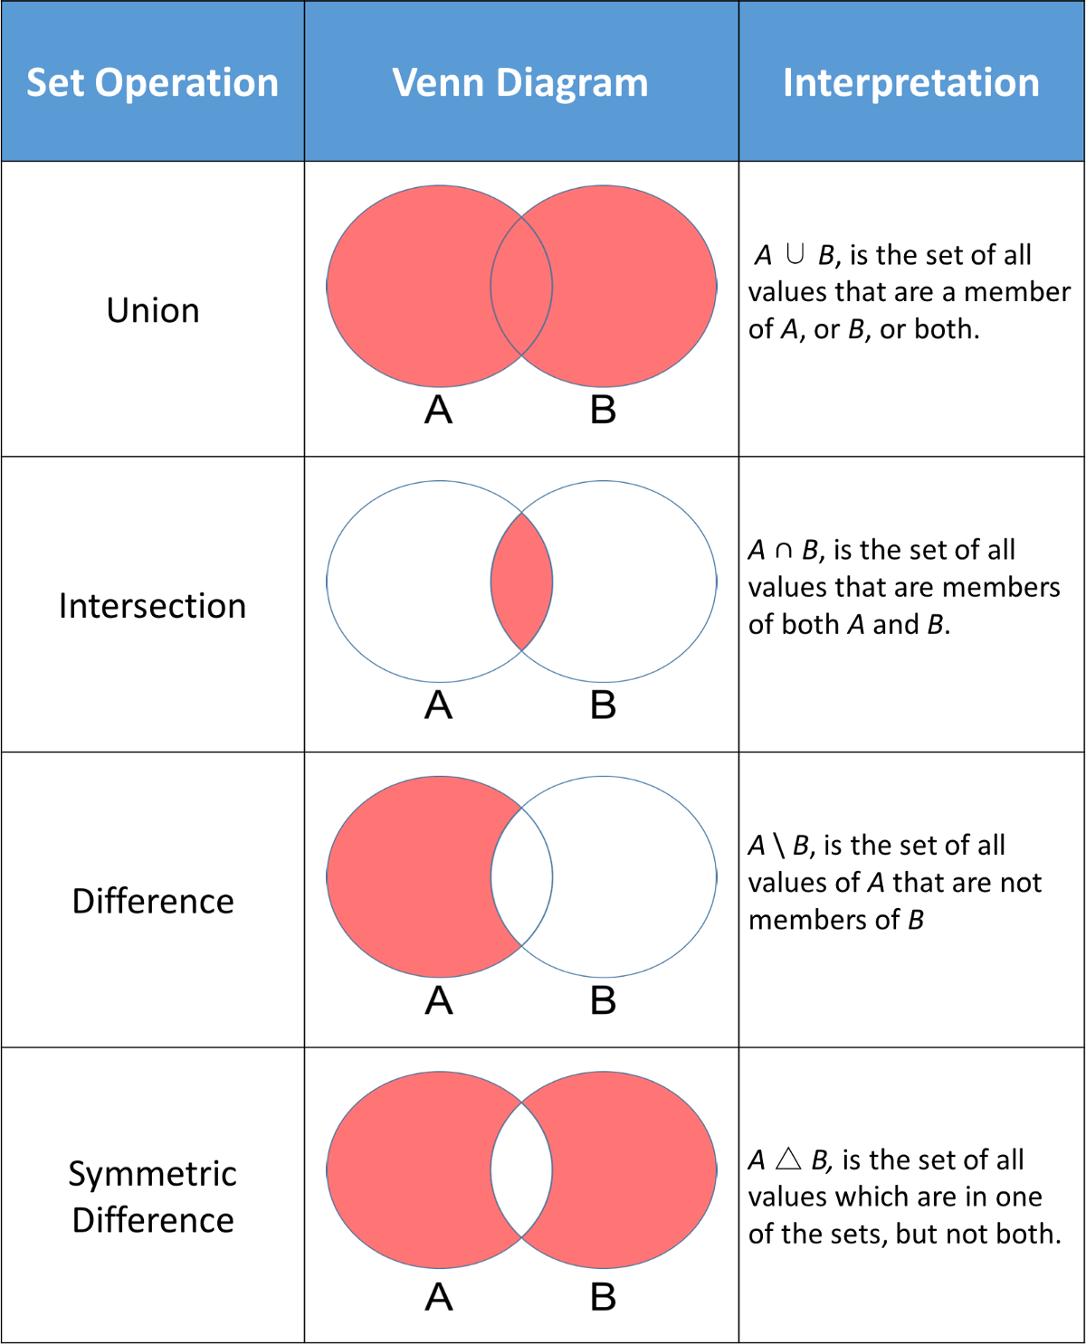

## dict

key : value

ordered (3.6 & above)

unordered (3.5 & below)

index

keys

keys:

immutable

numbers, strings, tuples

unique

values:

anything (mutable also)

by itself dict is mutable

### dict functions

## flow control

### if else

if

elif

else

### while

while

while with else (break)

### for

for

for with else (break)

## Functions

def

defining a function

return

by default None

can return any number

arguments (parameters):

any number (0 to n)

default values

always to the right most

named arguments

variable number of arguments:

args

inner functions

## module

once imported, will not import again

unless reloaded using importlib

### ways of import

1. import colours

colours.white()

colours.black()

colours.blue()

colours.estonia()

colours.greece()

1. from colours import white blue

white()

~~black()~~

blue()

~~estonia()~~

~~greece()~~

1. import colours as c

c.white()

c.black()

c.blue()

c.estonia()

c.greece()

1. from colours import whiteas w

w()

1. from colours import *

white()

black()

blue()

estonia()

greece()

### package

__init__.py in any folder will make it look like a package

if you import a folder, it will automatically run __init__.py within that folder

## OOP

### polymorphism

function overloading:

java, c++

operator overloading:

python, c++

no function overloading in python

overriding exists

### inheritance

multilevel

multiple

### encapsulation

private:

attributes and methods created using __ (double underscores)

example : __data

## exceptions

try except else finally

1. exception is raised and handled

except block executes

finally block executes

code continues

1. exception was never raised

else block will execute

finally block executes

code continues

1. exception was raised, not handled

finally executes

code crashes (stops)

## web frameworks

flask

django

web2py

bottle

pyramid

falcon

turbogears

cubicweb

pylons

## flask

## testing in python

Manual

automated

unit

integration

### assert

### Test runner

unitest

pytest

nose2

### unitest

FAIL F

(pass) .

ERROR E

OK

when everything passes

SKIP S

expected failure X

python3 one.py

python3 -m unittest

-v verbose( more detailed output)

-f stop at first failure

#### asserts

assertEqual()

assertNotEqual()

assertTrue()

assertFalse()

assertIs()

assertNotIs()

assertIsNone()

assertGreater()

assertGreaterEqual()

assertLess()

assertLessEqual()

assertIn()

assertNotIn()