## Basics

### installations

python.org

anaconda.org

### file extensions

.py regular file

.ipynb python notebook

jupyter

spyder

### IDE & editors

vscode

visual studio

pycharm

IDLE

jupyter

spyder

### keywords

True False

None

del

and or not

is in

### REPL

Read Eval Print Loop

everything is an object

type

### Data Types

regular:

int

float

str

complex

7 + 8j

### bool

True

False

### False

False

0

0.0

"" empty strings

[ ]

{ }

None

### comments

# single line comments

docstring used as multiline comment

## Functions

### general

print()

type()

### sequence

len()

sorted()

### cast (convert)

int()

float()

str()

list()

tuple()

set()

## Operators

### arithmetic

+

-

*

/

% remainder

// floor division

** power of

= assignment

### relational (conditional)

<

>

<=

>=

==

!=

### logical

and

or

not

### identity

is

is not

### membership

in

not in

## str

strings (text)

utf-8

ascii

double quotes or single quotes

indexed

IndexError (out of range)

negative indexing

slicing

upper range not included

steps are possible

no IndexError

| b | e | r | r | y |
| --- | --- | --- | --- | --- |
| 0 | 1 | 2 | 3 | 4 |
| -5 | -4 | -3 | -2 | -1 |

immutable

### str functions

upper, lower, capitalize, title

index, count, rindex

isalnum, isalpha, isdigit

replace,

strip, lstrip, rstrip

…. … …

### escape sequences

\n new line

\b backspace

\t tab

\\ \

\" "

obsolete:

\r return

\v vertical tab

## list

can include any/all data type

indexed

IndexError (out of range)

negative indexing

slicing

upper range not included

steps are possible

no IndexError

mutable

nesting

any level

### list functions

append, extend, insert

remove, pop, clear

reverse, sort

copy

count, index

## tuple

can include any/all data type

indexed

IndexError (out of range)

negative indexing

slicing

upper range not included

steps are possible

no IndexError

immutable

nesting

any level

### tuple functions

count, index

## set

unordered

only unique members

no duplicates

no index, no slicing, no step

members:

immutable

by itself is mutable

no nesting

### operations

| union

& intersection (union)

- difference (common members)

^ symmetric diff (uncommon members)

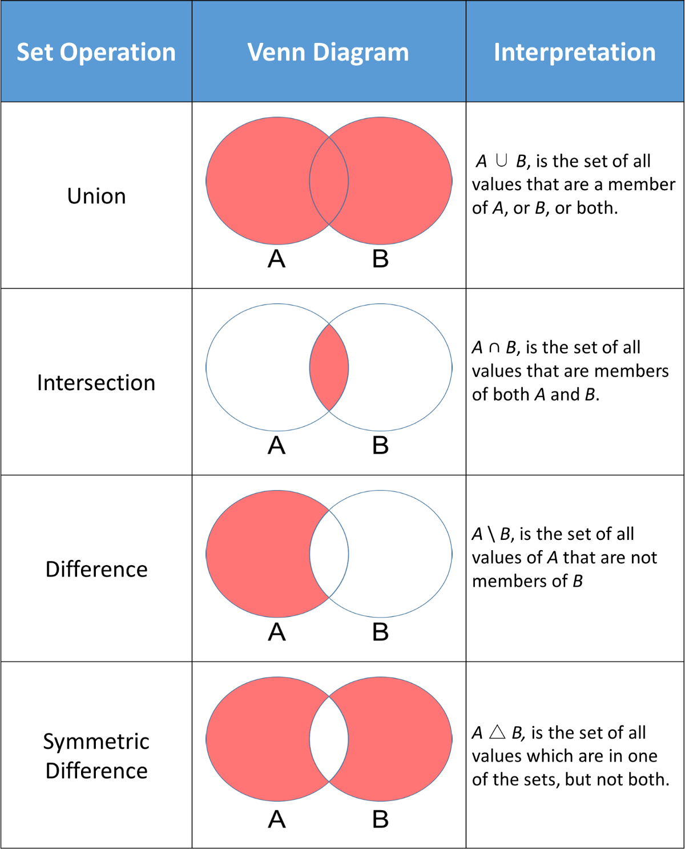

### set functions

add

remove (raises error if member not present), discard, clear

pop(removes some random member)

## dict

key:value pair

unordered : older

ordered : newer

indexed using keys

no slicing, no step

keys:

only unique

no duplicates

immutable (strings, integers, tuples)

values:

anything

by itself dict is mutable

nesting is possible

as values

## Flow control