## Basics

* operating system
* free
* open source

### History

Ken Thompson 1970s UNIX

GE → Bell labs

PDP7 PDP11

MULTICS

UNICS

Unix

Dennis Ritchie 1970s C

Brian Kernigham

Linus Torvalds 1990s Linux

Richard Stallman

### open source

1. sell the cake, recipe private
2. sell the cake, recipe public
3. free cake, recipe private
4. free cake, recipe public

source code open

firefox

VLC

GIMP

Blender

Audacity

wordpress

Linux

### standards

### kernel

* core part

### unix based

BSD Unix

Next

Darwin

Solaris

AIX

HP-UX

Xenix

Free BSD

### linux based

RedHat Linux

Linux Mint

OpenSuse

Debian Linux

Elementary OS

Raspbian

Kali Linux

Ubuntu

BOSS

## linux architecture



### layers

hardware layer

* CPU
* memory
* storage
* peripheral devices

kernel

* process management
* memory management
* File System management
* Device Drivers
* network stack

system libraries

* system call interface
  + write()
  + open()
  + file operations
  + process control
  + IPCs
* GNU C (glibc)
* utilities & commands
  + ls cp grep
  + systemctl

shell

user applications

web browsers

text editors

development tools

### key concepts

* modularity
* monolithic
* security
* flexibility

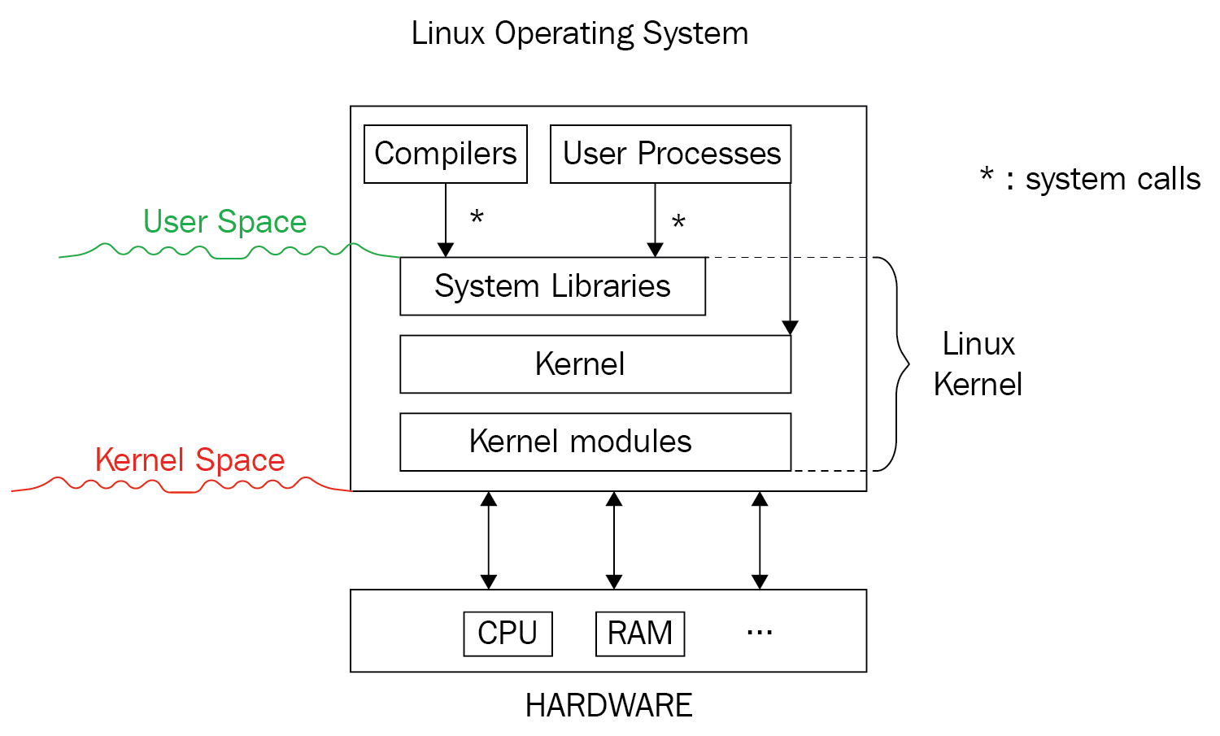

### file architecture

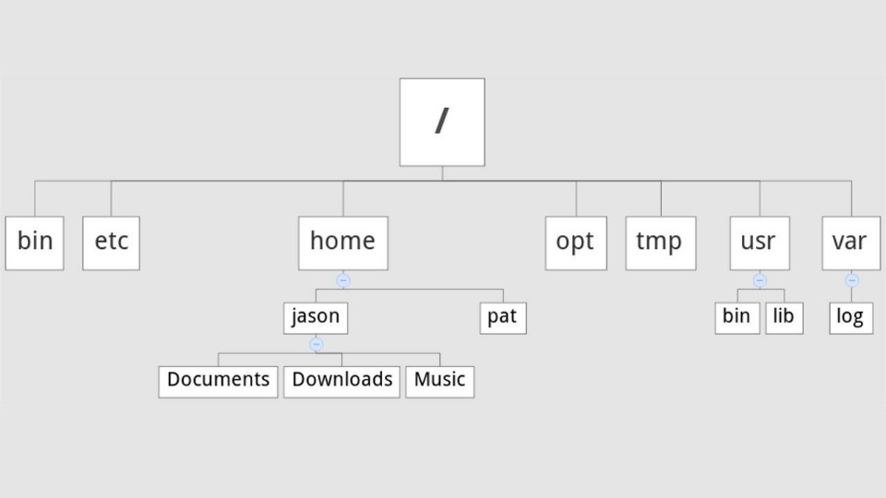

* inverted tree architecture

### init subsystem

* pid 1
* starting

legacy sysV init

* traditional
* /etc/inittab
* /sbin/init

systemd

* modern

other inits

OpenRC

runit

s6

### runlevels

* states of the system
* 0 halt the system
* 1 single user mode
* 2 multi user mode
* 3 multi user mode (with networking)
* 4 user-defined
* 5 multi user mode (with networking) with GUI
* 6 reboot the system

## shell

* terminal
* command line interpreter (CLI)

sh

ksh

csh

tcsh

zsh

fish

bash

username@hostname folder

$ normal user

>

#

### command structure

command options arguments

command arguments options

### man pages

1. user commands
2. system calls
3. library functions
4. special files

/dev

1. file formats & conventions
2. games , screensavers
3. misc

signals

man printf

### environment variables

SHELL

LOGNAME

HOME

PATH

PWD

PS1

PS2

HISTSIZE

set prompt = %n@%m:%~%”

## commands

* fundamental unit

### builtins

cd echo alias type history

### basic commands

ls

list down

-l long listing

-a all (hidden)

-h

date

cal

-y

clear

bc

pwd

cd

### help

whatis

- - help

apropos

#### man

/text search for “text”

n

shift + n

q

### other commands

who

whoami

wc

-l

-w

-c

alias

unalias

hostname

uname

### find

-name

-iname

-type

d

f

-exec

### pipes |

### 

## files & directories

### files

* basic unit of data storage
* text files

.py .c .cpp

* binary files

gedit

### view files

cat

less

more

nl

### other commands

cp

mv

move

rename

rm

-i

-r

-f

### directories

* other files & folders
* addresses of files & folders

cd

change directory

cd Desktop

.. parent directory

~ home directory

. current directory

mkdir

make a directory

rmdir

remove an empty directory

rm -r remove a directory with subdirectories & files

### editors

vi (vim)

nano

gedit

atom

sublimetext

vscode

emacs

notepad++

### redirection

>

> filename

>>

append

### types of files

-rw-rw-r–

1. regular files

-

1. directory

d

1. symbolic link

l

1. character device files

c

1. block device files

b

1. socket files

s

1. pipes (fifos)

p

### file numbers

#### inode

* unique identifier

ls -i

#### file descriptor

* temporary
* lowest possible number
* local to the process

stdin 0

stdout 1

stderr 2

hello.txt 3

stdin 0 → /dev

stdout 1 → /dev

stderr 2 → /dev

hello.txt 3 → /home/john……/hello.txt

### links

1. hard link
2. symbolic (soft) link

## vi (vim)

insert mode

i

command mode

esc

:w save (write)

:wq save & quit

:q! quit without saving

:w! save as

:x

dd cuts a line

delete

3dd cuts 3 lines

p paste

u undo

ctrl+r redo

yy copy

7yy copies 7 lines

## users groups

* uid
* gid

superuser root

access control list

### mode

| permissions (mode) | | |
| --- | --- | --- |
| jane | training | others |
| read write ~~execute~~ | read write ~~execute~~ | read ~~write~~ ~~execute~~ |
| r w - | r w - | r - - |
| 1 1 0 | 1 1 0 | 1 0 0 |
| 6 | 6 | 4 |
| u | g | o |
|  |  |  |

user group others

chmod o+w beatles.txt

chmod +w

### commands

sudo

su

useradd

passwd

groupadd

usermod

-g

chmod

chown

chgrp

## wild cards

*

?

[ ]

## scripts

.tcsh_profile

.tcshrc

.profile

## grep

-n

-i

-v

-w

find ~/Desktop -name "*.c" → names(paths) of these files

grep "thread" → look for “thread” in the name (path) of these files

### regex

#### metacharacters

. placeholder for 1 (any) character

^ starts with

$ ends with

* zero or more occurrences

[ ] options

range

#### extended regex

grep -E

egrep

? zero or one occurrence

+ one or more occurrences

{ } repetition

{n}

{n,m}

| alteration

## process

pid

ppid

username

uid

gid

blocked signals

process state

system time at launch

elapsed time

CPU time

number of threads

thread IDs

RSS

VIRT or VSZ

priority

nice value

### commands

ps

-a hidden process in the shell

-A all process in the system

-ax all process, limited columns

-C search for a process by name

-o customising the output

-o options

pid

ppid

tty

%cpu

%mem

time

stime

etime

cmd

pri

user

stat

lwp

nlwp

kill

top

fg

nice

renice

pstree

nohup

#### commands with names of process

stark_arya

stark_sansa

stark_bran

snow_jon

stark_tony

stark_robb

pkill stark

pidof

pkill

killall

prlimit

pmap

pgrep

skill

chrt

htop

ntop

watch

### state

| run | R | actively using the CPU |
| --- | --- | --- |
| sleep (wait) | S | waiting for an event to happen  waiting for a timer to get over |
| stop | T | paused and sent to background |
| kernel | I | kernel based process |

D

z

### signals

| signal | keyboard? | ignored? | default action |  |
| --- | --- | --- | --- | --- |
| SIGTERM | no | yes | terminate the process | 15 |
| SIGNIT | ctrl + C | yes | terminate the process | 2 |
| SIGKILL | no | no | terminate the process | 9 |
| SIGSTOP | ctrl + Z | no | put it in “stop” state |  |
| SIGSEGV |  | yes | terminate (segmentation fault) |  |
| SIGFPE |  |  |  |  |
|  |  |  |  |  |

default sigterm

### background process

1. background of the system

daemon

1. background of a shell

### priority nice

lower the number, higher the priority

higher the nice value, lesser consumption

pri 20 35

nice 0 15

nice

renice

-20 to 19

### sessions

shell → px → py → pz

session leader

nohup

### /proc

procfs

## all commands

pwd

ls

cal

bc

date

whatis

man

apropos

clear

mkdir

rmdir

cd

cp

mv

rm

cat

head

tail

less

more

most

nl

su

who

whoami

useradd

passwd

groupadd

usermod

chmod

chown

groups

id

exit

alias

unalias

hostname

uname