## Basics - History

Richard Stallman

Ken Thompson

Dennis Ritchie & Brain Kerningham

C

Linus Torvalds

### Unix

1960s AT&T Bell Labs

MULTICS

UNICS

UNIX

### BSD

Berkeley Software Distribution

vi

C shell

TCP/IP

### GNU

GNU Not Unix

GPL

### Linux

Linus Torvalds

### distributions

unix:

macOS

Darwin

solaris

IBM AIX

HP-UX

FreeBSD

BOSS

MX Linux

Manjaro

mint

ubuntu

debain

raspbian

## Basics

### Architecture

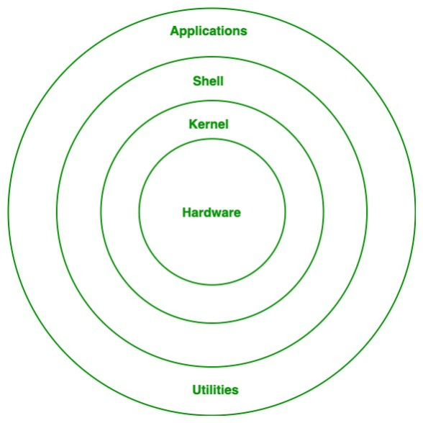

### libraries & tool chains

glibc

uClibc

Busybox

Readline

X Window System (X11, x)

Wayland

### Shell

ksh

tcsh

zsh

Fish

bash

## Commands

command

command with options

with arguments

### Basic commands

ls

-l long listing

-a hidden (all)

-h memory in kb/gb etc

-i inode number

#### man

1 commands

2 system calls

3 functions

7 signals

#### cd

absolute path

cd /Users/shobhit/Desktop/qualcomm/kalki

relative

cd kalki

home

cd ~

#### mkdir

## Editors

CLI & GUI

nano

vi (vim)

gedit

atom

sublimetext

vscode

emacs

notepad++

### vi

edit mode (insertion) i

command mode esc

#### vi commands (command mode)

i insert

esc command mode

:w save

:wq save & quit

:w! <filename> save as

:q! quit without saving

dd delete

3dd delete 3 lines

u undo

yy copy

p pasting

H top of screen

L bottom of screen

w start of word

e end of word

O start of line

^ first non blank character

## Files & Directories

cp copy

mv move

rename

rm remove

rmdir remove an empty directory

### output redirection

>

>>

## User & Groups

user

super user (root)

### modes (permissions)

r read

w write

x executable

trainings.data

user group others

rashmi training others

r w - r w - r - -

1 1 0 1 1 0 1 0 0

6 6 4

666

chmod 666 filename

chmod o+w filename add w for others

chmod +x add executable permission for others

chmod g-r remove read permission for group members

chown change owner

chgrp change group

application → user (owner) is Anish

→ run by Nithish

## intermediate concepts

### wc

-c

-l

-w

### inode

unique identifier

ls -i

### wild cards

*

?

### find

-name

-type

d

f

### pipe

### grep

-v

-w

-i

-n

### TAR ZIP

Tape ARchives

gzip

tar.gz .tgz

bz2

zip

### links

1. hard links
2. symbolic (short) links

### misc commands

lsof

list open files & the processes that have them open

lsdev

list info about installed devices

lsub

list USB devices connected to the system

lspci

list PCI devices connected to the system

procinfo

vmstat

## process

PID

ps

% CPU

blocked signals

process state

user name , UID  
group ID

system time at launch

CPU time

running since when

number of threads

pid

ppid

RSS

VIRT

% memory

priority

TTY terminal

### ps

-a hidden process in the shell

-A all process in the system

aux all process with a different set of columns

-ef all process with a different set of columns

-ax all process with only limited columns

-C search for a process by name

-o customising the output columns

### state of process

run R actively using the processor

sleep (wait) S waiting for an event to happen

waiting for a timer to get over

stop T paused & sent to the background

kernel I kernel based process

### signals

| signal | can be sent from keyboard ? | can be ignored ? | default action |
| --- | --- | --- | --- |
| SIGTERM | no | yes | terminate the process |
| SIGINT | ctrl + C | yes | terminate the process |
| SIGKILL | no | no | terminate the process |
| SIGSTOP | ctrl + Z | no | put in STOP state |
| SIGCONT | no | yes | continue a process |

### background process

daemon

### file descriptors



lowest possible number

stdin 0

stout 1

stderr 2

### priority

nice

nice -n 10 ./4.sh

### miscl commands

ulimit

prlimit

taskset

top

htop

choom

changes the OOM (out-of-memory)

choom -p -1000 812

slabtop

pgrep

pmap

sgrep

sgrep text 812

## file systems

extended file systems

ext4

btrf

zfs

xfs

vfs

procfs

processes

## Script

### environment variables

### user defined variables

age=41

name=”john doe”

### conditional

#### if else

if [ conditional expression ]

then

commands

else

other commands

fi

-eq

-ne

-lt

-le

-gt

-ge

-e file exists

-f file exists & is not a directory

-d directory exists

-x is executable

-w file is writable

-r file is readable

#### case

#### for

#### while

while [ conditional expression ]

do

commands

done

#### until

until [ conditional expression ]

do

commands

done

### special variables

$$ pid

$n argos ($1, $2, $3…….)

$0 name of the script

$? exit status of last command executed

$_ last argument of previous command

$! pid of last background command

## network

### MAC

Media Access Control

08:00:27:3e:4c:a2

### IP address

223.230.16.198

IPv4

127.0.0.1

### DNS

### ping

packet internet groper

### remote connections

FTP (file transfer protocol)

Telnet

SSH (secure shell)

RDP

HTTP

OpenSSH

### misc commands

ntop

ntop eth0

iptraf

## all commands

pwd

ls

cal

bc

date

whatis

man

apropos

clear

mkdir

rmdir

cd

cp

mv

rm

cat

head

whoami

su

chmod

chown

chgrp

exit

alias