## Basics

interpreted

REPL

Read Eval Print Loop

Data = everything is an object

### extensions & types

.py

.sh

#!/usr/bin/python3

.ipynb

python notebook files

jupyter

cell

shift + enter to execute

spyder

### comments

# single line

doc strings used as multiline

""" """

''' '''

## installation

### ubuntu

$sudo apt install python

$sudo apt install python3-pip

$pip install flask

## Data Types

### basic

int

float

str

complex

4+6i

4+6j

### bool

True

False

### False

0

0.0

[ ]

''

{ }

False

None

## Key Words

and or not

in is

False True None del

if else elif

for while break continue

def return

global

import as

with

pass

try except finally else raise

## Functions

### general

print

type

input

eval

### sequences

len

min

max

sum

all

any

sorted

### convert (cast)

int

float

str

list

tuple

set

## Operators

### arithmetic

+

-

/

*

% modulo (remainder)

// floor division

** power (raised to)

= assignment

### conditional (relational)

<

>

<=

>=

==

!=

### logical

and

or

not

### membership

in

not in

### identity

is

is not

## strings

text data

ascii, unicode

index

negative index

error prone

slice

no indexerror

step

| p | u | s | h | p | a |
| --- | --- | --- | --- | --- | --- |
| 0 | 1 | 2 | 3 | 4 | 5 |
| -6 | -5 | -4 | -3 | -2 | -1 |

immutable

### 

### string functions:

upper, lower, capitalize, title

index, rindex, count

isalpha, isalnum, isdigit

replace

split, splitlines

join

… … …

… … …

### escape sequences:

\n new line

\t tab

\b backspace

\\ \

\’ ‘

\” “

\r, \v, \f

### doc strings:

""" """

''' '''

used by some programmers as multiline comment

works only in scripts

used by all programmers for documentation

has to be first line of

class

method

function

modules

__doc__

## Data Structures

## list

any kind of data

all kinds of data

duplicates allowed

index

negative index

slice

step

nesting

mutable

### list functions

sort, sort(reverse=True)

reverse

index, count

insert, append, extend

remove, pop, clear

copy

## tuple

any kind of data

all kinds of data

duplicates allowed

index

negative index

slice

step

nesting

immutable

### tuple functions

index, count

## sets

no duplicates

unordered

no index

no slice

sets are mutable

members have to be immutable

no nesting

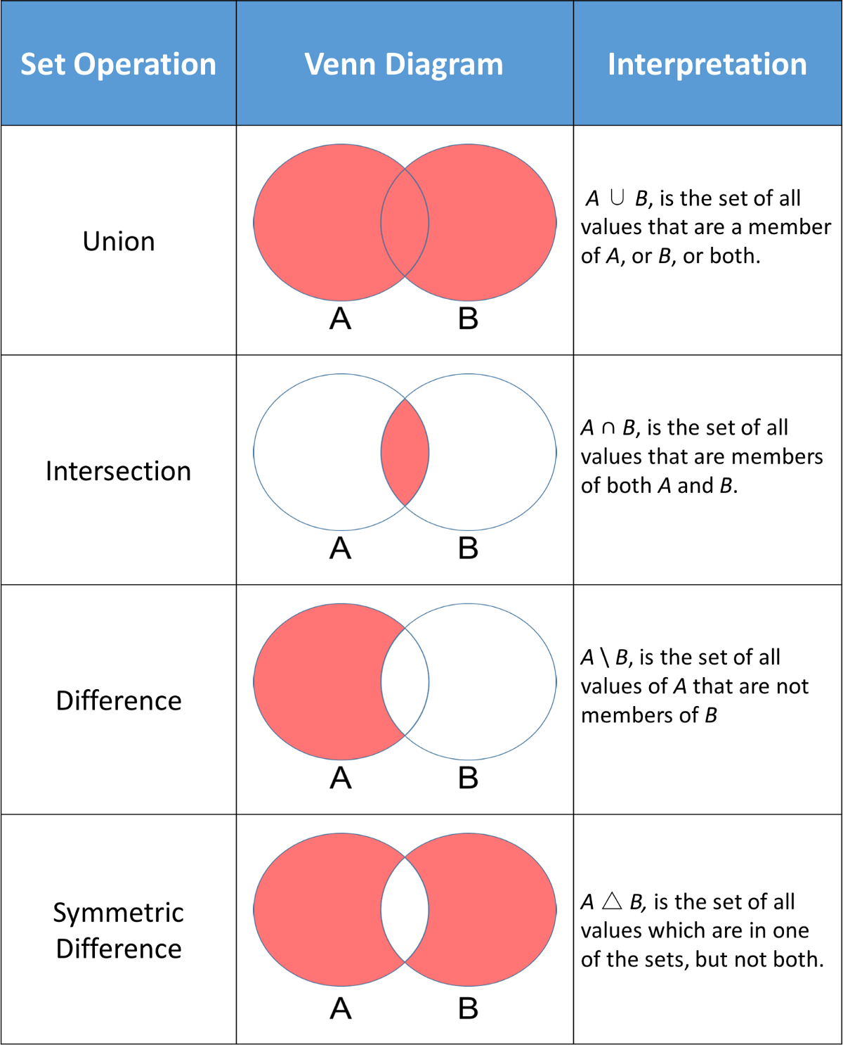

functions:

… … …

## dict

key:value pairs

keys:

immutable

unique

values:

anything

dict themselves are mutable

nesting is possible (as values)

unordered 3.6 & before

ordered 3.7 & later

functions:

values, keys

items

## flow control

### if else

if

elif

else

~~switch case~~

### while

while

~~do while~~

else with while

### for

with sequences

with range

for, break, continue, else

else with for

## User Defined Functions

def

no function overloading

latest definition stays

default arguments (values )

always to the right most

named arguments

return

can return multiple values

default is None

*args

**kwargs

global

## Modules

__builtin__

__builtins__

standard library:

<https://docs.python.org/3/library/index.html>

extra packages:

<https://pypi.org>

ways to import:

1. import colours

colours.blue()

colours.yellow()

colours.green()

1. from colours import blue, yellow

blue()

yellow()

~~green()~~

1. from colours import *

blue()

yellow()

green()

1. import colours as c

c.blue()

c.yellow()

c.green()

1. from colours import blue as b

b()

## OOPs

DRY Don’t repeat Yourself

class

self

__init__()

called by default

### encapsulation

__object

private

~~protected~~

~~inner~~

do not get inherited

### inheritance

multilevel

C++, Java, C#, Python, Ada, Algol…….

multiple

C++, Python

private do not get inherited

### polymorphism

function overloading

C++, Java, C#

operator overloading

C++, Python

magic methods

operator precedence doesn't change

can not create new operators

__add__

friday + saturday

class assumed is of the left data

__radd__

friday + saturday

class assumed is of the right data

chaining of operators

### magic methods

__add__

__mul__

__eq__

__lt__

## File Handling

open

with open

### modes:

r read

w write

(always opens file like a new files)

a append

r+ read & write

b binary

### functions

open

close

read

read(n)

readline

readlines

write

writeline

readable

writable

attribute:

closed

## Regular Expressions

### Meta Characters

^ if starts with a certain character

$ if ends with ascertain character

. any single character

except new line

[ ] set of characters to match

[a-z] all lower

[ _-] space/underscore/hyphen

[0-9] all digits

[a-zA-Z] all alphabets

[0-39] [01239]

[^ ] invert of characters to match

[^a-z] anything except lower case alphabets

* zero or more occurrences of the pattern left to it

+ one or more occurrences of the pattern left to it

? zero or one occurrence of the pattern left to it

| alteration

{ } number of repetitions

{2, 4} min 2 times , max 4 times

\ escape various characters (and metacharacters) \

### Special sequences

\d any digit

\D any non digit

\s whitespace character

space, tab, new line, \v, \r, \f

\S invert of \s

any non whitespace

\w alphanumeric (including underscore)

[a-zA-Z_]

\W invert of \w

re.match

re.findall

re.sub

re.subn

re.split

## Exception Handling

try except as finally else raise

### points:

1. try followed by except (always)
2. default except always at the end
3. nesting
4. custom exceptions

derived from Except class

1. raise exceptions
2. can be received like objects

### situations:

1. no exception

else block, finally block, code continues

1. exception raised, handled

except block, finally block, code continues

1. exception raised, not handled

finally block, code stops

## Concurrency

### multi threading

threading

threading.Thread

start

no priority

prints get distorted

## Parked topics

### (if time permits)

higher order functions

decorators

### to be done

packages

__main__

if __name__ == “__main__”

~~@classmethod~~

~~@staticmethod~~

## 