## Basics

interpreted

REPL

Read Eval Print Loop

Data = everything is an object

### comments

# single line

doc strings used as multiline

""" """

''' '''

## installation

### ubuntu

$sudo apt install python

$sudo apt install python3-pip

$pip install flask

## Data Types

### basic

int

float

str

complex

4+6i

4+6j

### bool

True

False

### False

0

0.0

[ ]

''

{ }

False

None

## Key Words

and or not

in is

False True None del

if else elif

for while break continue

## Functions

### general

print

type

input

eval

### sequences

len

min

max

sum

all

any

sorted

### convert (cast)

int

float

str

list

tuple

set

## Operators

### arithmetic

+

-

/

*

% modulo (remainder)

// floor division

** power (raised to)

= assignment

### conditional (relational)

<

>

<=

>=

==

!=

### logical

and

or

not

### membership

in

not in

### identity

is

is not

## strings

text data

ascii, unicode

index

negative index

error prone

slice

no indexerror

step

| p | u | s | h | p | a |
| --- | --- | --- | --- | --- | --- |
| 0 | 1 | 2 | 3 | 4 | 5 |
| -6 | -5 | -4 | -3 | -2 | -1 |

immutable

### 

### string functions:

upper, lower, capitalize, title

index, rindex, count

isalpha, isalnum, isdigit

replace

split, splitlines

join

… … …

… … …

### escape sequences:

\n new line

\t tab

\b backspace

\\ \

\’ ‘

\” “

\r, \v, \f

### doc strings:

""" """

''' '''

## Data Structures

## list

any kind of data

all kinds of data

duplicates allowed

index

negative index

slice

step

nesting

mutable

### list functions

sort, sort(reverse=True)

reverse

index, count

insert, append, extend

remove, pop, clear

copy

## tuple

any kind of data

all kinds of data

duplicates allowed

index

negative index

slice

step

nesting

immutable

### tuple functions

index, count

## sets

no duplicates

unordered

no index

no slice

sets are mutable

members have to be immutable

no nesting

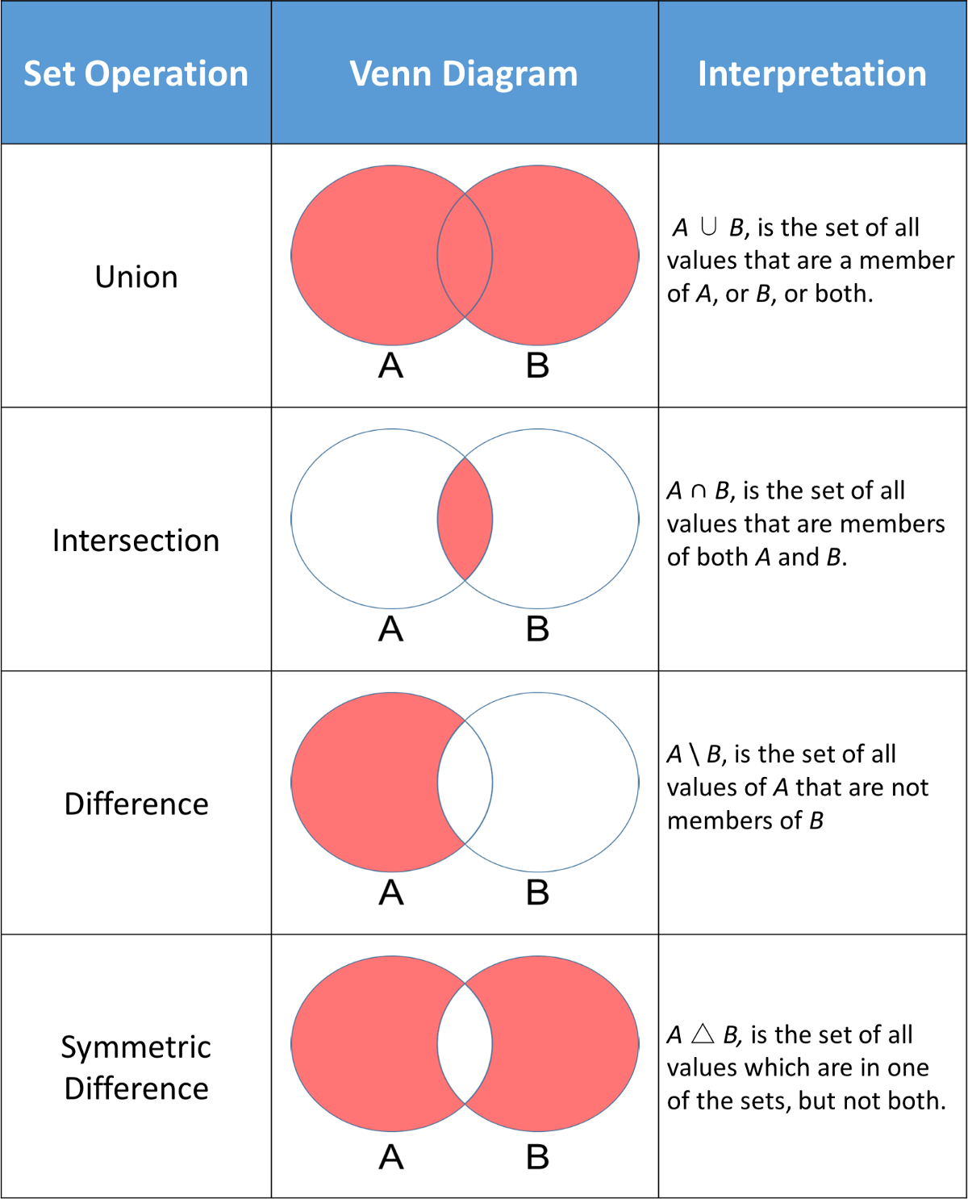

functions:

… … …

## dict

key:value pairs

keys:

immutable

unique

values:

anything

dict themselves are mutable

nesting is possible (as values)

unordered 3.6 & before

ordered 3.7 & later

functions:

values, keys

items

## flow control

### if else

if

elif

else

~~switch case~~

### while

while

~~do while~~

else with while

### for

with sequences

with range

for, break, continue, else

else with for

## 