**Assignment (MYSQL)**

**Name : Shobhit Gaidhane Branch : Pimpri Sid : #16772**

**SET A :**

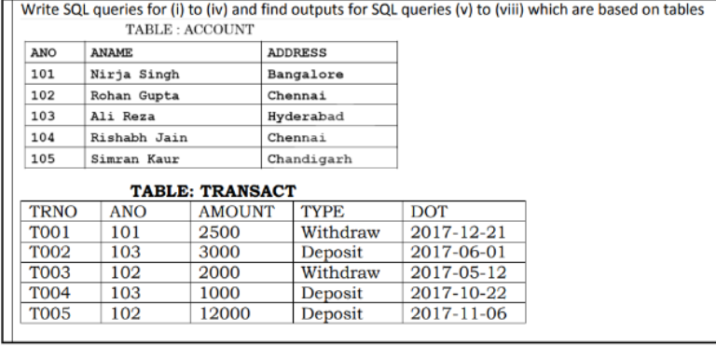

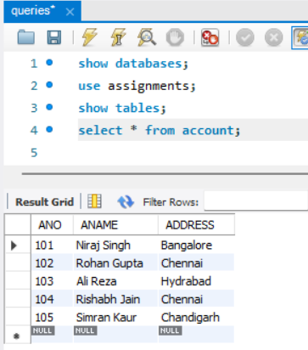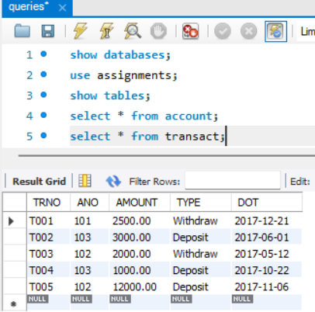

**Q.1]** To Display details of all transactions of Type withdraw from Transact table ?

: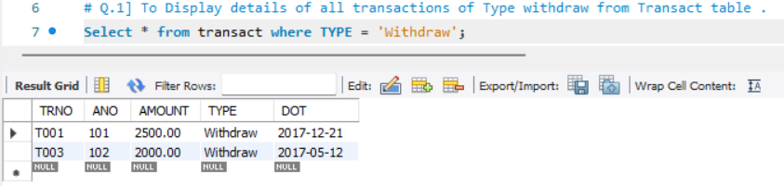

**Q.2]** To display details ANO and AMOUNT of all Deposit and Withdrawals done in month of ‘May’ 2017 from table TRANSACT?

:

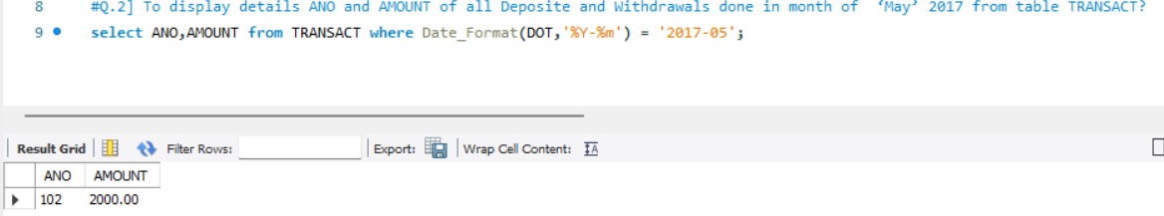

**Q.3]** To Display the first date of transaction DOT from the Transact for account having ANO as 102 ?

: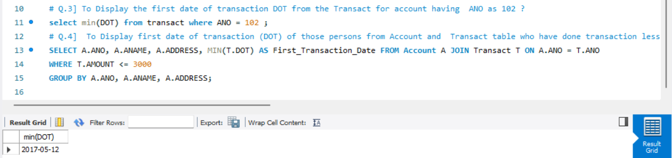

**Q.4]** To Display first date of transaction (DOT) of those persons from Account and Transact table who have done transaction less than or equal to 3000 ?

: 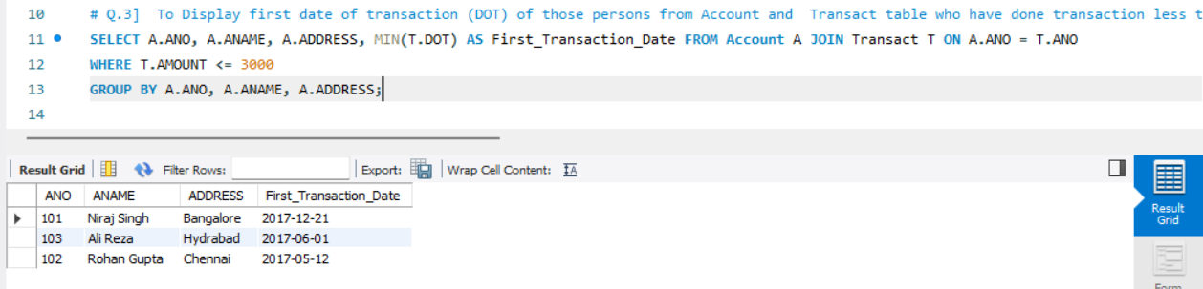

**Q.5]** Select ANO,ANAME From Account ?

:

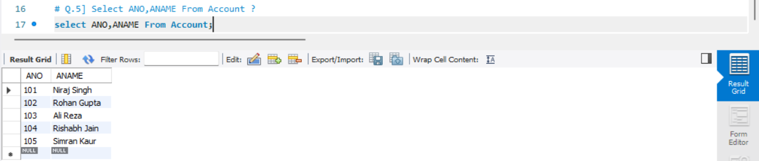

**Q.6]** Select Distinct ANO From Transact ?

:

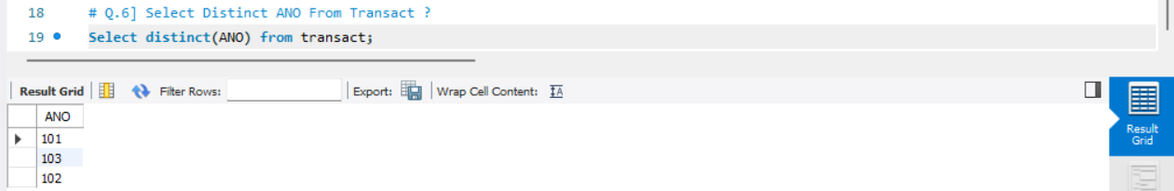

**Q.7]** Select Count(*),Sum(Amount) From Transact where DOT <= ‘2017-10-01’ ?

:

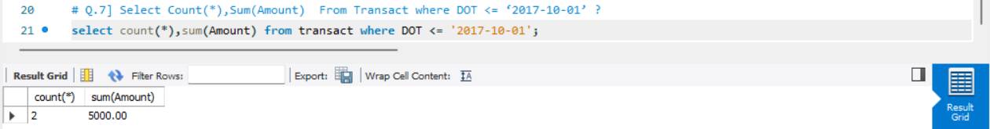

**SET B :**

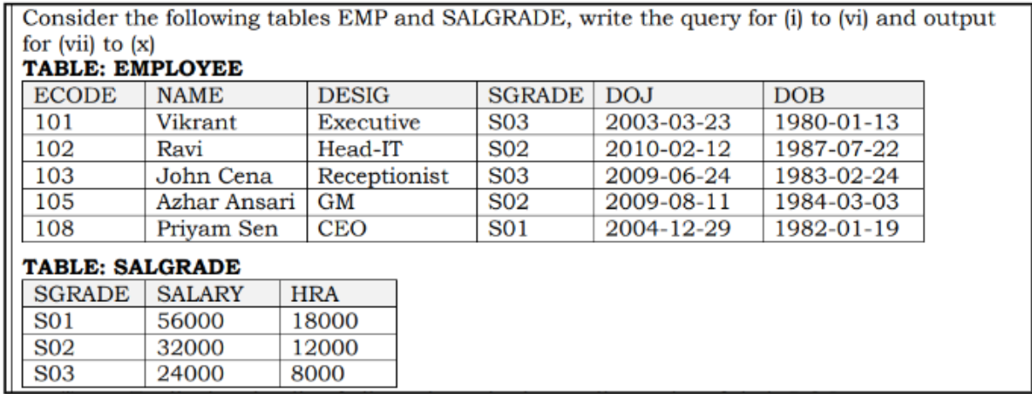

**Q.1]** To Display Details of all Employee in Descending order of their DOJ ?

:

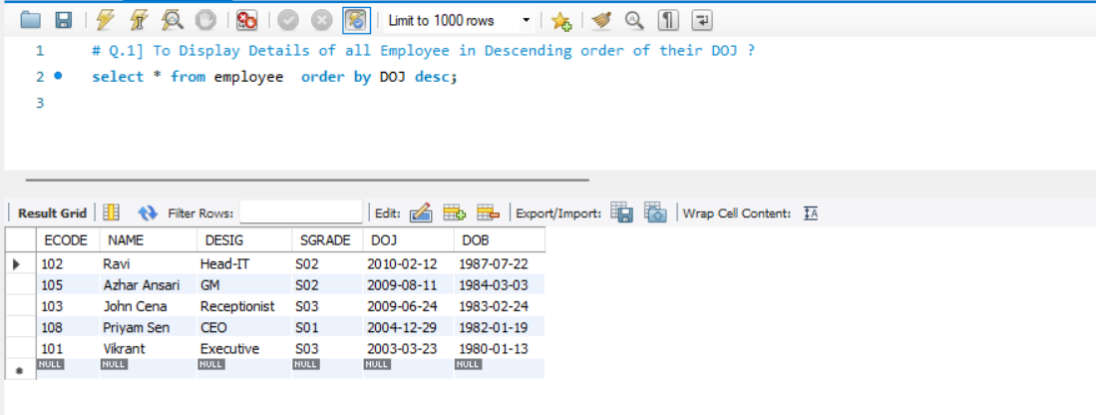

**Q.2]** To Display Name and Desig of those employees whose sgrade is either ‘So2’ or ‘So3’ ?

:

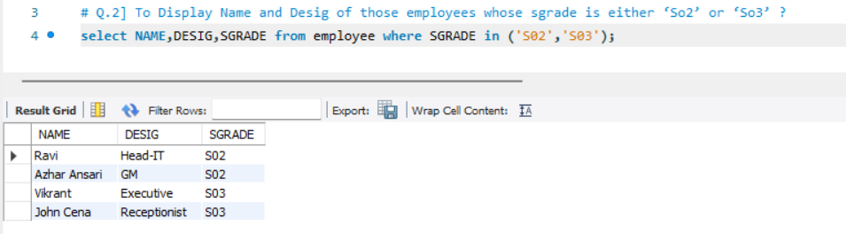

**Q.3]** To Display Name and Desig of those employees who joined in the year 2009 ?

:

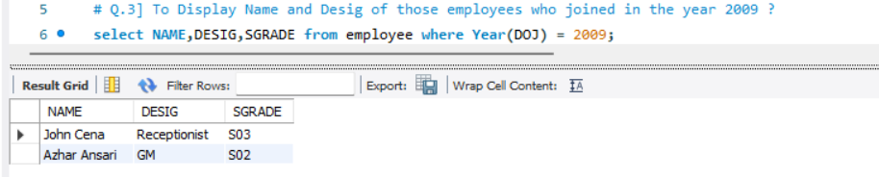

**Q.4]** To Display all SGRADE,AUNNAL_SALARY from table SALGRADE [ where ANNAUAL_SALARY = SALARY*12] ?

:

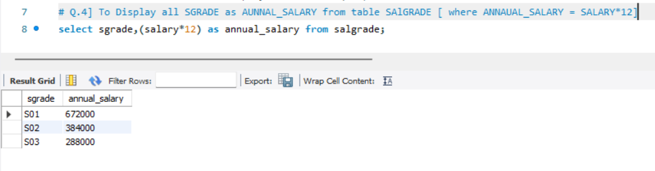

**Q.5]** To display the number of employees working in each SALGRADE from the EMPLOYEE table?

:

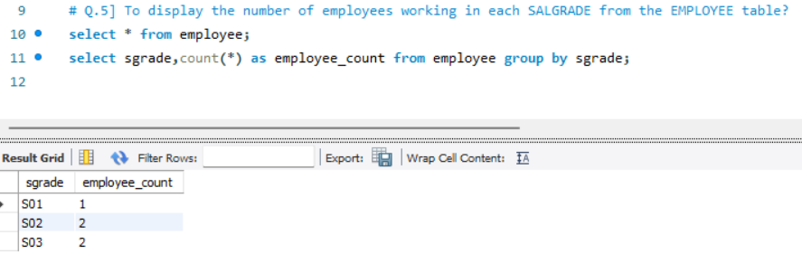

**Q.6]**To display NAME, DESIG, SALARY, and HRA from EMPLOYEE and SALGRADE where SALARY is less than 50,000?

:

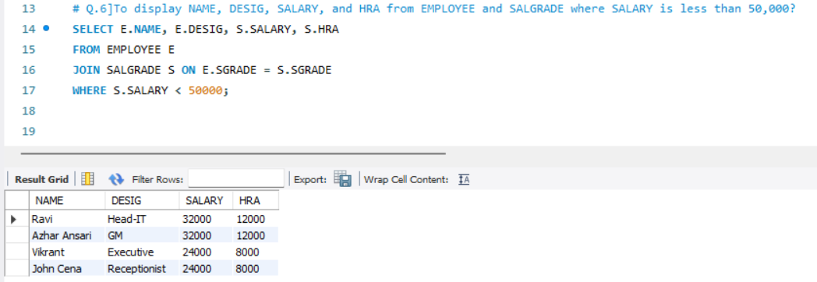

**Q.7]** Select SGRADE and (SALARY + HRA) from SALGRADE where SGRADE = 'S02' ?

:

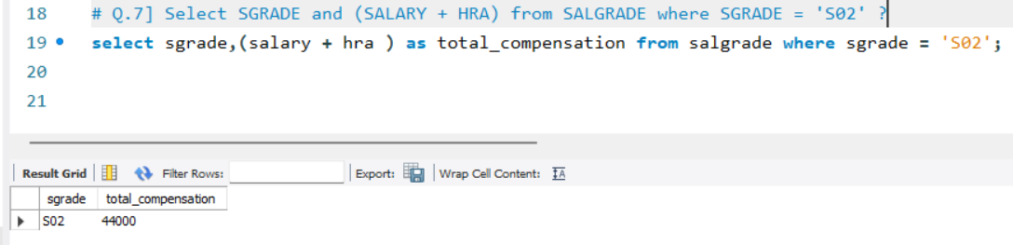

**Q.8]** Select MIN(DOJ) and MAX(DOB) from EMPLOYEE ?

:

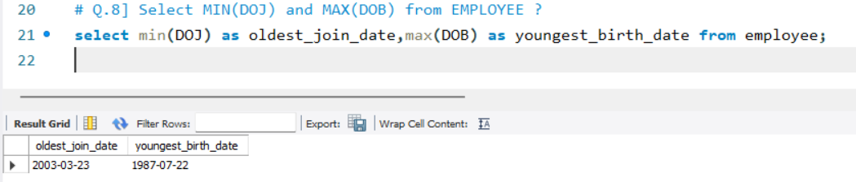

**Q.9]** Select the count of distinct SGRADE from EMPLOYEE ?

:

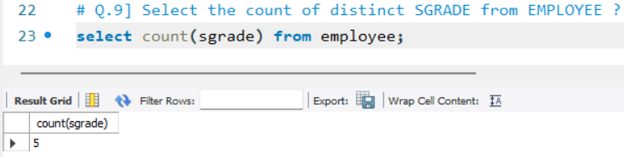

**Q.10]** Select the total (SUM) and average (AVG) salary from SALGRADE ?

:

