FINAL INTERNSHIP REPORT
Virtual Data Science with Python Apprentice Internship
Telco Customer Churn Analysis and Prediction
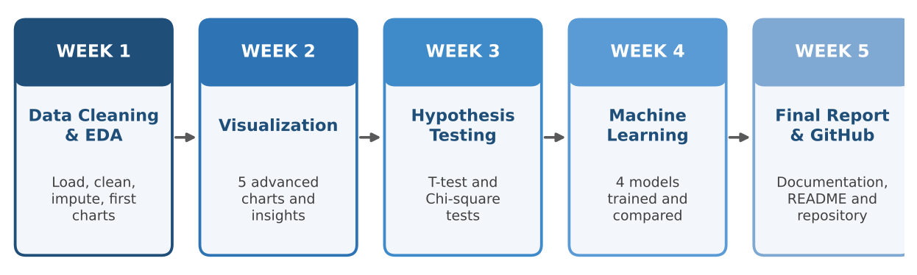

Contents
1. Executive Summary
2. Internship Overview
3. Project Background and Objectives
4. Methodology and Workflow
5. Week-by-Week Work
6. Consolidated Findings
7. Business Recommendations
8. Skills and Learning Outcomes
9. Challenges and Solutions
10. Limitations and Future Scope
11. Project Repository
12. Conclusion
Appendix A: Glossary

1. Executive Summary
This report summarizes the five-week Virtual Data Science with Python Apprentice Internship. The work followed a complete data science lifecycle on the Telco Customer Churn dataset: data cleaning, exploratory visualization, statistical hypothesis testing, machine learning modelling and final documentation on GitHub.
The central question was simple: why do telecom customers leave, and can we predict who will leave next? The analysis shows that churn is not random. Roughly one customer in four (about 26 to 27%) churns, and the risk is concentrated in customers who are new (median churner leaves after about 10 months), on Month-to-month contracts, using Fiber optic internet, paying by Electronic check, paying higher monthly bills (about $70 to $105), or are senior citizens.
Two statistical tests confirmed that the monthly-charge difference and the contract-type link are real and not due to chance. Four machine learning models were then compared. Logistic Regression performed best, with 81.97% accuracy, and also found the most churners (recall 0.60). The report ends with seven practical recommendations for a retention team.
7,043 | 5 | 8 | 2
Customers analysed | Weeks of work | Charts created (Weeks 1 and 2) | Hypothesis tests
4 | 81.97% | 0.60 | 26.5%
Models compared | Best accuracy (Logistic Regression) | Best churn recall | Approximate churn rate

2. Internship Overview
The internship was a virtual, task-based programme of five weekly assignments. Each week had a clear deliverable: a Jupyter notebook, a Word report and a GitHub update.
Week | Focus area | Main deliverable
1 | Data acquisition, cleaning and EDA | Cleaned dataset (df_cleaned.csv), first charts, Week 1 notebook and report
2 | Advanced visualization and storytelling | Five charts with insights, Week 2 notebook and report
3 | Statistical analysis and hypothesis testing | Independent t-test and chi-square test, Week 3 notebook and report
4 | Machine learning model development | Four trained classifiers with evaluation, Week 4 notebook and report
5 | Final report and repository documentation | This final report, README and organised GitHub repository

Tools and technologies
Category | Tools used
Language and environment | Python 3, Jupyter Notebook (Anaconda)
Data handling | pandas, NumPy
Visualization | Matplotlib, Seaborn
Statistics | SciPy (independent t-test, chi-square test of independence)
Machine learning | scikit-learn (Logistic Regression, Random Forest, SVM, StandardScaler, metrics), XGBoost
Version control and reporting | Git and GitHub, Microsoft Word

3. Project Background and Objectives

3.1 The business problem
Customer churn means a customer stops using a company's service. For a telecom operator it is costly, because winning a new customer usually costs more than keeping an existing one. If the company can understand why customers leave and spot them early, it can act with targeted offers before they cancel.

3.2 The dataset
- Source: the publicly available Telco Customer Churn dataset.
- Size: 7,043 customers and 21 columns.
- Contents: customer demographics (gender, SeniorCitizen, Partner, Dependents), account details (tenure, Contract, PaymentMethod, MonthlyCharges, TotalCharges), subscribed services (PhoneService, InternetService and others) and the target column Churn (Yes or No).
- Class balance: about 26.5% of customers churn (373 of the 1,409 customers in the Week 4 test set), so the data is moderately imbalanced.

3.3 Objectives
- Prepare a clean, analysis-ready dataset.
- Find and communicate the patterns that separate churners from retained customers.
- Check whether the main patterns are statistically significant.
- Build and compare models that predict churn.
- Turn the results into practical business recommendations and document the full project on GitHub.

4. Methodology and Workflow
Each week built on the previous one, following the standard data science workflow.
Stage | Method | Output
Prepare | Type conversion, median imputation, duplicate check | A clean dataset with 7,043 rows
Explore | Countplots, KDE plot, boxplots | Patterns and a first view of churn drivers
Test | Welch-type independent t-test and chi-square test | p-values showing the patterns are not due to chance
Model | One-hot encoding, scaling, 80/20 split, four classifiers | Accuracy, precision, recall and F1 for each model
Communicate | Word reports, README and GitHub | A documented and reproducible project

5. Week-by-Week Work

5.1 Week 1: Data acquisition, cleaning and EDA
Goal: simulate the data preparation stage that every data science project needs.
- Loaded the dataset into a pandas DataFrame and checked data types and missing values across all 21 columns.
- Found that TotalCharges was stored as text with blank entries. It was converted to a numeric column (blanks became missing values) and the missing values were filled with the median, which is not affected by extreme values.
- Checked for duplicate rows. The cleaned dataset still has 7,043 rows, which means no duplicate customers had to be removed.
- Created three exploratory charts: overall churn distribution, monthly charges by churn status (boxplot) and churn by contract type.
Outcome: a clean dataset saved as df_cleaned.csv, and the first insight that short-tenure customers with high monthly charges and Month-to-month contracts churn the most.

5.2 Week 2: Advanced visualization and storytelling
Goal: communicate churn patterns clearly using five charts. Values below are approximate and were read from the charts.
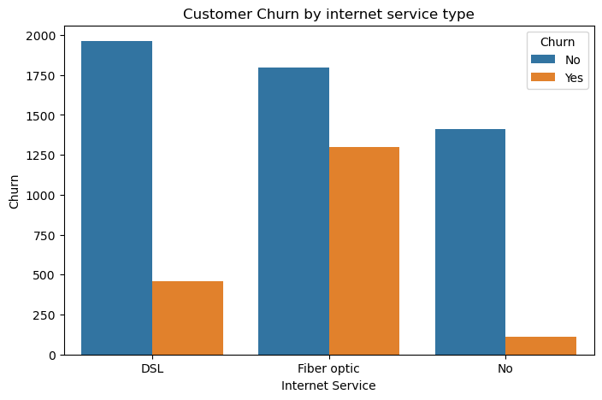  Figure 1: Churn by internet service type | 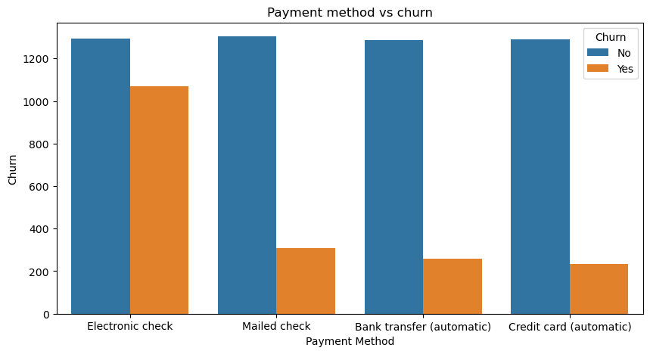  Figure 2: Churn by payment method
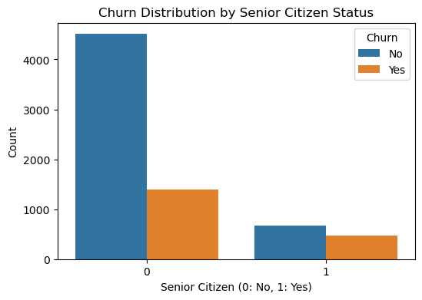  Figure 3: Churn by senior citizen status | 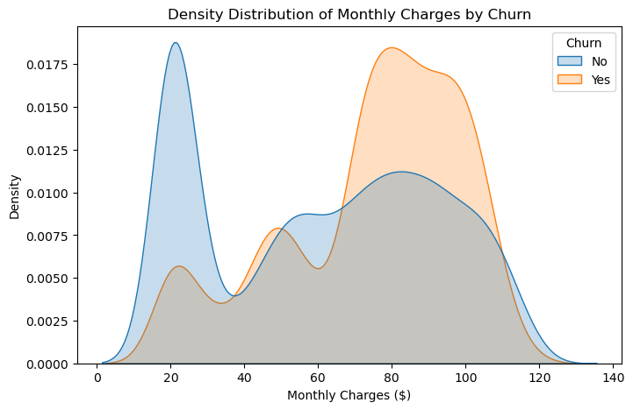  Figure 4: Monthly charges density by churn
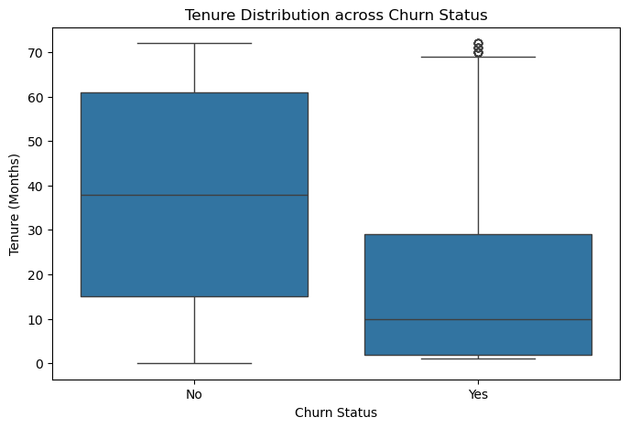
Figure 5: Tenure by churn status

Chart | What it showed | Insight
Internet service | Churn: Fiber optic about 42%, DSL about 19%, no internet about 7% | Fiber users are about 70% of all churners
Payment method | Electronic check about 45%, other methods 15 to 19% | Electronic check payers churn about 3 times as often
Senior citizen | Seniors about 41%, non-seniors about 24% | A small group (about 16%) with high risk
Monthly charges (KDE) | Churners peak between about $70 and $105; retained customers peak near $20 | High bills raise the risk of leaving
Tenure (boxplot) | Median tenure: churned about 10 months, retained about 38 months | The first year is the most dangerous period

5.3 Week 3: Statistical analysis and hypothesis testing
Goal: check whether the patterns seen in the charts are statistically significant (significance level 0.05).
Test | Result | Meaning
Independent t-test: Monthly Charges, churned vs not churned | t = 18.41, p = 8.59e-73 | Reject H0. Churned customers pay a higher average monthly charge, and the gap is not due to chance.
Chi-square test: Contract type vs Churn | Chi2 = 1184.60, p = 5.86e-258, df = 2 | Reject H0. Contract type and churn are linked. Cramer’s V is about 0.41 (moderate to strong, calculated for this report).

Outcome: the Week 1 and Week 2 findings about billing and contracts are backed by statistical evidence. Because the dataset is large, even small differences give tiny p-values, so the size of the effect (Cramer’s V of 0.41) matters as much as the p-value.

5.4 Week 4: Machine learning model development
Goal: build and compare models that predict churn.
- Preparation: Churn converted to 1/0, customerID dropped, text columns one-hot encoded, data split 80% training and 20% testing (1,409 test customers), features standardised for Logistic Regression and SVM using statistics learned from the training set only.
- Models: Logistic Regression, Random Forest, Support Vector Machine and XGBoost, all with random_state 42.
Model | Accuracy | Churn recall | Churn F1 | Churn precision
Logistic Regression | 81.97% | 0.60 | 0.64 | 0.68
Support Vector Machine | 81.41% | 0.53 | 0.60 | 0.69
XGBoost Classifier | 79.42% | 0.52 | 0.57 | 0.64
Random Forest | 78.92% | 0.46 | 0.54 | 0.64

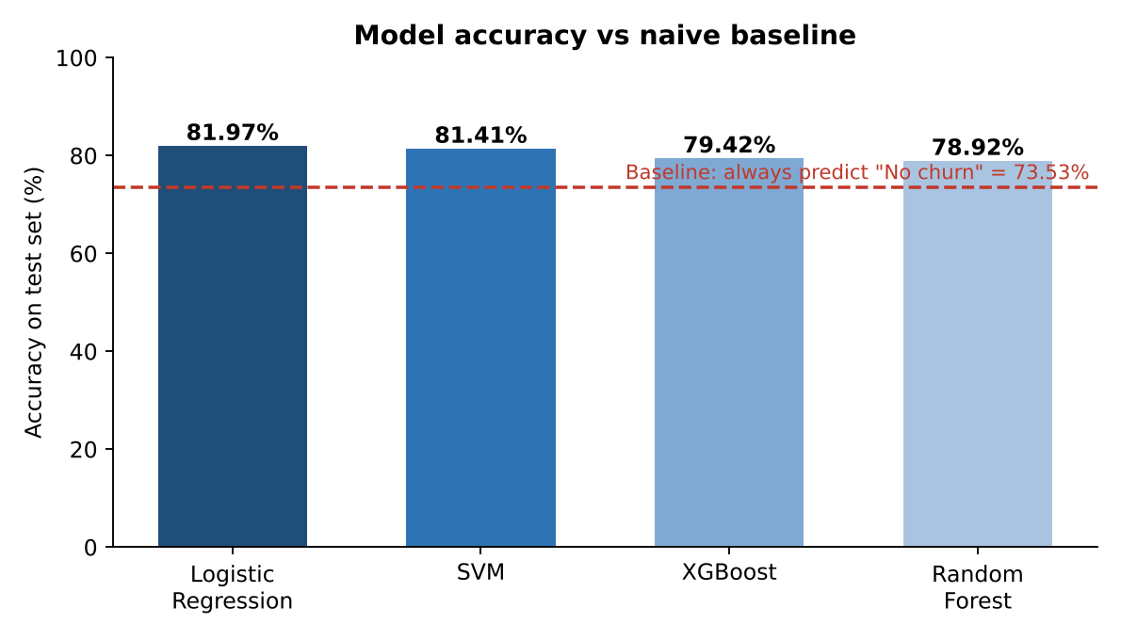
Figure 6: Test accuracy of the four models compared with the 73.53% baseline
Key points: all models beat the naive baseline of 73.53% (always predicting no churn), but only by 5 to 8 points. Logistic Regression is best on accuracy, recall and F1. Every model is much better at recognizing loyal customers (recall 0.89 to 0.92) than churners (recall 0.46 to 0.60). The best model still misses about 40% of real churners, so improving churn recall is the main next step.

5.5 Week 5: Consolidation, documentation and GitHub
- Reviewed all four weeks and merged the findings into one consistent story (Section 6).
- Wrote the final executive report and the business recommendations (Section 7).
- Organised the weekly notebooks, the cleaned data and a README in the GitHub repository (Section 11).

6. Consolidated Findings
The charts, tests and models point in the same direction. The figure below summarises the approximate churn rate for the main customer segments.
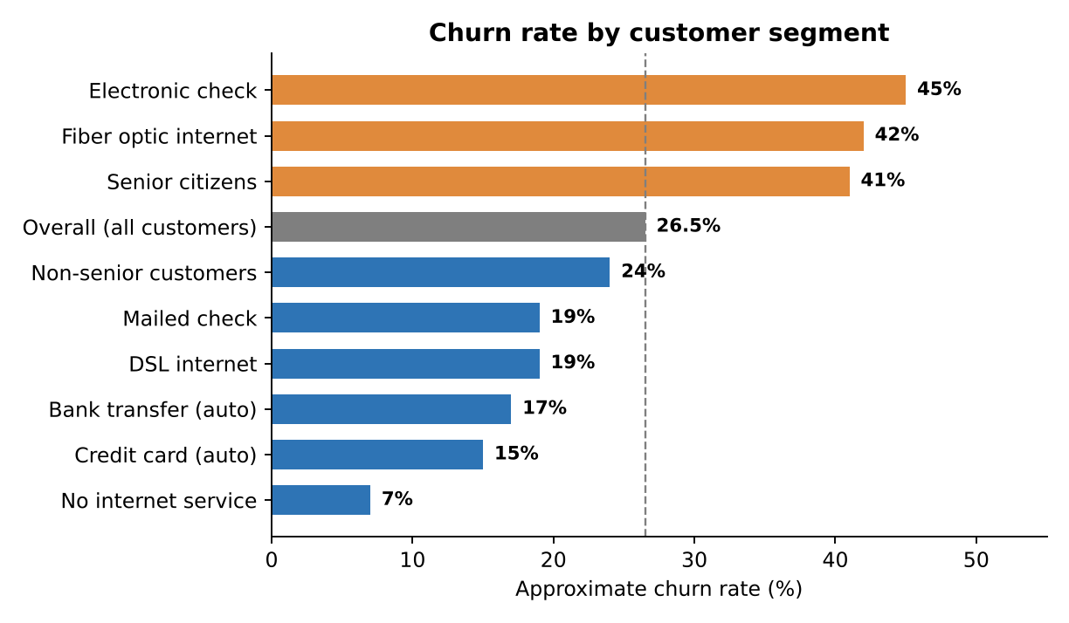
Figure 7: Approximate churn rate by customer segment (values read from the Week 2 charts)
Factor | Evidence from the project | Strength of evidence
Contract type | Week 1 chart; Week 3 chi-square (Chi2 = 1184.6, Cramer’s V about 0.41) | Strong. Statistically significant and a moderate to strong effect.
Monthly charges | Week 2 density plot; Week 3 t-test (t = 18.41) | Strong. Churners cluster at about $70 to $105.
Tenure | Week 1 insight; Week 2 boxplot (median 10 vs 38 months) | Strong visual evidence. Not yet tested statistically.
Internet service | Week 2 countplot (Fiber about 42%) | Strong visual evidence. Not yet tested statistically.
Payment method | Week 2 countplot (Electronic check about 45%) | Strong visual evidence. Not yet tested statistically.
Senior citizen | Week 2 countplot (about 41% vs 24%) | Moderate. Smaller group (about 16% of customers).

Customer risk profiles
Profile | Description
High risk | New customer (first year), Month-to-month contract, Fiber optic internet, pays by Electronic check, monthly bill of about $70 or more, possibly a senior citizen.
Low risk | Long-term customer, One-year or Two-year contract, DSL or no internet, pays automatically by bank or card, low monthly bill (about $20).
These profiles are working hypotheses: the factors overlap (for example, Fiber customers also pay more), and each chart looked at one factor at a time.
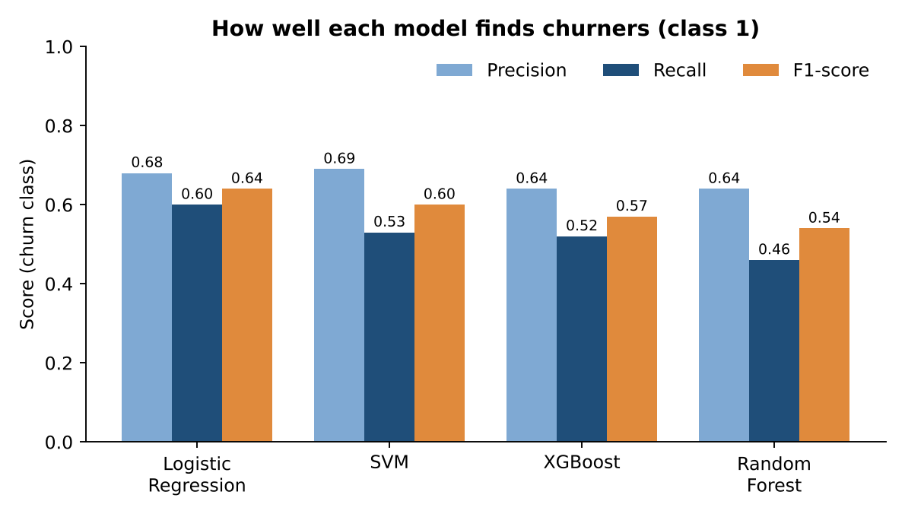
Figure 8: Precision, recall and F1-score of the four models for the churn class

7. Business Recommendations
No. | Recommendation | Evidence | Suggested horizon
1 | Early-life onboarding and check-ins in months 0 to 12 | Median churner leaves at about 10 months | Immediate
2 | Offer incentives to move Month-to-month customers to 1-year or 2-year plans | Contract type strongly linked to churn (V about 0.41) | Short term
3 | Incentivise automatic payment instead of Electronic check | About 45% churn vs 15 to 19% for other methods | Immediate
4 | Review Fiber optic pricing and service quality | About 42% churn; about 70% of all churners | Short term
5 | Add value bundles or loyalty discounts in the $70 to $105 price band | Higher charges linked to churn (t-test) | Short term
6 | Senior-friendly plans and easier support | About 41% churn vs 24% for non-seniors | Medium term
7 | Monthly churn-risk scoring with Logistic Regression, then improve recall | Best accuracy and F1; recall only 0.60 | Medium term

Expected impact: these actions focus effort on the segments that produce most of the churn. For example, electronic check payers are roughly 57% of churners, and Fiber optic customers roughly 70%. The size of the financial benefit depends on the cost of each retention offer, which is outside the scope of this dataset.
On the prediction model: missing a churner usually costs more than a false alarm, which costs only a retention offer. The team should therefore tune the model for higher recall, using class weights or a lower decision threshold, rather than aim only for higher accuracy.

8. Skills and Learning Outcomes
Week | Skills and tools practised | What was learned
1 | pandas, type conversion, imputation, duplicate checks | Data quality problems must be fixed before any analysis
2 | Matplotlib, Seaborn, data storytelling | A good chart answers one clear question
3 | SciPy, hypothesis testing, p-values | Statistical significance and effect size are different things
4 | scikit-learn, XGBoost, scaling, model evaluation | Accuracy alone can hide weak performance on the minority class
5 | Git, GitHub, README, technical writing | Clear documentation makes work reproducible

Professional skills also developed: planning work in weekly milestones, writing for a business audience, and linking technical results to business actions.

9. Challenges and Solutions
Week | Challenge | How it was handled
1 | TotalCharges stored as text with blank values | Converted to numeric with blanks as missing values, then filled with the median
3 | Choosing a suitable test for two different groups | Used an independent t-test for the numeric variable and a chi-square test for two categorical variables
4 | XGBoost not installed in the environment | Installed with %pip install xgboost (version 3.4.1)
4 | Features on very different scales | Applied StandardScaler, fitted on the training set only, for Logistic Regression and SVM
4 | Accuracy looked good but hid weak churn detection | Reviewed precision, recall and F1 for the churn class, and compared with the 73.5% baseline
4 | XGBoost warning about use_label_encoder | Identified it as a harmless outdated setting that can be removed

10. Limitations and Future Scope

Limitations
- The data is one snapshot from one company, so results may not transfer to other periods or markets.
- The findings show association, not cause. Factors overlap (for example internet type, price and contract).
- Models were evaluated on a single 80/20 split with default settings, so small differences between them are not reliable.
- Accuracy was the main score reported in the summary, although it is misleading when 73.5% of customers belong to one class.
- Several numbers in this report (such as churn rates by segment) were read from charts and are approximate.

Future scope
- Use stratified cross-validation and hyperparameter tuning for all models.
- Handle class imbalance (class weights, threshold tuning) and report ROC-AUC and confusion matrices.
- Add feature importance and Logistic Regression coefficients to show which factors drive each prediction.
- Run chi-square tests for Internet Service, Payment Method and Senior Citizen, and test tenure statistically.
- Turn the best model into a simple monthly scoring tool or dashboard for a retention team.

11. Project Repository
All work is stored in the public GitHub repository github.com/shobhit2518/telco-churn-analysis (main branch, 8 commits at the time of review).
File or folder | Purpose
week1_analysis.ipynb | Week 1: cleaning and first EDA
week2.ipynb | Week 2: advanced visualizations
week3.ipynb | Week 3: t-test and chi-square test
week4.ipynb | Week 4: model training and evaluation
df_cleaned.csv | Cleaned dataset used from Week 2 onwards
senior_citizen_churn.png | Saved chart from Week 2
data/ and data.zip | Original dataset files
README.md | Project overview, structure and key results

The README summarises the project as an end-to-end churn analysis and lists the main findings, including the 81.97% accuracy of Logistic Regression and 81.41% of SVM.

12. Conclusion
The internship delivered a complete, documented data science project. Starting from raw customer data, the work cleaned it, found the patterns behind churn, proved with statistical tests that the main patterns are real, and built models that classify about 82% of customers correctly.
The clearest message for the business is that churn is predictable and concentrated: new customers on Month-to-month contracts, using Fiber optic, paying by Electronic check and facing high bills are the ones to protect first. The clearest message for the next phase of the project is technical: the models need to find more of the customers who really leave, which calls for cross-validation, class balancing and threshold tuning.
Beyond the results, the internship built practical skills in Python, visualization, statistics, machine learning, Git and professional reporting that can be applied to real projects.

Appendix A: Glossary
Term | Simple meaning
Churn | A customer stops using the service.
EDA | Exploratory Data Analysis: looking at the data with charts and summaries to find patterns.
Imputation | Filling missing values, here with the median value.
p-value | How likely a result is if there were no real effect. A value below 0.05 is treated as significant.
Cramer’s V | A number from 0 to 1 showing how strong the link between two categories is.
One-hot encoding | Turning a text column into several 0/1 columns so models can use it.
Precision | Of the customers predicted to churn, the share who really churned.
Recall | Of the customers who really churned, the share the model found.
F1-score | One number that balances precision and recall.
Baseline | The score of a naive guess (always "no churn" gives 73.53% accuracy here).

