ASSIGNMENT 1

MOVIE TICKET BOOKING SYSTEM

A. Requirement Analysis
The system follows the assignment scope of a small, menu-driven C++ movie ticket booking application. The original brief requires eight core booking features; the design below adds optional popcorn without changing the mandatory booking and payment rules.

Functional Requirements
ID | Requirement
FR1 — Movie Listing | Display all currently playing movies with title, language and duration.
FR2 — Show Listing | For a selected movie, display its shows with screen number and start time.
FR3 — Seat Layout | For a selected show, display the complete seat layout, seat type and AVAILABLE/BOOKED state.
FR4 — Booking | Allow one or more seats; if any selected seat is BOOKED, reject the entire booking and change no seat state; confirm only after successful payment.
FR5 — Seat Pricing | Calculate charges by type: SILVER ₹150, GOLD ₹250, PLATINUM ₹400.
FR6 — Payment | Allow exactly one payment method: UPI, Card or Cash; failed payment must not confirm the booking and must release temporarily booked seats.
FR7 — Food Selection | Allow the customer to optionally add popcorn for ₹120; include the food charge in the booking total.
FR8 — Ticket Printing | After successful payment, print booking ID, customer details, movie, screen, time, seats, food selection/food amount, total amount and status.
FR9 — Cancellation | Allow a confirmed booking to be cancelled and make all its seats AVAILABLE again.

Non-Functional Requirements
ID | Requirement
NFR1 — Modularity | Keep major classes separate and give each class one clear responsibility; the code uses one major class per .cpp file and no header files.
NFR2 — Extensibility | New payment methods or optional services should be addable with minimal changes to existing classes.
NFR3 — Input Validation | Invalid menu, movie, show, seat, customer or payment input should produce a clear message without crashing.
NFR4 — Maintainability | Use meaningful names, small single-purpose functions, constants for prices, and avoid repeated code.

B. Noun–Verb Analysis

Noun Analysis
Noun | Class? | Reason
Movie | Yes | Own data and identity: title, language, duration.
Seat | Yes | Represents one physical seat with a number and type.
Screen | Yes | Represents an auditorium and owns its seats.
Cinema | Yes | Represents the theatre and owns screens.
Show | Yes | Represents a movie on a screen at a specific time.
ShowSeat | Yes | Stores the status of one seat for one show.
Customer | Yes | Stores customer name and phone.
Booking | Yes | Represents a booking and its selected seats, food, amount and status.
Payment | Yes | Abstract contract for payment.
UpiPayment | Yes | Concrete UPI implementation.
CardPayment | Yes | Concrete card implementation.
CashPayment | Yes | Concrete cash implementation.
PriceCalculator | Yes | Calculates seat + food total.
TicketPrinter | Yes | Formats and prints the ticket.
BookingService | Yes | Orchestrates the end-to-end booking flow.
AddFood | Yes | Represents the optional food selection and food charge.
Seat layout | No | A view of ShowSeat objects, not a separate entity.
Ticket | No | Produced by TicketPrinter; a separate persistent entity is unnecessary.
Popcorn | No | Handled as an option inside AddFood rather than as another class.

Verb → Method Mapping
Action | Class | Method
List movies | Cinema | listMovies()
List shows | Show / main menu | get/list show information
Display seats | Show | displaySeats()
Find seat | Show | findShowSeat(seatNumber)
Check availability | ShowSeat | isAvailable()
Book seat | ShowSeat | book()
Release seat | ShowSeat | release()
Calculate total | PriceCalculator | calculateTotal()
Choose food | AddFood | setPopcorn(choice)
Check food | AddFood | hasPopcorn()
Get food price | AddFood | getFoodPrice()
Pay | Payment | pay(amount)
Confirm booking | Booking | confirm()
Fail booking | Booking | fail()
Cancel booking | Booking | cancel()
Create booking | BookingService | createBooking(...)
Make payment | BookingService | makePayment(...)
Print ticket | TicketPrinter | printTicket(...)
Cancel booking | BookingService | cancelBooking(...)

C. Class Design and Responsibilities
Each class below has one primary responsibility. The design also records what the class knows, what it does, and what it must not do.
Class | Knows | Does | Must NOT do
Movie | title, language, duration | Provide movie information | Manage seats, bookings or payment
Seat | seatNumber, seatType | Provide physical seat identity and base price | Store show-specific BOOKED/AVAILABLE state
Screen | screenNumber, seats | Own/manage physical seats of an auditorium | Process bookings or payment
Cinema | name, screens, movies | Maintain theatre-level movies and screens | Calculate booking price or process payment
Show | movie, screen, startTime, showSeats | Represent a scheduled screening and its show-specific seats | Process payment or customer data
ShowSeat | seat, status | Check, book and release one seat for one show | Handle customer/payment logic
Customer | name, phone | Provide customer details | Manage booking rules or payment
AddFood | wantPopcorn, popcornPrice | Record optional popcorn selection and charge | Manage seats, payment or tickets
Booking | bookingId, customer, show, seats, food, totalAmount, status | Represent booking state and selected items | Implement pricing/payment/ticket formatting
Payment (abstract) | Payment contract | Define pay(amount) | Depend on a specific payment channel
UpiPayment | upiId | Process UPI payment | Manage seats or bookings
CardPayment | cardNumber | Process card payment | Manage seats or bookings
CashPayment | None beyond payment contract | Process cash payment | Manage seats or bookings
PriceCalculator | Pricing logic | Calculate seat + food totals | Book seats or process payment
TicketPrinter | Ticket formatting | Print ticket details | Change booking state or calculate prices
BookingService | PriceCalculator, TicketPrinter | Coordinate booking, payment, ticket and cancellation flow | Contain concrete payment implementation logic

D. Relationship Analysis
Pair | Relationship | Multiplicity | Lifetime / design justification
Cinema — Screen | Composition ◆ | 1 → 1..* | Screens belong to the cinema; when the cinema is destroyed, its owned screens are destroyed.
Screen — Seat | Composition ◆ | 1 → 1..* | Physical seats belong to the screen; destroying the screen removes its owned seats from the system.
Show — Movie | Aggregation ◇ | 1 → 1 | A show uses an existing movie; the same movie can be used by many shows.
Show — Screen | Association ──▶ | 1 → 1 | The show uses a screen for its time slot but does not own the screen.
Show — ShowSeat | Composition ◆ | 1 → 1..* | ShowSeats exist specifically for the show and disappear with that show.
Booking — Customer | Association ──▶ | 1 → 1 | A booking refers to a customer; destroying the booking must not destroy the customer.
Booking — ShowSeat | Aggregation ◇ | 1 → 1..* | Booking references existing ShowSeats owned by the Show.
Booking — Payment | Association ──▶ | 1 → 1 | Booking uses a payment object but does not own the payment hierarchy.
Payment — UpiPayment | Inheritance ──▷ | — | UpiPayment is a specialized Payment.
Payment — CardPayment | Inheritance ──▷ | — | CardPayment is a specialized Payment.
Payment — CashPayment | Inheritance ──▷ | — | CashPayment is a specialized Payment.
BookingService — Booking | Association ──▶ | 1 → 0..* | The service manages bookings but does not represent the booking data itself.
Booking — AddFood | Association ──▶ | 1 → 0..1 | Food is optional; a booking may have no food or one AddFood selection.
PriceCalculator — AddFood | Dependency ──▶ | — | PriceCalculator uses AddFood information to include the food price.
BookingService — PriceCalculator | Dependency ──▶ | — | BookingService uses PriceCalculator to obtain the total.
BookingService — TicketPrinter | Dependency ──▶ | — | BookingService delegates ticket formatting/printing.

Relationship Rules Used
- Composition: the part is owned by the whole and its lifetime is tied to the whole.
- Aggregation: the whole refers to an independently existing object.
- Association: objects collaborate without ownership.
- Inheritance: a specialized class is substitutable for its abstract/base type.
- Dependency: a class temporarily uses another class to perform a task.

E. UML Class Diagram
The class diagram below includes the 16 classes in the upgraded system, including the new AddFood class. It keeps the relationship notation, multiplicities, abstract Payment hierarchy and supporting service dependencies visible.
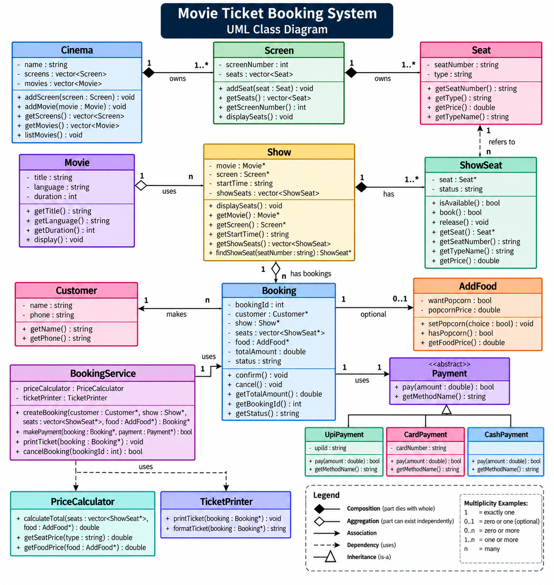
Figure 1. UML class diagram for the Movie Ticket Booking System.

F. UML Sequence Diagram
The sequence diagram models the booking use case with optional food selection. The successful branch creates/updates the booking, confirms payment and prints the ticket; the failed-payment branch releases seats and does not confirm the booking.
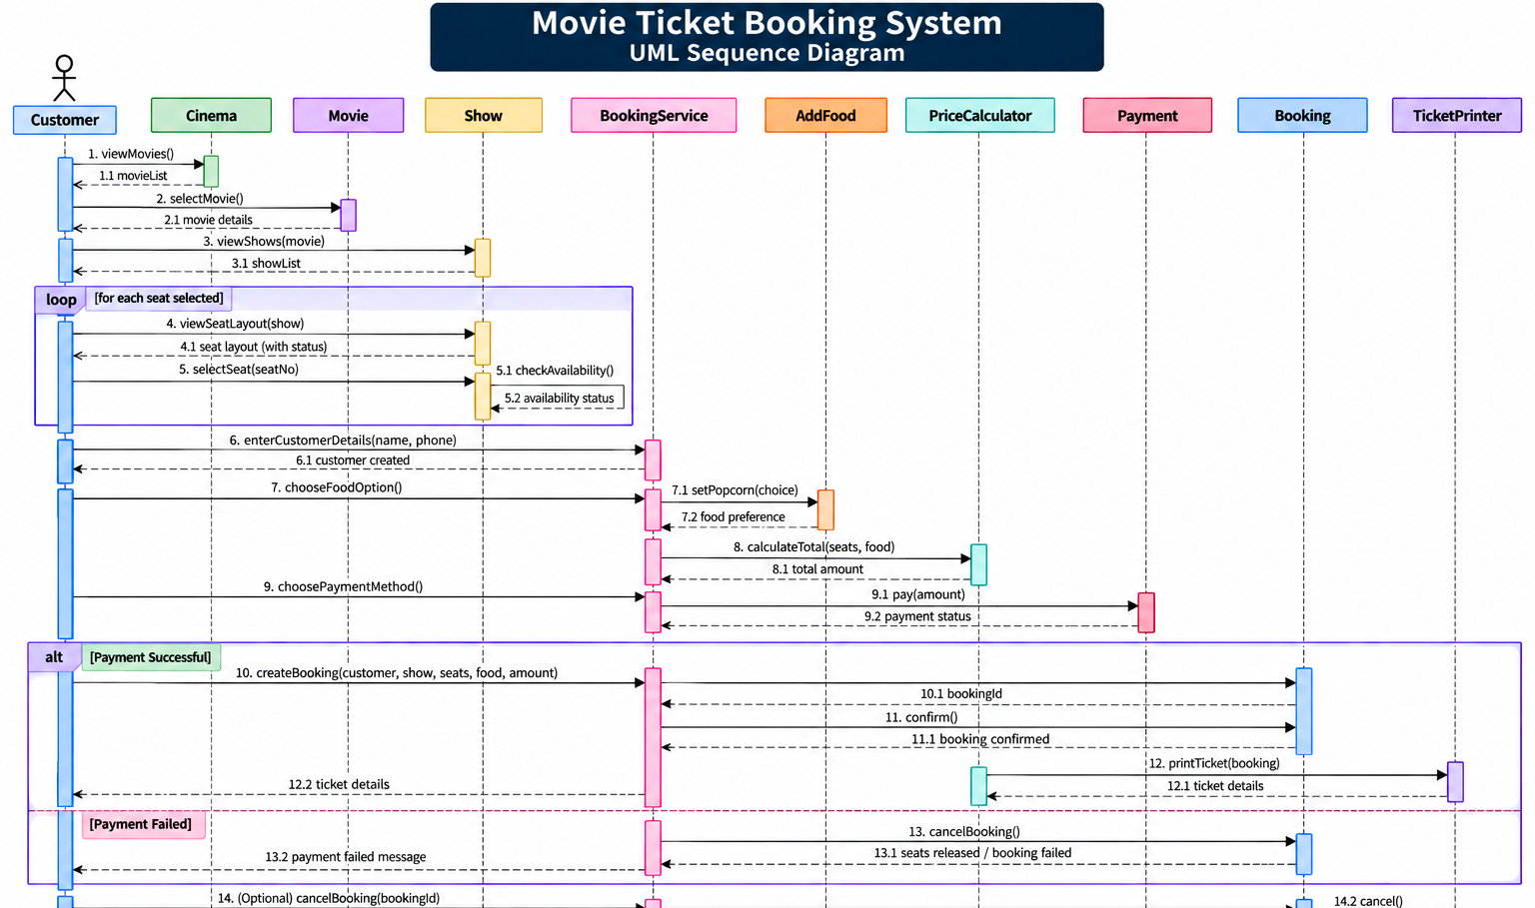
Figure 2. UML sequence diagram for booking, optional food and payment.

Sequence Flow Summary
Step | Action | Objects | Result
1 | Customer selects movie/show | Cinema / Movie / Show | Show information is returned.
2 | Customer selects one or more seats | BookingService / Show / ShowSeat | Availability is checked before any booking is confirmed.
3 | Customer enters name and phone | BookingService | Customer details are stored for this booking.
4 | Customer chooses food | AddFood | Popcorn is optional; food amount is ₹0 when not selected.
5 | Calculate total | PriceCalculator | Seat charges + food charge are returned.
6 | Create payment | Payment / UpiPayment, CardPayment or CashPayment | Payment implementation is selected.
7 | Process payment | Payment | Returns success/failure.
8 | Successful payment | Booking | Booking is confirmed.
9 | Print ticket | TicketPrinter | Ticket contains customer, movie, screen, time, seats, food and total.
10 | Failed payment | BookingService / ShowSeat | Seats are released and booking is marked FAILED.

G. Modular Working Code + Demo Run

Modular File Structure
- 01_Movie.cpp
- 02_Seat.cpp
- 03_Screen.cpp
- 04_Cinema.cpp
- 05_AddFood.cpp
- 05_Show.cpp
- 06_ShowSeat.cpp
- 07_Customer.cpp
- 08_Booking.cpp
- 09_Payment.cpp
- 10_PaymentTypes.cpp
- 11_PriceCalculator.cpp
- 12_TicketPrinter.cpp
- 13_BookingService.cpp
- main.cpp
The code follows the assignment rule of one major class per .cpp file and no header files. The compile command is:
g++ main.cpp -std=c++17 -o movie_booking.exe
.\movie_booking.exe

Demo Run

Representative Ticket Output

Demo Test Cases
Test | Input | Expected Result
Successful booking | E5+ E6, Popcorn, CARD success | Booking CONFIRMED; ticket printed; A1/A2 BOOKED.
Already booked seat | Select an already BOOKED seat | Entire booking rejected; no seat changes.
Mixed seat request | A3 + an already BOOKED seat | Entire booking rejected; A3 remains AVAILABLE.
Failed payment | Select seats, choose payment failure | Booking FAILED; all selected seats released.
No food | Select seats, choose No | Food amount ₹0; booking continues normally.
Invalid customer details | Blank name or phone | Booking step stops with an error.
Cancellation | Cancel confirmed Booking ID | Booking CANCELLED; booked seats become AVAILABLE.
Invalid menu/seat/payment | Enter invalid choice | Clear error; program continues without crashing.

Important Edge Cases
- Already-booked seat → reject the whole booking; no seat state changes.
- Multiple selected seats where one is already booked → reject all selected seats; no partial booking.
- Invalid seat number → show an error and do not create a booking.
- Failed payment → mark booking FAILED and release all selected seats.
- Invalid payment method → do not confirm; release temporarily held seats.
- Empty customer name/phone → do not proceed with booking.
- Invalid food choice → do not add food; ask again or cancel the booking step.
- No food selected → booking continues with ₹0 food charge.
- Cancel confirmed booking → mark CANCELLED and release its seats.
- Cancel failed/pending booking → reject cancellation.
- No seats selected → do not create a booking.
- Invalid menu/movie/show choice → display an error without crashing.

H. SOLID Mapping and Deliberate Scope Limitation
Principle | Application in this system
S — Single Responsibility | BookingService orchestrates the flow; PriceCalculator calculates amounts; TicketPrinter prints tickets; AddFood handles only optional food selection.
O — Open/Closed | A new payment method such as NetBanking can extend Payment without changing the booking orchestration logic.
L — Liskov Substitution | UpiPayment, CardPayment and CashPayment can be used through Payment* because each implements the same payment contract.
I — Interface Segregation | Payment contains only the common payment operation; unrelated operations such as refund are not forced on every payment class.
D — Dependency Inversion | BookingService works with the abstract Payment type rather than embedding concrete payment logic.

