Market Analysis Project Report

A data-driven investigation of order patterns, product performance, and reorder behavior to optimize marketing strategy and improve customer satisfaction

Executive Summary
This report presents a comprehensive analysis of online grocery ordering behavior for project CDACL-006, covering 63,100 customers, 49,355 products, 134 aisles, and 21 departments. The analysis was conducted across three integrated stages: data validation and exploration in MySQL, in-depth statistical and behavioral analysis in Python, and executive-level visual reporting in Power BI. The objective was not simply to describe historical order data, but to translate it into decisions that Marketing, Merchandising, and Operations teams can act on immediately.
The analysis confirms that the business is a high-frequency, low-basket-value grocery operation built around fresh, perishable staples. Produce and dairy items — bananas, organic strawberries, spinach, avocados, and milk — dominate both order volume and reorder rate, despite representing a comparatively small share of the total product catalogue. Ordering activity is heavily concentrated between 9 a.m. and 5 p.m., peaking mid-morning, and Sunday–Monday together account for a disproportionate share of weekly volume. Reorder behaviors are not uniform: perishable, routine-replenishment categories (milk, eggs, fresh fruit, water) show reorder rates 3–4 times higher than discretionary categories such as beauty, spices, or kitchen supplies.
Cross-referencing SQL validation, Python behavioral analysis, and the four Power BI dashboards produced a consistent, triangulated view of the customer base: a small set of high-frequency, high-loyalty SKUs carries a disproportionate share of demand, while the majority of the 49,355-product catalogue sees minimal repeat engagement. This 'few SKUs, most demand' pattern, combined with clear time-of-day and day-of-week seasonality, forms the basis of the recommendations in this report — spanning promotional timing, replenishment-based marketing (e.g. subscribe-and-save on top reorder items), staffing and delivery-slot allocation, and catalogue rationalization.
Report at a Glance
63,100 customers · 49,355 products · 134 aisles · 21 departments · ~10.5 items per order · 59.85% average reorder rate. Peak ordering window: 9 a.m.–5 p.m., highest volume Sunday–Monday.

Project Background
Online grocery platforms generate large volumes of transactional data every day — what was ordered, when, by whom, how it was categorized, and whether it was purchased again. On its own, this data is simply a log of activity. Its business value only emerges when it is validated, structured, and analyzed to reveal repeatable patterns in customer behavior and product performance.
This project works with a relational dataset (project_orders) modelled on the well-known Instacart Market Basket dataset structure, comprising five linked tables: aisles, departments, products, orders, and order_products_train. The order_products_train table maps products to the subset of orders flagged with eval_set = "train", which is the labelled, analysis-ready slice of the full order history. Together these tables allow every product purchased to be traced back to its aisle, its department, the customer who bought it, and the date/time context of the order.
The engagement was structured in three stages, mirroring how a real analytics team would typically operate: (1) MySQL was used to connect to the hosted database, validate data integrity, and perform first-pass exploration; (2) Python (via Google Colab) was used to merge the five tables into a single analytical dataset and answer 20 specific business questions with supporting statistical analysis; and (3) Power BI was used to convert the processed output into four interactive executive dashboards for non-technical stakeholders.

Business Problem
Grocery e-commerce operates on thin margins and high order frequency, which means small improvements in basket size, reorder rate, or delivery-slot efficiency compound into meaningful revenue impact. Without a structured view of purchasing behavior, Marketing and Merchandising teams are left to make decisions — which products to promote, which time slots to priorities, which customers are at risk of churn — based on intuition rather than evidence.
The core business problem addressed in this project is: how can historical order data be used to optimize marketing strategy and improve customer satisfaction? This requires answering three linked questions that recur throughout this report:
- What happened? — What are the dominant patterns in product demand, reorder behavior, and order timing?
- Why did it happen? — What structural or behavioral factors explain those patterns (perishability, routine replenishment, catalogue depth, weekly shopping rhythms)?
- What should stakeholders do? — Which concrete, data-backed actions should Marketing, Merchandising, and Operations take as a result?

Project Objective
The project brief specified 20 analytical questions spanning product catalogue structure, customer behavior, order timing, and reorder patterns. Rather than treating these as 20 isolated queries, they were grouped into four analytical objectives that map directly to business decisions:
- Catalogue & Assortment Objective — quantify how products are distributed across departments and aisles, and identify which categories carry the most SKUs versus the most demand (Qs 1–3, 20).
- Customer Behavior Objective — profile the customer base by order frequency, basket size, department reach, and purchase cadence (Qs 5, 6, 10, 11, 14, 19).
- Temporal / Demand-Timing Objective — identify peak ordering hours and days, and how basket size shifts across the week, to inform staffing and promotional scheduling (Qs 7, 8, 15, 16, 18).
- Product Performance & Loyalty Objective — surface the products and aisles with the highest reorder rates, and the categories that anchor repeat purchase behavior, to guide marketing and retention strategy (Qs 4, 9, 12, 13, 17).
Each objective is addressed using the same discipline: SQL for validation, Python for quantitative analysis, and Power BI for stakeholder-facing visualization — with every finding pushed one step further than "what happened" to explain why it matters and what action it implies.

Dataset Overview
The analysis is built on a five-table relational schema hosted in a MySQL database (project_orders). The tables and their validated row counts, confirmed independently in both SQL and Python, are summarized below.
Data Summary
Table | Description | Records
Aisles | Aisle reference list (aisle_id → aisle name) | 134
Departments | Department reference list (department_id → department name) | 21
Products | Product catalogue (product_id, name, aisle_id, department_id) | 49355
Orders | One row per order (user_id, eval_set, order timing fields) | 1,048,575
Order Products (Train) | One row per product within an order (order_id, product_id, cart position, reordered flag) | 1,048,575

Two structural points from the dataset were carried through into the analysis rather than treated as incidental detail:
Train-set scope: the order_products table is explicitly named order_products_train and only maps to orders where eval_set = "train". This is a deliberate, labelled analytical subset (consistent with the standard Instacart dataset design), not the full order history. After merging, the analytical base table (master_df) contains 318,051 order-product line items. All findings in this report describe patterns within this train-set slice.
Row-count ceiling: both the orders and order_products_train tables report exactly 1,048,575 rows — one short of 2^20 (1,048,576), the well-known row-import ceiling of tools such as Excel/CSV-based bulk loaders. This strongly suggests the source tables were truncated at import rather than reflecting a naturally occurring row count. It does not affect the validity of the patterns identified, but it is noted here as a data-limitation caveat for anyone extending this analysis.
The tables are connected using primary and foreign keys:
- order_id connects Orders and Order Products.
- product_id connects Order Products and Products.
- aisle_id connects Products and Aisles.
- department_id connects Products and Departments.
These relationships allow comprehensive analysis by combining customer, product, and order information into a unified analytical dataset.
Data Quality Result
Independent validation in both SQL and Python confirmed zero missing values and zero duplicate primary keys across all five tables, and referential integrity held across every join (products ↔ aisles,
products ↔ departments, orders ↔ order_products). The dataset is clean and analysis-ready. One notable exception is discussed in the SQL Analysis section: an aisle explicitly labelled "missing" (aisle_id 100) containing 1,254 products — a real category value, not a null.

Tools Used and Methodology
Tools Used
Layer | Table | Purpose in this Project
Database | MySQL (hosted, project_orders) | Source of truth; data validation and first-pass exploration
Analysis | Python (Google Colab): Pandas, NumPy | Table merging, aggregation, and the 20-question analysis
Visualization (analysis) | Matplotlib | Exploratory charts (peak hours, day-of-week volume)
Visualization (reporting) | Microsoft Power BI | Interactive executive dashboards
Data interchange | CSV (UTF-8) | Bridge format between the Python analysis layer and Power BI

Methodology
The project followed a standard end-to-end analytics pipeline, moving from raw relational data to validated analysis to stakeholder-facing reporting:
- Connect & Explore (SQL): Connected directly to the hosted MySQL instance, inspected schema structure (SHOW TABLES, DESCRIBE), and captured row counts for all five tables.
- Validate (SQL): Checked every table for missing values, duplicate primary keys, and referential integrity via join tests, before any analysis was trusted.
- Load & Merge (Python): Connected to the same database from Python using SQLAlchemy/PyMySQL, re-verified data quality independently, filtered orders to eval_set = "train", and merged order_products with orders, products, aisles, and departments into a single analytical table (master_df, 318,051 rows × 15 columns).
- Analyze (Python): Answered all 20 brief questions using groupby/aggregation logic, producing both summary statistics and two supporting exploratory charts (peak order hours, order volume by day of week).
- Export (Python → CSV): Exported the cleaned source tables and key derived results (e.g. master_df, top-reorder-product tables, department-level reorder summaries) to CSV, which serves as the interchange layer into the visualization tool.
- Visualize (Power BI): Imported the CSV outputs into Power BI and built four purpose-built dashboards — Executive Business Analysis, Customer Business Analysis, Product Performance Analysis, and Department & Category Analysis — for different stakeholder audiences.
Data Pipeline
MySQL Database
↓
SQL Validation (Missing Values, Duplicates, Relationships)
↓
Python (Pandas) Data Cleaning + Merging + Analysis
↓
CSV Export
↓
Power BI Dashboard + Business Insights + Recommendations

Database Exploration and Validation using SQL
Before any behavioral analysis was performed, the raw dataset was validated directly in MySQL. This stage exists to answer a single question that every later insight depends on: can this data be trusted? The SQL queries were grouped into purposeful categories rather than run and reported as a flat list.
Database Connection
The analysis began by connecting to the MySQL database provided for the project. The database contained five interconnected tables representing products, orders, departments, aisles, and customer purchase history. SQL was used as the primary tool to understand the database structure and verify data integrity before performing analytical tasks. To confirm a successful connection and verify the available schemas, the following query or command was executed.
SHOW DATABASES;
USE project_order;
Result Grid:
information_schema
project_orders

Database Exploration
A preliminary examination of the dataset was performed to determine the size of each table and to understand the overall volume of data available for analysis. Row counts were obtained for all tables, and sample records were inspected using SQL queries to verify that the imported data was complete and correctly structured.
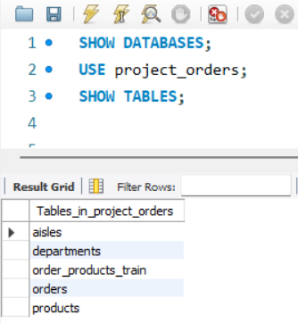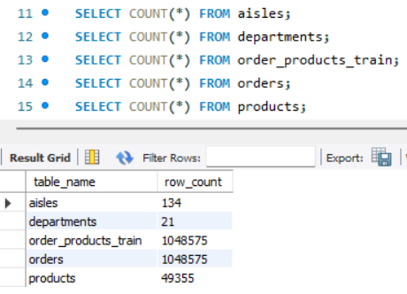
Figure 1: Database exploration queries and output grids.
The database schema was explored to understand the available tables, their attributes, and relationships. Commands such as SHOW TABLES and DESCRIBE were executed to identify the structure of each table, primary keys, and the data types of every attribute. This step provided a clear understanding of how different tables were connected and prepared the foundation for further analysis.
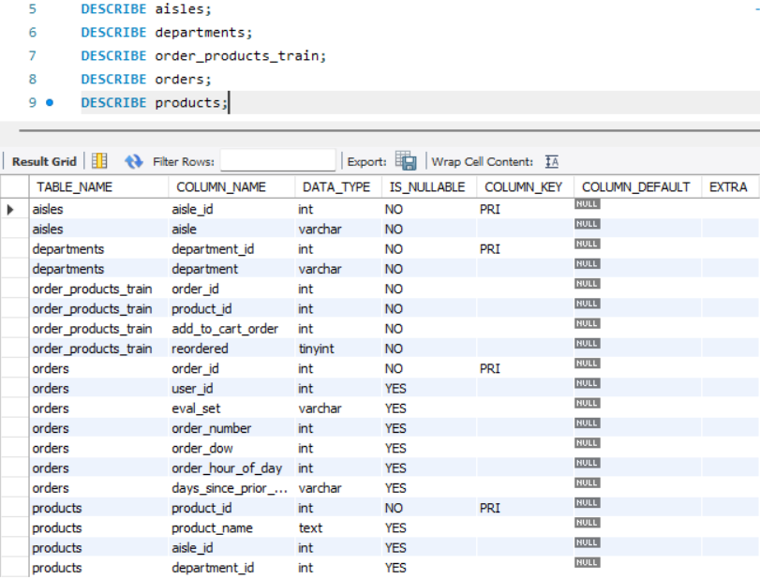
Figure 2: SQL queries utilized to inspect table schemas and the resulting column metadata grid
Database Summary Table:
Table | Row Count | Primary Key
aisles | 134 | aisle_id
departments | 21 | department_id
products | 49,355 | product_id
orders | 1,048,575 | order_id
order_products_train | 1,048,575 | order_id + product_id (composite)

Exploration Summary
Primary Keys were unique: Every table's designated primary key (such as product_id, order_id, and aisle_id) was verified to ensure it contained entirely unique values with no overlaps. This guarantees that each entity—whether it is a product, an order, or a department—can be distinctly and reliably identified without ambiguity.
Table Relationships were consistent: The foreign keys mapping across different tables (for example, linking a product_id in the transactional data back to the master products table) were completely aligned. This means there are no orphaned records or broken links, ensuring perfect referential integrity for deep-dive analysis.
Sample Data Verification
To understand the structure and contents of the database, sample records from each table were retrieved using the SELECT * FROM <table> LIMIT 5 command. This preliminary exploration helped verify the available attributes, data format, and relationships between tables before performing analytical queries.
The following tables were explored:
- Aisles: Contains the unique aisle identifiers and corresponding aisle names.
- Departments: Contains the department identifiers and department names.
- Products: Stores product information along with the associated aisle and department identifiers.
- Orders: Contains customer order details, including user ID, order sequence, order day, order hour, and days since the previous order.
- Order_Products_Train: Represents the relationship between orders and products, including the sequence in which products were added to the cart and whether they were reordered.
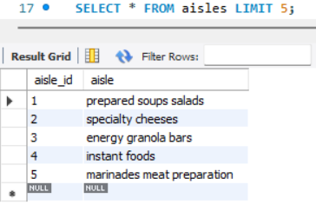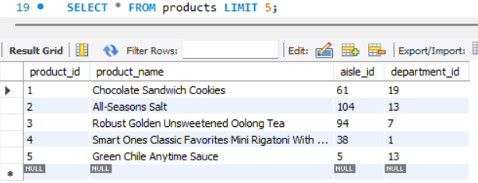
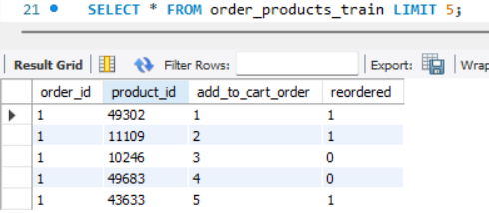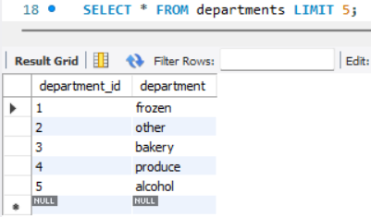
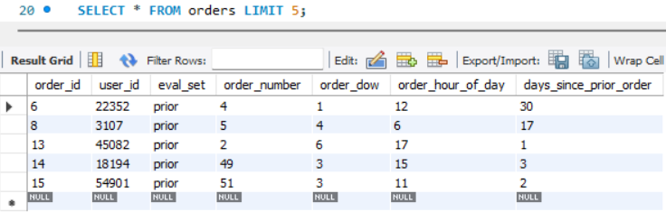
Figure 3: Sample Records Retrieved from the Five Database Tables

The sample records confirmed that the database structure matched the provided schema and that all tables contained valid and consistent data. This verification ensured that the dataset was ready for table joins and further analytical processing.

Data Validation
To ensure the utmost reliability and accuracy of the subsequent analysis, a series of rigorous data quality checks were systematically performed. The entire dataset underwent a thorough examination to guarantee it met the necessary standards for robust business intelligence, effectively eliminating the need for any additional pre-processing or data cleaning.
Missing Value Analysis: Every column across all five tables was scanned using targeted aggregation queries to detect null or missing values. Result: No Missing Values
- Checked all columns across all five tables for NULL values.
- No missing values were found in the dataset.
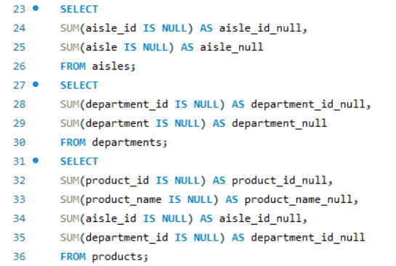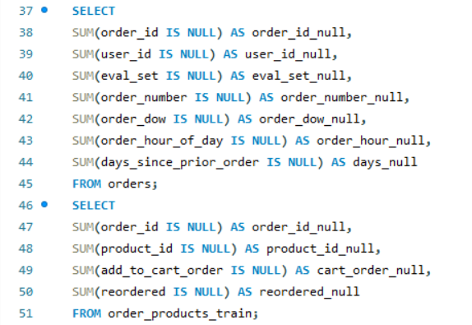
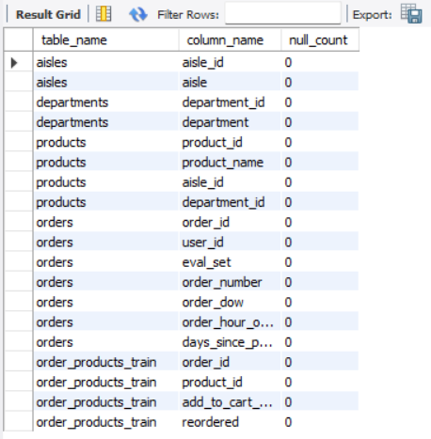
Figure 4: SQL queries used to aggregate and verify the count of null or missing values across all database tables, confirming a completely clean dataset.

Duplicate Record Verification: To prevent skewed aggregations and duplicate counting during analysis, an audit was conducted to identify any redundant rows or broken primary key constraints. Result: No Duplicate Records
- Verified duplicate records using Primary Keys and appropriate key combinations.
- No duplicate records were identified.
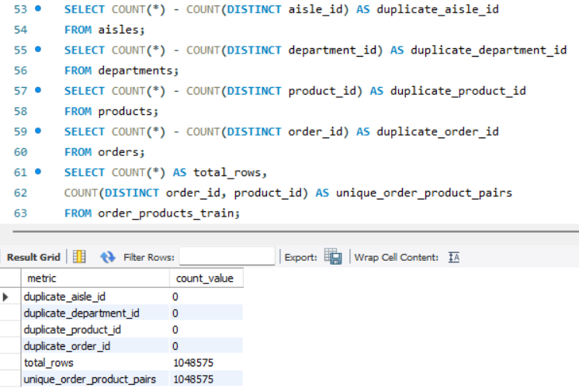
Figure 5: SQL queries used to check for duplicate records across the tables, along with the execution results
Database Validation Summary
All validation checks confirmed that the dataset is clean, consistent, and suitable for further analysis. Since no missing values or duplicate records were found, no additional data cleaning was required before proceeding with SQL and Python analysis.
Table Relationship Validation
Before beginning the business analysis, SQL JOIN operations were performed to validate the relationships among the five tables. Products were successfully linked with aisles and departments, while customer orders were connected with purchased products. These joins confirmed that the database relationships were accurate and enabled the creation of a unified analytical dataset.
The following relationships were verified:
- Products ↔ Aisles using aisle_id
- Products ↔ Departments using department_id
- Orders ↔ Order_Products_Train using order_id
- Complete Database Join combining Orders, Products, Aisles, Departments, and Order Products into a single analytical view
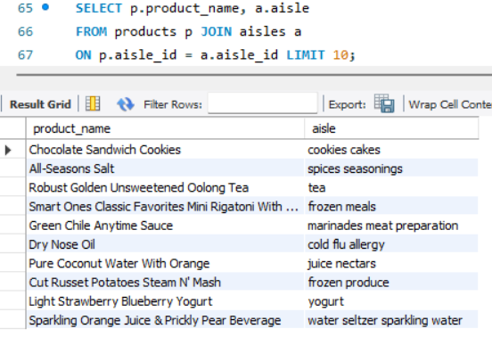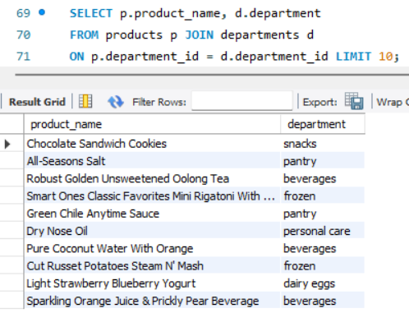

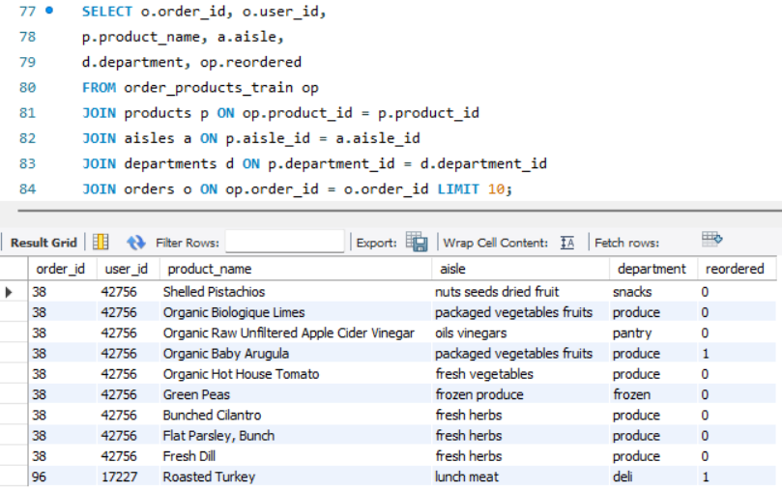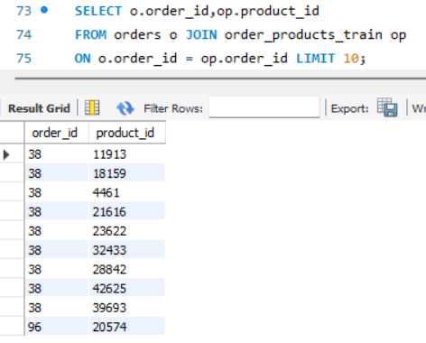
Figure 7: Validation of Table Relationships Using SQL JOIN Operations
The successful execution of these JOIN operations confirmed that the database schema was correctly linked, ensuring that customer orders, products, aisles, and departments could be analyzed together without inconsistencies.

Python-Based Data Analysis
Data Preparation in Python
After completing the database exploration and validation using SQL, the analysis was shifted to Python to efficiently handle large datasets and perform advanced data manipulation. Python was chosen because it provides greater flexibility for data processing, aggregation, and analysis compared to SQL, especially when working with over one million records.
Before starting the analytical tasks, the following preprocessing steps were performed:
- Installed the required Python libraries.
- Imported all necessary libraries, including Pandas, NumPy, and SQL Alchemy.
- Established a connection to the MySQL database.
- Imported all five tables into Pandas Data Frames.
- Verified the successful loading of each table by checking their dimensions.
- Verified column names, data types, missing values, and duplicate records.
- Merged the five tables into a single master dataset using the appropriate primary and foreign keys.
- Confirmed that the merged dataset was suitable for further analysis.
After completing the preprocessing stage, the business questions were solved using Python and Pandas.
Query 1 – Top 10 Aisles with the Highest Number of Products
Objective: To identify the aisles containing the highest number of products and understand how products are distributed across different store aisles.
q1_top_aisles = (
products
.merge(aisles, on="aisle_id")
.groupby("aisle", as_index=False)
.agg(total_products=("product_id", "count"))
.sort_values("total_products", ascending=False))
print(show(q1_top_aisles, 10))
# Additional verification: verifying what "missing" actually means
aisles[aisles["aisle"] == "missing"]
 | aisle | total_products
0 | missing | 1254
1 | candy chocolate | 1235
2 | ice cream ice | 1084
3 | vitamins supplements | 1030
4 | yogurt | 1023
5 | chips pretzels | 980
6 | packaged cheese | 888
7 | tea | 887
8 | frozen meals | 880 |  | aisle_id | aisle
9 | cookies cakes | 869 | 99 | 100 | missing
Interpretation
- The "missing" aisle contains the highest number of products (1,254).
- Candy Chocolate, Ice Cream, Vitamins & Supplements, and Yogurt also contain a large variety of products.
- The distribution indicates that certain aisles have a significantly broader product assortment than others.
- Verification confirmed that "missing" is an actual aisle name (aisle_id = 100) rather than missing or incomplete data.
Business Insight
Aisles with a larger product assortment require improved inventory planning, shelf management, and category organization. High-product aisles should receive greater attention during inventory replenishment and promotional planning.
Query 2 – Total Number of Unique Departments
Objective: To determine the total number of unique departments available in the dataset. This provides an overview of the major product categories offered by the store and helps understand the overall product classification.
q2_department_count = departments["department"].nunique()
print(f"Total Unique Departments: {q2_department_count}")
Total Unique Departments: 21
Interpretation
- The dataset contains 21 unique departments, representing the major product categories available.
- Each department groups together products with similar characteristics, making it easier to organize inventory and analyse product performance.
- This confirms that the store offers a wide variety of product categories to meet different customer needs.
Business Insight
The presence of 21 departments indicates a diverse product portfolio. Department-level analysis can help management identify high-performing and low-performing categories, optimize inventory allocation, and design targeted marketing strategies for different customer segments.

Query 3 – Distribution of Products Across Departments
Objective: To analyse how products are distributed across different departments and identify the departments with the largest product assortment.
q3_department_distribution = (
products
.merge(departments, on="department_id")
.groupby("department", as_index=False)
.agg(total_products=("product_id", "count"))
.sort_values("total_products", ascending=False))
show(q3_department_distribution)
 | department | total_products
0 | personal care | 6524
1 | snacks | 6221
2 | pantry | 5331
3 | beverages | 4324
4 | frozen | 3982
5 | dairy eggs | 3428
6 | household | 3068
7 | canned goods | 2073
8 | dry goods pasta | 1845
9 | produce | 1671

Interpretation
- Personal Care has the largest product assortment with 6,524 products, followed closely by Snacks and Pantry.
- Departments such as Produce, Dry Goods Pasta, and Canned Goods contain comparatively fewer products.
- The distribution of products across departments is uneven, indicating that certain departments offer a much broader variety of products than others.
Business Insight
The product catalogue is concentrated in a few major departments, particularly Personal Care, Snacks, and Pantry. These departments require greater attention in inventory planning, category management, and shelf space allocation due to their extensive product range.
Query 4 – Top 10 Products with the Highest Reorder Rates
Objective: To identify the products with the highest customer reorder rates and evaluate customer loyalty towards individual products. Since products with very few orders can produce misleadingly high reorder rates, different minimum order thresholds were applied to ensure the reliability of the analysis.
def top_reorder_products(min_orders):
result = (
master_df
.groupby("product_name", as_index=False)
.agg(
total_orders=("product_id", "count"),
reorder_count=("reordered", "sum")
)
)
result["reorder_rate"] = (
result["reorder_count"] / result["total_orders"] * 100
).round(2)
result = (
result[result["total_orders"] >= min_orders]
.sort_values(
["reorder_rate", "total_orders"],
ascending=[False, False]
)
.head(10)
)
return result
print("Minimum Orders = 20")
display(top_reorder_products(20))
print("Minimum Orders = 50")
display(top_reorder_products(50))
print("Minimum Orders = 100")
display(top_reorder_products(100))
Minimum Orders = 20
 | product_name | total_orders | reorder_count | reorder_rate
658 | A+ Cinnamon Sweet Potato Pancakes | 21 | 21 | 100.00
12449 | Maple Honey Ham | 23 | 22 | 95.65
22070 | Sparkling Water, Bottles | 20 | 19 | 95.00
22895 | Super Natural Organic Whole Milk | 20 | 19 | 95.00
15943 | Organic Low Fat Milk | 100 | 93 | 93.00
15859 | Organic Lactose Free 1% Lowfat Milk | 68 | 63 | 92.65
5762 | Crinkle Cut French Fries | 27 | 25 | 92.59
25670 | Wild Berry Smoothie | 50 | 46 | 92.00
7975 | French Vanilla Coffee Creamer | 25 | 23 | 92.00
25908 | Yogurt Tubes Blueberry | 21 | 19 | 90.48
Minimum Orders = 50
 | product_name | total_orders | reorder_count | reorder_rate
15943 | Organic Low Fat Milk | 100 | 93 | 93.00
15859 | Organic Lactose Free 1% Lowfat Milk | 68 | 63 | 92.65
25670 | Wild Berry Smoothie | 50 | 46 | 92.00
17136 | Organic Whole Milk with DHA Omega-3 | 115 | 104 | 90.43
13030 | Milk, Organic, Vitamin D | 139 | 124 | 89.21
16464 | Organic Reduced Fat Milk | 274 | 242 | 88.32
15961 | Organic Lowfat 1% Milk | 93 | 82 | 88.17
1809 | Banana | 4357 | 3840 | 88.13
8013 | Fresh CA Grown Eggs | 92 | 81 | 88.04
32 | 1% Lowfat Milk | 99 | 87 | 87.88

Minimum Orders = 100
 | product_name | total_orders | reorder_count | reorder_rate
15943 | Organic Low Fat Milk | 100 | 93 | 93.00
17136 | Organic Whole Milk with DHA Omega-3 | 115 | 104 | 90.43
13030 | Milk, Organic, Vitamin D | 139 | 124 | 89.21
16464 | Organic Reduced Fat Milk | 274 | 242 | 88.32
1809 | Banana | 4357 | 3840 | 88.13
19424 | Pure Sparkling Water | 258 | 222 | 86.05
1689 | Bag of Organic Bananas | 3522 | 3016 | 85.63
17126 | Organic Whole Milk | 1121 | 957 | 85.37
15396 | Organic Fat Free Milk | 188 | 160 | 85.11
15864 | Organic Large Brown Grade AA Cage Free Eggs | 257 | 216 | 84.05

Why the Threshold of 100 Was Selected
A threshold of 100 minimum orders was chosen because it provides a more reliable representation of customer purchasing behaviour. Lower thresholds (20 and 50) included products with limited purchase histories, which could produce inflated reorder rates due to small sample sizes. Using a higher threshold ensures that the reported reorder rates are based on a substantial number of customer purchases, making the analysis more suitable for business decision-making.
Interpretation
- Products with very low order volumes can achieve artificially high reorder rates, making them less reliable indicators of customer loyalty.
- Comparing multiple thresholds demonstrated that increasing the minimum order requirement filters out statistically weak results.
- Organic milk products consistently ranked among the highest reordered products across all thresholds, indicating strong and stable customer loyalty.
- Banana and Bag of Org. Bananas remained among the top reordered products despite having thousands of total orders, confirming that their popularity is supported by a large cust base rather than a small sample.
Business Insight
To ensure meaningful business decisions, a minimum order threshold of 100 was selected for the final analysis. This approach balances sample size with statistical reliability and prevents products with very few purchases from dominating the rankings. The findings indicate that organic dairy products, bananas, and sparkling water are highly loyal products that should be prioritized for inventory planning, promotional campaigns, and customer retention strategies.

Query 5 – Total Number of Unique Users
Objective: To determine the total number of unique customers who have placed orders in the dataset. This helps understand the size of the active customer base and provides a foundation for customer behaviour analysis.
q5_unique_users = orders["user_id"].nunique()
print(f"Total Unique Users: {q5_unique_users}")
Total Unique Users: 63100
Interpretation
- The dataset contains 63,100 unique customers who have placed orders.
- This indicates a large and diverse customer base, making the dataset suitable for customer behaviour and purchasing pattern analysis.
- A larger customer base improves the reliability of analytical insights and business decision-making.
Business Insight
The presence of over 63,000 unique customers indicates a broad market reach. This provides opportunities for customer segmentation, personalized marketing campaigns, loyalty programs, and targeted promotional strategies to improve customer retention and increase sales.
Query 6 – What is the Average Number of Days Between Orders for Each User?
Objective: To calculate the average number of days between consecutive orders for each customer. This helps understand customer purchasing frequency and provides insights into shopping behaviour and customer retention.
q6_avg_days_between_orders = (
orders[orders["days_since_prior_order"].notna()]
.copy()
.assign(days_since_prior_order=lambda df: pd.to_numeric(df["days_since_prior_order"]))
.groupby("user_id", as_index=False)
.agg(avg_days_between_orders=("days_since_prior_order", "mean")))
show(q6_avg_days_between_orders)
 | user_id | avg_days_between_orders
0 | 1 | 19.000000
1 | 2 | 16.285714
2 | 3 | 12.000000
3 | 4 | 17.000000
4 | 5 | 11.500000
5 | 6 | 13.333333
6 | 7 | 10.450000
7 | 8 | 23.333333
8 | 9 | 22.000000
9 | 10 | 21.800000
Interpretation
- The average number of days between orders varies across customers, indicating different purchasing habits.
- Some customers place orders approximately every 10–12 days, while others wait 20 days or more before making another purchase.
- This variation suggests the presence of both frequent and occasional shoppers within the customer base.
Business Insight
Customer purchase intervals provide valuable information about buying behavior. Customers with shorter ordering intervals are generally more engaged and may respond well to loyalty programs, while customers with longer intervals can be targeted through personalized reminders and promotional offers to encourage repeat purchases.

Query 7 – Peak Hours of Order Placement During the Day
Objective: To identify the hours of the day during which customers place the highest number of orders. This analysis helps understand customer purchasing patterns and supports better operational planning.
q7_peak_order_hours = (
orders
.groupby("order_hour_of_day", as_index=False)
.agg(total_orders=("order_id", "count"))
.sort_values("total_orders", ascending=False))
print(q7_peak_order_hours)
# Visualization
import matplotlib.pyplot as plt
plt.figure(figsize=(10,5))
plt.bar(
q7_peak_order_hours["order_hour_of_day"],
q7_peak_order_hours["total_orders"])
plt.title("Orders by Hour of Day")
plt.xlabel("Hour of Day")
plt.ylabel("Number of Orders")
plt.show()
 | order_hour_of_day | total_orders
10 | 10 | 88228
11 | 11 | 87087
14 | 14 | 86905
15 | 15 | 86888
13 | 13 | 85652
12 | 12 | 84204
16 | 16 | 83421
9 | 9 | 78737
17 | 17 | 69960
18 | 18 | 56284
8 | 8 | 54868
19 | 19 | 43076
20 | 20 | 31375
7 | 7 | 28199
21 | 21 | 23972
22 | 22 | 18824
23 | 23 | 12112
6 | 6 | 9253
0 | 0 | 6881
1 | 1 | 3698
5 | 5 | 2882
2 | 2 | 2312
4 | 4 | 1748
3 | 3 | 1649
Interpretation
- Customer ordering activity is highest between 10:00 AM and 4:00 PM.
- The single busiest hour is 10:00 AM, with 88,228 orders.
- Order volume gradually decreases after 4:00 PM.
- The lowest ordering activity occurs during the early morning hours (12:00 AM to 5:00 AM), when customer activity is minimal.
Business Insight
Customer demand is concentrated during the late morning and afternoon, indicating predictable shopping behaviour. This information can be used to optimize staffing levels, warehouse operations, inventory replenishment schedules, and delivery planning during peak demand periods.

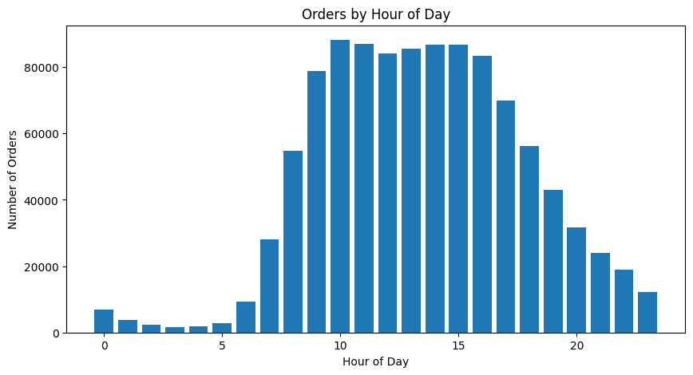
Query 8 – How Does Order Volume Vary by Day of the Week?
Objective: To analyse the distribution of customer orders across different days of the week and identify the busiest shopping days. This helps understand customer purchasing patterns and supports better inventory planning and workforce management.
import matplotlib.pyplot as plt
q8_orders_by_day = (
orders
.groupby("order_dow", as_index=False)
.agg(total_orders=("order_id", "count"))
.sort_values("order_dow"))
display(q8_orders_by_day)
plt.figure(figsize=(8,5))
plt.bar(
q8_orders_by_day["order_dow"],
q8_orders_by_day["total_orders"])
plt.title("Order Volume by Day of Week")
plt.xlabel("Day of Week (0 = Sunday)")
plt.ylabel("Total Orders")
plt.xticks(range(7))
plt.tight_layout()
plt.show()
 | order_dow | total_orders
0 | 0 | 183939
1 | 1 | 180025
2 | 2 | 143162
3 | 3 | 133839
4 | 4 | 130367
5 | 5 | 139183
6 | 6 | 138060
Interpretation
- The highest number of orders was placed on Sunday (183,939), followed closely by Monday (180,025).
- Order volume gradually decreases from Tuesday to Thursday.
- A slight increase in order volume is observed on Friday and Saturday.
- The results indicate that customer purchasing activity is concentrated at the beginning of the week.
Business Insight
The analysis suggests that Sunday and Monday are the busiest shopping days, making them critical periods for inventory availability and operational planning. The business should ensure adequate stock levels, workforce allocation, and delivery capacity during these peak days to meet customer demand efficiently. Promotional campaigns and product launches can also be strategically scheduled around these high-traffic days to maximize customer engagement and sales performance.
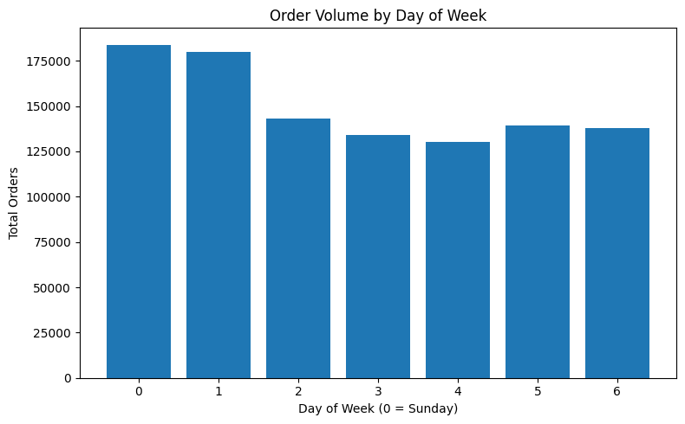
Query 9 – Top 10 Most Ordered Products
Objective: To identify the products that are purchased most frequently by customers. This analysis helps determine the highest-demand products and supports inventory planning, demand forecasting, and promotional strategies.
q9_top_ordered_products = (
master_df
.groupby("product_name", as_index=False)
.agg(total_orders=("product_id", "count"))
.sort_values("total_orders", ascending=False)
.head(10)
)
display(q9_top_ordered_products)
 | product_name | total_orders
1809 | Banana | 4357
1689 | Bag of Organic Bananas | 3522
16768 | Organic Strawberries | 2520
14733 | Organic Baby Spinach | 2286
11392 | Large Lemon | 1841
15689 | Organic Hass Avocado | 1705
14706 | Organic Avocado | 1661
22556 | Strawberries | 1479
11930 | Limes | 1383
16388 | Organic Raspberries | 1279

Interpretation
- Banana is the most frequently ordered product, with 4,357 orders, making it the highest-demand item in the dataset.
- Fresh fruits and vegetables dominate the list, indicating that customers frequently purchase fresh produce.
- Organic products such as Organic Bananas, Organic Strawberries, Organic Baby Spinach, and Organic Avocados appear multiple times among the top-selling products, suggesting strong customer preference for organic food items.
- The top 10 products are primarily everyday grocery essentials that customers purchase regularly.
Business Insight
The analysis indicates that fresh produce and organic products are the primary demand drivers within the store. Maintaining adequate inventory levels for these high-demand products is essential to prevent stock shortages and improve customer satisfaction. Additionally, these products can be leveraged in promotional campaigns, bundle offers, and cross-selling strategies to increase customer engagement and overall sales.
Query 10 – Number of Users Who Have Placed Orders in Each Department
Objective: To identify the number of unique customers who have purchased products from each department. This analysis helps understand customer reach across different product categories and identifies the departments that attract the largest customer base.
q10_users_per_department = (
master_df
.groupby("department", as_index=False)
.agg(unique_users=("user_id", "nunique"))
.sort_values("unique_users", ascending=False))
display(q10_users_per_department)
 | department | unique_users
19 | produce | 22303
7 | dairy eggs | 20153
3 | beverages | 14024
20 | snacks | 13304
10 | frozen | 11742
16 | pantry | 10886
2 | bakery | 8326
8 | deli | 7430
6 | canned goods | 6697
9 | dry goods pasta | 5942
13 | meat seafood | 5193
4 | breakfast | 5027
11 | household | 4897
17 | personal care | 3416
12 | international | 2188
14 | missing | 1630
1 | babies | 1435
0 | alcohol | 679
18 | pets | 622
15 | other | 392
5 | bulk | 323
Interpretation
- Produce has the highest customer reach, with 22,303 unique customers, making it the most widely purchased department.
- Dairy Eggs follows closely with 20,153 unique customers, indicating strong demand for everyday grocery essentials.
- Beverages, Snacks, Frozen, and Pantry also attract a large number of customers, highlighting their importance in customers' regular shopping baskets and Departments such as Bulk, Other, Pets, and Alcohol have comparatively fewer unique customers, indicating lower customer engagement.
Business Insight
The analysis shows that customers primarily purchase products from essential grocery departments such as Produce, Dairy Eggs, Beverages, Snacks, and Frozen. These departments should receive higher priority for inventory planning, promotional campaigns, and shelf space allocation, as they contribute to the largest customer reach. On the other hand, departments with lower customer engagement may require assortment optimization or targeted marketing strategies to improve their performance.
Query 11 – Average Number of Products per Order
Objective: To calculate the average number of products purchased in a single customer order. This helps in understanding the typical basket size and overall purchasing behaviour of customers.
q11_avg_products_per_order = (
master_df
.groupby("order_id")
.size()
.mean())
print(f"Average Products per Order: {q11_avg_products_per_order:.2f}")
Average Products per Order: 10.51
Interpretation
- The analysis shows that customers purchase an average of 10.51 products per order.
- This indicates that most customers tend to buy multiple products in a single shopping session rather than making single-item purchases.
- The result suggests a moderate basket size, reflecting planned grocery shopping behaviour.
Business Insight
An average basket size of approximately 11 products presents opportunities for cross-selling and upselling strategies. Retailers can increase the average order value by recommending complementary products, offering bundle discounts, or promoting frequently bought together items during checkout.
Query 12 – Most Reordered Product in Each Department
Objective: To identify the product with the highest number of repeat purchases in each department. This analysis helps determine the most popular and customer-loyal product within every product category.
q12_most_reordered = (
master_df
.groupby(["department", "product_name"], as_index=False)
.agg(reorder_count=("reordered", "sum")))
q12_most_reordered = (
q12_most_reordered
.sort_values(
["department", "reorder_count"],
ascending=[True, False]
)
.drop_duplicates("department")
)
display(q12_most_reordered)
 | department | product_name | reorder_count
294 | alcohol | Sauvignon Blanc | 53
435 | babies | Baby Food Stage 2 Blueberry Pear & Purple Carrot | 44
943 | bakery | 100% Whole Wheat Bread | 412
3921 | beverages | Sparkling Water Grapefruit | 637
4580 | breakfast | Honey Nut Cheerios | 167
4999 | bulk | Dried Mango | 78
5611 | canned goods | Organic Black Beans | 215
7737 | dairy eggs | Organic Whole Milk | 957
9086 | deli | Original Hummus | 539
9849 | dry goods pasta | Marinara Sauce | 117
10644 | frozen | Blueberries | 354
13040 | household | 100% Recycled Paper Towels | 177
14812 | international | Organic Sea Salt Roasted Seaweed Snacks | 61
15300 | meat seafood | Ground Turkey Breast | 170
15894 | missing | Organic Riced Cauliflower | 89
16218 | other | Roasted Almond Butter | 19
16916 | pantry | Extra Virgin Olive Oil | 257
19838 | personal care | Lavender Hand Soap | 28
20962 | pets | 24/7 Performance Cat Litter | 13
21467 | produce | Banana | 3840
24204 | snacks | Lightly Salted Baked Snap Pea Crisps | 164
Interpretation
- Banana is the most reordered product overall, with 3,840 repeat purchases, making it the strongest-performing product in the Produce department.
- Organic Whole Milk (957) and Sparkling Water Grapefruit (637) also demonstrate exceptionally high customer loyalty within their respective departments.
- Departments such as Pets, Alcohol, and Babies have comparatively lower reorder counts, indicating lower repeat purchasing activity. Each department has a distinct product that customers reorder most frequently.
Business Insight
The results highlight the flagship product of each department. These products should be considered priority items for inventory management, promotional campaigns, and shelf placement, as they consistently drive repeat purchases and customer retention.
Query 13 – Products Reordered More Than Once
Objective: To identify how many products have been reordered more than once. This helps measure the number of products that encourage repeat purchases and indicates overall customer loyalty towards the product catalogue.
q13_products_reordered = (
master_df
.groupby("product_name")
.agg(reorder_count=("reordered", "sum")))
q13_products_reordered = (
q13_products_reordered["reorder_count"] > 1
).sum()
print(f"Products Reordered More Than Once: {q13_products_reordered}")
Products Reordered More Than Once: 11529
Interpretation
- A total of 11,529 products were reordered more than once by customers.
- This indicates that a significant portion of the product catalogue experiences repeat purchases rather than one-time sales.
- The result suggests that customers exhibit consistent purchasing behaviour across many products, demonstrating product loyalty within the marketplace.
Business Insight
A large number of repeatedly purchased products indicates a strong base of customer loyalty. The business should prioritize maintaining inventory for these products, monitor their availability closely, and use them in personalized recommendations, loyalty programs, and targeted promotional campaigns to maximize repeat sales and customer retention.
Query 14 – Average Number of Products Added to Cart per Order
Objective: To determine the average number of products added to the shopping cart in a single order. This helps understand the typical customer basket size and purchasing behaviour.
q14_avg_cart_size = (
master_df
.groupby("order_id")
.agg(cart_size=("add_to_cart_order", "max")))
print(f"Average Cart Size: {q14_avg_cart_size['cart_size'].mean():.2f}")
Average Cart Size: 10.51
Interpretation
- On average, customers add approximately 10.51 products to their shopping cart per order.
- The result reflects a moderate basket size, suggesting planned grocery shopping behaviour.
- Since add_to_cart_order reaches the maximum item position in an order, both analyses produce the same business result (Query 11 and 14).
Business Insight
The average cart size indicates opportunities for increasing basket value through cross-selling and product recommendations. Since customers already purchase multiple items in each order, introducing bundle offers, complementary product suggestions, or volume-based discounts could encourage customers to add even more products to their carts, thereby increasing the average order value and overall revenue.

Query 15 – How Does the Number of Orders Vary by Hour of the Day?
Objective: To identify how the number of customer orders is distributed across different hours of the day and determine the busiest shopping hours.
This query requires the same analysis performed in Query 7 (Peak Hours of Order Placement During the Day). Since both questions analyse the distribution of orders across the 24-hour period, the same Python implementation and results have been reused to avoid duplication.
Reference: Query 7 – Peak Hours of Order Placement During the Day.
Query 16 – Distribution of Order Sizes
Objective: To analyse the distribution of customer order sizes by determining how many products customers purchase in each order. This helps understand typical shopping behaviour and identify the frequency of small, medium, and large orders.
q16_order_size_distribution = (
master_df
.groupby("order_id")
.agg(order_size=("product_id", "count"))
.groupby("order_size", as_index=False)
.agg(number_of_orders=("order_size", "count"))
.sort_values("order_size"))
display(q16_order_size_distribution)
 | order_size | number_of_orders
0 | 1 | 1536
1 | 2 | 1742
2 | 3 | 1883
3 | 4 | 1890
4 | 5 | 2032
... | ... | ...
62 | 66 | 1
63 | 67 | 1
64 | 70 | 1
65 | 72 | 1
66 | 74 | 1
Total Distinct Order Sizes: 67
Interpretation
- Customers place orders ranging from 1 to 74 products.
- Smaller and medium-sized orders occur much more frequently than very large orders.
- As the order size increases, the number of orders gradually decreases.
- Orders containing more than 60 products are extremely rare, with only one order recorded for several of the largest basket sizes.
Business Insight
The analysis indicates that most customers prefer purchasing a moderate number of products in a single order, while exceptionally large orders are uncommon. This purchasing pattern can help the business optimize inventory planning, warehouse operations, and order fulfilment processes. It also suggests an opportunity to increase the average basket size through personalized recommendations, product bundles, and cross-selling strategies.

Query 17 – Average Reorder Rate by Aisle
Objective: To identify the aisles with the highest average reorder rates and understand which product categories encourage the strongest repeat purchasing behaviour among customers.
q17_avg_reorder_rate = (
master_df
.groupby("aisle", as_index=False)
.agg(avg_reorder_rate=("reordered", "mean")))
q17_avg_reorder_rate["avg_reorder_rate"] = (
q17_avg_reorder_rate["avg_reorder_rate"] * 100
).round(2)
q17_avg_reorder_rate = (
q17_avg_reorder_rate
.sort_values("avg_reorder_rate", ascending=False))
display(q17_avg_reorder_rate)
 | aisle | avg_reorder_rate
83 | milk | 79.30
131 | water seltzer sparkling water | 73.97
50 | fresh fruits | 73.50
41 | eggs | 73.46
96 | packaged produce | 70.98
... | ... | ...
29 | cold flu allergy | 21.11
8 | beauty | 20.00
7 | baking supplies decor | 18.25
122 | spices seasonings | 17.65
76 | kitchen supplies | 16.33
Total Aisles Analyzed: 134
Interpretation
- The Milk aisle recorded the highest average reorder rate (79.30%), indicating that customers frequently repurchase products from this category.
- Other high-performing aisles, including Water Seltzer & Sparkling Water, Fresh Fruits, Eggs, and Packaged Produce, also demonstrated strong customer loyalty.
- In contrast, aisles such as Kitchen Supplies, Spices & Seasonings, Baking Supp. Decor, and Beauty exhibited comparatively lower reorder rates, suggesting that prod. in these categories are purchased less frequently.

Business Insight
The analysis indicates that essential grocery categories consistently achieve higher customer retention and repeat purchases, whereas discretionary and non-consumable categories generally experience lower reorder behaviour. This information can help the business prioritize inventory planning, promotional campaigns, and customer retention strategies for high-loyalty aisles while exploring initiatives to improve engagement in lower-performing categories.
Query 18 – Average Order Size by Day of the Week
Objective: To analyse how the average number of products purchased per order varies across different days of the week. This helps identify customer purchasing patterns and determine whether customers tend to place larger orders on specific days.
q18_avg_order_size_by_day = (
master_df
.groupby(["order_dow", "order_id"])
.agg(order_size=("product_id", "count"))
.reset_index()
.groupby("order_dow", as_index=False)
.agg(avg_order_size=("order_size", "mean"))
.sort_values("order_dow"))
display(q18_avg_order_size_by_day)
 | order_dow | avg_order_size
0 | 0 | 11.720820
1 | 1 | 10.292162
2 | 2 | 9.908470
3 | 3 | 9.667867
4 | 4 | 9.853087
5 | 5 | 10.198272
6 | 6 | 11.030755
Interpretation
- Customers place the largest orders on Day 0, with an average of 11.72 products per order.
- Day 6 also records a relatively high average order size of 11.03 products.
- The smallest average order size is observed on Day 3, with approximately 9.67 products per order.
- Overall, the variation in average order size throughout the week is moderate, ranging from 9.67 to 11.72 products, indicating relatively consistent purchasing behaviour.
Business Insight
Customers tend to purchase larger baskets on Day 0 and Day 6, suggesting these are major grocery shopping days. Retailers can leverage this pattern by ensuring adequate inventory, increasing staff availability, and promoting bundled offers or discounts during these high-volume shopping days to maximize sales and improve customer satisfaction.

Query 19 – Top 10 Users with the Highest Number of Orders
Objective: To identify the most active customers based on the total number of orders placed. This helps understand customer purchasing frequency and recognize highly engaged customers.
q19_top_users = (
orders
.groupby("user_id", as_index=False)
.agg(total_orders=("order_id", "count"))
.sort_values("total_orders", ascending=False)
.head(10))
display(q19_top_users)
 | user_id | total_orders
15895 | 15896 | 100
16289 | 16290 | 100
57837 | 57838 | 100
57850 | 57851 | 100
16297 | 16298 | 100
16312 | 16313 | 100
16339 | 16340 | 100
16356 | 16357 | 100
16363 | 16364 | 100
963 | 964 | 100
Interpretation
- The analysis identified the top 10 customers based on the total number of orders placed.
- Each of these customers has placed 100 orders, making them the most active users in the dataset.
- The identical order count among the top customers suggests that 100 orders may represent the maximum order history available within the dataset rather than an unusual purchasing pattern.
- These customers demonstrate consistent purchasing behaviour and can be considered highly engaged shoppers.
Business Insight
Highly active customers represent the business's most valuable customer segment. They are ideal candidates for loyalty programs, personalized offers, premium memberships, and targeted retention campaigns. Understanding the purchasing behavior of these customers can help improve customer lifetime value and strengthen long-term customer relationships.

Query 20 – Number of Products in Each Aisle and Department
Objective: To determine the distribution of products across each aisle within every department. This analysis helps understand the product assortment available in different categories and identifies aisles with the highest concentration of products.
q20_products_by_aisle_department = (
products
.merge(aisles, on="aisle_id")
.merge(departments, on="department_id")
.groupby(["department", "aisle"], as_index=False)
.agg(total_products=("product_id", "count"))
.sort_values(
["department", "total_products"],
ascending=[True, False]))
display(q20_products_by_aisle_department)
 | department | aisle | total_products
0 | alcohol | beers coolers | 384
1 | alcohol | red wines | 232
3 | alcohol | spirits | 192
4 | alcohol | white wines | 146
2 | alcohol | specialty wines champagnes | 95
... | ... | ... | ...
128 | snacks | fruit vegetable snacks | 356
132 | snacks | popcorn jerky | 315
130 | snacks | mint gum | 168
129 | snacks | ice cream toppings | 83
133 | snacks | trail mix snack mix | 69
Total of 134 department–aisle combinations were identified.
Interpretation
- The analysis provides a detailed breakdown of product distribution across aisles within each department.
- Certain aisles contain significantly more products than others, indicating a broader product assortment within those categories.
- For example, within the Alcohol department, Beers Coolers contains the highest number of products, while in the Snacks department, Fruit Vegetable Snacks has the largest product assortment.
Business Insight
Understanding product distribution at both the department and aisle levels enables better category management, shelf space optimization, and inventory planning. Departments with large assortments should receive greater attention in merchandising strategies, while lower-volume aisles can be evaluated for assortment optimization or expansion based on customer demand.

Power BI Dashboard Development
After completing the Python-based analysis, the processed datasets were exported in CSV format to facilitate interactive dashboard development in Microsoft Power BI. The following datasets were exported:
- Aisles
- Departments
- Products
- Orders
- Order Products
- Master Dataset
- Top Reordered Products (Minimum 100 Orders)
- Most Reordered Product by Department
These datasets were imported into Power BI to create interactive dashboards and visualizations. The dashboards were designed to summarize key business metrics, customer purchasing behaviour, product performance, and department-wise analysis. The dashboard development process included:
- Exporting processed datasets from Python into CSV format.
- Importing the datasets into Microsoft Power BI.
- Establishing relationships between the imported tables where required.
- Creating calculated measures and KPI cards.
- Developing interactive visualizations and filters.
- Designing four dashboard pages to present the analytical findings in a structured and user-friendly format.

Power BI Dashboard
After completing the SQL and Python-based analysis, an interactive dashboard was developed in Microsoft Power BI to present the analytical findings in a clear and business-friendly format. To improve readability and avoid overcrowding, the dashboard was divided into four separate pages, with each page focusing on a specific aspect of the business. This approach enables decision-makers to quickly understand key metrics, customer behavior, product performance, and category-level insights.
The dashboard consists of the following four pages:
- Executive Business Analysis
- Customer Business Overview
- Product Performance Overview
- Department & Category Analysis
Executive Business Analysis Dashboard
Overview
The Executive Business Analysis Dashboard provides a high-level summary of the supermarket's overall performance. It combines key business metrics with product, customer, and order insights, allowing management to quickly understand the current business situation without exploring detailed reports.
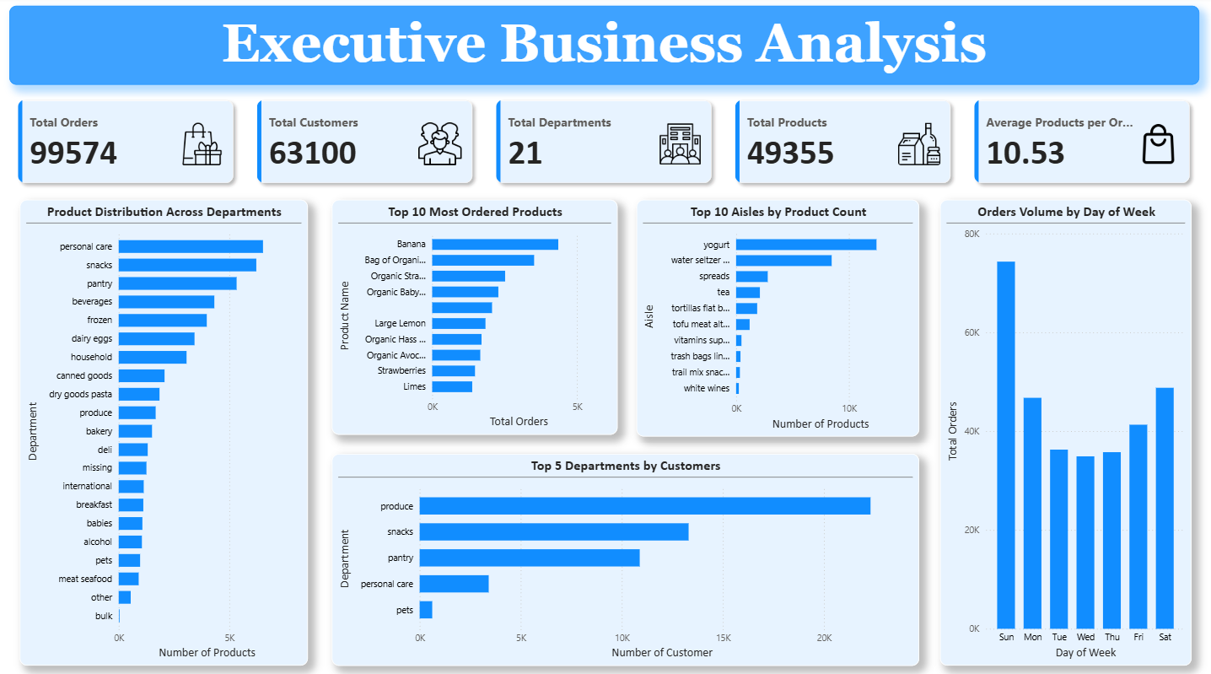
Key Visualization 1: Product Distribution Across Departments
This chart displays the number of products available in each department. It helps identify departments with the largest product assortment and highlights how inventory is distributed across the business. Some Key Insights are:
- Personal Care contains the highest number of products.
- Snacks and Pantry also have a large product assortment.
- Bulk contains the fewest products, indicating a much smaller inventory compared to other departments.
Key Visualization 2: Top 10 Most Ordered Products
This visualization identifies the products that customers purchase most frequently. These products represent the highest demand items and play a significant role in overall sales performance. Some Key Insights are:
- Banana is the most frequently ordered product.
- Organic fruits and vegetables dominate the top-selling products.
- Fresh produce contributes significantly to customer purchasing behaviour.
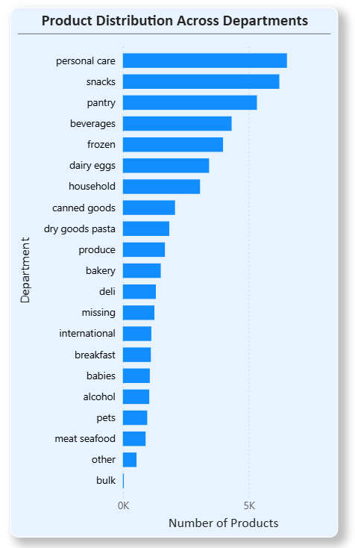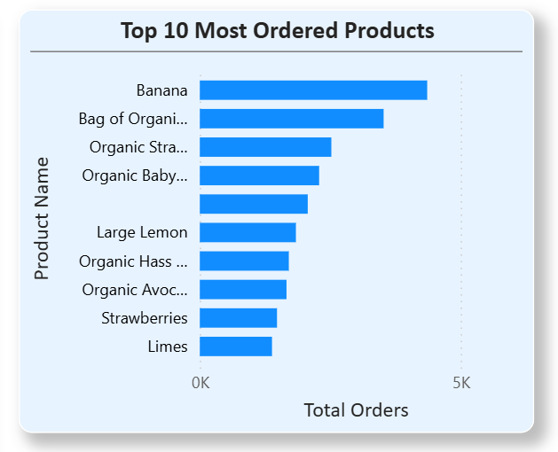
Key Visualization 3: Orders Volume by Day of Week
This chart illustrates how customer order volume changes throughout the week. It helps identify peak shopping days and supports operational planning. Some Key Insights are:
- Customer activity is highest at the beginning of the week (based on the dataset's day mapping).
- Mid-week order volume is comparatively lower.
- Understanding weekly order patterns optimize staffing, inventory replenishment, and promotional plans.
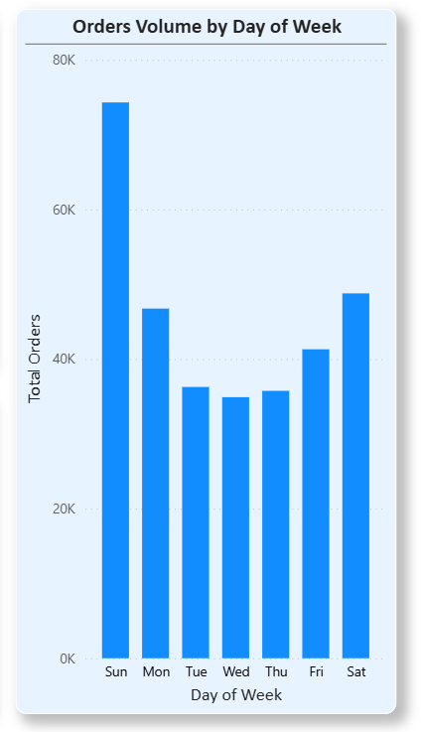
Dashboard Summary
The Executive Business Analysis Dashboard provides a concise overview of the supermarket's overall performance by combining business KPIs, product distribution, customer activity, and order trends into a single page. It enables management to quickly identify high-performing product categories, understand customer purchasing patterns, and make informed decisions related to inventory management, promotions, and operational planning.
Key Findings
- 63,100 active customers analysed
- Peak ordering occurs between 9 AM–5 PM
- Sunday and Monday receive highest order volume
- Organic dairy and fresh produce dominate reorder behaviour
- Average basket size = 10.5 items
- 11,529 products reordered multiple times

Customer Business Analysis Dashboard
Overview
The Customer Business Analysis Dashboard focuses on understanding customer purchasing behavior and shopping patterns. It provides insights into customer distribution, ordering habits, purchase frequency, reorder behavior, and shopping trends across different departments and time periods. These insights help businesses optimize marketing strategies, inventory planning, and customer engagement initiatives.
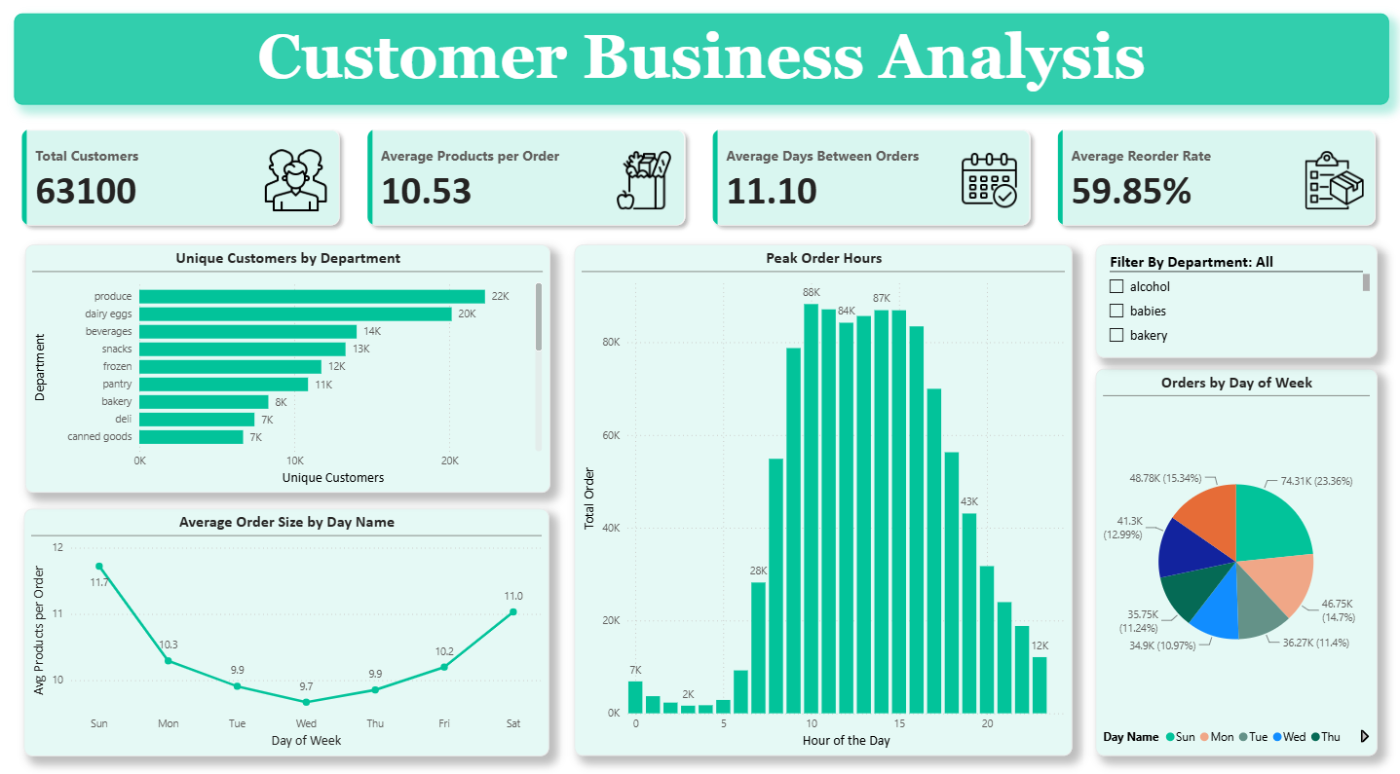

Key Visualization 1: Unique Customers by Department
This chart displays the number of unique customers purchasing products from each department. It helps identify departments that attract the largest customer base and highlights areas with the highest customer engagement. Some Key Insights are:
- Departments with higher customer reach present strong opportunities for promotions, cross-selling, and customer retention programs.
- Produce attracts the highest number of unique customers.
- Dairy Eggs, Beverages, and Snacks also have a large customer base.
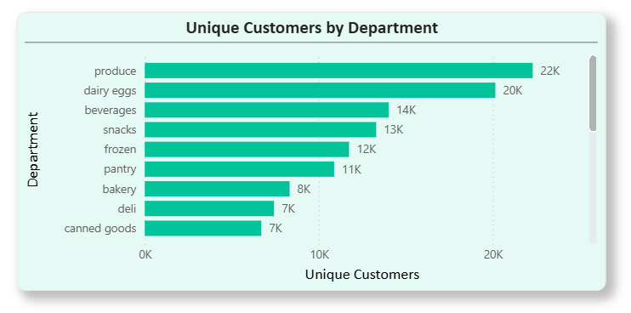
Key Visualization 2: Peak Order Hours
This visualization shows the distribution of customer orders throughout the day, allowing the identification of peak shopping hours and periods of low customer activity. Some Key Insights are:
- Customer orders increase significantly during the morning hours.
- The highest order volume occurs between 10 AM and 3 PM, with the peak around 10 AM.
- Order activity declines steadily after the afternoon and reaches its lowest level during late-night and early-morning hours.
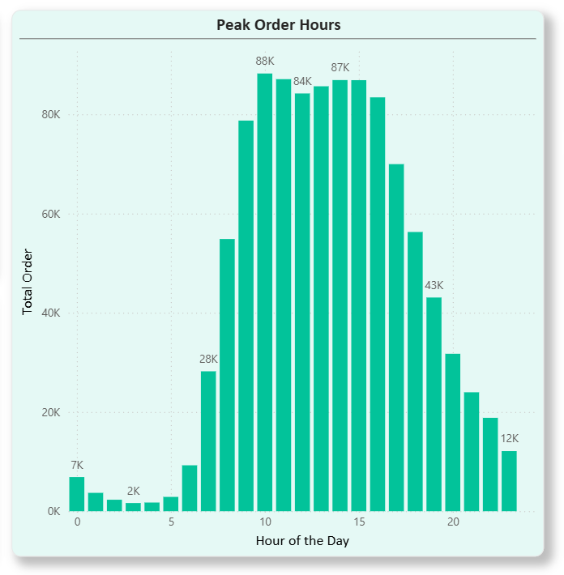
Key Visualization 3: Average Order Size by Day of Week
This chart illustrates the average number of products purchased per order on each day of the week, helping understand weekly shopping behavior. Some Key Insights are:
- Customers place the largest orders on Sunday, averaging approximately 11.7 products per order.
- Average order size gradually decreases during the middle of the week.
- Order size begins increasing again toward the weekend, indicating that customers tend to make larger grocery purchases at the beginning and end of the week.
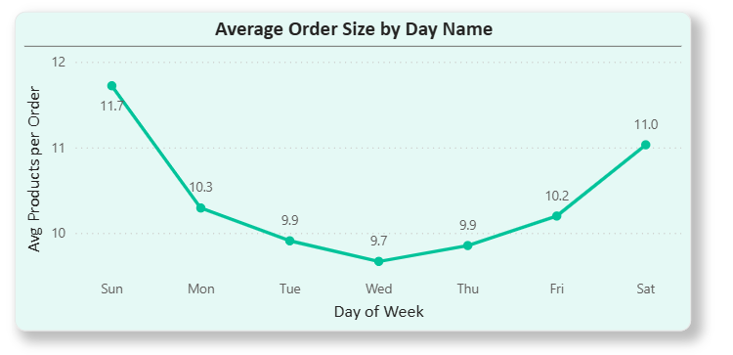
Dashboard Summary
The Customer Business Analysis Dashboard provides valuable insights into customer purchasing behavior by analyzing shopping frequency, department preferences, ordering patterns, and average basket size. The analysis reveals that Produce and Dairy departments attract the largest customer base, customer activity peaks between 10 AM and 3 PM, and larger shopping baskets are typically observed on weekends. These findings can support decisions related to staffing, inventory replenishment, promotional timing, and customer relationship management.
Product Performance Analysis Dashboard
Overview
The Product Performance Analysis Dashboard focuses on evaluating product-level performance by analyzing customer purchasing patterns, reorder behavior, and product demand across different departments. It highlights the best-performing products, identifies products with high customer loyalty, and provides insights that support inventory management, merchandising, and product planning decisions.
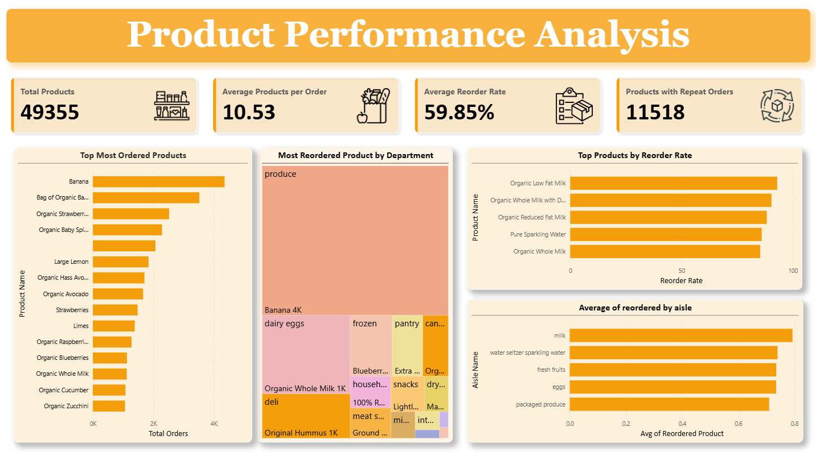
Key Visualization 1: Top Most Ordered Products
This chart displays the products with the highest number of customer orders, helping identify the store's best-selling products and the primary drivers of overall sales. Some Key Insights are:
- Banana is the most ordered product, followed by Bag of Organic Bananas and Organic Strawberries.
- Fresh fruits and vegetables dominate the list of top-selling products.
- These products represent consistently high customer demand and require careful inventory planning to avoid stock shortages.
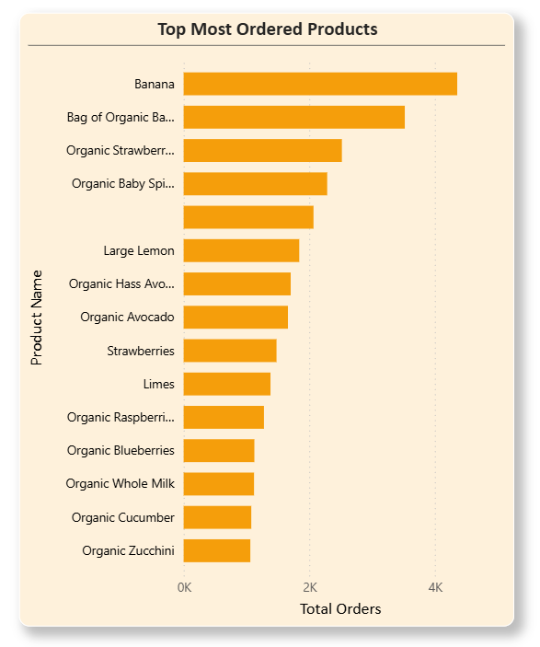
Key Visualization 2: Top Products by Reorder Rate
This visualization highlights products with the highest reorder rates after applying a minimum order threshold. This approach ensures that only products with sufficient purchase history are considered, making the analysis more reliable. Some Key Insights are:
- Organic Low-Fat Milk has the highest reorder rate, followed by Organic Whole Milk with DHA Omega-3 and Organic Reduced Fat Milk.
- Organic dairy products demonstrate exceptionally strong customer loyalty.
- High reorder rates indicate products that customers repeatedly purchase and are ideal candidates for customer retention and loyalty campaigns.
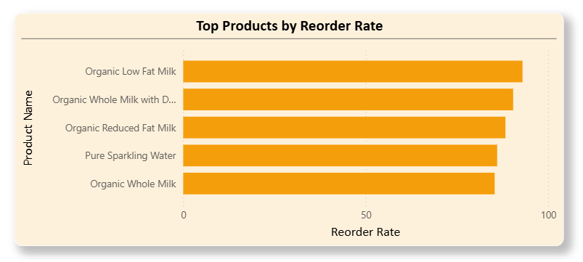
Key Visualization 3: Most Reordered Product by Department
This tree map identifies the most reordered product within each department, providing a department-level view of customer preferences and product loyalty. Some Key Insights are:
- Banana is the most reordered product in the Produce department.
- Organic Whole Milk leads the Dairy Eggs department, while Original Hummus is the most reordered product in the Deli department.
- Every department has a distinct high-performing product that can be used as a flagship item for promotions and merchandising strategies.
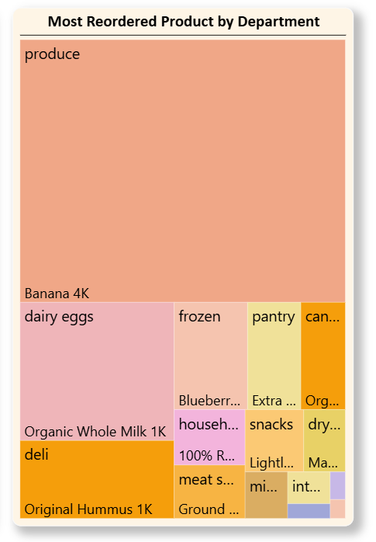
Dashboard Summary
The Product Performance Analysis Dashboard provides a comprehensive evaluation of product demand and customer loyalty. The analysis reveals that fresh produce and organic dairy products consistently achieve the highest sales volume and reorder rates, indicating strong customer preference and repeat purchasing behaviour. These insights can support inventory optimization, promotional planning, assortment management, and customer retention strategies by focusing on high-performing products and departments.
Department & Category Analysis Dashboard
Overview
The Department & Category Analysis Dashboard provides a detailed view of product distribution and customer engagement across different departments and aisles. It helps evaluate category performance, identify high-performing departments, and understand how products are organized throughout the store. This dashboard supports strategic decisions related to inventory management, category optimization, and merchandising.
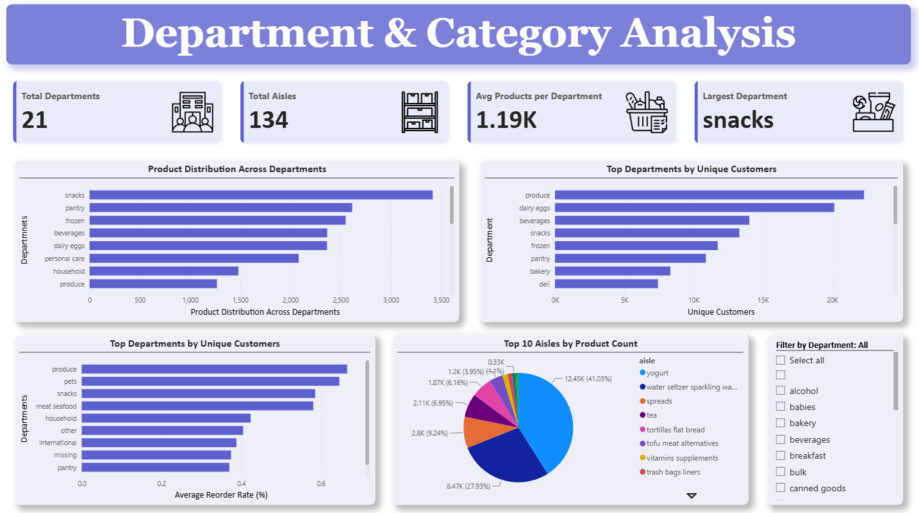

Key Visualization 1: Product Distribution Across Departments
This chart illustrates the number of products available in each department, providing an overview of how the overall product catalogue is distributed across business categories. Some Key Insights are:
- Snacks contains the highest number of products among all departments.
- Pantry, Frozen, and Beverages also maintain a large product assortment.
- Departments with larger inventories require more effective inventory management and shelf space planning.
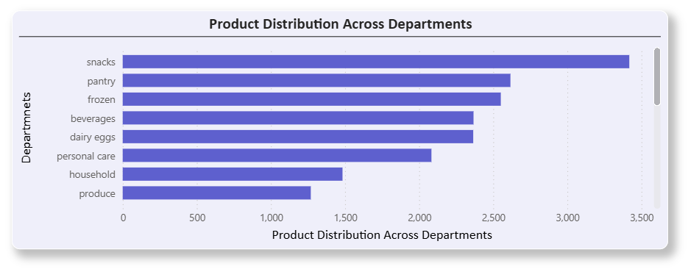

Key Visualization 2: Top Departments by Unique Customers
This visualization presents the departments that attract the highest number of unique customers, highlighting customer preferences across major product categories. Some Key Insights are:
- Produce attracts the largest customer base, followed by Dairy Eggs, Beverages, and Snacks.
- These departments represent the store's primary customer traffic drivers.
- Focusing promotional campaigns and inventory investments on these departments can significantly improve customer satisfaction and sales performance.
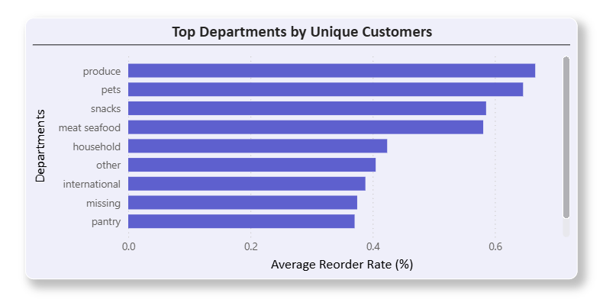
Key Visualization 3: Top 10 Aisles by Product Count
This pie chart illustrates the distribution of products among the top 10 aisles with the highest product counts. It helps identify which aisles contribute the largest share of the overall product assortment and highlights categories with the greatest inventory concentration. Some Key Insights are:
- Yogurt represents the largest share of products among the top 10 aisles, accounting for approximately 41% of the displayed product distribution.
- Water Seltzer Sparkling Water is the second-largest aisle, followed by Spreads and Tea, indicating that these aisles also maintain substantial product assortments.
- The remaining aisles each contribute a comparatively smaller proportion, suggesting that product availability is concentrated in a few major aisles.
- Understanding aisle-level product distribution helps optimize shelf allocation, category management, and inventory planning for high-volume product categories.
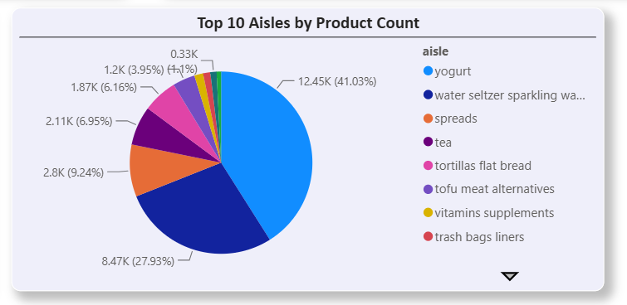
Dashboard Summary
The Department & Category Analysis Dashboard provides a comprehensive understanding of product distribution, customer engagement, and category performance across the supermarket. The analysis highlights that while Snacks offers the largest product assortment, Produce attracts the highest number of customers and demonstrates strong repeat purchasing behaviour. These insights support more effective category management, inventory allocation, merchandising strategies, and data-driven business decision-making.

Business Insights
A. Product Portfolio Insights
Product Catalogue and Distribution: The store features a broad and highly diversified product portfolio of 49,355 products across 21 departments and 134 aisles to cater to varied customer needs. However, product distribution is highly uneven; major categories like Personal Care (6,524), Snacks (6,221), and Pantry (5,331) hold the largest shares, whereas the Bulk department is the smallest with only 38 products. Suggested Business Impact:
- Inventory management efforts should focus more on departments with large assortments.
- Smaller departments may require assortment optimization.
Aisle Variety: Certain aisles exhibit extremely large product variety, led by Missing (1,254), Candy Chocolate (1,235), Ice Cream (1,084), and Vitamins & Supplements (1,030). Suggested Business Impact:
- Large aisles require better shelf planning.
- Higher assortment may increase customer choice but also operational complexity.

B. Customer Base Insights
Customer Base: The store maintains a large active customer base, with the dataset capturing 63,100 unique customers. Suggested Business Impact:
- Large enough customer base for segmentation and personalized marketing.
Purchase frequency: Customers purchase regularly, with the average time between transactions typically ranging from 10 to 25 days. Suggested Business Impact:
- Customers exhibit recurring purchasing behaviour.
- Good opportunity for reminder campaigns and subscription models.

C. Purchasing Behaviour
Customers Prefer Shopping During Midday: Customer orders peak during the midday hours of 10 AM, 11 AM, 2 PM, and 3 PM, while the lowest transaction volumes occur during the early morning between 2 AM and 5 AM. Suggested Business Impact:
- Schedule staff during peak hours.
- Launch promotional notifications before peak ordering windows.
Weekends Are Busier: Order volume peaks during the weekend on Saturday and Sunday, while Wednesday experiences the lowest traffic. Suggested Business Impact (Interpret according to the dataset's day mapping.):
- Increase inventory and staffing during busy days.
Customers Buys Products Per Order: On average, customers purchase 10.51 products per order. Suggested Business Impact:
- Customers generally purchase medium-sized baskets.
- Cross-selling opportunities exist.
Order Sizes Vary Widely: Order sizes vary widely, ranging from 1 to 74 products, though most customers purchase relatively small-to-medium baskets. Suggested Business Impact:
- Large orders represent valuable customers.
- Bundle offers may encourage larger baskets.

D. Product Loyalty
Organic Products Show Strong Customer Loyalty: Organic dairy products demonstrate exceptionally strong customer loyalty when applying a minimum threshold of 100 orders. For instance, Organic Low-fat Milk, Organic Whole Milk, Organic Whole Milk DHA, and Organic Reduced Fat Milk all maintain reorder rates exceeding 85%. Suggested Business Impact:
- Organic products drive repeat purchases.
Bananas Dominate the Store: Bananas dominate the store's inventory performance, ranking repeatedly as both the single highest-ordered product overall and the highest-reordered item within the Produce department. Suggested Business Impact:
- Bananas are a core demand driver.
- Inventory shortages could directly affect customer satisfaction.
Different Departments Have Different Loyalty Drivers: Each department is anchored by its own specific hero product that drives customer loyalty. Notable examples include Bananas in Produce, Organic Whole Milk in Dairy, Original Hummus in Deli, and Sauvignon Blanc in Alcohol. Suggested Business Impact:
- Department-specific promotions should focus on these products.

E. Customer Reach
Produce Reaches the Largest Number of Customers
The Produce department reaches the largest number of customers, followed closely by Dairy Eggs, Beverages, and Snacks as the categories with the highest unique customer counts. Suggested Business Impact:
- These departments attract the broadest customer base.
- They deserve greater promotional investment.

F. Product Demand
Fresh Produce Dominates Orders: Fresh produce dominates customer orders, with top-ordered products consisting of bananas, organic bananas, organic strawberries, organic baby spinach, avocados, and lemons. Suggested Business Impact:
- Fresh produce drives customer traffic.
- Demand forecasting is especially important for perishables.

G. Reordering Behaviour
High Reorder Rates Need Context: While several products initially showed a 100% reorder rate, these figures were skewed by low purchase volumes; applying a minimum threshold of 100 orders established a much more reliable metric. Suggested Business Impact:
- Business decisions should not rely solely on percentages; sufficient sample size is essential for reliable conclusions.

Key Variables from Cross Analysis
- Departments with the largest product assortment are not necessarily the ones with the highest reorder rates. Meaning: A wider assortment does not automatically create stronger customer loyalty.
- Produce has comparatively fewer products than Personal Care, yet it serves the largest number of unique customers. Meaning: Produce items are everyday essentials with broad customer appeal.
- Organic dairy products consistently appear among the highest reorder-rate products.
- Meaning: Customers who buy organic dairy are highly loyal.
- Peak shopping hours (10 AM–3 PM) align with medium basket sizes (~10 products), indicating customers are likely doing planned grocery shopping rather than impulse purchases.
- Fresh produce dominates both most ordered products and most reordered products, reinforcing its importance in overall store performance.
- Some departments (e.g., Bulk, Pets) have relatively few products and fewer customers, suggesting they contribute less to overall engagement than major grocery categories.
- High-performing departments (Produce, Dairy Eggs, Beverages, Snacks) combine large customer reach with strong repeat purchasing, making them strategic focus areas for promotions and inventory planning.

Business Recommendations
A. Prioritize Inventory for High-Demand Products
Observation: Products like Banana, Organic Bananas, Organic Strawberries, Organic Baby Spinach, and Organic Whole Milk consistently rank among the most ordered and reordered items.
Recommendation
- Maintain higher safety stock for these products.
- Use demand forecasting to prevent stockouts.
- Monitor inventory daily for these fast-moving products.

Expected Benefit
- Higher product availability.
- Increased customer satisfaction.
- Reduced lost sales.

B. Strengthen Organic Product Portfolio
Observation: Organic dairy and produce products have exceptionally high reorder rates.
Recommendation
- Expand organic product offerings.
- Promote organic bundles.
- Feature organic products in marketing campaigns.
Expected Benefit
- Improved customer retention.
- Higher repeat purchases.
- Increased revenue from loyal customers.

C. Optimize Staffing During Peak Hours
Observation: Most orders occur between 10 AM and 3 PM.
Recommendation
- Increase staffing during peak shopping hours.
- Schedule replenishment before peak demand.
- Allocate more delivery resources during these hours.
Expected Benefit
- Faster service.
- Reduced customer waiting time.
- Better operational efficiency.

D. Increase Weekend Readiness
Observation: Order volume is highest on Day 0 and Day 1.
Recommendation
- Increase inventory before weekends.
- Schedule additional staff.
- Run weekend promotional campaigns.
Expected Benefit
- Better customer experience.
- Increased sales.
- Reduced stock shortages.

E. Focus Promotions on High-Customer Departments
Observation: Produce, Dairy Eggs, Beverages, and Snacks attract the highest number of unique customers.
Recommendation
- Launch targeted promotions in these departments.
- Place featured products at store entrances.
- Offer bundle discounts across these departments.
Expected Benefit
- Increased customer engagement.
- Higher average basket value.
- More cross-selling opportunities.

F. Improve Low-Performing Departments
Observation: Departments like Bulk, Pets, Alcohol, and Other have fewer products and fewer customers.
Recommendation
- Review product assortment.
- Remove consistently underperforming products.
- Test new products based on customer demand.
Expected Benefit
- Better inventory utilization.
- Lower holding costs.
- Improved department performance.

G. Increase Average Basket Size
Observation: Customers purchase an average of 10.5 products per order.
Recommendation
- Introduce "Frequently Bought Together" recommendations.
- Offer "Buy More, Save More" promotions.
- Create meal kits and bundled product offers.
Expected Benefit
- Higher average order value.
- Increased revenue per customer.

H. Build Customer Loyalty Programs
Observation: Many products have high reorder rates, indicating strong repeat purchasing behavior.
Recommendation
- Introduce personalized loyalty rewards.
- Offer repeat-purchase discounts.
- Send reorder reminders based on purchase frequency.
Expected Benefit
- Higher customer retention.
- Increased lifetime customer value.
- More recurring sales.

I. Improve Shelf Space Allocation
Observation: Personal Care, Snacks, and Pantry contain the largest number of products.
Recommendation
- Allocate shelf space based on product demand rather than only product count.
- Regularly review category performance to optimize layouts.
Expected Benefit
- Better product visibility.
- Improved shopping experience.
- Increased sales from high-demand categories.

J. Use Customer Purchase Patterns for Marketing
Observation: Customers exhibit consistent purchasing cycles and predictable shopping behaviour.
Recommendation
- Schedule email campaigns and app notifications before peak shopping periods.
- Personalize offers using previous purchase history.
- Recommend complementary products during checkout.
Expected Benefit
- Higher campaign conversion rates.
- Increased repeat purchases.
- Better customer engagement.

K. Develop Department-Specific Marketing Strategies
Observation: Each department has a distinct top-performing product (e.g., Banana in Produce, Organic Whole Milk in Dairy).
Recommendation
- Design promotions around each department's best-selling product.
- Use these products as "traffic drivers" to encourage additional purchases within the department.
Expected Benefit
- Increased department-level sales.
- Higher cross-selling opportunities.

L. Base Business Decisions on Reliable Metrics
Observation: Products with very few purchases can show misleadingly high reorder rates.
Recommendation
- Apply a minimum order threshold (e.g., 100 orders) before evaluating product loyalty.
- Combine reorder rate with total order volume when identifying high-performing products.
Expected Benefit
- More reliable decision-making.
- Reduced risk of acting on statistically weak patterns.

Conclusion & Future Scope
This analysis converts a relational grocery-order dataset into a validated, cross-checked picture of what's bought, how often, by whom, and when — anchored by SQL-level integrity checks, complete pandas answers to all 20 brief questions, and four Power BI dashboards for stakeholder self-service. The single most decision-ready finding is the convergent evidence across four independent metrics that a small set of perishable staples anchor customer engagement, while catalog breadth sits elsewhere — this insight alone should drive the next round of assortment and retention-marketing planning.
Future Scope
- Validate the extraction cap — confirm whether the ~1,048,575-row tables represent a capped extract and, if so, re-run this analysis against the full order history.
- Enrich with pricing/margin and marketing-channel data so reorder-rate insights can be turned into ROI-ranked recommendations rather than volume-ranked ones.
- Extend to a rolling/cohort view — e.g. reorder cadence by customer tenure — once more than a 10-user sample is available for Q6-style analysis.
- Resolve the "missing" category and the small Power BI/Python metric discrepancies as a formal data-quality remediation backlog item.
- Move from a point-in-time CSV export to a refreshable Power BI model so the dashboards stay current as new orders arrive, rather than reflecting a single export snapshot.

