Q0.

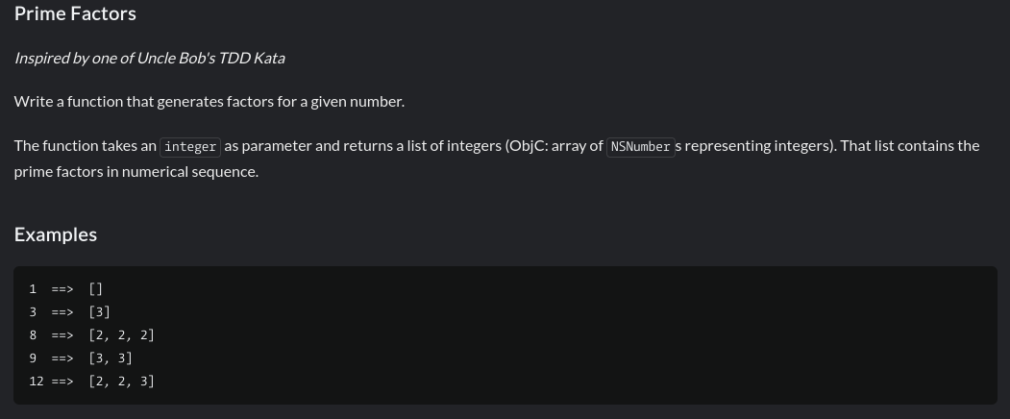

Q1. 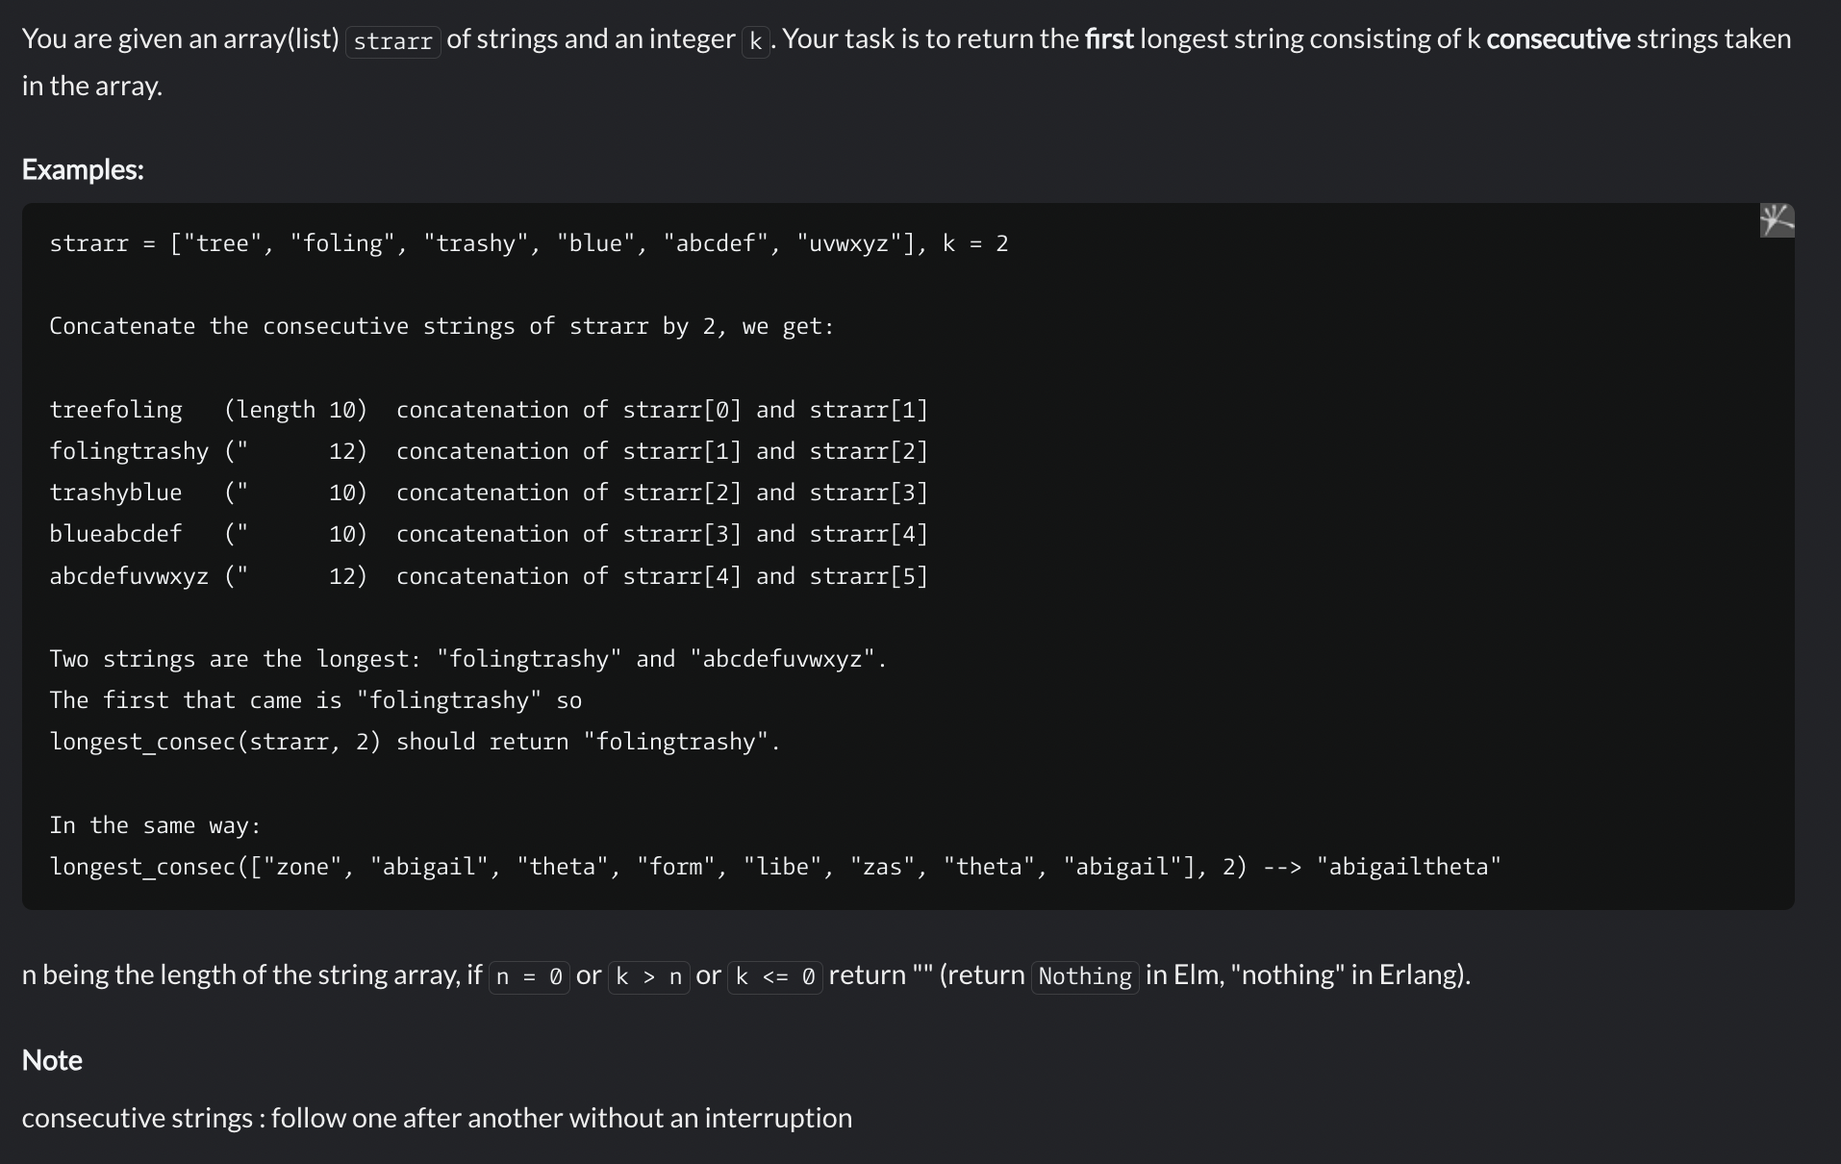

Q2.

Parameter num and returns its multiplicative persistence, which is the number of times you must multiply the digits in num until you reach a single digit.

For example (Input --> Output):

39 --> 3 (because 3*9 = 27, 2*7 = 14, 1*4 = 4 and 4 has only one digit)

999 --> 4 (because 9*9*9 = 729, 7*2*9 = 126, 1*2*6 = 12, and finally 1*2 = 2)

4 --> 0 (because 4 is already a one-digit number)

NOTE: WITHOUT USING toString or String or anyother mechanism that converts the number to string, you need to achieve this task without converting the number to string.

Q3.

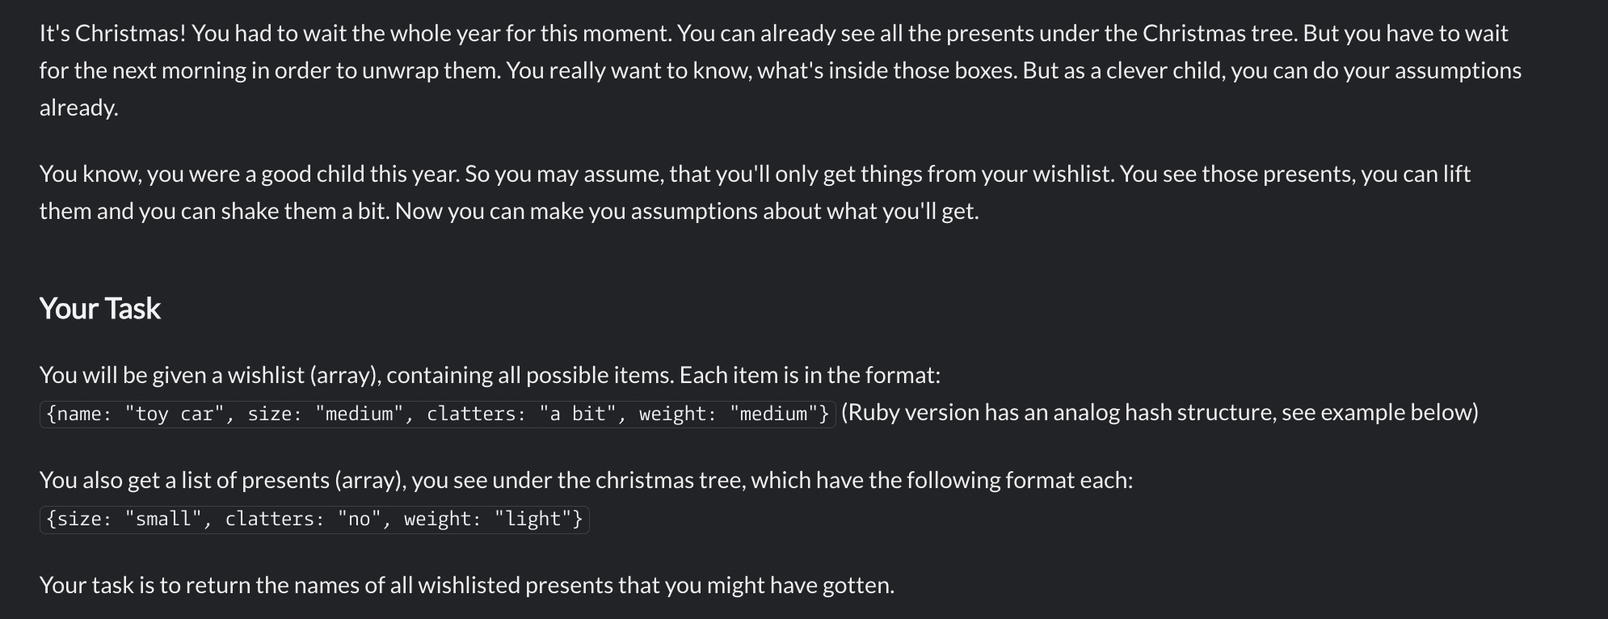

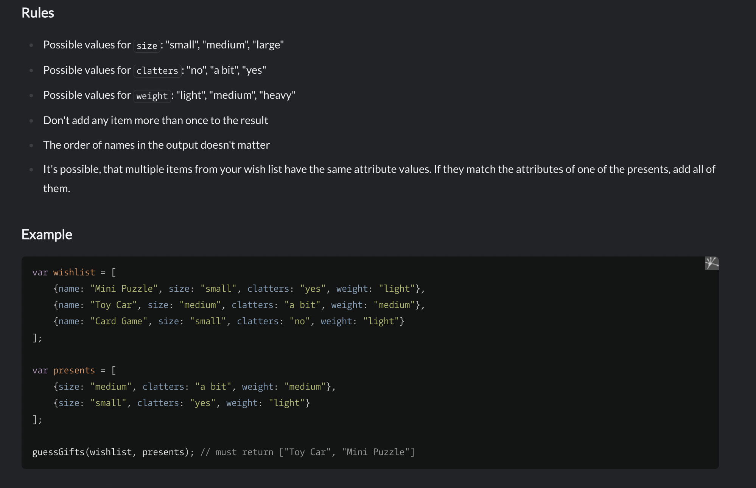

Q4.

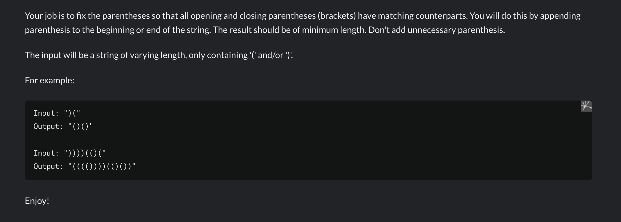

Q5.

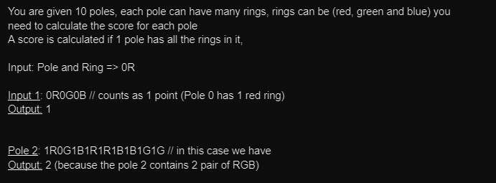

**Q6.**

