Hospital Patient Appointment & Care Management System (HPACMS)
User story :
The Hospital Patient Appointment & Care Management System (HPACMS) is a Salesforce-based application built so that patients, receptionists, doctors, and hospital administrators can handle the entire appointment and care process in one unified platform. As a patient, I want to browse departments and doctors, check availability and time slots, and book an appointment online, so that I can get care quickly without long queues or phone calls. As a receptionist, I want appointment requests to move through an automated approval process, with the system validating doctor availability, slot conflicts, and patient details, so that I can confirm or reject bookings accurately and without manual checking. As a doctor, I want to view my scheduled appointments and patient histories and record diagnosis notes and follow-ups, so that I can manage my day and continue care without extra paperwork. As an administrator, I want to create and manage patient records, doctors, departments, and billing details, so that the hospital's data stays accurate and up to date. I also want dashboards and reports on appointments, department demand, payment status, and doctor workload, so that I can make informed decisions about scheduling, staffing, and resources.
1. INTRODUCTION
1.1 Project Overview :
The Hospital Patient Appointment & Care Management System (HPACMS) aims to bring all patient, doctor, department, and appointment-related data together in a single Salesforce application, ensuring easy data access, structured workflows, and accurate reporting. The system allows receptionists to manage patient registration, appointment booking, billing, and communication effectively, while doctors and administrators gain full transparency into schedules, patient visits, and care progress. It also supports automated doctor assignment, task creation, validation checks, and multi-level approval processes to keep appointment management accurate and consistent.
Using Salesforce Flows, Approval Processes, Validation Rules, Reports, and Dashboards, the hospital can ensure that every stage of the patient journey, from registration and booking to consultation and follow-up, is handled systematically. Validation Rules prevent double-booked slots, past-dated appointments, and incomplete records. Flows automate repetitive tasks such as assigning doctors, sending confirmations, and creating follow-up tasks.
1.2 Purpose:
The primary purpose of HPACMS is to replace manual and fragmented appointment handling with a scalable, automated, and secure Salesforce solution that brings speed, accuracy, and transparency to the hospital's outpatient operations. The system ensures:
- Centralized patient and doctor data management: All patient profiles, doctor details, departments, and appointment records are stored in one place, reducing duplication and data entry errors.
- Structured appointment workflows: Every appointment follows a defined path from request to approval, consultation, and follow-up, so no booking is missed or delayed.
- Automated approvals and validations: Approval Processes and Validation Rules automatically check slot availability, duplicate bookings, and required information, reducing manual verification effort.
- Transparent reporting and monitoring: Reports and Dashboards give administrators and receptionists real-time visibility into appointment volume, revenue, patient status, and pending approvals.
2. IDEATION PHASE
2.1 Problem Statement (Customer Problem Statement Template)
PS (Customer) | I'm trying to | But | Because | Which makes me feel
PS-1 Receptionist | Manage patient appointments efficiently | Appointment data is scattered across registers and phone notes | Systems are manual and unintegrated | Frustrated and error-prone
PS-2 Administrator | Track appointments and revenue | Reporting is delayed and often inaccurate | Data is not centralized in one platform | Uncertain in decision-making
PS-3 Doctor | View my schedule and patient details | I don't get updated appointment lists on time | Schedule changes are communicated manually | Unprepared and disconnected
PS-4 Patient | Book an appointment and check its status | I don't know whether my booking is confirmed or pending | There is no automated approval tracking or notification system | Anxious and uninformed
2.2 Empathy Map Canvas
User Persona: Receptionist
- Think & Feel: Worried about double bookings, missed confirmations, and long patient queues. Feels pressured to keep records accurate while handling a growing number of requests.
- Hear: Complaints from patients about delayed confirmations, and questions from management about pending approvals and daily appointment numbers.
- See: Multiple registers, scattered notes, and paper forms with no single view of appointment status.
- Say & Do: Rechecks schedules repeatedly, follows up manually with patients and doctors, and updates records by hand.
2.3 Brainstorming & Idea Prioritization
Step 1: Brainstormed Ideas
- Spreadsheet automation: Use macros and shared spreadsheets to track patients, doctors, and appointments more consistently.
- Standalone booking portal: Build a custom web application where patients book appointments online.
- Hospital ERP extension: Extend the hospital's existing ERP with appointment and patient management modules.
- Salesforce-based appointment system: Build a unified cloud application using custom objects, Flows, Approval Processes, Validation Rules, Reports, and Dashboards.
- Automated notifications: Send email confirmations and reminders to patients and doctors when an appointment is approved, rejected, or rescheduled.
- Real-time dashboards: Give administrators live views of appointment volume, revenue, and pending approvals.
Step 2: Grouping
Group | Ideas | Description
Manual solutions | Spreadsheet automation | Low cost and quick to start, but still depends on manual updates and is prone to duplicate entries
Semi-automated solutions | Standalone booking portal, ERP extension | Automate parts of the process, but often need separate systems, heavy customization, or complex integration
Fully automated cloud solutions | Salesforce-based appointment system, automated notifications, real-time dashboards | End-to-end automation of booking, approvals, validations, and reporting on one scalable platform
Step 3: Idea Prioritization
Each idea is rated High, Medium, or Low against the criteria below.
Idea | Impact | Feasibility | Cost Efficiency
Spreadsheet automation | Low | High | High
Standalone booking portal | Medium | Medium | Low
Hospital ERP extension | Medium | Low | Low
Salesforce-based appointment system | High | High | High
Automated notifications | High | High | High
Real-time dashboards | High | Medium | High
3. REQUIREMENT ANALYSIS PHASE
3.1 Customer Journey Map
The journey map follows a patient and the hospital staff through the care process, from first contact to follow-up.
Stage 1: Awareness & Registration
- User Actions: Learns about the hospital and its departments, then registers as a patient.
- Touchpoints: Website, helpdesk, receptionist.
- Pain Points: Manual data entry and duplicate patient records.
- HPACMS Solution: The patient record is created in Salesforce, with validation rules that prevent duplicates and incomplete data.
- Emotion: Curious and hopeful.
Stage 2: Doctor Selection
- User Actions: Browses departments and doctors and checks specialization, fees, and available slots.
- Touchpoints: Doctor directory, receptionist.
- Pain Points: Outdated doctor information and unclear slot availability.
- HPACMS Solution: Centralized Department and Doctor objects show specialization, fees, and availability.
- Emotion: Interested but unsure.
Stage 3: Appointment Request
- User Actions: Submits a request for the selected doctor and time slot.
- Touchpoints: Booking form, phone, email.
- Pain Points: Paper registers, missed requests, and double bookings.
- HPACMS Solution: Each request becomes an Appointment record, with validation rules that block double-booked and past-dated slots.
- Emotion: Anxious.
Stage 4: Fee Payment
- User Actions: Pays the consultation fee and shares proof of payment.
- Touchpoints: Billing counter, online payment, receptionist.
- Pain Points: Manual payment tracking and delayed confirmation.
- HPACMS Solution: A Payment Status field linked to the appointment updates automatically.
- Emotion: Cautious.
Stage 5: Approval
- User Actions: Waits while the request is reviewed and approved.
- Touchpoints: Receptionist, department head.
- Pain Points: Approval bottlenecks and no visibility of status.
- HPACMS Solution: A multi-level Approval Process routes requests to the right reviewers and sends automatic notifications.
- Emotion: Impatient and uncertain.
Stage 6: Doctor Assignment
- User Actions: Receives appointment confirmation while a doctor is assigned to the slot.
- Touchpoints: Doctor, administrator.
- Pain Points: Manual assignment and late schedule updates.
- HPACMS Solution: A Flow assigns the doctor automatically and creates follow-up tasks.
- Emotion: Relieved.
Stage 7: Reporting & Follow-up
- User Actions: Attends the consultation and receives a follow-up plan, while management reviews performance.
- Touchpoints: Dashboards, reports, doctor.
- Pain Points: Delayed and inaccurate reporting.
- HPACMS Solution: Reports and Dashboards track appointment volume, revenue, patient status, and pending approvals.
- Emotion: Satisfied and confident.
3.2 Solution Requirements
Functional Requirements
FR-1: Patient Management
- Description: Manage patient records.
- Details: Create, update, and view patient profiles with contact details, medical history summary, and appointment history. Validation rules prevent duplicate and incomplete records.
FR-2: Doctor & Department Management
- Description: Create and manage doctors and departments.
- Details: Maintain doctor name, specialization, department, consultation fee, working hours, and status. Slot availability updates automatically as appointments are booked.
FR-3: Appointment Processing
- Description: Request, approve, and reject appointments.
- Details: Patients or receptionists submit appointment requests, which move through a multi-level Approval Process. Validation rules block double-booked and past-dated appointments, and notifications keep everyone informed of the status.
FR-4: Doctor Assignment
- Description: Auto-assign doctors.
- Details: A Flow assigns an available doctor from the selected department once the appointment is approved, and creates follow-up tasks for the doctor and receptionist.
FR-5: Reporting
- Description: Dashboards and reports.
- Details: Track appointment volume, revenue collected, patient status distribution, doctor workload, and pending approvals in real time.
Non-Functional Requirements
NFR-1: Security
- Description: Protect patient and payment data.
- Details: Profiles, roles, and permission sets give each user access only to the information they need.
NFR-2: Usability
- Description: Simple and consistent user experience.
- Details: Clean Lightning App pages, page layouts, and record views that receptionists and doctors can use with minimal training.
NFR-3: Performance
- Description: Fast processing of appointment operations.
- Details: Records, approvals, and reports load quickly, even during peak clinic hours.
NFR-4: Scalability
- Description: Support growth in patients and doctors.
- Details: The cloud platform handles increasing data volume and users without redesign.
NFR-5: Reliability and Availability
- Description: Dependable access to the system.
- Details: The Salesforce cloud platform provides high uptime and automatic data backup.
NFR-6: Data Accuracy
- Description: Consistent and correct data.
- Details: Validation rules, required fields, and automation reduce manual errors.
3.3 Data Flow Diagram
This is the Level-1 data flow diagram for the main steps of the system.
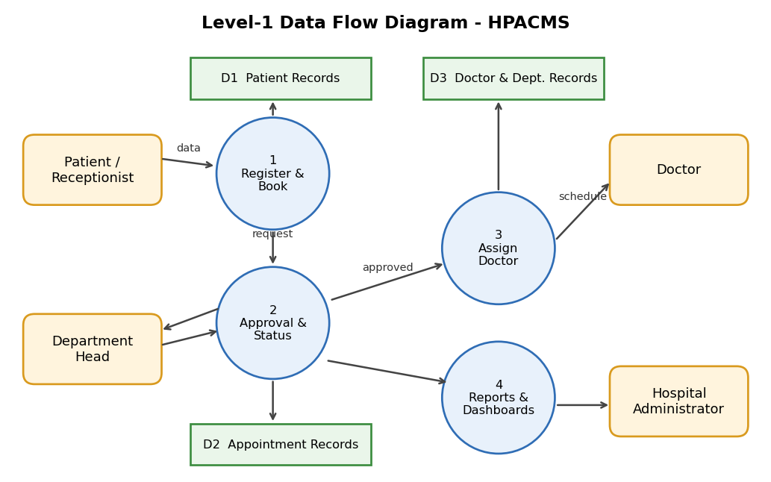
Here is how the diagram maps to the steps:
- Step 1, input: The patient or receptionist submits patient and appointment data into process 1.
- Step 2, validation and storage: Process 1 checks the data and saves it to D1 (patient records). Process 2 keeps appointment status in D2.
- Step 3, approval routing: Process 2 sends each request to the department head and receives the decision back. It then updates the appointment status in D2.
- Doctor assignment: Process 3 matches approved appointments to doctors using D3 and sends the schedule to the doctor.
- Step 4, reports and dashboards: Process 4 reads the processed appointment data from D2 and feeds the dashboards and reports.
4. PROJECT DESIGN PHASE
4.1 Problem–Solution Fit
HPACMS directly addresses fragmented appointment workflows by aligning user behavior, constraints, and automation using Salesforce-native capabilities.
Problem Statement
Hospitals and clinics often manage patient registration, appointment booking, approvals, and doctor scheduling through separate registers, phone calls, and paper forms. This causes duplicate records, double-booked slots, delayed confirmations, and no single view of hospital data. Receptionists spend time on manual checking, administrators lack visibility, and patients are left waiting for updates.
Problem–Solution Mapping
Problem (User Behavior / Constraint) | HPACMS Solution | Salesforce-Native Capability
Patient data scattered across registers and notes | Centralized patient and appointment records | Custom objects (Patient, Doctor, Appointment) with relationships
Incorrect or incomplete data entry | Data checked at the point of entry | Validation rules and required fields
Duplicate patients or double-booked slots | Duplicate and conflicting bookings blocked automatically | Duplicate rules and validation logic
Slow, manual approval of appointments | Requests routed to the right approver, with one-click approve or reject | Approval Processes and Flow automation
Manual doctor allocation | Doctors assigned automatically based on department and availability | Record-triggered Flows
Unauthorized access to sensitive records | Users see only what their role permits | Profiles, permission sets, roles, and sharing rules
No visibility into appointment progress | Real-time status tracking and management reporting | Reports and Dashboards
Different needs for each user type | Role-based interfaces for receptionists, doctors, and administrators | Lightning App pages and Lightning record pages
4.2 Proposed Solution
Parameter | Description
Problem | Manual appointment handling through registers, phone calls, and paper forms, leading to duplicate records, double bookings, delayed approvals, and unclear status.
Solution | Salesforce-based HPACMS managing registration, appointment booking, approvals, doctor assignment, and reporting on one platform.
Novelty | End-to-end automation of validation, approval routing, doctor assignment, and status updates using Salesforce-native tools (Flows, Approval Processes, Lightning).
Social Impact | Improved patient experience through shorter waiting times, accurate status, and less administrative delay.
Revenue Model | Institutional deployment: licensing, implementation, and support for hospitals and clinics.
Scalability | Multi-department support; new departments, doctors, and users can be added without redesign.
4.3 Solution Architecture
The architecture integrates Salesforce objects, automation flows, approval processes, dashboards, and security layers. Users interact through the Lightning interface, automation processes their requests, and the results are stored in custom objects. A security layer controls access at every level.
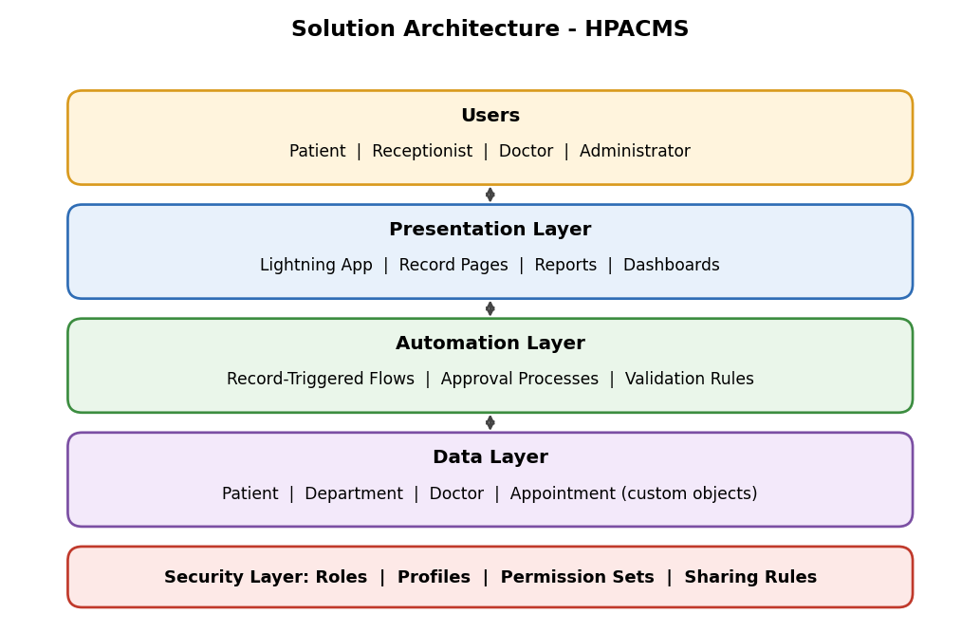
Here is how the layers work together:
- Users: Receptionists, administrators, doctors, and patients each get a role-specific view.
- Presentation layer: The Lightning app, dashboards, and reports give users a simple interface.
- Automation layer: Flows, approval processes, and validation rules handle checking, routing, and assignment.
- Data layer: The Patient, Department, Doctor, and Appointment objects hold all records and their relationships.
- Security layer: Profiles, permission sets, roles, and sharing rules apply at every layer, so users see only the records they are allowed to.
5. PROJECT PLANNING & SCHEDULING
5.1 Project Planning
The project follows the Agile methodology. Work is organized as Epics → User Stories → Story Points and delivered in sprints. Velocity from completed sprints is used to estimate the remaining work.
Product Backlog and Sprint Schedule
Sprint | Functional Requirement (Epic) | User Story Number | User Story / Task | Story Points | Priority | Team Members
Sprint-1 | Developer Setup | USN-1 | As a system administrator, I want to create a Salesforce developer account so that I can configure and deploy the Hospital Appointment system. | 1 | High | Member1
Sprint-1 | Data Modeling | USN-2 | As an admin, I want to create custom objects for Patient, Department, Doctor, and Appointment so that hospital data can be stored and managed efficiently. | 3 | High | Member2
Sprint-2 | Data Modeling | USN-3 | As a user, I want dedicated tabs for each object so that I can easily navigate between patients, departments, doctors, and appointments. | 3 | High | Member3
Sprint-2 | Data Modeling | USN-4 | As an admin, I want to create relevant fields such as patient details, doctor information, and appointment status so that complete records can be captured accurately. | 5 | High | Member4
Sprint-2 | Data Modeling | USN-5 | As a receptionist, I want a centralized Lightning App so that I can access all hospital operations from one interface. | 3 | High | Member4
Sprint-2 | Data Modeling | USN-6 | As an admin, I want to define relationships between patients, doctors, and appointments so that the system can logically link and track hospital activities. | 5 | Medium | Member1
Sprint-2 | Data Modeling | USN-7 | As a user, I want customized page layouts so that only relevant information is displayed, improving clarity and ease of data entry. | 5 | High | Member2
Sprint-3 | Automation | USN-8 | As a system, I want to validate input data such as mandatory fields and slot conflicts so that incorrect or incomplete records are prevented. | 3 | High | Member4
Sprint-3 | Automation | USN-9 | As a system, I want automated flows to handle appointment processing and notifications so that manual effort is reduced and processes become faster. | 3 | High | Member4
Sprint-3 | Automation | USN-10 | As an administrator, I want an approval process for appointment requests so that bookings are verified before confirmation. | 5 | High | Member1
Sprint-4 | Security | USN-11 | As an admin, I want to configure role-based security so that users can only access data relevant to their responsibilities. | 5 | High | Member2
Sprint-5 | Reports | USN-12 | As a manager, I want reports on patient appointments, department demand, and doctor assignments so that I can monitor hospital operations. | 4 | High | Member3
Sprint-6 | Dashboards | USN-13 | As a manager, I want visual dashboards showing appointment statistics and trends so that I can quickly analyze system performance. | 4 | Medium | Member4
Epic Summary
Epic | Stories | Story Points
Developer Setup | USN-1 | 1
Data Modeling | USN-2 to USN-7 | 24
Automation | USN-8 to USN-10 | 11
Security | USN-11 | 5
Reports | USN-12 | 4
Dashboards | USN-13 | 4
Total | 13 stories | 49
Sprint Schedule
Sprint | Total Story Points | Duration | Sprint Start Date | Sprint End Date (Planned) | Story Points Completed | Sprint Release Date
Sprint-1 | 4 | 7 days | 5 Oct 2026 | 11 Oct 2026 | 4 | 11 Oct 2026
Sprint-2 | 21 | 7 days | 12 Oct 2026 | 18 Oct 2026 | 21 | 18 Oct 2026
Sprint-3 | 11 | 7 days | 19 Oct 2026 | 25 Oct 2026 | 11 | 25 Oct 2026
Sprint-4 | 5 | 7 days | 26 Oct 2026 | 1 Nov 2026 | 5 | 1 Nov 2026
Sprint-5 | 4 | 7 days | 2 Nov 2026 | 8 Nov 2026 | 4 | 8 Nov 2026
Sprint-6 | 4 | 7 days | 9 Nov 2026 | 15 Nov 2026 | 4 | 15 Nov 2026
Total | 49 | 42 days |  |  | 49
Team Workload
Member | Stories | Total Story Points
Member1 | USN-1, USN-6, USN-10 | 11
Member2 | USN-2, USN-7, USN-11 | 13
Member3 | USN-3, USN-12 | 7
Member4 | USN-4, USN-5, USN-8, USN-9, USN-13 | 18

6. Project Development Phase
Milestone 1: Salesforce Developer Account Creation
Definition: A free Salesforce Developer Edition org is the working environment where the whole HPACMS solution is built, tested and demonstrated. It gives full access to the platform without affecting any production system.
Key steps:
- Sign up at developer.salesforce.com/signup
- Verify the email and set a password
- Log in and open Setup
Milestone 2: Custom Object Creation (Patient, Department, Doctor, Appointment)
Definition: A custom object is a database table in Salesforce. Four objects store the core hospital data: Patient, Department, Doctor, and Appointment (the link between a patient and a doctor).
Key steps:
- Setup > Object Manager > Create > Custom Object
- Enter label, plural label and record name (Auto Number for Appointment)
- Tick Allow Reports, Allow Search and Launch New Custom Tab Wizard
Milestone 3: Tabs Creation
Definition: A tab is a navigation shortcut that opens an object's list of records. Dedicated tabs let users move quickly between patients, departments, doctors and appointments.
Key steps:
- Setup > Tabs > Custom Object Tabs > New
- Select the object and choose a tab style
- Set visibility for profiles and add the tab to apps
Milestone 4: Lightning App Creation
Definition: A Lightning App groups tabs and utilities into one branded workspace. The HPACMS app gives receptionists a single interface for all hospital operations.
Key steps:
- Setup > App Manager > New Lightning App
- Set name, branding and navigation style
- Add the four object tabs, Reports and Dashboards
- Assign the app to user profiles
Milestone 5: Fields Creation
Definition: Fields are the columns of an object, and each holds one piece of data. They capture patient details, doctor information and appointment status accurately.
Key steps:
- Object Manager > (object) > Fields & Relationships > New
- Choose the data type (Text, Email, Date, Picklist, Number)
- Set field name, required flag and picklist values such as Scheduled, Confirmed, Cancelled, Completed
- Set field-level security and add to layouts
Milestone 6: Create Relationships
Definition: Relationships link records across objects. A Lookup or Master-Detail field connects Appointment to both Patient and Doctor so that activity can be tracked and rolled up.
Key steps:
- Create a Master-Detail or Lookup field on Appointment referencing Patient
- Create a second relationship field referencing Doctor
- Relate Doctor to Department with a Lookup field
- Check the related lists on parent records
Milestone 7: Page Layout Customization
Definition: A page layout controls which fields, sections and related lists appear on a record page. Customizing it keeps screens clean and makes data entry easier.
Key steps:
- Object Manager > (object) > Page Layouts
- Drag fields into logical sections and mark key fields required
- Add related lists and buttons
- Assign layouts to profiles
Milestone 8: Validation Rules
Definition: A validation rule is a formula that blocks a record from being saved when data is wrong or incomplete, for example a missing mandatory field, a past-dated appointment, or a doctor slot that is already booked.
Key steps:
- Object Manager > (object) > Validation Rules > New
- Write the error condition formula
- Enter the error message and choose where it appears
- Activate and test with invalid data
Milestone 9: Flows (Automation)
Definition: Flow is Salesforce's declarative automation tool. Record-triggered flows process appointments, send confirmation notifications and assign doctors automatically, replacing manual work.
Key steps:
- Setup > Flows > New Flow > Record-Triggered Flow
- Choose the object (Appointment) and trigger condition
- Add decision, update and email-alert elements
- Save, activate and test
Milestone 10: Approval Process
Definition: An approval process routes a record to the right approver, who can approve or reject it with one click. Appointment requests are verified before they are confirmed.
Key steps:
- Setup > Approval Processes > Appointment > Create New
- Set entry criteria and approver (user, role or queue)
- Define approval and rejection actions, such as updating status
- Activate the process
Milestone 11: Reports
Definition: Reports are saved queries that list records by criteria and grouping. Managers use them to monitor patient appointments, department demand and doctor assignments.
Key steps:
- Reports > New Report
- Select a report type such as Appointments with Patients and Doctors
- Add filters, grouping and columns
- Save into a folder
Milestone 12: Dashboards
Definition: Dashboards display report data as charts, gauges and tables. They give managers a real-time view of appointment statistics and trends.
Key steps:
- Dashboards > New Dashboard
- Add components from saved reports
- Choose chart types and set titles
- Save and set the running user
Milestone 13: Security Setup
Definition: Security controls who can see and edit what. Roles, profiles, permission sets and sharing rules ensure users only access data relevant to their responsibilities.
Key steps:
- Create roles (Admin, Receptionist, Doctor, Patient) in the role hierarchy
- Configure profiles and permission sets for object and field access
- Set organization-wide defaults and sharing rules
- Test using Login As
Milestone 14: Conclusion
Project Summary
HPACMS (the Salesforce-based appointment and care management system) replaces the registers, phone calls and paper forms that previously held the process together. It brings registration, appointments, approvals, doctor assignment and reporting into one Salesforce platform, so everyone works from a single source of truth.
Outcomes and Benefits
- Efficiency: Less manual data entry, chasing of approvals and reconciling of schedules.
- Accuracy: Validation reduces duplicate, missing and inconsistent records.
- Speed: Automated approvals and assignments shorten waiting times.
- Transparency: Stakeholders see current status through dashboards instead of asking for updates.
- Accountability: Every record, approval and change is traceable in one system.
- Scalability and maintainability: Because it uses standard Salesforce functionality rather than heavy custom code, new departments can be onboarded through configuration, and administrators can maintain it without specialist developers.
Possible Future Enhancements
- Patient portal (for example, an Experience Cloud site) for self-service booking, status tracking and report downloads
- Mobile access through the Salesforce mobile app or a tailored mobile experience for staff and doctors
- Automated reminders by email or SMS for upcoming appointments, schedule changes and follow-ups
- Advanced analytics such as demand forecasting, capacity planning and trend reporting
- Integrations with an electronic health record system, payment gateway, lab system or calendar tools
- Expansion to additional departments and branches using the existing framework
- AI-assisted features, such as smarter doctor matching or flagging scheduling bottlenecks
Closing Statement
HPACMS delivers on its core objectives: one platform, cleaner data, faster approvals, automated assignments and live reporting. Its native, configuration-first design gives the organization a solid foundation to grow from.

