1.

Query:

select ord.orderNumber,pd.productName,cms.customerName, pm.amount, pm.checkNumber from orders ord, customers cms, payments pm, orderdetails ordd, products pd

where ord.customerNumber = cms.customerNumber and pm.customerNumber = cms.customerNumber and ordd.orderNumber = ord.orderNumber and ordd.productCode = pd.productCode;

Output Screenshot:

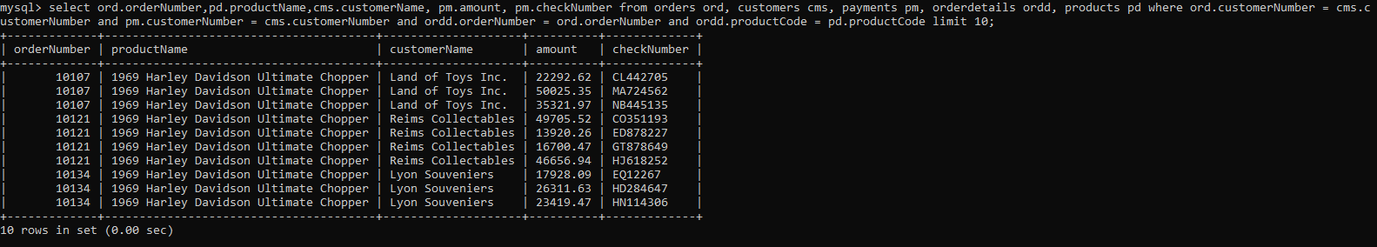

2

Query:

select sum(pay.amount) from orders ord, payments pay

where ord.customerNumber = pay.customerNumber and ord.orderNumber = 10100;

Output Screenshot:

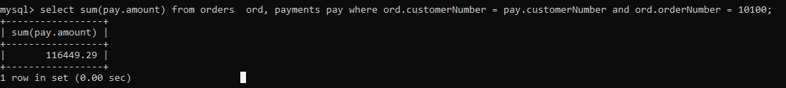

3

Query:

select ord.orderNumber,pay.checkNumber from orders ord, payments pay

where ord.customerNumber = pay.customerNumber and ord.orderNumber = 10100;

Output Screenshot:

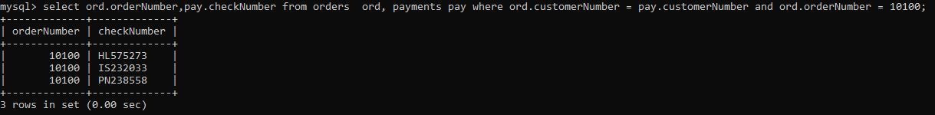

4,

Query :-

select min(quantityInStock) as least_value, max(quantityInStock) as max_value from products ;

Output Screenshot:

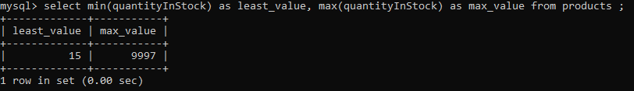

5

Query:-

select p.productCode, p.productLine, pl.htmlDescription from products p, productlines pl

where p.productLine = pl.productLine and p.productLine = (select productLine from productlines

where productLine = "Classic Cars");

Output screenshot:-

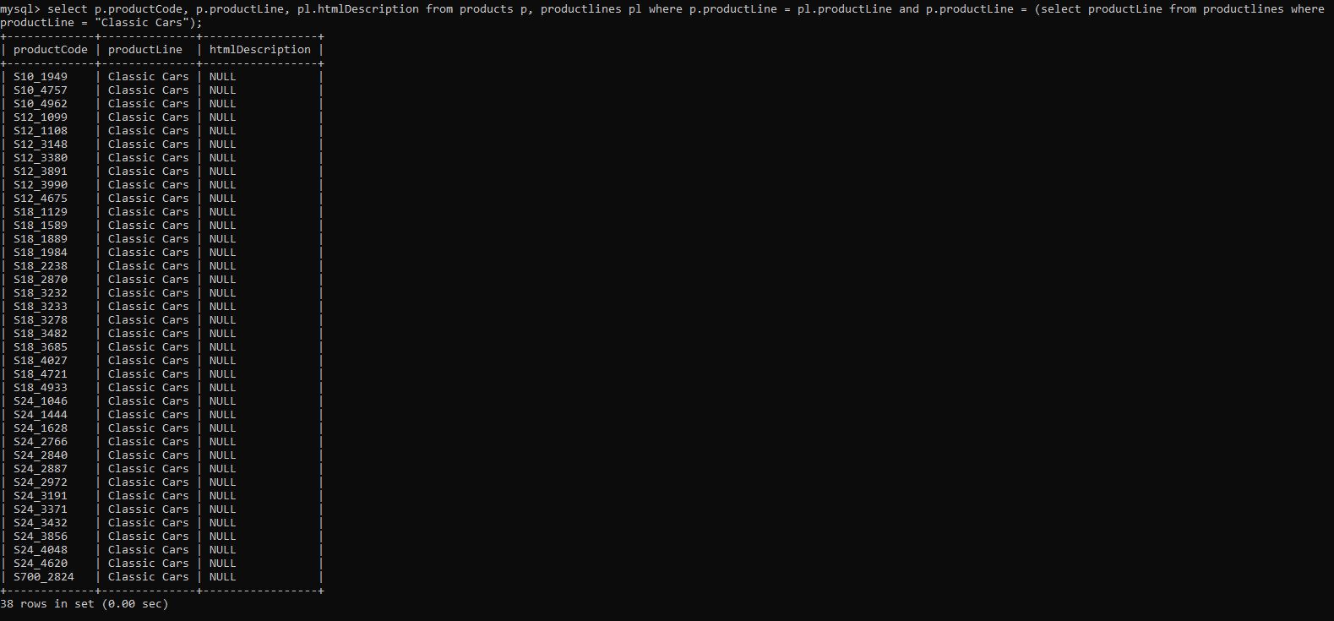

6

Query:-

select count(*) from productlines where htmlDescription is null;

Output screenshot:-

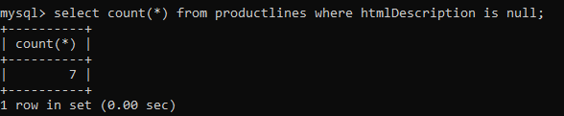

7.

Query:-

select date_format("2008-05-15 22:23:00",'%Y %b %a')

Output screenshot:-

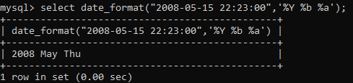

8.

Query:-

select amount from payments order by amount desc limit 3,1

Output screenshot:-

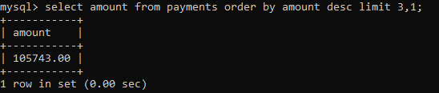

9



10.

